Tutorial 04 to do in class – Remember to upload the repo link to Teams.
Antes de iniciar:
- Terminar los talleres no calificables anteriores.
- Este taller muestra ejemplos de creación de servicios REST en Django.

Setup
- Create a directory named todoapp.
- Inside the todoapp folder, create a new django project named backend.
- Create an app in the backend folder named todo.
- Go to /backend/settings.py and add the following code:

Add Bold Code

INSTALLED_APPS = [
'django.contrib.admin',
'django.contrib.auth',
'django.contrib.contenttypes',
'django.contrib.sessions',
'django.contrib.messages',
'django.contrib.staticfiles',
# Custom apps start here
'todo.apps.TodoConfig',;

- Go to /backend/models.py and add the following code:

Replace Entire Code

from django.db import models
from django.contrib.auth.models import User

# Create your models here.
class ToDo(models.Model):
title = models.CharField(max_length=100)
memo = models.TextField(blank=True)

# Set to current time
created = models.DateTimeField(auto_now_add=True)
completed = models.BooleanField(default=False)

# User who posted
user = models.ForeignKey(User, on_delete=models.CASCADE)

def __str__(self):
return self.title

- Go to the Terminal and run the following commands:
python manage.py makemigrations
python manage.py migrate

- Go to the Terminal and run the following commands:
python manage.py createsuperuser

- Create an admin login, then run the app by executing the following command in the Terminal:

python manage.py runserver

- Go to todo/admin.py and add the following code:

Replace Entire Code

from django.contrib import admin
from .models import ToDo

# Register your models here.
admin.site.register(ToDo)
- Go to http://localhost:8000/admin/ , log in with your superuser credentials. You should see the following:
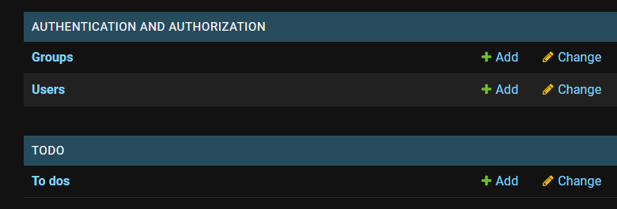

- You can add a To Do by clicking +Add.

- An API system
Django REST Framework (DRF)
- Go to the Terminal and install DRF:
pip install djangorestframework

- Go to backend/setting.py and add the following code:
Add Bold Code

INSTALLED_APPS = [
'django.contrib.admin',
'django.contrib.auth',
'django.contrib.contenttypes',
'django.contrib.sessions',
'django.contrib.messages',
'django.contrib.staticfiles',
# Custom apps start here
'todo.apps.TodoConfig',
# Third-party apps start here
'rest_framework',

Creating an API
- Go to the Terminal and run the following command:

Python manage.py startapp api

- Go to the /backend/settings.py and add the following code:
Add Bold Code

INSTALLED_APPS = [
'django.contrib.admin',
'django.contrib.auth',
'django.contrib.contenttypes',
'django.contrib.sessions',
'django.contrib.messages',
'django.contrib.staticfiles',
# Custom apps start here
'todo.apps.TodoConfig',
api.apps.ApiConfig',
# Third-party apps start here
'rest_framework',

API Serializers
- Create a new file in the api app called serializers.py and add the following code:
Add Entire Code

from rest_framework import serializers
from todo.models import ToDo

class ToDoSerializer(serializers.ModelSerializer):
created = serializers.ReadOnlyField()
completed = serializers.ReadOnlyField()

class Meta:
model = ToDo
fields = ['id', 'title', 'memo', 'created', 'completed']
API Controller

- Go to api/views.py and add the following content:

Replace Entire Code

from rest_framework import generics
from .serializers import TodoSerializer
from todo.models import Todo

class TodoList(generics.ListAPIView):
# ListAPIView requires two mandatory attributes, serializer_class and
# queryset.
# We specify TodoSerializer which we have earlier implemented
serializer_class = TodoSerializer

def get_queryset(self):
user = self.request.user
return Todo.objects.filter(user=user).order_by('-created')

API routes
- Go to backend/urls.py and make the following changes in bold.

Modify Bold Code
…
from django.contrib import admin
from django.urls import path, include

urlpatterns = [
path('admin/', admin.site.urls),
path('api/', include('api.urls')) # Include urls from API.
]

- Create a file named urls.py in the api app and add the following code:
from django.urls import path
from . import views

urlpatterns = [
path(todos/', views.ToDoList.as_view(), name=’list’),
]

Run the application
- Go to http://127.0.0.1:8000/api/todos and it should display a screen like this:
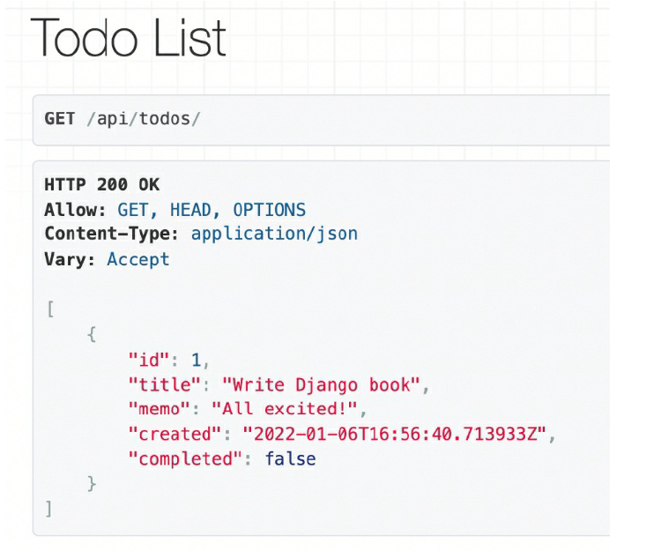

Improve API Controller
- Got to api/views.py and add the following code:

Modify Bold Code
from rest_framework import generics
from .serializers import TodoSerializer
from todo.models import Todo

class TodoListCreate(generics.ListCreateAPIView):
# ListAPIView requires two mandatory attributes, serializer_class and
# queryset.
# We specify TodoSerializer which we have earlier implemented
serializer_class = TodoSerializer

def get_queryset(self):
user = self.request.user
return Todo.objects.filter(user=user).order_by('-created')

def perform_create(self, serializer):
#serializer holds a django model
serializer.save(user=self.request.user)

Modify API routes
Modify Bold Code

from django.urls import path
from . import views

urlpatterns = [
path(todos/', views.ToDoListCreate.as_view(), name=’list’),
]

Run the application
- Go to http://127.0.0.1:8000/api/todos and it should display a screen like this:
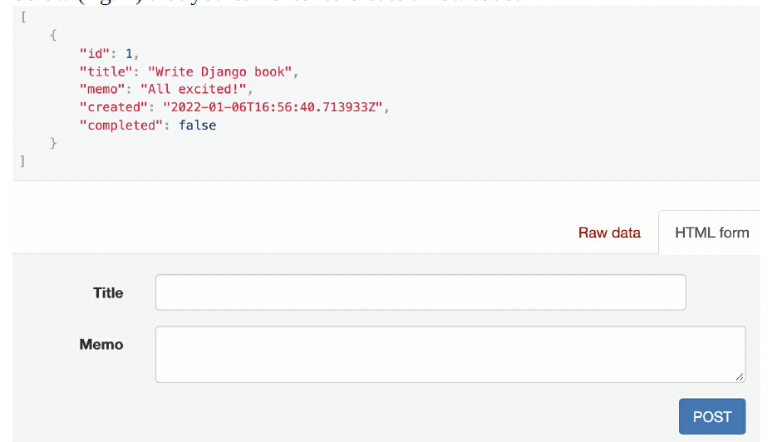

- You can now create To Do lists from the API.

- An API system with Permissions
Api Controller
- Go to api/views.py and add the following code:

Modify Bold Code
from rest_framework import generics, permissions
from .serializers import TodoSerializer
from todo.models import Todo

class TodoListCreate(generics.ListCreateAPIView):
…
serializer_class = TodoSerializer
permission_classes = [permissions.IsAuthenticated]

Run the application
- Go to localhost:8000/admin and log out of your superuser account.
- Next, go to localhost:8000/todos and you should see the following screen:

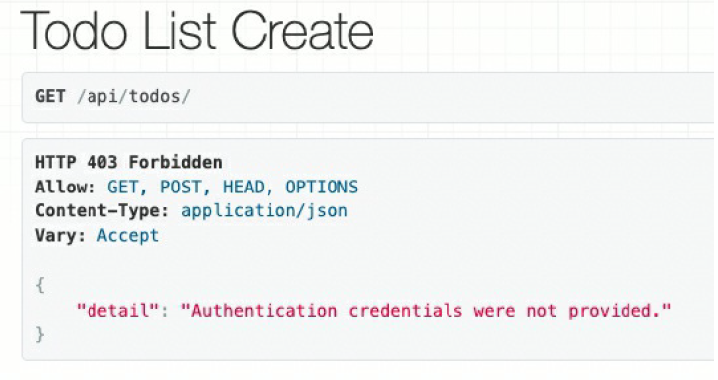

- Before proceeding with finalizing user authentication, we will explore other operations with our API endpoint.

- Other C.RU.D. operations with an API system
API routes
- Go to api/urls.py/ and add the follwoing content:

Add Bold Code
...
urlpatterns = [
path('todos/', views.TodoListCreate.as_view()),
path('todos/<int:pk>', views.TodoRetrieveUpdateDestroy.as_view()),
]

API Controller
- Go to api/views.py and add the follwing content:

Add Bold Code
...
class TodoListCreate(generics.ListCreateAPIView):
...

class TodoRetrieveUpdateDestroy(generics.RetrieveUpdateDestroyAPIView):
serializer_class = TodoSerializer
permission_classes = [permissions.IsAuthenticated]
def get_queryset(self):
user = self.request.user
# user can only update, delete own posts
return Todo.objects.filter(user=user)

Run the application
- Go to http://localhost:8000/api/todos/1 and you should see the following screen:

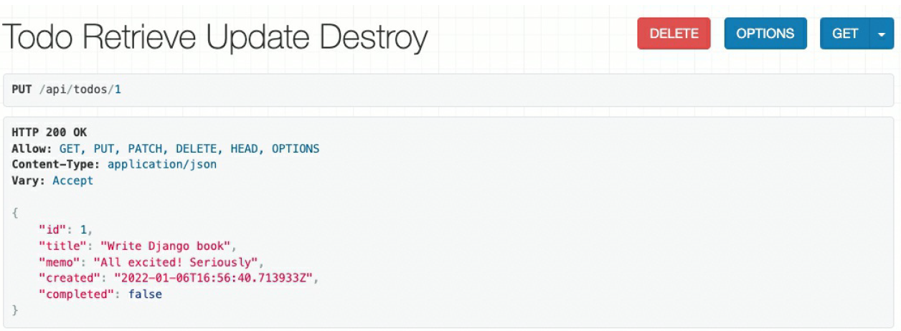
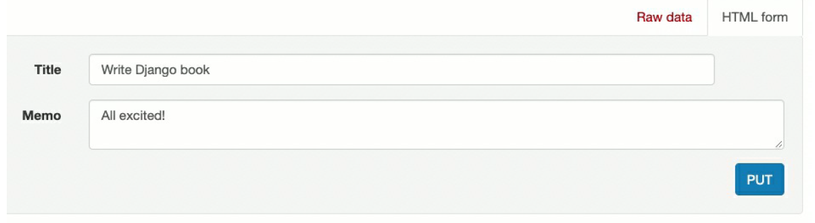

- Non-C.R.U.D. operations

- We will add logic to implement a view that completes a To Do List
API routes
- Go to apì/urls.py and add the following code:

Add Bold Code
...
urlpatterns = [
path('todos/', views.TodoListCreate.as_view()),
path('todos/<int:pk>', views.TodoRetrieveUpdateDestroy.as_view()),
path('todos/<int:pk>/complete', views.TodoToggleComplete.as_view()),
]

API Serializer
- Go to api/serializers.py and add the following code:
Add Bold Code

from rest_framework import serializers
from todo.models import ToDo

class ToDoSerializer(serializers.ModelSerializer):
…

class ToDoSerializer(serializers.ModelSerializer):

class Meta:
model = ToDo
fields = ['title', 'memo', 'created', 'completed']

API Controller
- Go to api/views.py and add the following code:
Add Bold Code
from rest_framework import generics, permissions
from .serializers import TodoSerializer, TodoToggleCompleteSerializer
from todo.models import Todo

class TodoListCreate(generics.ListCreateAPIView):
...

class TodoRetrieveUpdateDestroy(generics.RetrieveUpdateDestroyAPIView):
...

class TodoToggleComplete(generics.UpdateAPIView):
serializer_class = TodoToggleCompleteSerializer
permission_classes = [permissions.IsAuthenticated]

def get_queryset(self):
user = self.request.user
return Todo.objects.filter(user=user)

def perform_update(self,serializer):
serializer.instance.completed=not(serializer.instance.completed)
serializer.save()
Running the application
- Go to localhost:8000/api/todos/2/complete and click on ‘PUT’ on the following screen:
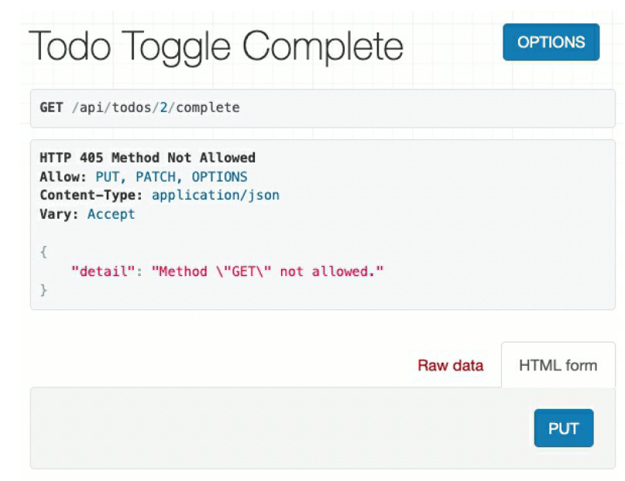

- Go to localhost:8000/api/todos and you should see the following screen:
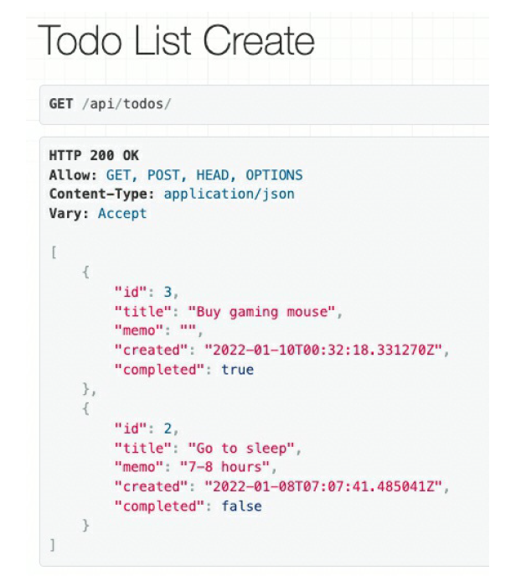

- An API System with signup & login

Setting up authentication token
- Go to backend/settings.py and add the following app:
Add Bold Code
INSTALLED_APPS = [
'django.contrib.admin',
'django.contrib.auth',
'django.contrib.contenttypes',
'django.contrib.sessions',
'django.contrib.messages',
'django.contrib.staticfiles',
# Custom apps start here
'todo.apps.TodoConfig',
'api.apps.ApiConfig',
# Third-party apps start here
'rest_framework',
'rest_framework.authtoken',
]

- Run the following command in the Terminal:

Add Bold Code
python manage.py migrate

- Go to backend/settings.py and add the following configuration (at the bottom of the file):

Add Bold Code
...
REST_FRAMEWORK = {
'DEFAULT_AUTHENTICATION_CLASSES':[
'rest_framework.authentication.TokenAuthentication',
]

API routes
- Next, head to api/urls.py and add the following code:

Add Bold Code
from django.urls import path
from . import views

urlpatterns = [
path('todos/', views.ToDoListCreate.as_view(), name='todo_list'),
path('todos/<int:pk>', views.ToDoRetrieveUpdateDestroy.as_view(), name='todo_RUD'),
path('todos/<int:pk>/complete', views.ToDoToggleComplete.as_view()),
path('signup/', views.signup, name='signup'),
path('login/', views.login, name='login'),
]
API controller
- Go to api/views.py and add the following code:
...
from todo.models import Todo
from django.db import IntegrityError
from django.contrib.auth.models import User
from rest_framework.parsers import JSONParser
from rest_framework.authtoken.models import Token
from django.http import JsonResponse
from django.views.decorators.csrf import csrf_exempt
from django.contrib.auth import authenticate
...

class TodoToggleComplete(generics.UpdateAPIView):
...

@csrf_exempt
def signup(request):
if request.method == 'POST':
try:
data = JSONParser().parse(request) # data is a dictionary
user = User.objects.create_user(
username=data['username'],
password=data['password'])
user.save()
token = Token.objects.create(user=user)
return JsonResponse({'token':str(token)},status=201)
except IntegrityError:
return JsonResponse(
{'error':'username taken. choose another username'},
status=400)

@csrf_exempt
def login(request):
if request.method == 'POST':
data = JSONParser().parse(request)
user = authenticate(
request,
username=data['username'],
password=data['password'])
if user is None:
return JsonResponse(
{'error':'unable to login. check username and password'}, status=400)
else: # return user token
try:
token = Token.objects.get(user=user)
except: # if token not in db, create a new one
token = Token.objects.create(user=user)
return JsonResponse({'token':str(token)}, status=201)

Testing API
- You can download the Insomnia client from https://insomnia.rest then go to http://localhost:8000/api/signup/ and do the following:

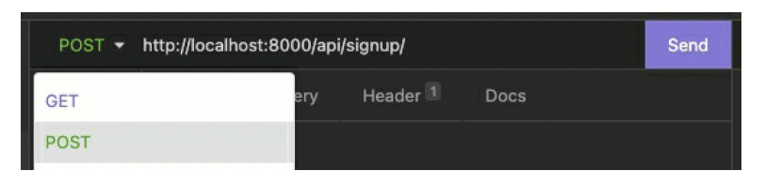
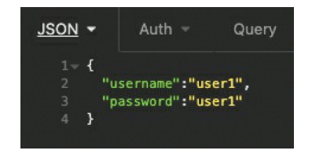
- When you hit send, the following should some up:
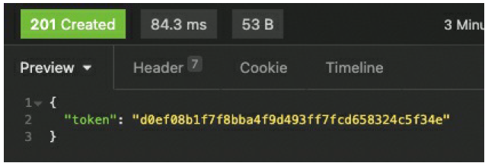

- To test the login go to Insomnia and run the following:
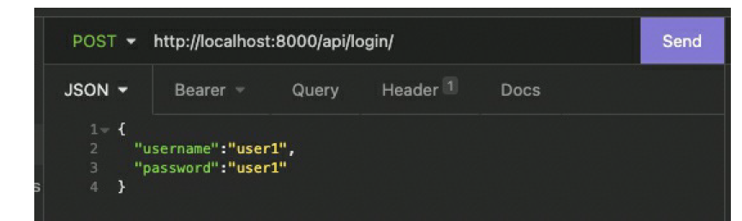

- After hitting send you should see the authorization token.
- Go to db.sqlite3 and in the todo_todo table make the following change:
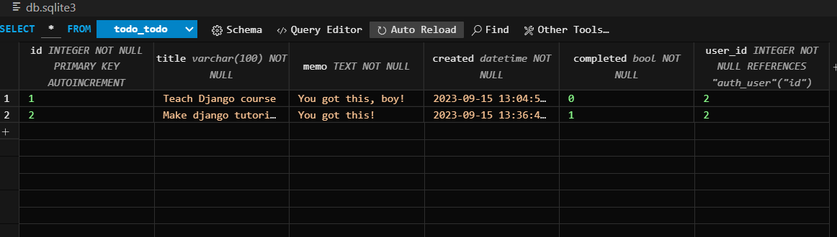

- Go to https://reqbin.com/curl and type the following command:

curl http://127.0.0.1:8000/api/todos/ -H "Authorization: Token <YOUR TOKEN>"

- Click run, and you should see the following screen:
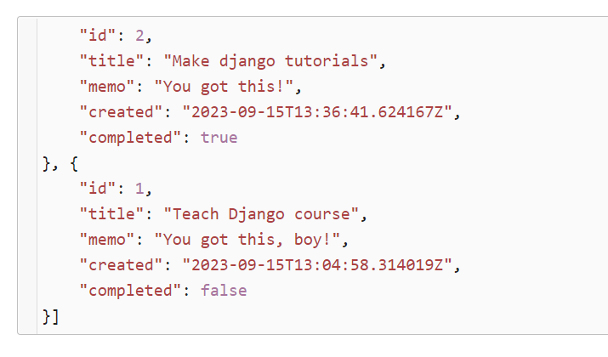

Challenge
- Take you helloworld app and generate an API endpoint for it (for simplicity you can leave the authentication until the end).
- HINT: You do not need to delete your MVT controllers to do this.

