1. Write the user stories you think could support your design

* As a YouTube User, I want to be able to search and watch videos on the site so that I can have content of my interest.
* As a YouTube user, I want to be able to subscribe to channels to receive notifications when they publish new videos
* As a YouTube user, I want to be able to leave comments on videos to express my opinions.
* As a YouTube user, I want to be able to like or dislike (react) videos to express my opinion on their content.
* As a YouTube user, I want to be able to see statistics about the videos, such as the number of views, likes, comments, etc.
* As a YouTube user, I want to be able to create playlists to organize and save videos that interest me.
* As a YouTube user, I want to be able to receive personalized video recommendations based on my interests and browsing behavior on the platform.
* As a content creator on YouTube, I want to be able to live stream to interact in real time with my audience.
* As a content creator on YouTube, I want to be able to upload videos to my channel to share my content with my audience.
* As a YouTube administrator, I want to be able to manage and moderate comments to maintain a safe and respectful environment on the platform.

2. Write down the 10 steps methodology to get the Data Structure Entity-Relationship Model.

STEP 0: Definir componentes

- User

- Video

- Channel

- Comment

- I like it I do not like it

- Live broadcast

STEP 1: Definir entidades

* e1. User
* e2. Video
* e3.Chanel
* e4.Comment
* e5I like it/ I don't like
* e.6 Live broadcast
* e.7 Playlist
* e.8 Video category
* e.9 Playback history
* e.10 Subscription
* e.11 Video statistics

STEP 2:

* e1: User ID, username, email, password, registration date
* e2: Video ID, title, description, upload date, duration, number of views.
* e3: Channel ID, channel name, description, creation date, subscribers
* e4: Comment ID, content, post date, user who posted it.
* e5: ID de me gusta/no me gusta, usuario que lo dio, video al que pertenece
* e6: Live stream ID, title, description, start date and time, user who started it
* e7: Playlist ID, name, description, user who created it, included videos
* e8: Category ID, name, description, associated videos, etc.
* e9: History ID, associated user, viewed videos, viewing date and time
* e10:Subscription ID, subscriber user, channel subscribed to, subscription date
* e11: Statistics ID, associated video, number of views, likes, dislikes, comments

STEP3:

|  |  |  |  |  |  |  |  |  |  |  |  |
| --- | --- | --- | --- | --- | --- | --- | --- | --- | --- | --- | --- |
|  | e1 | e2 | e3 | e4 | e5 | e6 | e7 | e8 | e9 | e10 | e11 |
| e1 |  |  |  | ✔ | ✔ |  | ✔ |  | ✔ | ✔ |  |
| e2 |  |  |  | ✔ |  |  | ✔ | ✔ |  |  | ✔ |
| e3 |  |  |  |  |  | ✔ |  |  | ✔ |  |  |
| e4 | ✔ | ✔ |  |  |  |  |  |  |  |  |  |
| e5 | ✔ |  |  |  |  |  |  |  |  |  |  |
| e6 |  |  | ✔ |  |  |  |  |  |  |  |  |
| e7 | ✔ | ✔ |  |  |  |  |  |  |  |  |  |
| e8 |  | ✔ |  |  |  |  |  |  |  |  |  |
| e9 | ✔ |  | ✔ |  |  |  |  |  |  |  |  |
| e10 | ✔ |  |  |  |  |  |  |  |  |  |  |
| e11 |  |  |  |  |  |  |  |  |  |  |  |

STEP 4. TIPOS DE RELACIONES

1 to 1 relationships (1-1):

User <----> Playlist (A user can have a specific playlist and a playlist is associated with a single user.)

Video <----> Video Statistics (Each video is associated with a specific set of statistics and some statistics belong to a single video).

1-to-many (1-n) relationships:

User -----> Comment (A user can make multiple comments, but a comment belongs to a single user).

User -----> Like/Dislike (A user can like or dislike multiple videos, but each reaction is associated with a single user).

Channel -----> Live Stream (A channel can make multiple live streams, but each stream is associated with a single channel).

Video -----> Comment (A video can have multiple comments, but each comment belongs to a single video.)

Video Category -----> Video (A video category can contain multiple videos, but each video belongs to a single category.)

Many-to-many relationships (n-n):

User <----> Subscription (A user can subscribe to multiple channels and a channel can have multiple subscribers.)

Video <----> Playlist (A video can be in multiple playlists and a playlist can contain multiple videos.)

User <----> Playback History (A user can have multiple videos in their playback history, and one video can be in the playback history of multiple users.)

Channel <----> Play History (A channel can have multiple videos in its play history and one video can be in the play history of multiple channels.)

STEP 5

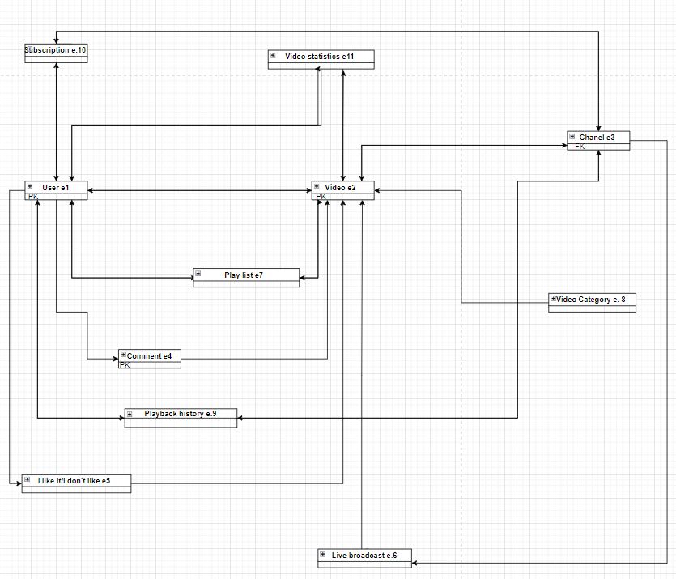

3. Write any technical decision/consideration you made in the design process

An entity-relationship (ER) model was used to represent the entities, attributes and relationships between the different components of the YouTube system. This provided a clear view of the database structure and facilitated its design and development.

4. Write any concern or challenge you have completed the test

My question is when establishing the types of relationships, in the case when they are repeated, that is, the relationship e1, e2 and e2, e1, how is the relationship established? Which of the two do you start with?