BIOL3712 Integrated Physiology of Plants and Animals

Semester 2, 2022

Salinity experiment

data analysis workbook

Completion and submission of this workbook is worth 40% of the marks for your Salinity assignment.

Use the files provided and your r code to answer the questions on the following pages. Once you have completed this, please save it as a .pdf and submit it to FLO.

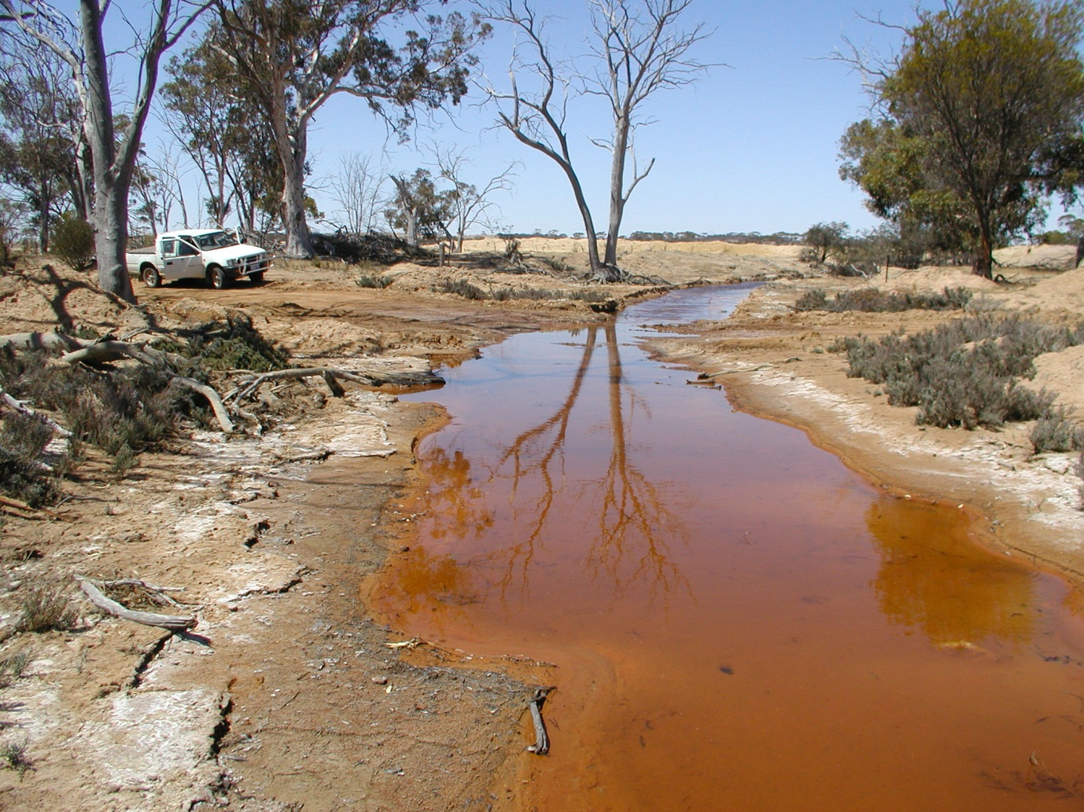

1. **R Basics.**

Please open and run through the “workshop1_rbasics.R” code.

Answer the questions embedded in the script. Once you have completed this section, please copy and paste the output from your console here. **/5**

1. **Salinity (data standardisation)**

Open the file called “2022_data.xlsx”. This contains three sheets – the data we saved as a .csv and imported into R, the data including the calculations (click on each cell to see the formula used), and the raw data we collected. Use this spreadsheet to answer the following questions:

1. How many replicates are there for each factor and treatment? **/1**
2. How were the variables leaf number (as a ratio of control mean), shoot height (as a ratio of control mean), and root length (as a ratio of control mean) calculated? **/2**
3. How were the variables FW shoot/root ratio and DW shoot/root ratio calculated? **/2**
4. **Salinity (first three response variables)**

Now open the file called “workshop1_salinity.R”. Use the code in this file to answer the following questions for each of the response variables. This will form the basis of your statistical methods and results sections.

***Methods:***

For all variables:

1. How did you test the assumption that data was normally distributed? **/1**
2. How did you test the assumption that variances are homogenous? **/1**
3. Did you need to test the assumption that data are independent? Why/why not? **/1**

**VARIABLE: __________________________________ /9**

***Methods:***

1. What was the *p*-value for your normality test? Was your data normally distributed?
2. Did you remove outliers? Complete the table below for your final *n* for each treatment:

|  |  |  |  |  |  |
| --- | --- | --- | --- | --- | --- |
|  | **Salt Concentration (g/L)** | | | | |
| **Species** | 1.5 | 2.5 | 5 | 10 | 15 |
| Barley |  |  |  |  |  |
| Wheat |  |  |  |  |  |

1. Was your data normally distributed once you removed outliers? What was the p-value?
2. Did your data have homogenous variances? What was the *p*-value?

***Results:***

1. Complete the table below with the results from your two-way ANOVA

|  |  |  |  |
| --- | --- | --- | --- |
|  | df | F-value | *p*-value |
| species |  |  |  |
| saltConc |  |  |  |
| species*saltConc |  |  |  |

1. Which of these results were significant?
2. Which of the salt concentrations were significantly different from each other? How different were they from each other? (HINT: you will need to use your summary statistics and the results from your Tukey’s post-hoc test to answer this question).
3. Paste your final means plot below. Use text boxes to annotate your plot with the groups from your post-hoc tests.

**VARIABLE: __________________________________ /9**

***Methods:***

1. What was the *p*-value for your normality test? Was your data normally distributed?
2. Did you remove outliers? Complete the table below for your final *n* for each treatment:

|  |  |  |  |  |  |
| --- | --- | --- | --- | --- | --- |
|  | **Salt Concentration (g/L)** | | | | |
| **Species** | 1.5 | 2.5 | 5 | 10 | 15 |
| Barley |  |  |  |  |  |
| Wheat |  |  |  |  |  |

1. Was your data normally distributed once you removed outliers? What was the p-value?
2. Did your data have homogenous variances? What was the *p*-value?

***Results:***

1. Complete the table below with the results from your two-way ANOVA

|  |  |  |  |
| --- | --- | --- | --- |
|  | df | F-value | *p*-value |
| species |  |  |  |
| saltConc |  |  |  |
| species*saltConc |  |  |  |

1. Which of these results were significant?
2. Which of the salt concentrations were significantly different from each other? How different were they from each other? (HINT: you will need to use your summary statistics and the results from your Tukey’s post-hoc test to answer this question).
3. Paste your final means plot below. Use text boxes to annotate your plot with the groups from your post-hoc tests.

**VARIABLE: __________________________________ /9**

***Methods:***

1. What was the *p*-value for your normality test? Was your data normally distributed?
2. Did you remove outliers? Complete the table below for your final *n* for each treatment:

|  |  |  |  |  |  |
| --- | --- | --- | --- | --- | --- |
|  | **Salt Concentration (g/L)** | | | | |
| **Species** | 1.5 | 2.5 | 5 | 10 | 15 |
| Barley |  |  |  |  |  |
| Wheat |  |  |  |  |  |

1. Was your data normally distributed once you removed outliers? What was the p-value?
2. Did your data have homogenous variances? What was the *p*-value?

***Results:***

1. Complete the table below with the results from your two-way ANOVA

|  |  |  |  |
| --- | --- | --- | --- |
|  | df | F-value | *p*-value |
| species |  |  |  |
| saltConc |  |  |  |
| species*saltConc |  |  |  |

1. Which of these results were significant?
2. Which of the salt concentrations were significantly different from each other? How different were they from each other? (HINT: you will need to use your summary statistics and the results from your Tukey’s post-hoc test to answer this question).
3. Paste your final means plot below. Use text boxes to annotate your plot with the groups from your post-hoc tests.
4. **Salinity (Final five response variables)**

If you’d like to be in the running for a HD, please paste your code for the last five variables here. This code will be worth 15 marks. Otherwise, please open the file “workshop1_salinitycont.R”.

**/15**

Either way, continue completing the questions on the following pages for each variable.

**VARIABLE: __________________________________ /9**

***Methods:***

1. What was the *p*-value for your normality test? Was your data normally distributed?
2. Did you remove outliers? Complete the table below for your final *n* for each treatment:

|  |  |  |  |  |  |
| --- | --- | --- | --- | --- | --- |
|  | **Salt Concentration (g/L)** | | | | |
| **Species** | 1.5 | 2.5 | 5 | 10 | 15 |
| Barley |  |  |  |  |  |
| Wheat |  |  |  |  |  |

1. Was your data normally distributed once you removed outliers? What was the p-value?
2. Did your data have homogenous variances? What was the *p*-value?

***Results:***

1. Complete the table below with the results from your two-way ANOVA

|  |  |  |  |
| --- | --- | --- | --- |
|  | df | F-value | *p*-value |
| species |  |  |  |
| saltConc |  |  |  |
| species*saltConc |  |  |  |

1. Which of these results were significant?
2. Which of the salt concentrations were significantly different from each other? How different were they from each other? (HINT: you will need to use your summary statistics and the results from your Tukey’s post-hoc test to answer this question).
3. Paste your final means plot below. Use text boxes to annotate your plot with the groups from your post-hoc tests.

**VARIABLE: __________________________________ /9**

***Methods:***

1. What was the *p*-value for your normality test? Was your data normally distributed?
2. Did you remove outliers? Complete the table below for your final *n* for each treatment:

|  |  |  |  |  |  |
| --- | --- | --- | --- | --- | --- |
|  | **Salt Concentration (g/L)** | | | | |
| **Species** | 1.5 | 2.5 | 5 | 10 | 15 |
| Barley |  |  |  |  |  |
| Wheat |  |  |  |  |  |

1. Was your data normally distributed once you removed outliers? What was the p-value?
2. Did your data have homogenous variances? What was the *p*-value?

***Results:***

1. Complete the table below with the results from your two-way ANOVA

|  |  |  |  |
| --- | --- | --- | --- |
|  | df | F-value | *p*-value |
| species |  |  |  |
| saltConc |  |  |  |
| species*saltConc |  |  |  |

1. Which of these results were significant?
2. Which of the salt concentrations were significantly different from each other? How different were they from each other? (HINT: you will need to use your summary statistics and the results from your Tukey’s post-hoc test to answer this question).
3. Paste your final means plot below. Use text boxes to annotate your plot with the groups from your post-hoc tests.

**VARIABLE: __________________________________ /9**

***Methods:***

1. What was the *p*-value for your normality test? Was your data normally distributed?
2. Did you remove outliers? Complete the table below for your final *n* for each treatment:

|  |  |  |  |  |  |
| --- | --- | --- | --- | --- | --- |
|  | **Salt Concentration (g/L)** | | | | |
| **Species** | 1.5 | 2.5 | 5 | 10 | 15 |
| Barley |  |  |  |  |  |
| Wheat |  |  |  |  |  |

1. Was your data normally distributed once you removed outliers? What was the p-value?
2. Did your data have homogenous variances? What was the *p*-value?

***Results:***

1. Complete the table below with the results from your two-way ANOVA

|  |  |  |  |
| --- | --- | --- | --- |
|  | df | F-value | *p*-value |
| species |  |  |  |
| saltConc |  |  |  |
| species*saltConc |  |  |  |

1. Which of these results were significant?
2. Which of the salt concentrations were significantly different from each other? How different were they from each other? (HINT: you will need to use your summary statistics and the results from your Tukey’s post-hoc test to answer this question).
3. Paste your final means plot below. Use text boxes to annotate your plot with the groups from your post-hoc tests.

**VARIABLE: __________________________________ /9**

***Methods:***

1. What was the *p*-value for your normality test? Was your data normally distributed?
2. Did you remove outliers? Complete the table below for your final *n* for each treatment:

|  |  |  |  |  |  |
| --- | --- | --- | --- | --- | --- |
|  | **Salt Concentration (g/L)** | | | | |
| **Species** | 1.5 | 2.5 | 5 | 10 | 15 |
| Barley |  |  |  |  |  |
| Wheat |  |  |  |  |  |

1. Was your data normally distributed once you removed outliers? What was the p-value?
2. Did your data have homogenous variances? What was the *p*-value?

***Results:***

1. Complete the table below with the results from your two-way ANOVA

|  |  |  |  |
| --- | --- | --- | --- |
|  | df | F-value | *p*-value |
| species |  |  |  |
| saltConc |  |  |  |
| species*saltConc |  |  |  |

1. Which of these results were significant?
2. Which of the salt concentrations were significantly different from each other? How different were they from each other? (HINT: you will need to use your summary statistics and the results from your Tukey’s post-hoc test to answer this question).
3. Paste your final means plot below. Use text boxes to annotate your plot with the groups from your post-hoc tests.

**VARIABLE: __________________________________ /9**

***Methods:***

1. What was the *p*-value for your normality test? Was your data normally distributed?
2. Did you remove outliers? Complete the table below for your final *n* for each treatment:

|  |  |  |  |  |  |
| --- | --- | --- | --- | --- | --- |
|  | **Salt Concentration (g/L)** | | | | |
| **Species** | 1.5 | 2.5 | 5 | 10 | 15 |
| Barley |  |  |  |  |  |
| Wheat |  |  |  |  |  |

1. Was your data normally distributed once you removed outliers? What was the p-value?
2. Did your data have homogenous variances? What was the *p*-value?

***Results:***

1. Complete the table below with the results from your two-way ANOVA

|  |  |  |  |
| --- | --- | --- | --- |
|  | df | F-value | *p*-value |
| species |  |  |  |
| saltConc |  |  |  |
| species*saltConc |  |  |  |

1. Which of these results were significant?
2. Which of the salt concentrations were significantly different from each other? How different were they from each other? (HINT: you will need to use your summary statistics and the results from your Tukey’s post-hoc test to answer this question).
3. Paste your final means plot below. Use text boxes to annotate your plot with the groups from your post-hoc tests.