BIOL3712 Integrated Physiology of Plants and Animals
Semester 2, 2026
Snail respiration
data analysis workbook

Use the files provided and your r code to answer the questions on the following pages. Once you have completed this, please save it as a .pdf and submit it to FLO. Please answer all questions in full sentences. They don’t have to be long, but they have to be full sentences that could go straight into your results section!
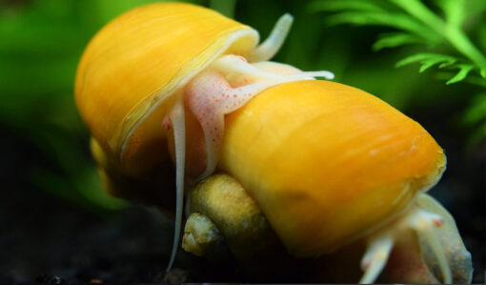

This time, you have to do a bit more of your own decision making. We’ll walk you through this in the CML, but here’s the decision making tree:

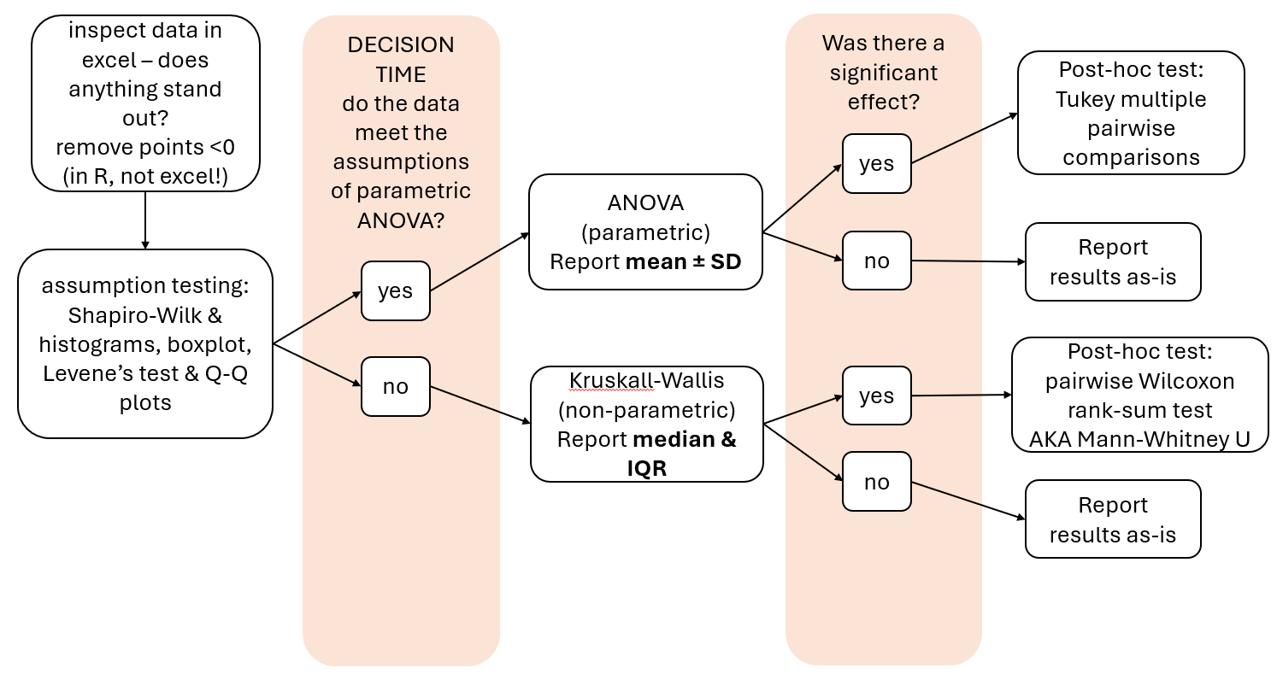

- Snails (data standardisation)
Open the file called “AllSnailData.xlsx” on FLO. This contains three sheets – the data we saved as a .csv and imported into R, the raw data including the calculations (click on each cell to see the formula used), and the control values. Use this spreadsheet to answer the following questions:
- How were the final values calculated? /2

- Why is it important to consider the weight of the snails in our calculations? /2

- Why is it important to record and consider the controls?
Did the control values indicate any issues for our study? /2

Open the file called “ws2_students2026.R”. Use the code in this file to answer the following questions for your response variable. This will form the basis of your statistical methods and results sections.
Methods:
- What were our predictor and response variables? /2

- What was our sample size overall and for each of the levels of your predictor variable? /2

- How many values below 0 did we remove, and why did we do this? /2

- How did you test the assumption that data were normally distributed?
  - What was the name of the test used? /1

  - What was the p-value for this test? /1

  - Does this mean the data were normally distributed? /2

  - If the data were not normally distributed, did you remove outliers? How many, and from which levels? /1

  - When you re-tested for normality, what was the p-value? /1

  - Do the data meet the assumption? If not, is it OK to proceed? Why? /2

Include screengrab(s) of any graphs you created in this step. /2

- How did you test the assumption that variances are homogenous (do this regardless of your assessment of normality)?
  - What was the name of the test used? /1

  - What was the p-value for this test? /1

  - Does this mean that the variances are homogenous? /1

  - If the assumption is not met, is it OK to proceed? Why? /2

Include a screengrab of any graphs you created in this step. /2

- Did you need to test the assumption that data are independent? Why/why not? /2

- DECISION TIME: What test did you decide to use the see if there was an effect of temperature on respiration? Explain your decision. There’s no wrong decision, only bad justifications /2

- What test did you use to see where the effect was? /1

You will need to combine the above information into the statistical methods section of your poster. You can put a draft of it here if you would like feedback. A flow chart is fine for a poster – dot points tend to be unclear and waste space, so use them with caution.

- Results:

- Fill in the table for the statistical test you used (parametric or non-parametric) /5

Response variable | Predictor variable | df | F-value OR H-value | p-value

- Did temperature have a significant effect on DO consumption rate? /5

- If so, where were the significant differences between temperature levels? /10
(HINT: you will need to use your summary statistics and the results from your post-hoc test to answer this question).

- Insert your final means plot below (or on the next page). Include an informative caption. /20

To get a HD for this assignment, you will need to introduce a change to at least four separate elements of the plot. This means entering four different commands for different modifications (i.e. it is not enough to change the colour of letters, points, lines and background repeating the same command). You’re allowed to use AI to help you find nice plot additions – but it is not permitted to let AI write your whole plotting code! /16

- Code
Copy and paste your finished code (from Rstudio – not the console output) below. /10

