BIOL3712 Integrated Physiology of Plants and Animals
Semester 2, 2026
Salinity experiment
data analysis workbook

Completion and submission of this workbook is worth 10% of your total topic grade.
Use the files provided and your r code to answer the questions on the following pages. Once you have completed this, please save it as a .pdf and submit it to FLO.

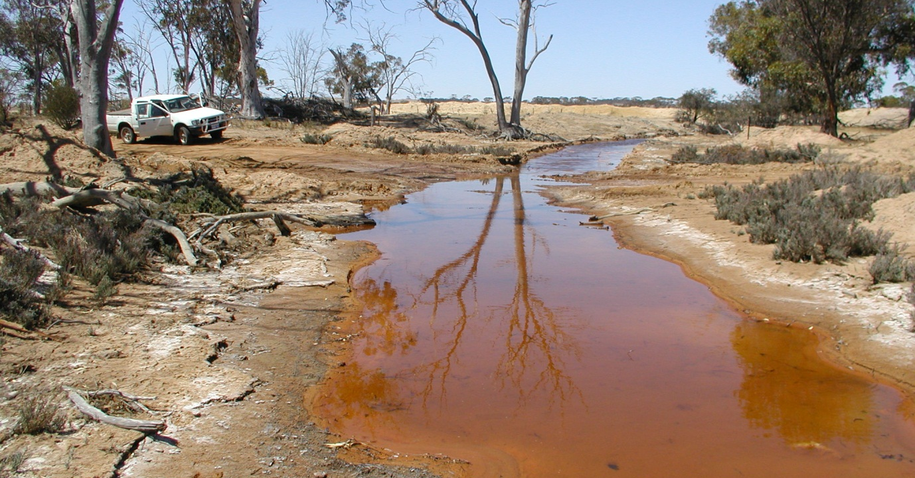
- R Basics.
Please open and run through the “workshop1_rbasics2026.R” code.
Answer the questions embedded in the script. Once you have completed this section, please copy and paste the output from your console here. /5

- Salinity (data standardisation)
Open the file called “Salinity_data_excel.xlsx”. This contains two sheets – the data we saved as a .csv and will import into R, and a sheet for generating the dropdown lists (you don’t need to worry about this). Use this spreadsheet to answer the following questions:
- How many predictor variables are there? How many levels of each predictor? How many replicates (n) for each level? /3

- How were the variables FW root:shoot ratio and DW root:shoot ratio calculated? /2

- Salinity (first three response variables)
Now open the file called “workshop1_salinity. R”. Use the code in this file to answer the following questions for each of the response variables. This will form the basis of your statistical methods and results sections.
Methods:
For all variables:
- How did you test the assumption that data was normally distributed? /1

- How did you test the assumption that variances are homogenous? /1

- Did you need to test the assumption that data are independent? Why/why not? /1

VARIABLE: __________________________________ /9
Methods:

- What was the p-value for your normality test? Were your data normally distributed?

- Did you remove outliers? Complete the table below for your final n for each treatment:

Salt Concentration (g/L)
0 | 1.5 | 2.5 | 5 | 10 | 15

- Were your data normally distributed once you removed outliers? What was the p-value?

- Did your data have homogenous variances? What was the p-value?

Results:
- Complete the table below with the results from your one-way ANOVA

Response variable | Predictor variable | df | F-value | p-value

- Were these results significant?

- Which salt concentration treatments were significantly different for your variable? How different were they from each other? (HINT: you will need to use your summary statistics and the results from your Tukey’s post-hoc test to answer this question).

- Paste your final means plot below. Use text boxes to annotate your plot with the groups from your post-hoc tests.

VARIABLE: __________________________________ /9
Methods:

- What was the p-value for your normality test? Were your data normally distributed?

- Did you remove outliers? Complete the table below for your final n for each treatment:

Salt Concentration (g/L)
0 | 1.5 | 2.5 | 5 | 10 | 15

- Were your data normally distributed once you removed outliers? What was the p-value?

- Did your data have homogenous variances? What was the p-value?

Results:
- Complete the table below with the results from your one-way ANOVA

Response variable | Predictor variable | df | F-value | p-value

- Were these results significant?

- Which salt concentration treatments were significantly different for your variable? How different were they from each other? (HINT: you will need to use your summary statistics and the results from your Tukey’s post-hoc test to answer this question).

- Paste your final means plot below. Use text boxes to annotate your plot with the groups from your post-hoc tests.

VARIABLE: __________________________________ /9
Methods:

- What was the p-value for your normality test? Were your data normally distributed?

- Did you remove outliers? Complete the table below for your final n for each treatment:

Salt Concentration (g/L)
0 | 1.5 | 2.5 | 5 | 10 | 15

- Were your data normally distributed once you removed outliers? What was the p-value?

- Did your data have homogenous variances? What was the p-value?

Results:
- Complete the table below with the results from your one-way ANOVA

Response variable | Predictor variable | df | F-value | p-value

- Were these results significant?

- Which salt concentration treatments were significantly different for your variable? How different were they from each other? (HINT: you will need to use your summary statistics and the results from your Tukey’s post-hoc test to answer this question).

- Paste your final means plot below. Use text boxes to annotate your plot with the groups from your post-hoc tests.

Salinity (final five response variables)
If you’d like to be in the running for a HD, please paste your code for the last five variables here. This code will be worth 15 marks. Otherwise, please open the file “workshop1_salinitycont_2026.R”.
/15
Either way, continue completing the questions on the following pages for each variable.
VARIABLE: __________________________________ /9
Methods:

- What was the p-value for your normality test? Were your data normally distributed?

- Did you remove outliers? Complete the table below for your final n for each treatment:

Salt Concentration (g/L)
0 | 1.5 | 2.5 | 5 | 10 | 15

- Were your data normally distributed once you removed outliers? What was the p-value?

- Did your data have homogenous variances? What was the p-value?

Results:
- Complete the table below with the results from your one-way ANOVA

Response variable | Predictor variable | df | F-value | p-value

- Were these results significant?

- Which salt concentration treatments were significantly different for your variable? How different were they from each other? (HINT: you will need to use your summary statistics and the results from your Tukey’s post-hoc test to answer this question).

- Paste your final means plot below. Use text boxes to annotate your plot with the groups from your post-hoc tests.

VARIABLE: __________________________________ /9
Methods:

- What was the p-value for your normality test? Were your data normally distributed?

- Did you remove outliers? Complete the table below for your final n for each treatment:

Salt Concentration (g/L)
0 | 1.5 | 2.5 | 5 | 10 | 15

- Were your data normally distributed once you removed outliers? What was the p-value?

- Did your data have homogenous variances? What was the p-value?

Results:
- Complete the table below with the results from your one-way ANOVA

Response variable | Predictor variable | df | F-value | p-value

- Were these results significant?

- Which salt concentration treatments were significantly different for your variable? How different were they from each other? (HINT: you will need to use your summary statistics and the results from your Tukey’s post-hoc test to answer this question).

- Paste your final means plot below. Use text boxes to annotate your plot with the groups from your post-hoc tests.

VARIABLE: __________________________________ /9
Methods:

- What was the p-value for your normality test? Were your data normally distributed?

- Did you remove outliers? Complete the table below for your final n for each treatment:

Salt Concentration (g/L)
0 | 1.5 | 2.5 | 5 | 10 | 15

- Were your data normally distributed once you removed outliers? What was the p-value?

- Did your data have homogenous variances? What was the p-value?

Results:
- Complete the table below with the results from your one-way ANOVA

Response variable | Predictor variable | df | F-value | p-value

- Were these results significant?

- Which salt concentration treatments were significantly different for your variable? How different were they from each other? (HINT: you will need to use your summary statistics and the results from your Tukey’s post-hoc test to answer this question).

- Paste your final means plot below. Use text boxes to annotate your plot with the groups from your post-hoc tests.

VARIABLE: __________________________________ /9
Methods:

- What was the p-value for your normality test? Were your data normally distributed?

- Did you remove outliers? Complete the table below for your final n for each treatment:

Salt Concentration (g/L)
0 | 1.5 | 2.5 | 5 | 10 | 15

- Were your data normally distributed once you removed outliers? What was the p-value?

- Did your data have homogenous variances? What was the p-value?

Results:
- Complete the table below with the results from your one-way ANOVA

Response variable | Predictor variable | df | F-value | p-value

- Were these results significant?

- Which salt concentration treatments were significantly different for your variable? How different were they from each other? (HINT: you will need to use your summary statistics and the results from your Tukey’s post-hoc test to answer this question).

- Paste your final means plot below. Use text boxes to annotate your plot with the groups from your post-hoc tests.

VARIABLE: __________________________________ /9
Methods:

- What was the p-value for your normality test? Were your data normally distributed?

- Did you remove outliers? Complete the table below for your final n for each treatment:

Salt Concentration (g/L)
0 | 1.5 | 2.5 | 5 | 10 | 15

- Were your data normally distributed once you removed outliers? What was the p-value?

- Did your data have homogenous variances? What was the p-value?

Results:
- Complete the table below with the results from your one-way ANOVA

Response variable | Predictor variable | df | F-value | p-value

- Were these results significant?

- Which salt concentration treatments were significantly different for your variable? How different were they from each other? (HINT: you will need to use your summary statistics and the results from your Tukey’s post-hoc test to answer this question).

- Paste your final means plot below. Use text boxes to annotate your plot with the groups from your post-hoc tests.

