BIOL3712 Integrated Physiology of Plants and Animals

Semester 2, 2023

Salinity experiment

data analysis workbook

Completion and submission of this workbook is worth 10% of your total topic grade.

Use the files provided and your r code to answer the questions on the following pages. Once you have completed this, please save it as a .pdf and submit it to FLO.

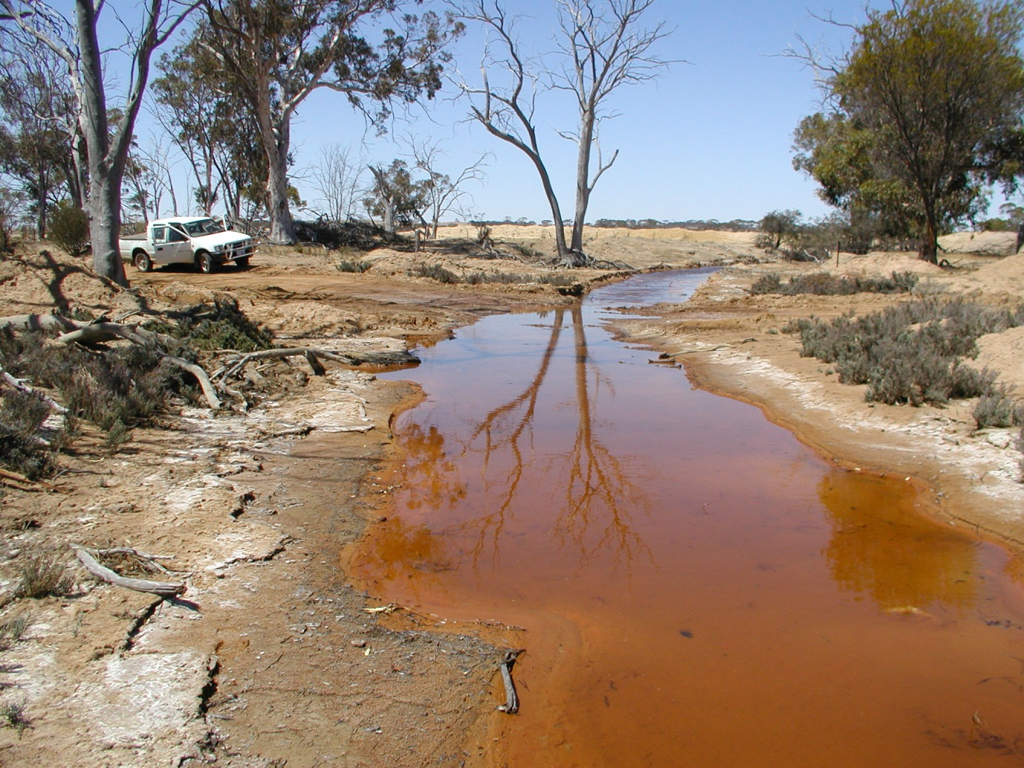

1. **R Basics.**

Please open and run through the “workshop1_rbasics.R” code.

Answer the questions embedded in the script. Once you have completed this section, please copy and paste the output from your **console** here. **/5**

1. **Salinity (data standardisation)**

Open the file called “2023_data.xlsx”. This contains three sheets – the data we saved as a .csv and imported into R, the data including the calculations (click on each cell to see the formula used), a sheet for generating the dropdown lists (you don’t need to worry about this). Use this spreadsheet to answer the following questions:

1. How many replicates are there for each factor and treatment? **/1**
2. How were the variables leaf number (as a ratio of control mean), shoot height (as a ratio of control mean), and root length (as a ratio of control mean) calculated? **/2**
3. How were the variables FW shoot/root ratio and DW shoot/root ratio calculated? **/2**
4. **Salinity (first three response variables)**

Now open the file called “workshop1_salinity. R”. Use the code in this file to answer the following questions for each of the response variables. This will form the basis of your statistical methods and results sections.

***Methods:***

For all variables:

1. How did you test the assumption that data was normally distributed? **/1**
2. How did you test the assumption that variances are homogenous? **/1**
3. Did you need to test the assumption that data are independent? Why/why not? **/1**

**VARIABLE: __________________________________ /9**

***Methods:***

1. What was the *p*-value for your normality test? Was your data normally distributed?
2. Did you remove outliers? Complete the table below for your final *n* for each treatment:

|  |  |  |  |  |  |  |
| --- | --- | --- | --- | --- | --- | --- |
|  | **Salt Concentration (g/L)** | | | | | |
| **Species** | 0 | 1.5 | 2.5 | 5 | 10 | 15 |
| Barley |  |  |  |  |  |  |
| Wheat |  |  |  |  |  |  |

1. Was your data normally distributed once you removed outliers? What was the p-value?
2. Did your data have homogenous variances? What was the *p*-value?

***Results:***

1. Complete the table below with the results from your two-way ANOVA

|  |  |  |  |
| --- | --- | --- | --- |
|  | df | F-value | *p*-value |
| species |  |  |  |
| saltConc |  |  |  |
| species*saltConc |  |  |  |

1. Which of these results were significant?
2. Which of the salt concentrations were significantly different from each other? How different were they from each other? (HINT: you will need to use your summary statistics and the results from your Tukey’s post-hoc test to answer this question).
3. Paste your final means plot below. Use text boxes to annotate your plot with the groups from your post-hoc tests.

**VARIABLE: __________________________________ /9**

***Methods:***

1. What was the *p*-value for your normality test? Was your data normally distributed?
2. Did you remove outliers? Complete the table below for your final *n* for each treatment:

|  |  |  |  |  |  |  |
| --- | --- | --- | --- | --- | --- | --- |
|  | **Salt Concentration (g/L)** | | | | | |
| **Species** | 0 | 1.5 | 2.5 | 5 | 10 | 15 |
| Barley |  |  |  |  |  |  |
| Wheat |  |  |  |  |  |  |

1. Was your data normally distributed once you removed outliers? What was the p-value?
2. Did your data have homogenous variances? What was the *p*-value?

***Results:***

1. Complete the table below with the results from your two-way ANOVA

|  |  |  |  |
| --- | --- | --- | --- |
|  | df | F-value | *p*-value |
| species |  |  |  |
| saltConc |  |  |  |
| species*saltConc |  |  |  |

1. Which of these results were significant?
2. Which of the salt concentrations were significantly different from each other? How different were they from each other? (HINT: you will need to use your summary statistics and the results from your Tukey’s post-hoc test to answer this question).
3. Paste your final means plot below. Use text boxes to annotate your plot with the groups from your post-hoc tests.

**VARIABLE: __________________________________ /9**

***Methods:***

1. What was the *p*-value for your normality test? Was your data normally distributed?
2. Did you remove outliers? Complete the table below for your final *n* for each treatment:

|  |  |  |  |  |  |  |
| --- | --- | --- | --- | --- | --- | --- |
|  | **Salt Concentration (g/L)** | | | | | |
| **Species** | 0 | 1.5 | 2.5 | 5 | 10 | 15 |
| Barley |  |  |  |  |  |  |
| Wheat |  |  |  |  |  |  |

1. Was your data normally distributed once you removed outliers? What was the p-value?
2. Did your data have homogenous variances? What was the *p*-value?

***Results:***

1. Complete the table below with the results from your two-way ANOVA

|  |  |  |  |
| --- | --- | --- | --- |
|  | df | F-value | *p*-value |
| species |  |  |  |
| saltConc |  |  |  |
| species*saltConc |  |  |  |

1. Which of these results were significant?
2. Which of the salt concentrations were significantly different from each other? How different were they from each other? (HINT: you will need to use your summary statistics and the results from your Tukey’s post-hoc test to answer this question).
3. Paste your final means plot below. Use text boxes to annotate your plot with the groups from your post-hoc tests.
4. **Salinity (final five response variables)**

If you’d like to be in the running for a HD, please paste your code for the last five variables here. This code will be worth 15 marks. Otherwise, please open the file “workshop1_salinitycont.R”.

**/15**

Either way, continue completing the questions on the following pages for each variable.

**VARIABLE: __________________________________ /9**

***Methods:***

1. What was the *p*-value for your normality test? Was your data normally distributed?
2. Did you remove outliers? Complete the table below for your final *n* for each treatment:

|  |  |  |  |  |  |  |
| --- | --- | --- | --- | --- | --- | --- |
|  | **Salt Concentration (g/L)** | | | | | |
| **Species** | 0 | 1.5 | 2.5 | 5 | 10 | 15 |
| Barley |  |  |  |  |  |  |
| Wheat |  |  |  |  |  |  |

1. Was your data normally distributed once you removed outliers? What was the p-value?
2. Did your data have homogenous variances? What was the *p*-value?

***Results:***

1. Complete the table below with the results from your two-way ANOVA

|  |  |  |  |
| --- | --- | --- | --- |
|  | df | F-value | *p*-value |
| species |  |  |  |
| saltConc |  |  |  |
| species*saltConc |  |  |  |

1. Which of these results were significant?
2. Which of the salt concentrations were significantly different from each other? How different were they from each other? (HINT: you will need to use your summary statistics and the results from your Tukey’s post-hoc test to answer this question).
3. Paste your final means plot below. Use text boxes to annotate your plot with the groups from your post-hoc tests.

**VARIABLE: __________________________________ /9**

***Methods:***

1. What was the *p*-value for your normality test? Was your data normally distributed?
2. Did you remove outliers? Complete the table below for your final *n* for each treatment:

|  |  |  |  |  |  |  |
| --- | --- | --- | --- | --- | --- | --- |
|  | **Salt Concentration (g/L)** | | | | | |
| **Species** | 0 | 1.5 | 2.5 | 5 | 10 | 15 |
| Barley |  |  |  |  |  |  |
| Wheat |  |  |  |  |  |  |

1. Was your data normally distributed once you removed outliers? What was the p-value?
2. Did your data have homogenous variances? What was the *p*-value?

***Results:***

1. Complete the table below with the results from your two-way ANOVA

|  |  |  |  |
| --- | --- | --- | --- |
|  | df | F-value | *p*-value |
| species |  |  |  |
| saltConc |  |  |  |
| species*saltConc |  |  |  |

1. Which of these results were significant?
2. Which of the salt concentrations were significantly different from each other? How different were they from each other? (HINT: you will need to use your summary statistics and the results from your Tukey’s post-hoc test to answer this question).
3. Paste your final means plot below. Use text boxes to annotate your plot with the groups from your post-hoc tests.

**VARIABLE: __________________________________ /9**

***Methods:***

1. What was the *p*-value for your normality test? Was your data normally distributed?
2. Did you remove outliers? Complete the table below for your final *n* for each treatment:

|  |  |  |  |  |  |  |
| --- | --- | --- | --- | --- | --- | --- |
|  | **Salt Concentration (g/L)** | | | | | |
| **Species** | 0 | 1.5 | 2.5 | 5 | 10 | 15 |
| Barley |  |  |  |  |  |  |
| Wheat |  |  |  |  |  |  |

1. Was your data normally distributed once you removed outliers? What was the p-value?
2. Did your data have homogenous variances? What was the *p*-value?

***Results:***

1. Complete the table below with the results from your two-way ANOVA

|  |  |  |  |
| --- | --- | --- | --- |
|  | df | F-value | *p*-value |
| species |  |  |  |
| saltConc |  |  |  |
| species*saltConc |  |  |  |

1. Which of these results were significant?
2. Which of the salt concentrations were significantly different from each other? How different were they from each other? (HINT: you will need to use your summary statistics and the results from your Tukey’s post-hoc test to answer this question).
3. Paste your final means plot below. Use text boxes to annotate your plot with the groups from your post-hoc tests.

**VARIABLE: __________________________________ /9**

***Methods:***

1. What was the *p*-value for your normality test? Was your data normally distributed?
2. Did you remove outliers? Complete the table below for your final *n* for each treatment:

|  |  |  |  |  |  |  |
| --- | --- | --- | --- | --- | --- | --- |
|  | **Salt Concentration (g/L)** | | | | | |
| **Species** | 0 | 1.5 | 2.5 | 5 | 10 | 15 |
| Barley |  |  |  |  |  |  |
| Wheat |  |  |  |  |  |  |

1. Was your data normally distributed once you removed outliers? What was the p-value?
2. Did your data have homogenous variances? What was the *p*-value?

***Results:***

1. Complete the table below with the results from your two-way ANOVA

|  |  |  |  |
| --- | --- | --- | --- |
|  | df | F-value | *p*-value |
| species |  |  |  |
| saltConc |  |  |  |
| species*saltConc |  |  |  |

1. Which of these results were significant?
2. Which of the salt concentrations were significantly different from each other? How different were they from each other? (HINT: you will need to use your summary statistics and the results from your Tukey’s post-hoc test to answer this question).
3. Paste your final means plot below. Use text boxes to annotate your plot with the groups from your post-hoc tests.

**VARIABLE: __________________________________ /9**

***Methods:***

1. What was the *p*-value for your normality test? Was your data normally distributed?
2. Did you remove outliers? Complete the table below for your final *n* for each treatment:

|  |  |  |  |  |  |  |
| --- | --- | --- | --- | --- | --- | --- |
|  | **Salt Concentration (g/L)** | | | | | |
| **Species** | 0 | 1.5 | 2.5 | 5 | 10 | 15 |
| Barley |  |  |  |  |  |  |
| Wheat |  |  |  |  |  |  |

1. Was your data normally distributed once you removed outliers? What was the p-value?
2. Did your data have homogenous variances? What was the *p*-value?

***Results:***

1. Complete the table below with the results from your two-way ANOVA

|  |  |  |  |
| --- | --- | --- | --- |
|  | df | F-value | *p*-value |
| species |  |  |  |
| saltConc |  |  |  |
| species*saltConc |  |  |  |

1. Which of these results were significant?
2. Which of the salt concentrations were significantly different from each other? How different were they from each other? (HINT: you will need to use your summary statistics and the results from your Tukey’s post-hoc test to answer this question).
3. Paste your final means plot below. Use text boxes to annotate your plot with the groups from your post-hoc tests.