School of Informatics & Cybersecurity - Assessment Submission Coversheet

Student Information
Student Number: | B00173541
Student Name: | Sofiia Prymak

Module Information
Module Title: | Security Architecture
Module Code: | COMP H2701

Assessment Information
Assessment Title: | Designing and Implementing a Proof of Concept Cloud  Solution based on a clients needs

Declaration
☐ I confirm that I have read and understood the University’s Academic Integrity Policy.
https://www.tudublin.ie/explore/about-the-university/academic-affairs/academic-quality-assurance-and-enhancement/academic-integrity/
☐ I have completed the TU Dublin AI Driving License theory test.
https://www.tudublin.ie/explore/about-the-university/academic-affairs/lta/lta-resources/artificial-intelligence-driving-license/
☐ I declare that this assessment submission is my own work.
☐ I confirm that I have read and understood the AI traffic light system used as part of this assessment brief and I have adhered to the level of AI usage allowed for this assessment.

Student signature: | Sofiia prymak
Date: | 23.04.26

Designing and Implementing a Proof of Concept Cloud
Student ID: B00173541
Sofiia prymak

Table of Contents:
Introduction 4
1. Architecture Overview 5
3. Proof of Concept Implementation 6
3.1 VPC and Networking 6
3.2 Bastion Host 8
3.3 Web Servers (EC2) 9
3.4 Load Balancer 11
3.5 Auto Scaling Group 13
3.6 RDS MySQL 14
3.7 Static Backup Website (S3) 16
4. Additional Amazon Web Services (Justification) 16
4.1 AWS WAF 16
4.2 Amazon CloudTrail 16
5. Sustainability (Amazon Web Services Well-Architected Framework) 16
6. Conclusion 17

Introduction
I had to build and test a cloud setup in Amazon Web Services. The main goal of this project was to show how a simple web application can be moved from an environment into Amazon Web Services in order to improve stability, security and scalability of the web application. Even though this project was a Proof of Concept it still required me to design an architecture and deploy several core Amazon Web Services services.

To complete the Proof of Concept I created a Virtual Private Cloud configured private subnets, deployed web servers set up a load balancer created an RDS MySQL database configured a bastion host for secure access to the Amazon Web Services cloud setup and built a static backup website hosted on Amazon S3.

During the work on the Amazon Web Services cloud setup I faced real world technical problems with the cloud setup. These included incorrect Security Group rules, issues with routing tables, problems with connecting to the RDS MySQL database and configuration mistakes that caused health checks to fail in the Amazon Web Services cloud setup. In this report I describe how I solved these issues with the Amazon Web Services cloud setup and what I learned from the process of working with Amazon Web Services.

This project helped me understand how cloud infrastructure works in practice with Amazon Web Services not in theory. I learned how different Amazon Web Services components interact with each other in the cloud setup how important correct network configuration is for the cloud setup and how small mistakes can break the Amazon Web Services cloud setup. The experience also showed me how to troubleshoot issues with the cloud setup step, by step and how to think like a cloud engineer working with Amazon Web Services.
This was done to make it more stable, secure and able to handle users.
- I set up a private network,
- created public and private areas for servers
- added web servers
- a load balancer to distribute traffic
- an RDS database to store data,
- a special server, for secure access,
- and a backup website on S3.
During my work I faced real-world problems.These included setting up Security Groups and not being able to access databases.In this report I explain how I fixed these issues.I also share what I learned from these experiences.

Architecture Overview

I built an architecture in Amazon Web Services that has these things:
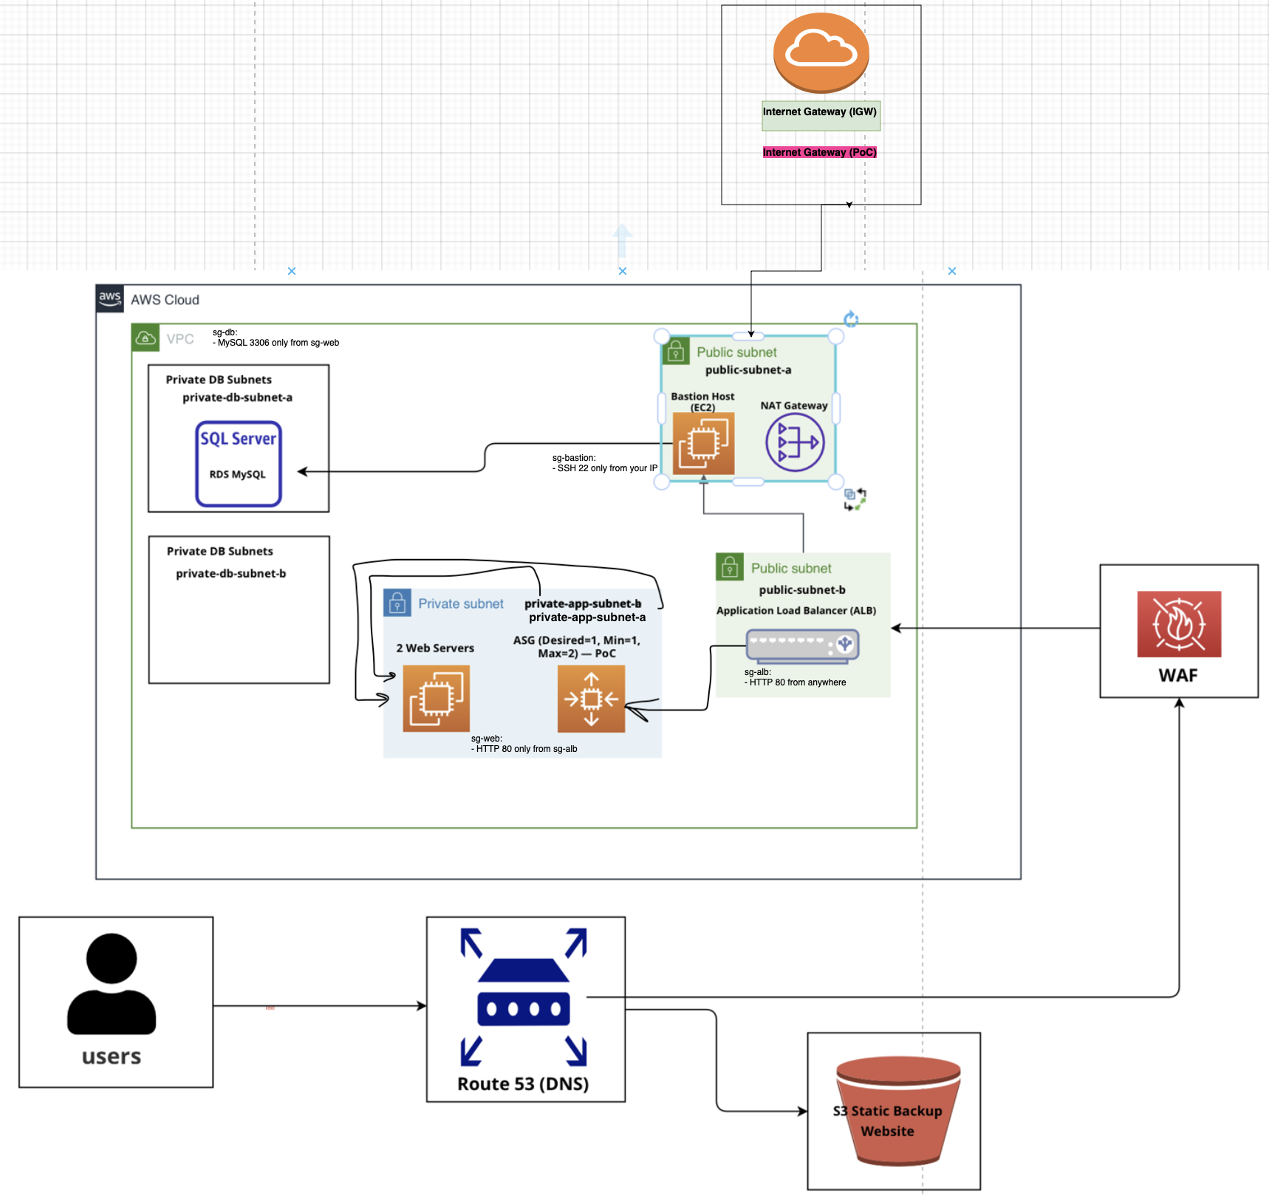
- VPC with private subnets
- Application Load Balancer
- Auto Scaling Group
- Two EC2 web servers in private subnets
- Bastion Host for SSH access
- NAT Gateway
- Amazon RDS MySQL
- Route 53 DNS plus Failover
- S3 Static Backup Website
This architecture is not too complicated but it is close to what you would use in a real production environment.
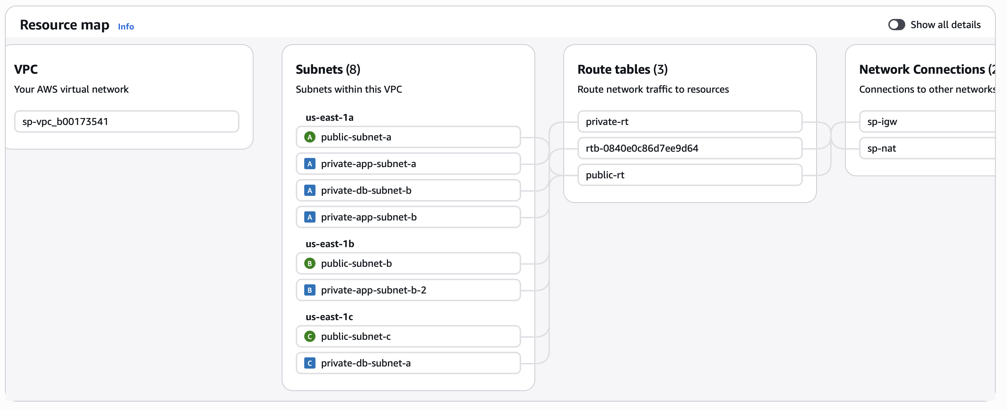
It is divided into layers: Internet, Application Load Balancer, then Web Servers, then Database.
This architecture is not really complicated. It is pretty close to what people actually use when they are working on real projects. It is set up in a way:
- Internet layer – users get to the application through Route 53
- Load balancing layer – the Application Load Balancer distributes traffic
- Application layer – the web servers are on EC2
- Database layer – the database is RDS MySQL
Breaking it down like this makes the system more secure and easier to work with when it needs to be scaled up or fixed.
The architecture also has a plan: if the main application is down Route 53 can send users to a static website on S3. This way users will always see a message instead of a error page. The architecture is designed to keep users on the application or the static website so the application is always available. The database is always safe because it is on the Database layer, which is RDS MySQL and the web servers are, on the Application layer, which is EC2.

3. Proof of Concept Implementation

3.1 VPC and Networking
What I did:
I started by creating a VPC with the address range 10.0.0.0/16. Inside the VPC
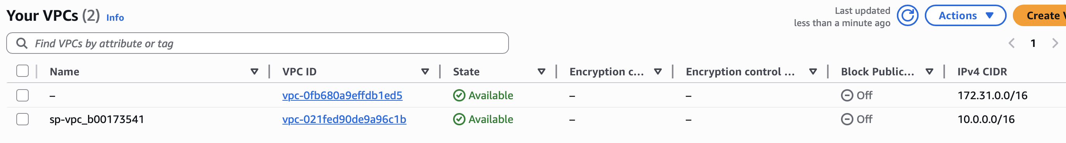
I configured six subnets: two public, two private for application servers, and two private for the database. I created two route tables: a public one and a private one. The public route table was connected to the Internet Gateway, and the private route table was connected to the NAT Gateway
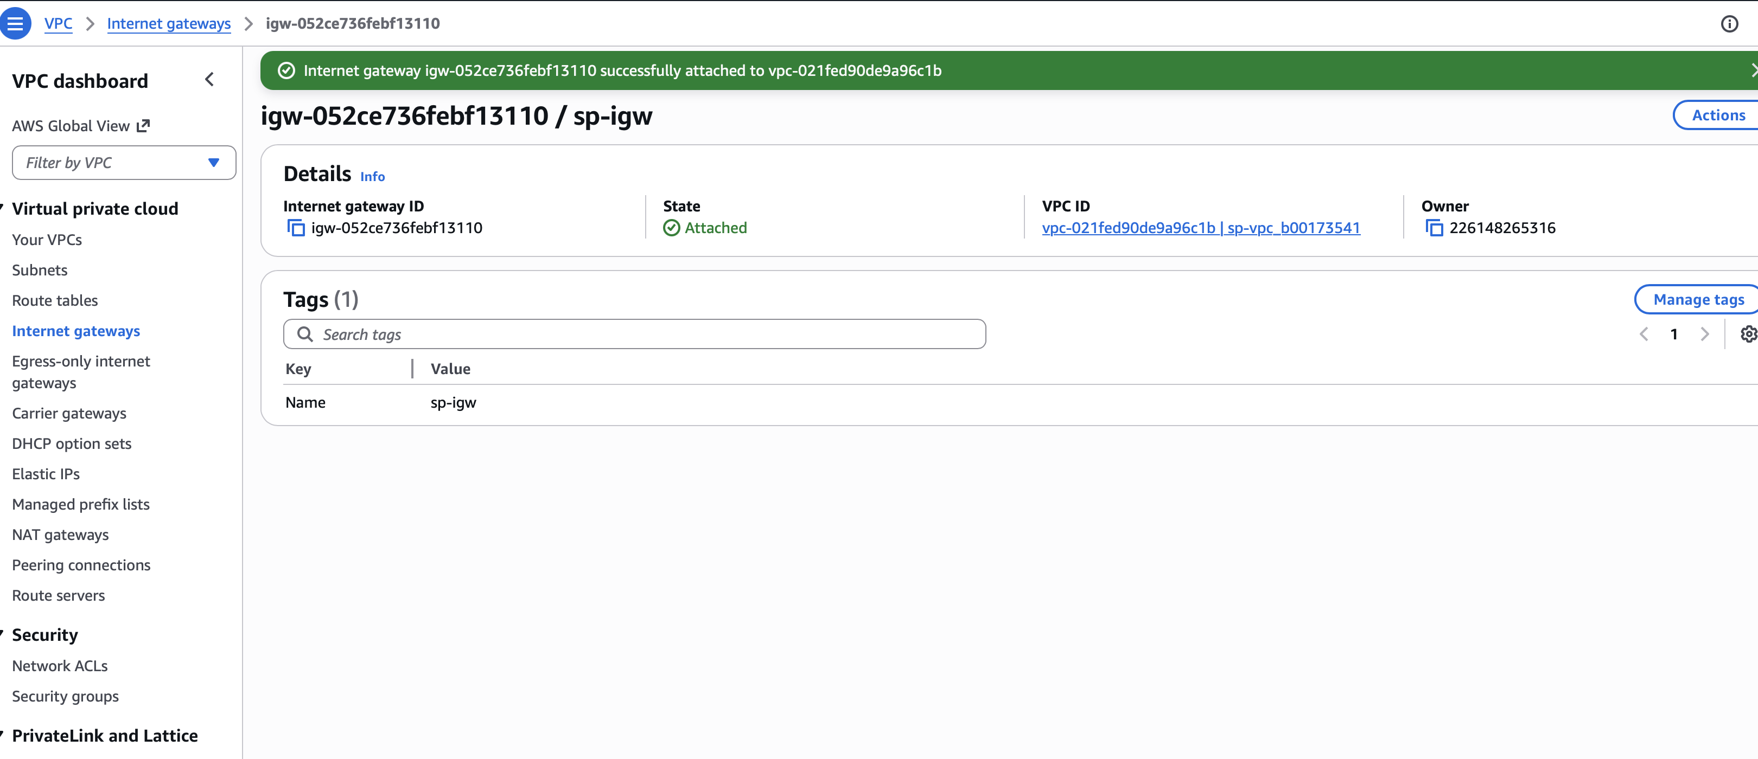
- At first the private EC2 instances could not access the internet. I could not install things with Yum.
- It turned out that the private subnets were not associated with the private route table.
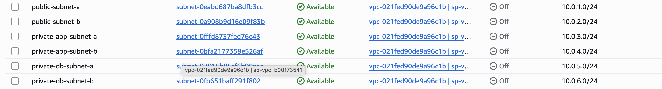
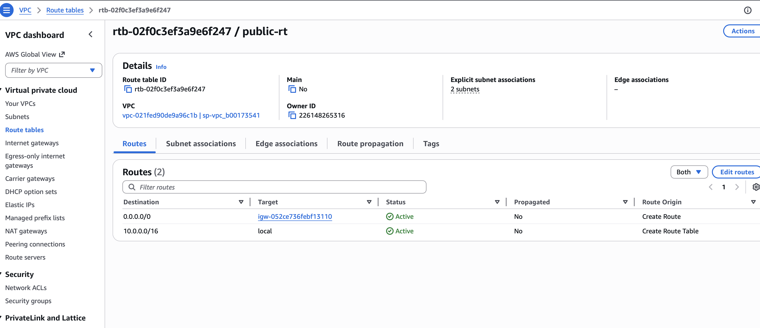
Problems:
At first the private EC2 instances had no internet access. I tried to install Apache on the EC2 instances using yum install but the installation of Apache on the private EC2 instances failed every time I tried. I looked at the NAT Gateway and the route tables and the subnets of the private EC2 instances. I did not find the problem, with the private EC2 instances right away.
Solution :
Eventually, I discovered that the private subnets were not associated with the private route table. This meant that even though the NAT Gateway existed, the subnets were not using it. After I manually added the subnet associations, everything started working correctly. This taught me how important routing is in AWS and how one small misconfiguration can break the entire network

3.2 Bastion Host
What I did:
To securely access the private EC2 instances, I created a bastion host in a public subnet. I configured its Security Group to allow SSH only from my own IP address. Then I used the bastion host to connect to the private servers
- I created an EC2 instance in a subnet
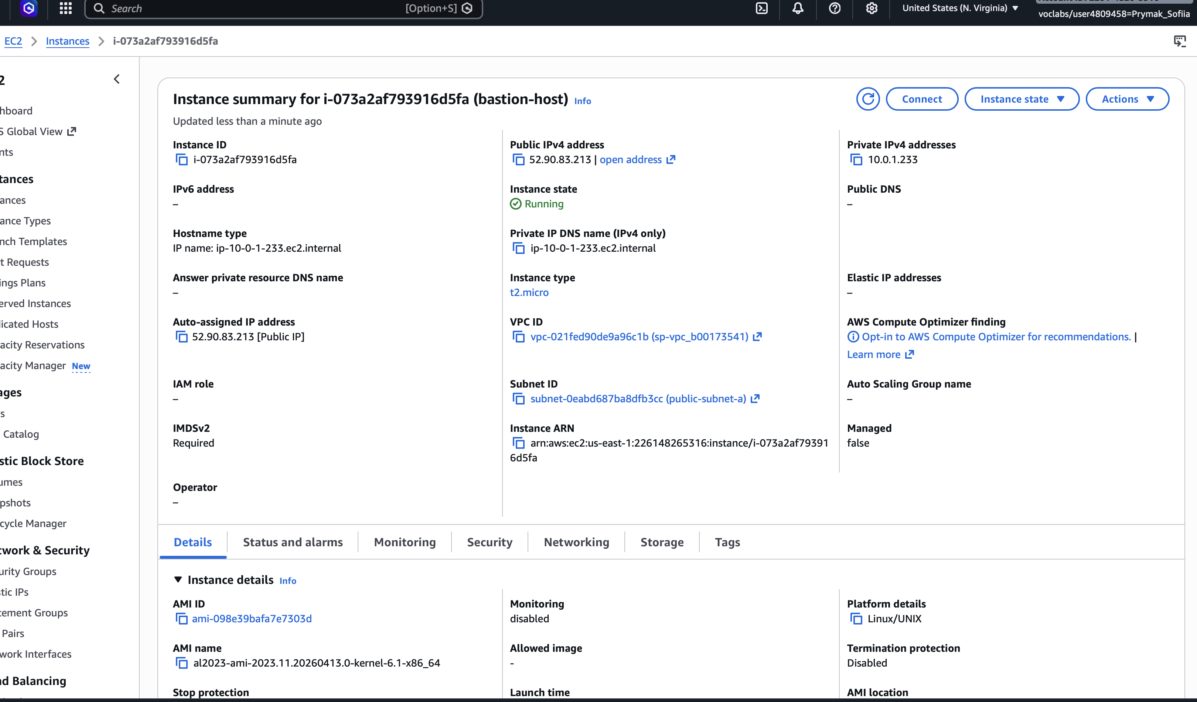
- I only allowed SSH access from my own IP address
- I connected to the servers through the bastion host
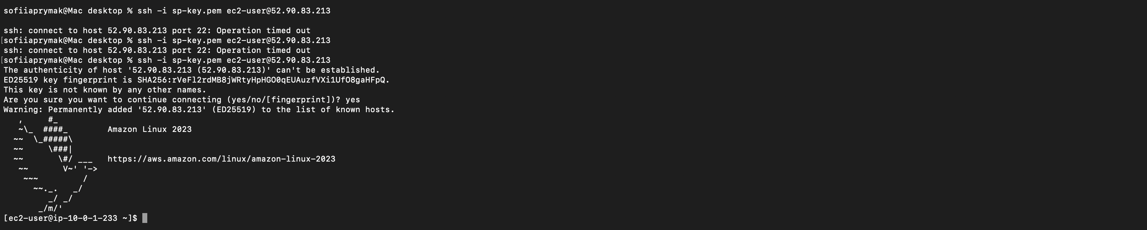
Problems:
I was trying to get into the server using SSH.. I got a message that said "permission denied". So I looked at the key and the username to see what was wrong. I also checked the Security Groups to make sure everything was okay.. No matter what I did I just could not get in. The private server was not letting me in.
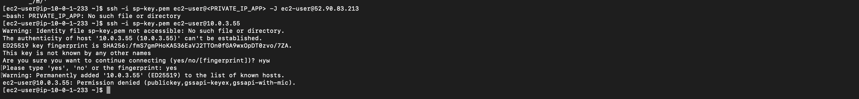
Solution: The issue was that the private key was not uploaded to the bastion host. I used AWS Systems Manager Session Manager to upload the key securely. After that, SSH access worked without any issues. This experience helped me understand how important it is to manage SSH keys correctly and how bastion hosts improve security.

3.3 Web Servers (EC2)
What I did:
- I created two EC2 servers in subnets
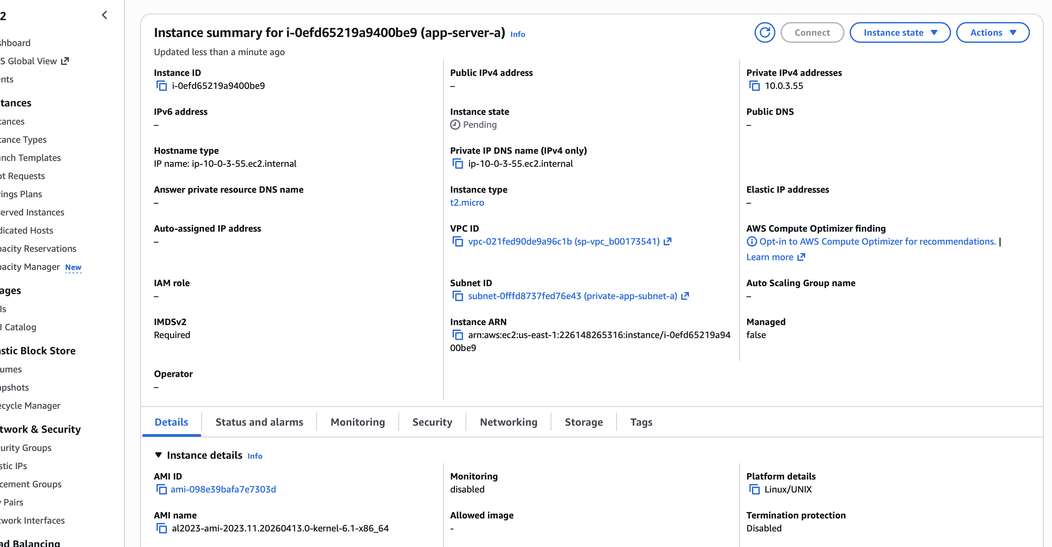
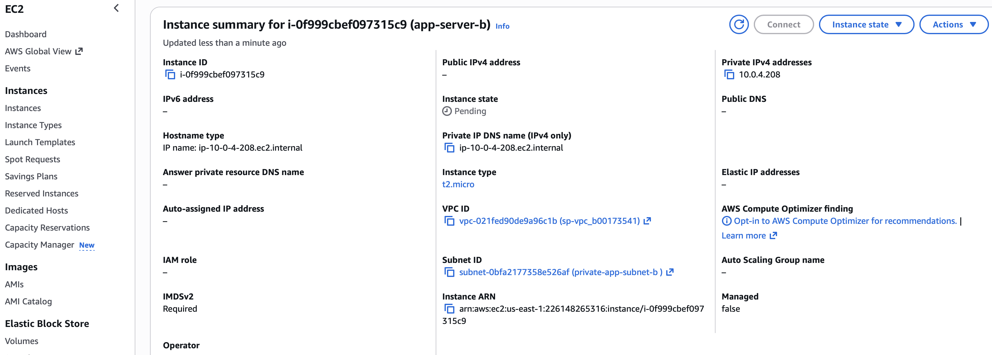
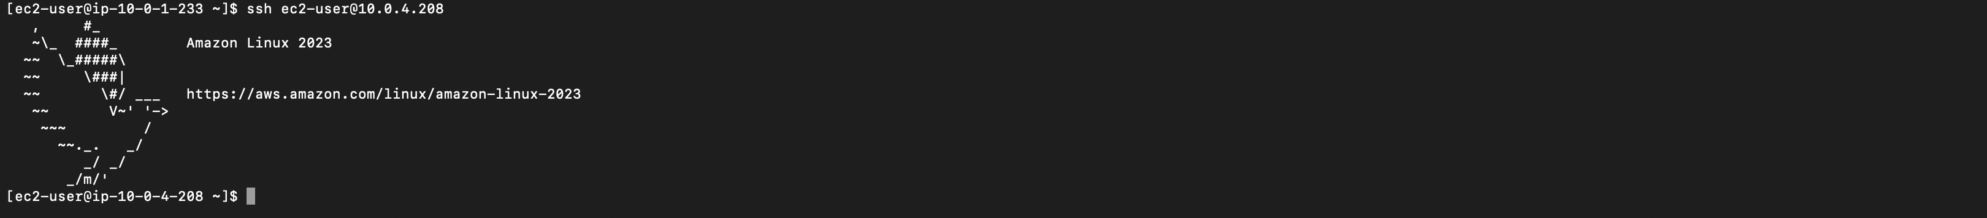
- I installed Apache on them
- I checked that they were working by using curl localhost
Problems: Apache would not start on one of the servers.
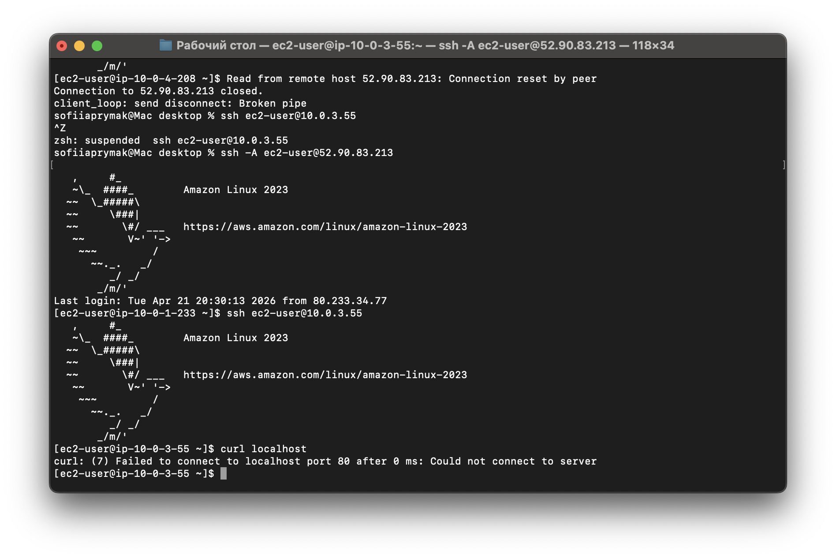
Solution: I enabled autostart by using the command sudo systemctl enable httpd. After that the server started responding.

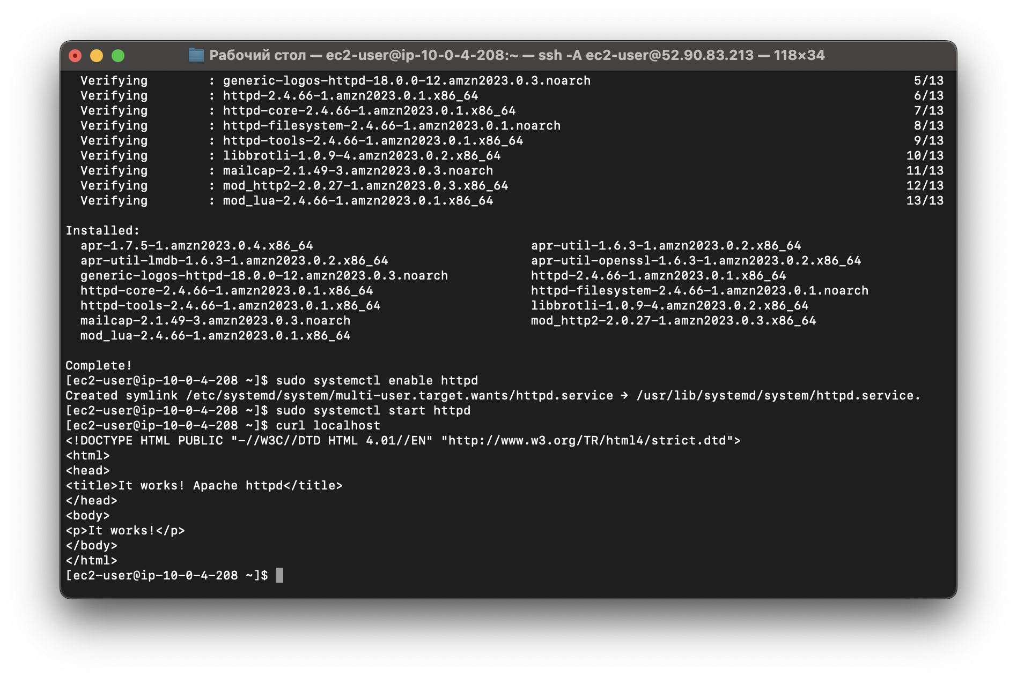
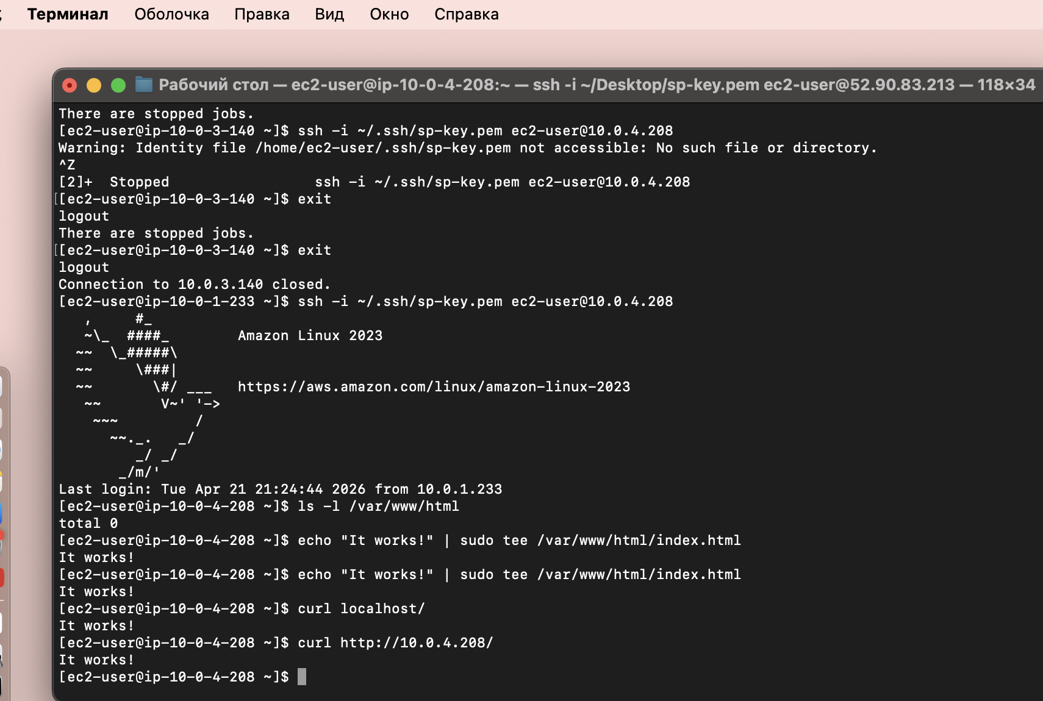
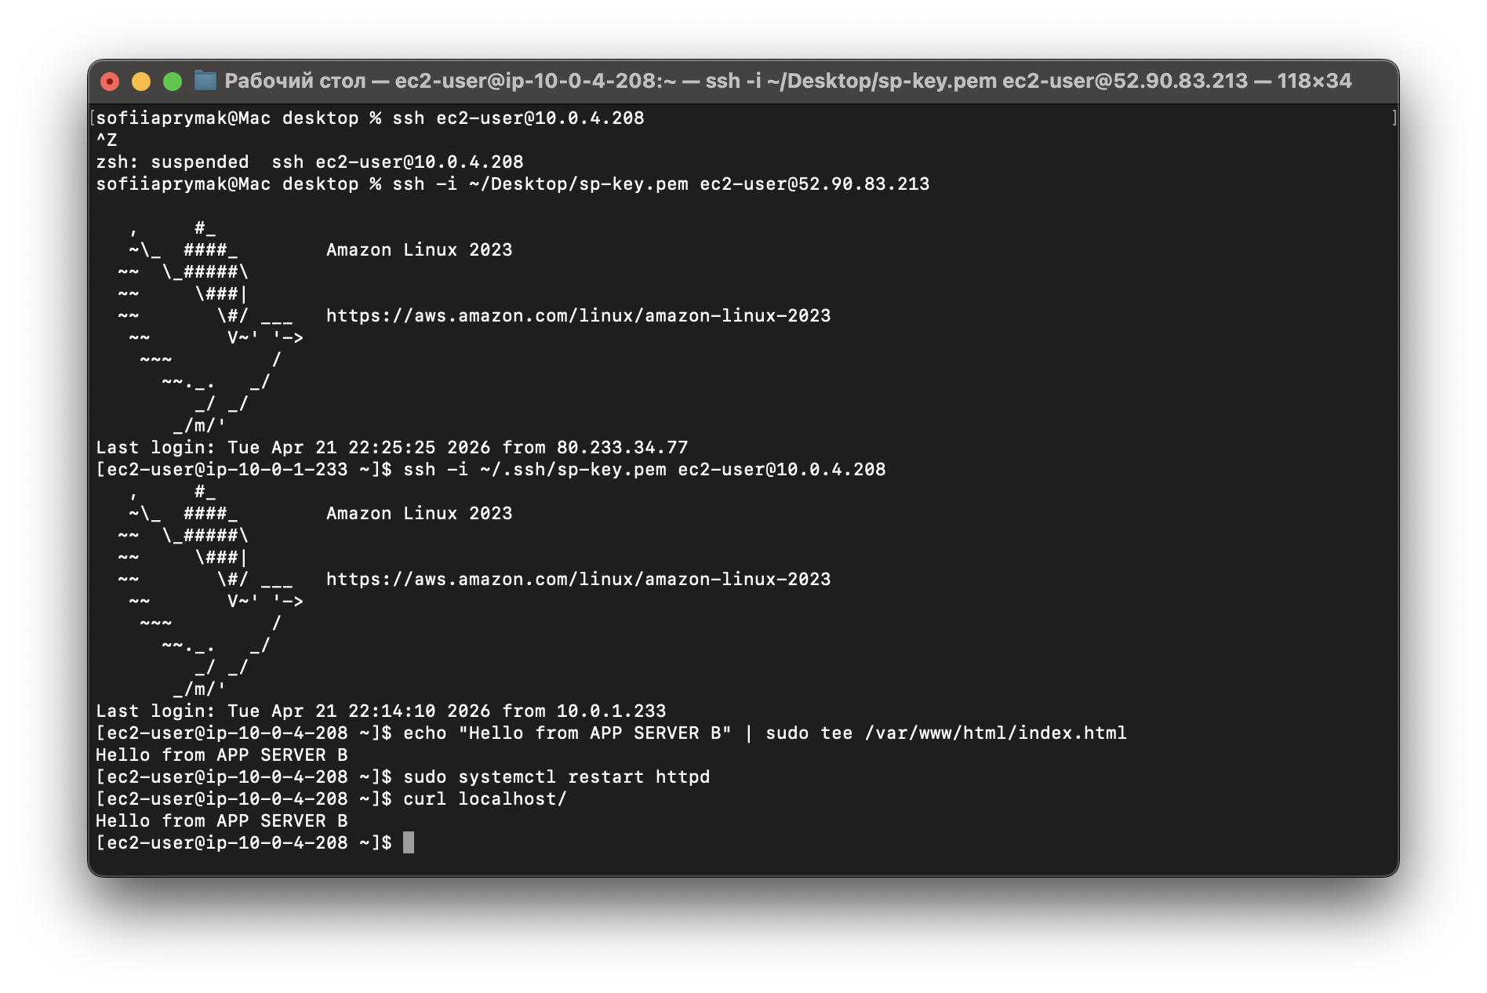

3.4 Load Balancer
What I did:
- I created an Application Load Balancer
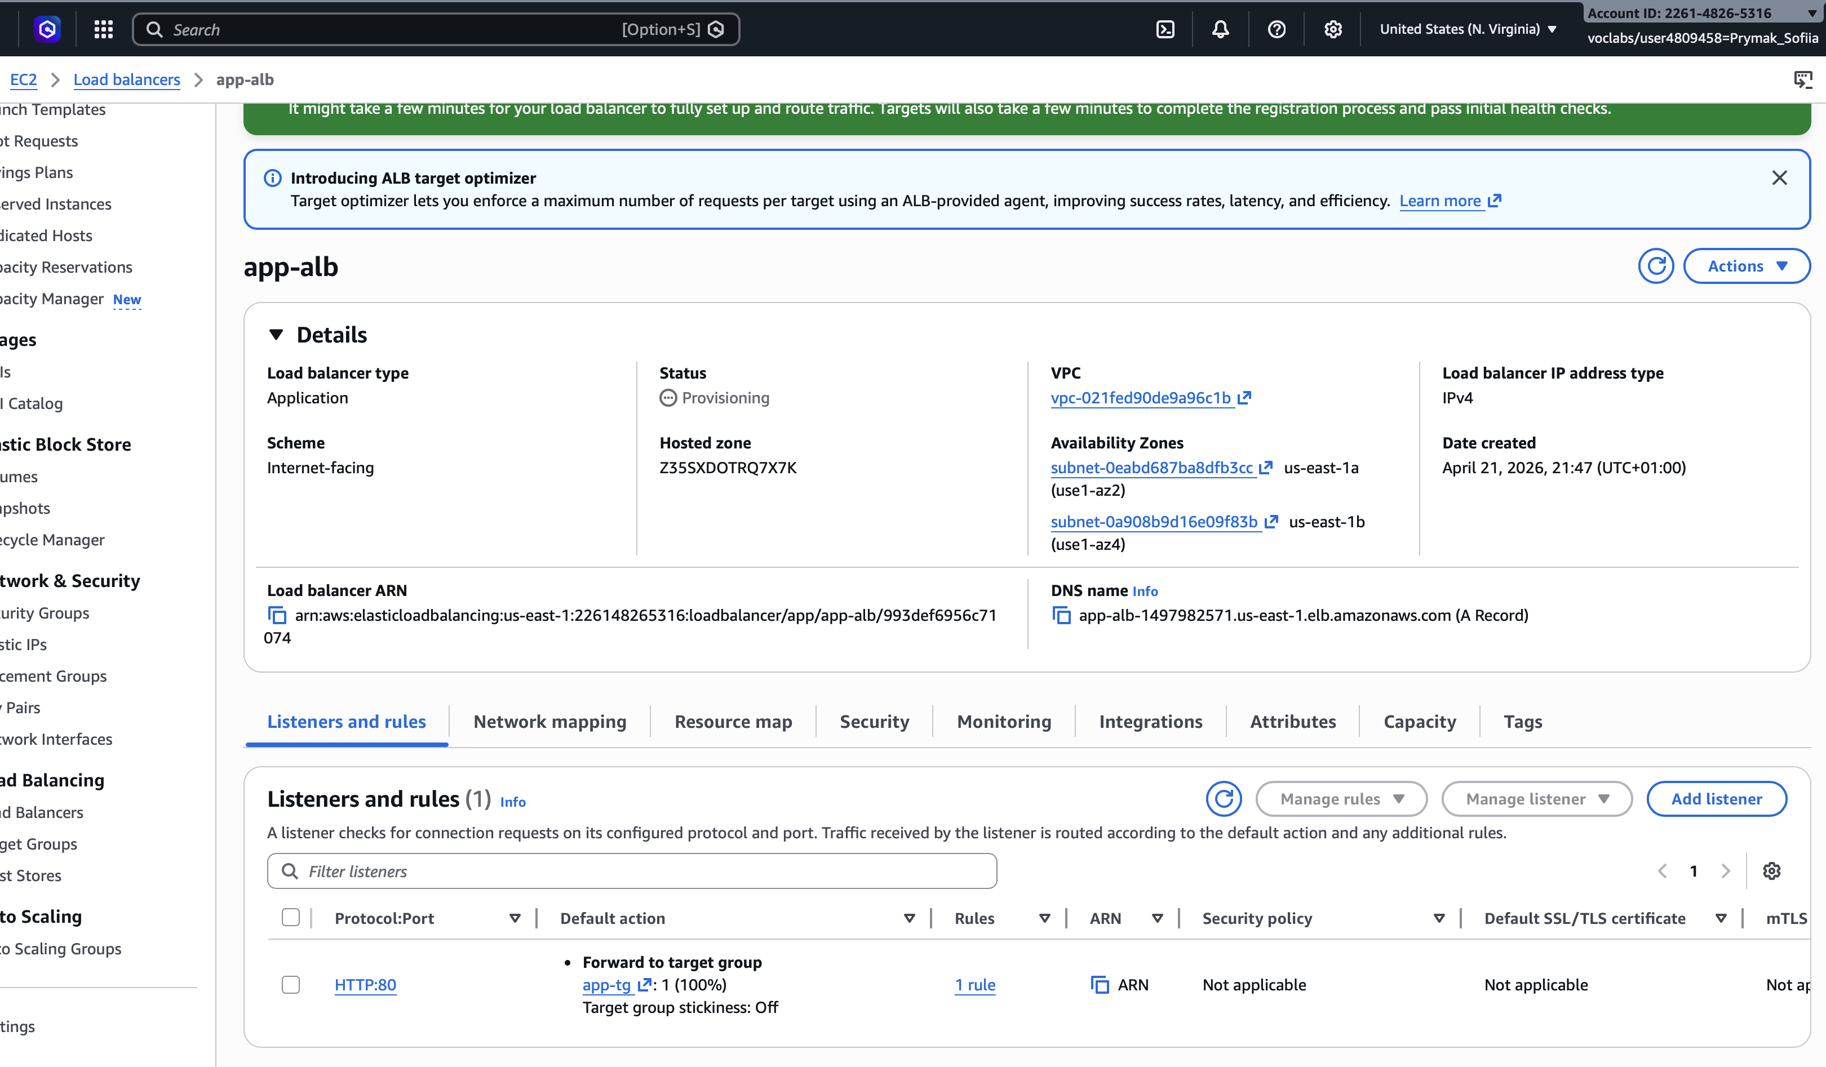
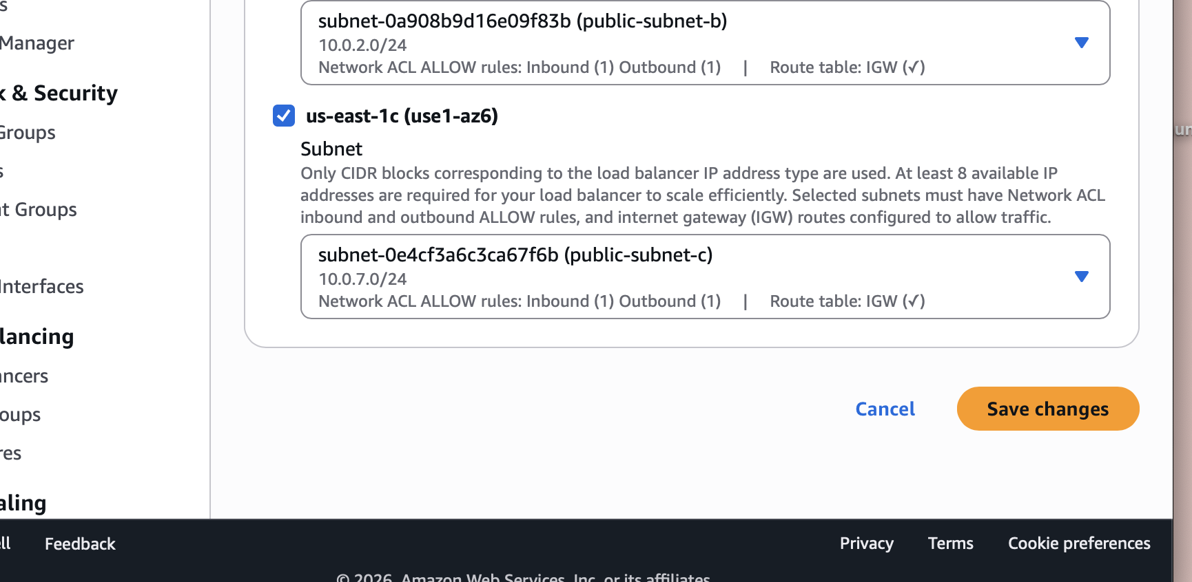
- I created a Target Group
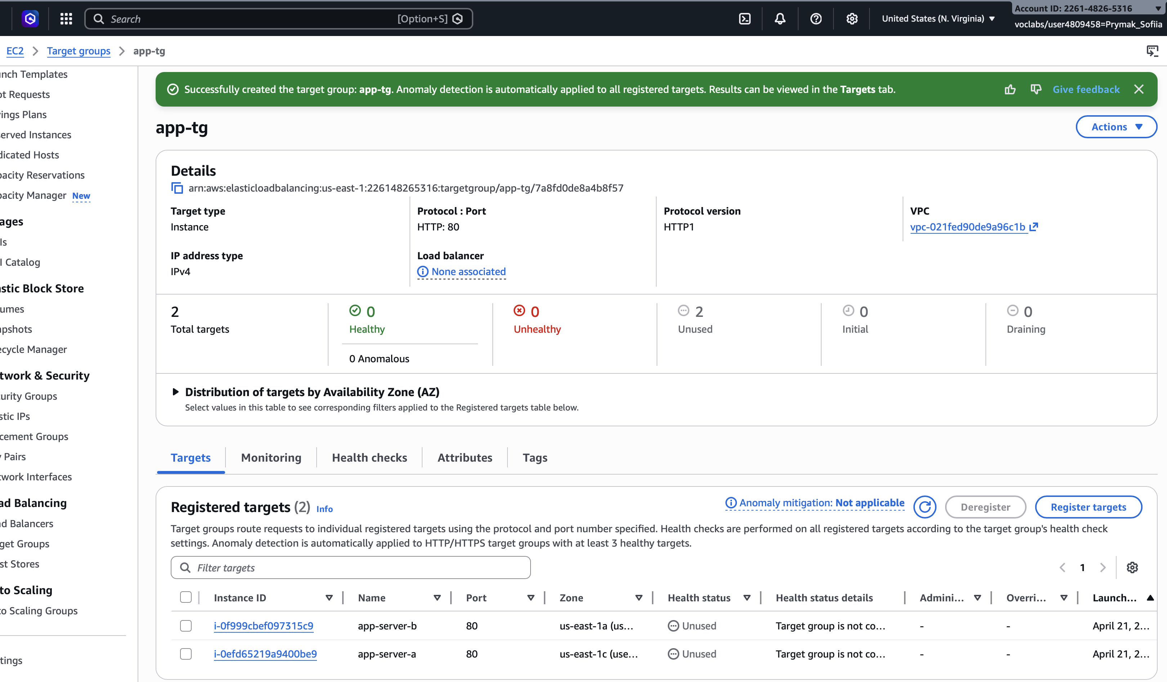
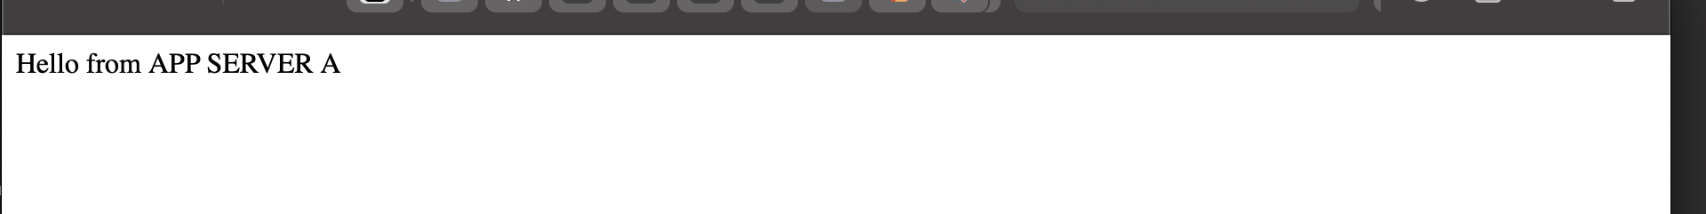
- I associated both EC2 instances with it
Problems:
One of the servers was not healthy.
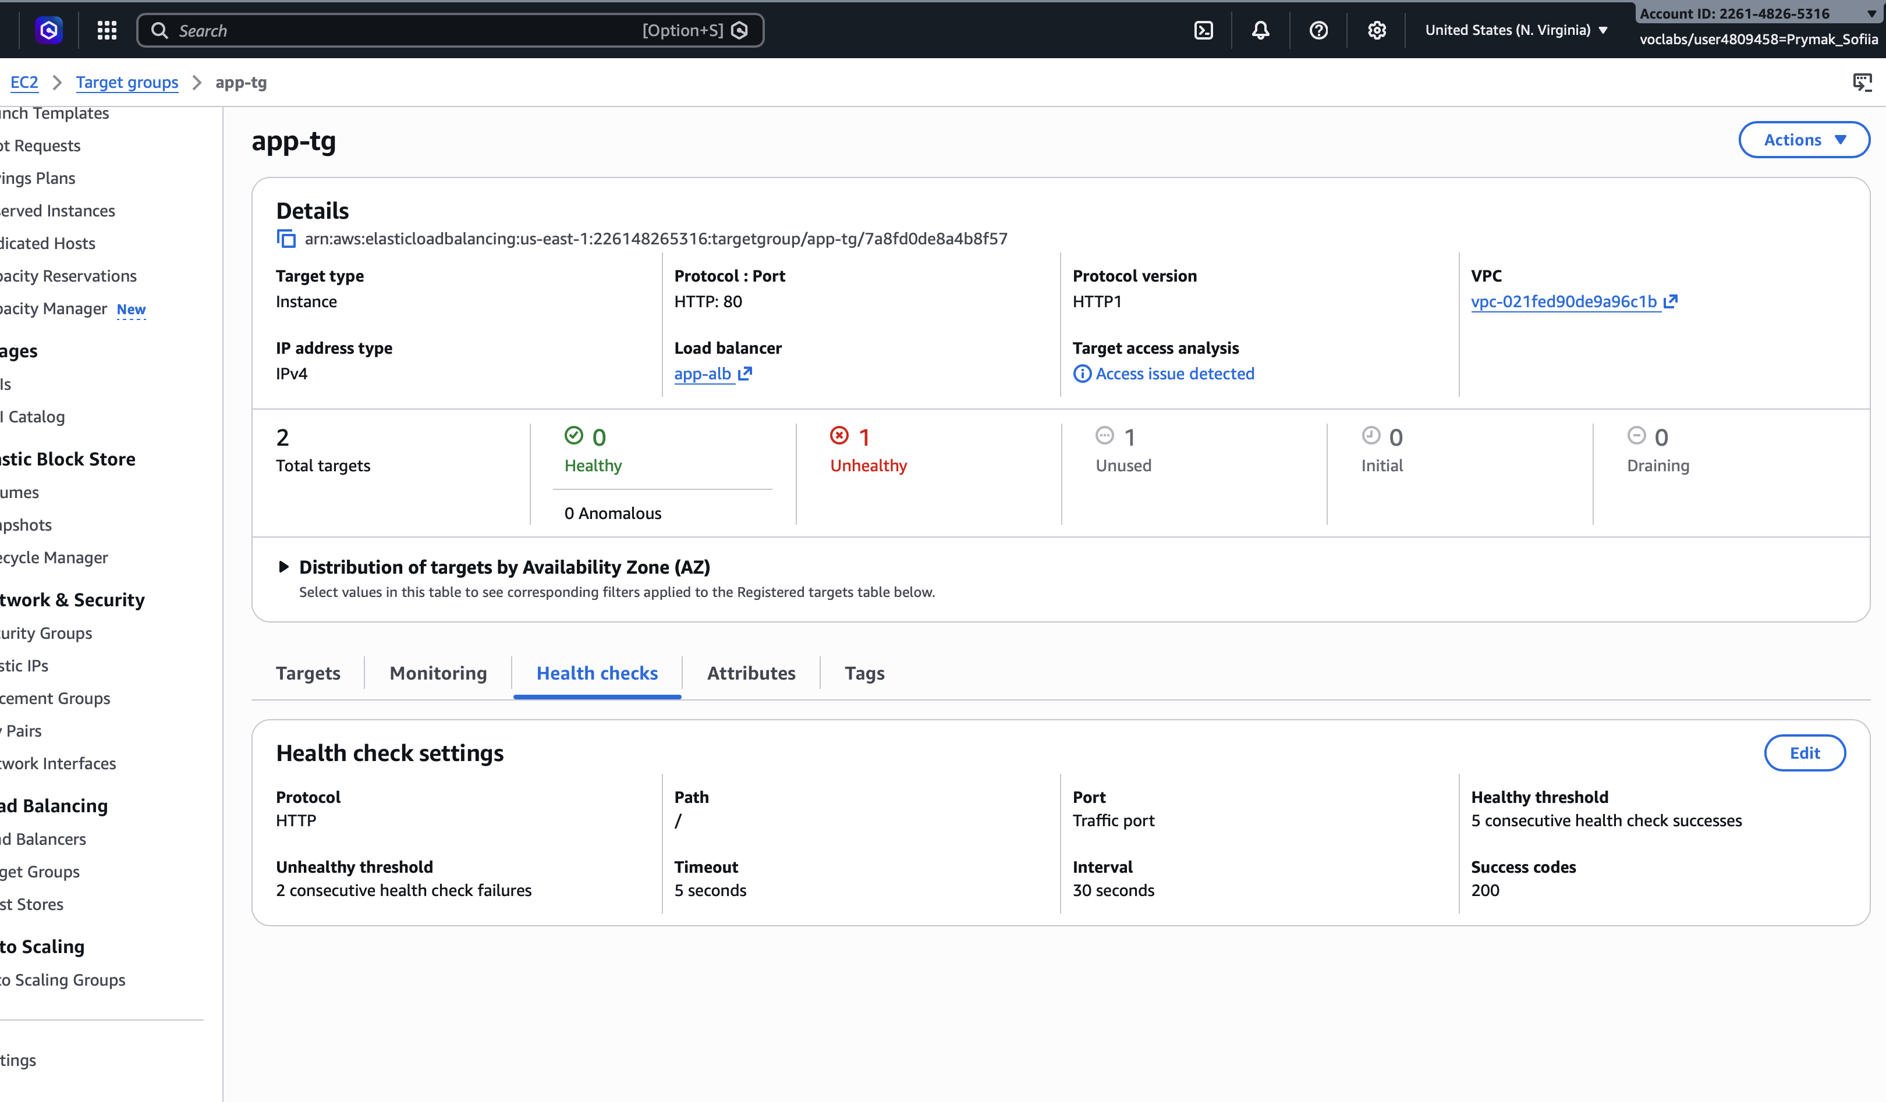
The health check was returning a 403 error.
Solution: The issue was that the index.html file was in the wrong directory. After I moved it to /var/www/html, both servers became healthy. This helped me understand how ALB health checks work and why they are important.
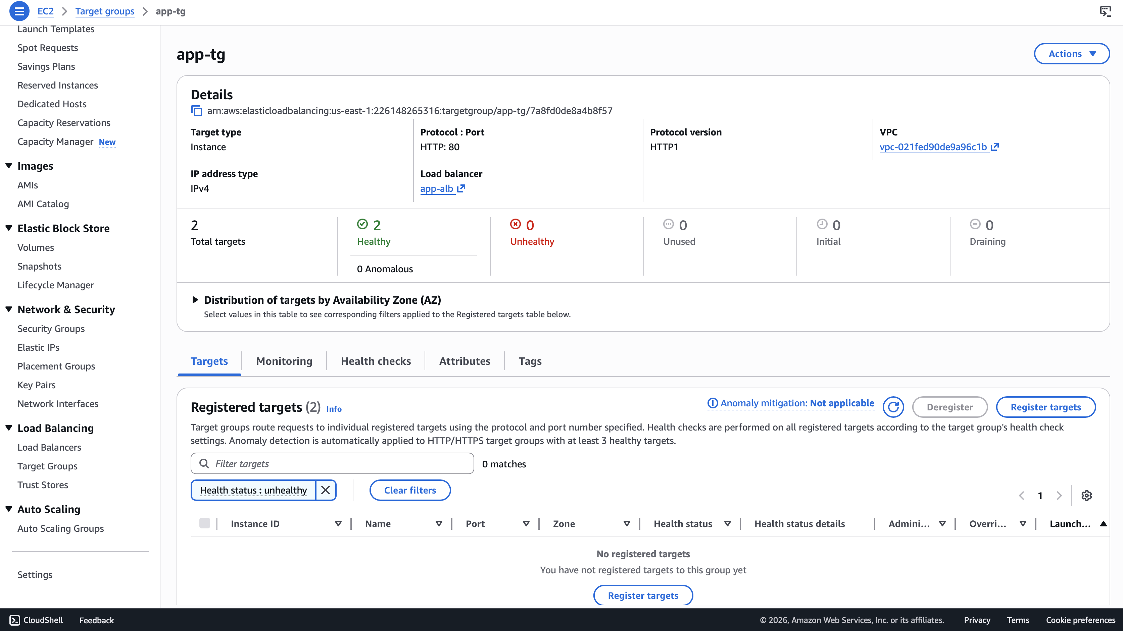

3.5 Auto Scaling Group
What I did:
- I created a Launch Template
- I created an Auto Scaling Group with a desired size of one, a size of one and a maximum size of two
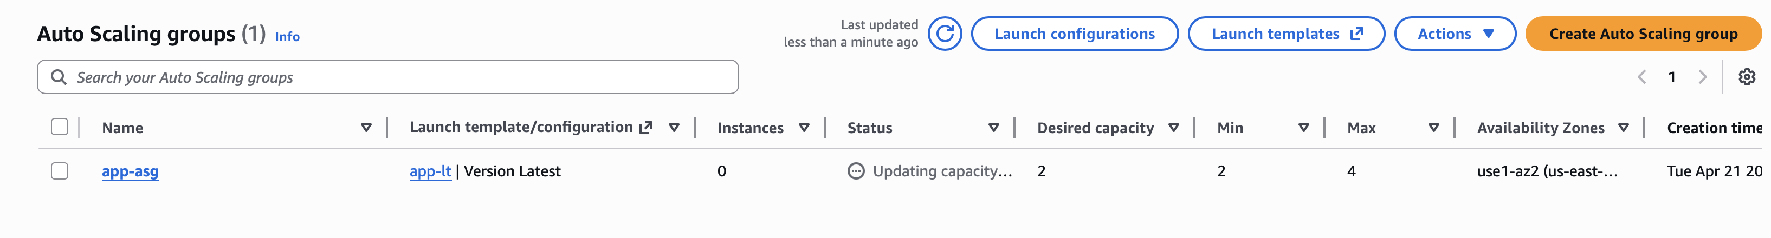
- I configured a scaling policy based on 60 percent CPU usage
Problems: The Auto Scaling Group did not create instances. It gave an AMI error.
Solution: I created a custom AMI from a working EC2 instance and used it in the Launch Template. After that, the ASG worked correctly.
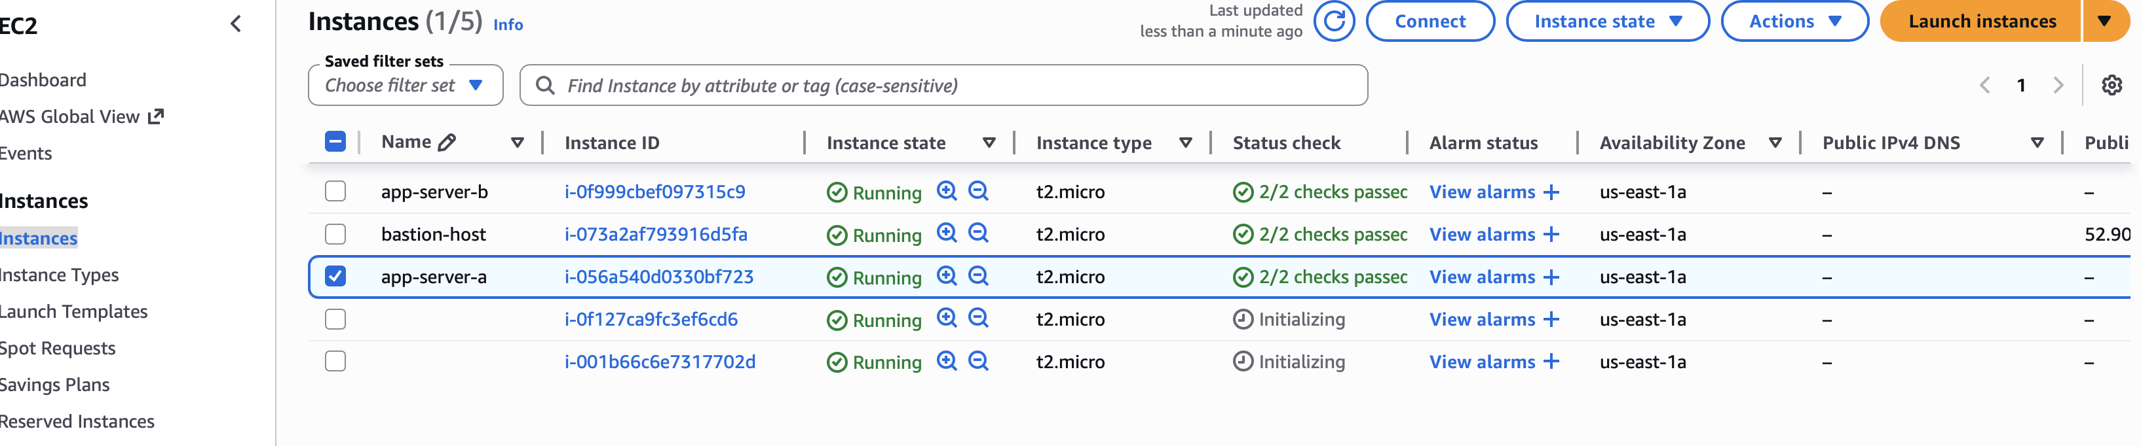
This taught me how AMIs are used in scaling and why they must be configured properly
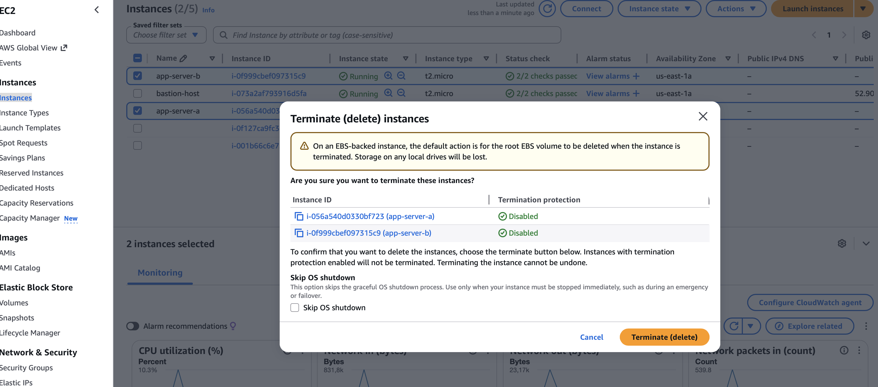
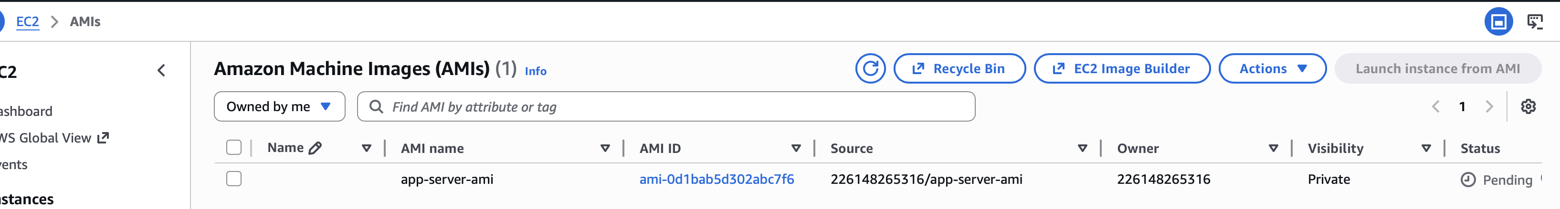

3.6 RDS MySQL
What I did:
I created an RDS MySQL instance in a private subnet. I connected to it through the bastion host and created a database and tables manually
- I created an RDS MySQL instance
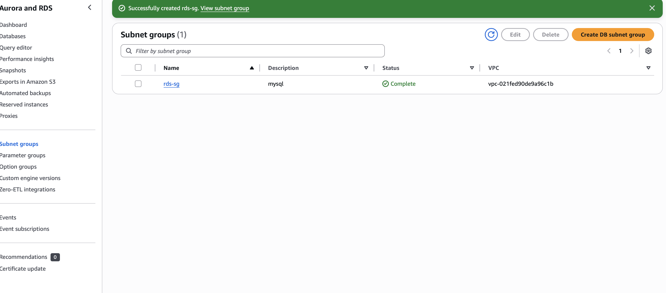
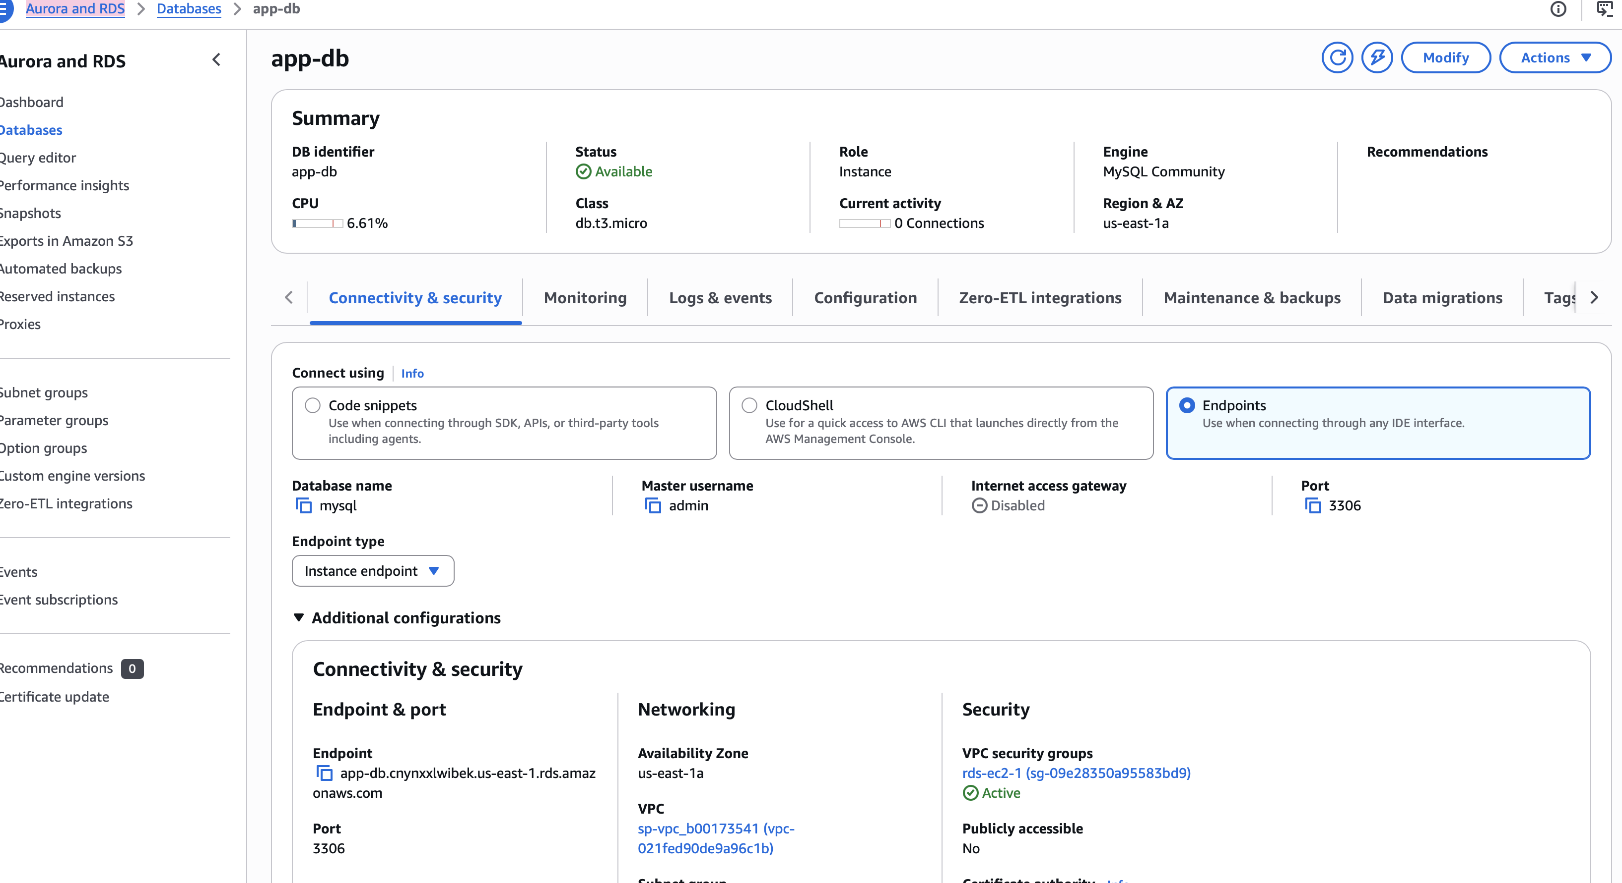
- I connected to it through the bastion host
- I created a database and tables by hand
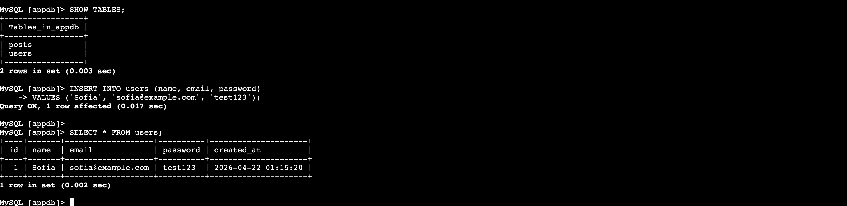
Problems:
The EC2 instance could not connect to the RDS instance. It gave an access error.
Solution: I added a rule to the RDS Security Group that lets MySQL get access from the Web Server Security Group
This made the connection work. I learned that Security Groups are really important because they control the traffic between services like the Web Server Security Group and the RDS Security Group
The RDS Security Group and the Web Server Security Group are, like two things that need to talk to each other and the Security Groups make sure they can do that safely..

3.7 Static Backup Website (S3)
What I did:
- I created an S3 bucket
- I enabled hosting
- I uploaded a backup page
Problems:
I got a 403 error when I tried to open the site.
Solution: I added a bucket policy and enabled public access for the object. After that, the site worked. This taught me how S3 permissions work and why they can be tricky

4. Additional Amazon Web Services (Justification)

4.1 AWS WAF

The Amazon Web Services Web Application Firewall protects web applications from attacks like SQL injection and cross-site scripting. This is really helpful when the web application is there on the internet for everyone to access. The AWS WAF is a tool for keeping web applications safe, from these kinds of attacks

4.2 Amazon CloudTrail

CloudTrail records everything that happens in Amazon Web Services. This is really helpful when we need to look into something, for security reasons or when we have to check what people are doing. We also use CloudTrail to keep track of any changes that are made. CloudTrail is very important because it helps us understand what people are doing in the cloud environment. We can see who did what in the cloud environment with CloudTrail.

5. Sustainability (Amazon Web Services Well-Architected Framework)
The proof of concept implements sustainability measures:
- Auto Scaling reduces the number of running servers.
- S3 replaces energy- local storage.
- RDS reduces the load on the infrastructure.
- Using t2.micro minimizes power consumption.
Recommendations:
- Switch, to Graviton instances for better
- Enable S3 Lifecycle poliecies
- Use Spot Instances for non-critical workloads

Conclusion
I got to work on a project where I had to design and set up a cloud infrastructure in Amazon Web Services or AWS for short from scratch. I started with an environment and ended up with a fully working Proof of Concept. The final setup included a Virtual Private Cloud or VPC and public and private subnets. I also set up EC2 web servers, an Application Load Balancer, an Auto Scaling Group, a bastion host, a MySQL database with RDS and a static backup website hosted on S3.
Even though this was not a production system I followed the same practices that real companies use, which helped me understand how cloud systems are built. One of the important things I learned from this project was how AWS networking works. At first I did not think that routing tables NAT gateways and subnet associations were that important.. When my private EC2 instances could not access the internet I realized how easy it is to mess up the connection with just one small mistake.
Fixing this issue taught me how to troubleshoot problems with the VPC and how to use the VPC Resource Map to understand the network. Another big part of the project was security. I learned how to set up Security Groups how to limit SSH access and why a bastion host is necessary. Before this project I did not fully understand how internal access works in subnets.
After setting up the bastion host and fixing the permission errors I got hands-on experience with access patterns that are used in real cloud environments. Working with EC2 web servers and Apache also taught me a lot. I learned how to install and configure software on Linux servers how to check logs and how to fix issues with services starting up.
When Apache failed to start on one of the servers I had to figure out what was wrong of just recreating the instance. This taught me how important it is to set up services especially when using Auto Scaling. The Application Load Balancer and Target Group configuration taught me about health checks. Why they are essential.
When one of my servers returned a 403 error the ALB immediately marked it as unhealthy. Fixing the index.html path helped me understand how the ALB decides whether an instance is ready to receive traffic. This experience showed me how AWS automatically handles failures and improves availability.
Setting up the Auto Scaling Group was another learning moment. When the ASG failed to launch instances due to an AMI error I realized how important it is to create a proper AMI that contains all necessary software. After creating my AMI the ASG worked correctly. This taught me how scaling works in practice and how AWS can automatically adjust capacity based on demand.
Working with RDS MySQL helped me understand the difference between self-managed databases and managed services. I learned how to connect to a database in a subnet, how to configure inbound rules and how to create tables manually. Fixing the database access error helped me understand how Security Groups control communication between application and database layers.
Finally creating the S3 static backup website and configuring Route 53 failover showed me how to build resilience into an application. Even if the main servers fail users can still see a page instead of an error. This is a effective way to improve user experience during outages.
Overall this project helped me gain hands-on experience with AWS. I learned how to design cloud architectures how to deploy and configure services how to troubleshoot problems and how to think about security and reliability. The challenges I faced made the learning process more meaningful and solving them gave me confidence, in working with cloud technologies. The final Proof of Concept works as intended. I now have a much better understanding of how modern cloud systems are built and maintained

