**Product Count Microservice**

This is a simple microservice for counting a number of products in a MongoDB database. The microservice is implemented in Node.js using the Mongoose library.

**Requirements:**

* Node.js
* MongoDB
* Mongoose library

**Installation:**

1. Clone the repository:

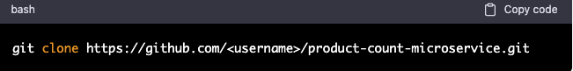

1. Install the dependencies:

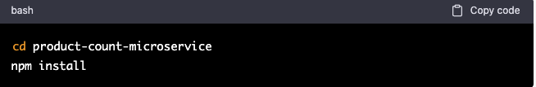

1. Set up the environment variables:

Create a `.env` file in the root directory of the project and set the following environment variable:

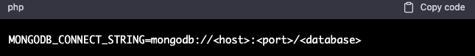

Replace `<host>`, `<port>` and `<database>` with the appropriate values for your MongoDB installation.

**Usage:**

1. Start the microservice:

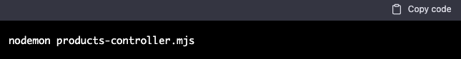

1. Retrieve the number of products:

Make a GET request to the endpoint `/api/products/count` to retrieve the number of products in the database. The response will be a JSON object with a single property `count` that contains the number of products.

**UML sequence diagram:**

