
МИНОБРНАУКИ РОССИИ
Федеральное государственное бюджетное образовательное учреждение
высшего образования
«МИРЭА − Российский технологический университет»
РТУ МИРЭА
Институт информационных технологий (ИИТ)
Кафедра цифровой трансформации (ЦТ)

ОТЧЕТ ПО ПРАКТИЧЕСКОЙ РАБОТЕ
по дисциплине «Проектирование баз данных»

Практическая работа № 6

Студент группы ИНБО-01-17 | ИКБО-31-24 Жильцова С.О. | (подпись)
Ассистент | Копылова Я.А. | (подпись)
Отчет представлен | «___»________2026 г.

Москва 2026 г.
Цель работы:
Целью данной практической работы является осуществление корректного перехода от логической реляционной модели данных к оптимизированному физическому DDL-скрипту (Data Definition Language). Студентам предстоит транслировать абстрактные структуры под конкретные архитектурные особенности, механизмы выделения памяти и строгие стандарты СУБД PostgreSQL.
Выбранная предметная область
В данной работе проектирование базы данных будет вестись для типового учреждения культуры - «Городская библиотека».
Ход выполнения работы
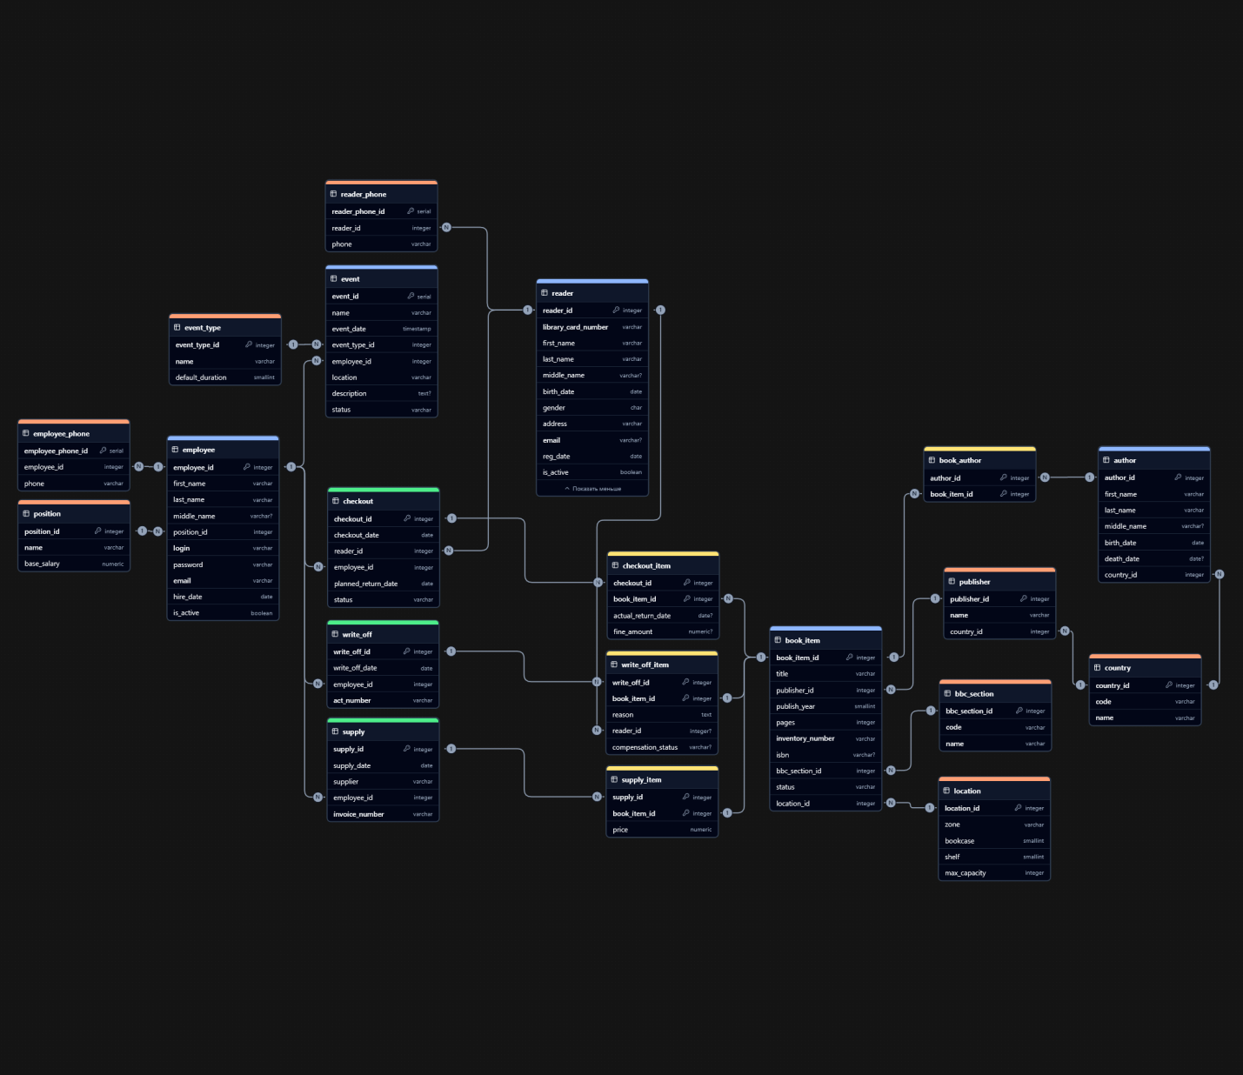
Рисунок 1. Готовая диаграмма
Листинг 1. Итоговый SQL-скрипт
--
-- УРОВЕНЬ 1. НЕЗАВИСИМЫЕ СПРАВОЧНИКИ
--
CREATE TABLE country (
country_id int GENERATED BY DEFAULT AS IDENTITY PRIMARY KEY,
code varchar(3) NOT NULL UNIQUE,
name varchar(100) NOT NULL UNIQUE
);
CREATE TABLE position (
position_id int GENERATED BY DEFAULT AS IDENTITY PRIMARY KEY,
name varchar(100) NOT NULL UNIQUE,
base_salary numeric(10,2) NOT NULL
);
CREATE TABLE bbc_section (
bbc_section_id int GENERATED BY DEFAULT AS IDENTITY PRIMARY KEY,
code varchar(20) NOT NULL UNIQUE,
name varchar(200) NOT NULL UNIQUE
);
CREATE TABLE event_type (
event_type_id int GENERATED BY DEFAULT AS IDENTITY PRIMARY KEY,
name varchar(100) NOT NULL UNIQUE,
default_duration smallint NOT NULL DEFAULT 60
);
CREATE TABLE location (
location_id int GENERATED BY DEFAULT AS IDENTITY PRIMARY KEY,
zone varchar(50) NOT NULL,
bookcase smallint NOT NULL,
shelf smallint NOT NULL,
max_capacity integer NOT NULL DEFAULT 100
);
--
-- УРОВЕНЬ 2. ЗАВИСИМЫЕ СПРАВОЧНИКИ
--
CREATE TABLE publisher (
publisher_id int GENERATED BY DEFAULT AS IDENTITY PRIMARY KEY,
name varchar(200) NOT NULL UNIQUE,
country_id integer NOT NULL
);
--
-- УРОВЕНЬ 3. КЛЮЧЕВЫЕ ОБЪЕКТЫ
--
CREATE TABLE employee (
employee_id int GENERATED BY DEFAULT AS IDENTITY PRIMARY KEY,
first_name varchar(100) NOT NULL,
last_name varchar(100) NOT NULL,
middle_name varchar(100),
position_id integer NOT NULL,
login varchar(50) NOT NULL UNIQUE,
password varchar(255) NOT NULL,
email varchar(100) NOT NULL UNIQUE,
hire_date date NOT NULL DEFAULT CURRENT_DATE,
is_active boolean NOT NULL DEFAULT true
);
CREATE TABLE reader (
reader_id int GENERATED BY DEFAULT AS IDENTITY PRIMARY KEY,
library_card_number varchar(20) NOT NULL UNIQUE,
first_name varchar(100) NOT NULL,
last_name varchar(100) NOT NULL,
middle_name varchar(100),
birth_date date NOT NULL,
gender char(1) NOT NULL,
address varchar(255) NOT NULL,
email varchar(100) UNIQUE,
reg_date date NOT NULL DEFAULT CURRENT_DATE,
is_active boolean NOT NULL DEFAULT true
);
CREATE TABLE book_item (
book_item_id int GENERATED BY DEFAULT AS IDENTITY PRIMARY KEY,
title varchar(255) NOT NULL,
publisher_id integer NOT NULL,
publish_year smallint NOT NULL,
pages integer NOT NULL,
inventory_number varchar(50) NOT NULL UNIQUE,
isbn varchar(20),
bbc_section_id integer NOT NULL,
status varchar(20) NOT NULL DEFAULT 'В наличии',
location_id integer NOT NULL
);
CREATE TABLE author (
author_id int GENERATED BY DEFAULT AS IDENTITY PRIMARY KEY,
first_name varchar(100) NOT NULL,
last_name varchar(100) NOT NULL,
middle_name varchar(100),
birth_date date NOT NULL,
death_date date,
country_id integer NOT NULL
);
--
-- УРОВЕНЬ 4. ДОКУМЕНТЫ И РЕГИСТРЫ
--
CREATE TABLE event (
event_id int GENERATED BY DEFAULT AS IDENTITY PRIMARY KEY,
name varchar(100) NOT NULL,
event_date timestamp NOT NULL,
event_type_id integer NOT NULL,
employee_id integer NOT NULL,
location varchar(100) NOT NULL,
description text,
status varchar(20) NOT NULL DEFAULT 'Планируется'
);
CREATE TABLE checkout (
checkout_id int GENERATED BY DEFAULT AS IDENTITY PRIMARY KEY,
checkout_date date NOT NULL DEFAULT CURRENT_DATE,
reader_id integer NOT NULL,
employee_id integer NOT NULL,
planned_return_date date NOT NULL DEFAULT (CURRENT_DATE + INTERVAL '30 days'),
status varchar(20) NOT NULL DEFAULT 'Активна'
);
COMMENT ON COLUMN checkout.status IS 'Статус выдачи: "Активна" или "Закрыта"';
CREATE TABLE supply (
supply_id int GENERATED BY DEFAULT AS IDENTITY PRIMARY KEY,
supply_date date NOT NULL DEFAULT CURRENT_DATE,
supplier varchar(200) NOT NULL,
employee_id integer NOT NULL,
invoice_number varchar(50) NOT NULL UNIQUE
);
CREATE TABLE write_off (
write_off_id int GENERATED BY DEFAULT AS IDENTITY PRIMARY KEY,
write_off_date date NOT NULL DEFAULT CURRENT_DATE,
employee_id integer NOT NULL,
act_number varchar(50) NOT NULL UNIQUE
);
COMMENT ON TABLE write_off IS 'Акт списания ветхих, утерянных или испорченных книг. Содержит номер акта, дату и сотрудника, оформившего списание.';
--
-- УРОВЕНЬ 5. ПРОМЕЖУТОЧНЫЕ ТАБЛИЦЫ (позиции документов и связи M:N)
--
CREATE TABLE checkout_item (
checkout_id integer NOT NULL,
book_item_id integer NOT NULL,
actual_return_date date,
fine_amount numeric(10,2),
PRIMARY KEY (checkout_id, book_item_id)
);
COMMENT ON TABLE checkout_item IS 'Cписок книг, выданных читателю в рамках одного чека, с информацией о возврате и штрафах';
COMMENT ON COLUMN checkout_item.actual_return_date IS 'Дата фактического возврата книги (NULL означает, что книга ещё на руках у читателя)';
CREATE TABLE supply_item (
supply_id integer NOT NULL,
book_item_id integer NOT NULL,
price numeric(10,2) NOT NULL,
PRIMARY KEY (supply_id, book_item_id)
);
CREATE TABLE write_off_item (
write_off_id integer NOT NULL,
book_item_id integer NOT NULL,
reason text NOT NULL,
reader_id integer,
compensation_status varchar(20),
PRIMARY KEY (write_off_id, book_item_id)
);
CREATE TABLE employee_phone (
employee_phone_id int GENERATED BY DEFAULT AS IDENTITY PRIMARY KEY,
employee_id integer NOT NULL,
phone varchar(20) NOT NULL
);
CREATE TABLE reader_phone (
reader_phone_id int GENERATED BY DEFAULT AS IDENTITY PRIMARY KEY,
reader_id integer NOT NULL,
phone varchar(20) NOT NULL
);
CREATE TABLE book_author (
author_id integer NOT NULL,
book_item_id integer NOT NULL,
PRIMARY KEY (author_id, book_item_id)
);
--
-- БЛОК ОГРАНИЧЕНИЙ ВНЕШНИХ КЛЮЧЕЙ (С ПРАВИЛАМИ ON DELETE / ON UPDATE)
--
-- Защита справочников: объекты зависят от справочников (ON DELETE RESTRICT)
ALTER TABLE publisher ADD CONSTRAINT publisher_country_id_fk FOREIGN KEY (country_id) REFERENCES country (country_id) ON DELETE RESTRICT;
ALTER TABLE author ADD CONSTRAINT author_country_id_fk FOREIGN KEY (country_id) REFERENCES country (country_id) ON DELETE RESTRICT;
ALTER TABLE employee ADD CONSTRAINT employee_position_id_fk FOREIGN KEY (position_id) REFERENCES position (position_id) ON DELETE RESTRICT;
ALTER TABLE event ADD CONSTRAINT event_event_type_id_fk FOREIGN KEY (event_type_id) REFERENCES event_type (event_type_id) ON DELETE RESTRICT;
ALTER TABLE book_item ADD CONSTRAINT book_item_publisher_id_fk FOREIGN KEY (publisher_id) REFERENCES publisher (publisher_id) ON DELETE RESTRICT;
ALTER TABLE book_item ADD CONSTRAINT book_item_bbc_section_id_fk FOREIGN KEY (bbc_section_id) REFERENCES bbc_section (bbc_section_id) ON DELETE RESTRICT;
ALTER TABLE book_item ADD CONSTRAINT book_item_location_id_fk FOREIGN KEY (location_id) REFERENCES location (location_id) ON DELETE RESTRICT;
-- Зависимые атрибуты объектов: телефоны исчезают вместе с владельцем (ON DELETE CASCADE)
ALTER TABLE employee_phone ADD CONSTRAINT employee_phone_employee_id_fk FOREIGN KEY (employee_id) REFERENCES employee (employee_id) ON DELETE CASCADE;
ALTER TABLE reader_phone ADD CONSTRAINT reader_phone_reader_id_fk FOREIGN KEY (reader_id) REFERENCES reader (reader_id) ON DELETE CASCADE;
-- Историческая безопасность: документы блокируют удаление участников сделок (ON DELETE RESTRICT)
ALTER TABLE checkout ADD CONSTRAINT checkout_employee_id_fk FOREIGN KEY (employee_id) REFERENCES employee (employee_id) ON DELETE RESTRICT;
ALTER TABLE checkout ADD CONSTRAINT checkout_reader_id_fk FOREIGN KEY (reader_id) REFERENCES reader (reader_id) ON DELETE RESTRICT;
ALTER TABLE supply ADD CONSTRAINT supply_employee_id_fk FOREIGN KEY (employee_id) REFERENCES employee (employee_id) ON DELETE RESTRICT;
ALTER TABLE write_off ADD CONSTRAINT write_off_employee_id_fk FOREIGN KEY (employee_id) REFERENCES employee (employee_id) ON DELETE RESTRICT;
ALTER TABLE write_off_item ADD CONSTRAINT write_off_item_reader_id_fk FOREIGN KEY (reader_id) REFERENCES reader (reader_id) ON DELETE RESTRICT;
-- Целостность документов: промежуточные таблицы жёстко зависят от документов (ON DELETE CASCADE)
ALTER TABLE checkout_item ADD CONSTRAINT checkout_item_checkout_id_fk FOREIGN KEY (checkout_id) REFERENCES checkout (checkout_id) ON DELETE CASCADE ON UPDATE CASCADE;
ALTER TABLE supply_item ADD CONSTRAINT supply_item_supply_id_fk FOREIGN KEY (supply_id) REFERENCES supply (supply_id) ON DELETE CASCADE ON UPDATE CASCADE;
ALTER TABLE write_off_item ADD CONSTRAINT write_off_item_write_off_id_fk FOREIGN KEY (write_off_id) REFERENCES write_off (write_off_id) ON DELETE CASCADE ON UPDATE CASCADE;
ALTER TABLE book_author ADD CONSTRAINT book_author_book_item_id_fk FOREIGN KEY (book_item_id) REFERENCES book_item (book_item_id) ON DELETE CASCADE ON UPDATE CASCADE;
ALTER TABLE book_author ADD CONSTRAINT book_author_author_id_fk FOREIGN KEY (author_id) REFERENCES author (author_id) ON DELETE CASCADE ON UPDATE CASCADE;
ALTER TABLE event ADD CONSTRAINT event_employee_id_fk FOREIGN KEY (employee_id) REFERENCES employee (employee_id) ON DELETE RESTRICT;
ALTER TABLE checkout_item ADD CONSTRAINT checkout_item_book_item_id_fk FOREIGN KEY (book_item_id) REFERENCES book_item (book_item_id) ON DELETE RESTRICT;
ALTER TABLE write_off_item ADD CONSTRAINT write_off_item_book_item_id_fk FOREIGN KEY (book_item_id) REFERENCES book_item (book_item_id) ON DELETE RESTRICT;
ALTER TABLE supply_item ADD CONSTRAINT supply_item_book_item_id_fk FOREIGN KEY (book_item_id) REFERENCES book_item (book_item_id) ON DELETE RESTRICT;

