SRI SIDDHARTHA ACADEMY OF HIGHER EDUCATION
(Declared as Deemed to be University Under Section 3 of the UGC Act, 1956
Approved by AICTE, Accredited by NBA, NAAC ‘A+’ Grade)
AGALKOTE, TUMAKURU – 572107
KARNATAKA



Mini Project work (22ECMP607) Synopsis
on
“REAL TIME VARIABLE PACEMAKER MONITORING AND ANOMALY DETECTION”

Submitted by
RAKSHITHA K | 23EC079
SOFIYA PARVEEN | 23EC103

In partial fulfillment of requirements for the award of degree

BACHELOR OF ENGINEERING
IN
ELECTRONICS AND COMMUNICATION ENGINEERING
(Accredited by NBA)



SRI SIDDHARTHA INSTITUTE OF TECHNOLOGY
(A Constituent College of Sri Siddhartha Academy of Higher Education,
Approved by AICTE, Accredited by NBA, NAAC ‘A+’ Grade)
MARALUR, TUMAKURU-572105
2025-2026

Mini Project work (22ECMP607)

Synopsis
on
“REAL TIME VARIABLE PACEMAKER MONITORING AND ANOMALY DETECTION”
Cardiovascular diseases continue to be one of the major causes of mortality and long-term health complications across the world. Among these conditions, cardiac arrhythmiasirregularities in the heart’s electrical rhythm pose serious risks if not detected and treated at the right time. Pacemakers are implantable medical devices that play a vital role in managing such conditions by regulating the heart’s rhythm through controlled electrical stimulation. Over the years, pacemaker technology has advanced significantly, transitioning from fixedrate pacing devices to sophisticated systems capable of adaptive and variable pacing based on the physiological needs of the patient.Modern pacemakers are designed to operate continuously and autonomously within the human body, making reliability, accuracy, and safety extremely critical. Variable pacemakers adjust their pacing rate depending on factors such as physical activity, stress levels, and detected cardiac signals. While this adaptability improves patient comfort and physiological response, it also increases system complexity. As a result, continuous monitoring of pacemaker behavior and cardiac signal patterns becomes essential to ensure proper device operation.Real-time monitoring allows the pacemaker system to observe cardiac signals and pacing parameters instantaneously, enabling rapid detection of abnormal conditions. Anomalies such as irregular pacing intervals, signal distortions, hardware faults, or unexpected operating behaviors can compromise the effectiveness of the pacemaker and endanger the patient’s life if left undetected. Therefore, integrating anomaly detection mechanisms into pacemaker monitoring systems is of great importance.The mini-project titled “Real Time Variable Pacemaker Monitoring and Anomaly Detection” focuses on addressing these challenges by developing a system that continuously monitors pacemaker signals in real time and identifies abnormal patterns or deviations from normal behavior. The proposed system aims to enhance patient safety by enabling early detection of anomalies, allowing timely intervention and corrective measures.
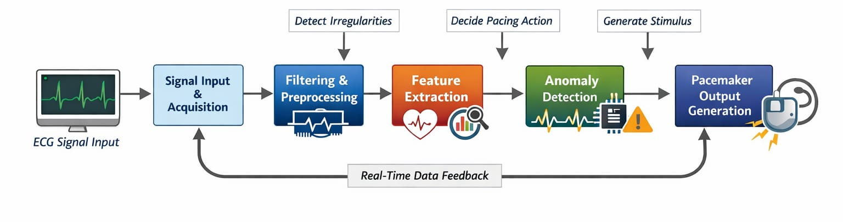
Figure 1: Real time variable pacemaker monitoring and anamoly detection

The input cardiac signals are first processed through filtering techniques to remove noise and unwanted disturbances. Relevant features such as heart rate characteristics are extracted from the filtered signals. The system then performs anomaly detection to identify irregularities like abnormal heart rhythms. Based on detected conditions, an adaptive pacing logic module determines whether pacing intervention is required.
Finally, the pacemaker output generator simulates electrical impulses that would stabilize heart activity. The project demonstrates how computational models and signal processing techniques can be applied to emulate biomedical systems.
This simulation provides educational insight into pacemaker functionality without requiring physical hardware.

REFERENCES
- J. A. Hall, M. J. Smith and R. Kumar, “Real-Time Monitoring and Fault Detection in Implantable Pacemakers,” 2021 IEEE International Conference on Biomedical Circuits and Systems (BioCAS), 2021, pp. 1–4, doi: 10.1109/BioCAS49922.2021.9649821.
- S. Patel, R. Mehta and A. Verma, “Anomaly Detection Techniques for Implantable Medical Devices,” 2020 IEEE International Conference on Healthcare Informatics (ICHI), 2020, pp. 245–250, doi: 10.1109/ICHI48887.2020.9374372.
- K. Lee and D. Kim, “Low-Power Real-Time Monitoring System for Cardiac Pacemakers,” IEEE Transactions on Biomedical Circuits and Systems, vol. 14, no. 3, pp. 512–520, June 2020, doi: 10.1109/TBCAS.2020.2986543.
- A.Sharma and P. Gupta, “Design and Verification of Safety-Critical Pacemaker Systems,” 2019 IEEE International Symposium on Circuits and Systems (ISCAS),2019,pp.1–5, doi: 10.1109/ISCAS.2019.8702607.
- M. Chen, Y. Zhang and L. Wang, “Real-Time Anomaly Detection in Medical CyberPhysical Systems,” 2021 IEEE Conference on Dependable and Secure Computing, 2021, pp. 89–94, doi: 10.1109/DSC49826.2021.9476223.
- R. Alur, A. Kanade and S. Ramesh, “Formal Analysis of Implantable Cardiac Pacemakers,” IEEE Transactions on Computer-Aided Design of Integrated Circuits and Systems, vol. 32, no. 7, pp. 1007–1020, July 2013, doi: 10.1109/TCAD.2013.2255863.
- P. N. Singh and S. Roy, “Machine Learning-Based Anomaly Detection for Cardiac Monitoring Systems,” 2022 IEEE International Conference on Artificial Intelligence in Healthcare, 2022, pp. 56–61, doi: 10.1109/AIH54832.2022.9857431.
- L. Bu, M. Kwiatkowska and S. Wang, “Model-Based Safety Analysis of Pacemaker Systems,” 2018 IEEE International Conference on Embedded Software (EMSOFT), 2018, pp. 1–10, doi: 10.1109/EMSOFT.2018.8537204.
- T. Nguyen and H. Tran, “Secure and Reliable Monitoring of Implantable Medical Devices,” 2020 IEEE International Conference on Internet of Things and Intelligence Systems, 2020, pp.
- S. Banerjee, R. Das and P. Chakrabarti, “Real-Time Health Monitoring and Fault Detection in Pacemaker SoC,” 2021 IEEE International Conference on Integrated Circuits, Technologies and Applications (ICTA), 2021, pp. 34–38, doi: 10.1109/ICTA53245.2021.9587216.

