Codebook for nhanes_clean

Autogenerated data summary from dataMaid

2025-09-26 14:42:28.729898

# Data report overview

The dataset examined has the following dimensions:

| Feature | Result |
| --- | --- |
| Number of observations | 2015 |
| Number of variables | 12 |

# Codebook summary table

| Label | Variable | Class | # unique values | Missing | Description |
| --- | --- | --- | --- | --- | --- |
|  | **SEQN** | numeric | 2015 | 0.00 % |  |
|  | **RIDAGEYR** | numeric | 26 | 0.00 % |  |
|  | **RIAGENDR** | factor | 2 | 0.00 % |  |
|  | **RIDRETH1** | factor | 5 | 0.00 % |  |
|  | **LBXBPB** | numeric | 369 | 0.00 % |  |
|  | **LBXBCD** | numeric | 231 | 0.00 % |  |
|  | **LBXBMN** | numeric | 997 | 0.00 % |  |
|  | **BPXSY1** | numeric | 62 | 0.00 % |  |
|  | **BPXDI1** | numeric | 46 | 0.00 % |  |
|  | **WTMEC2YR** | numeric | 1917 | 0.00 % |  |
|  | **SDMVPSU** | numeric | 2 | 0.00 % |  |
|  | **SDMVSTRA** | numeric | 15 | 0.00 % |  |

# Variable list

## SEQN

| Feature | Result |
| --- | --- |
| Variable type | numeric |
| Number of missing obs. | 0 (0 %) |
| Number of unique values | 2015 |
| Median | 98287 |
| 1st and 3rd quartiles | 95988.5; 100695.5 |
| Min. and max. | 93711; 102954 |

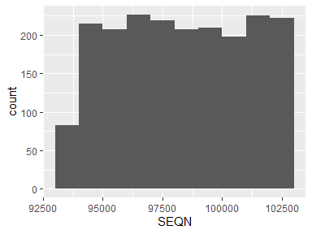

## RIDAGEYR

| Feature | Result |
| --- | --- |
| Variable type | numeric |
| Number of missing obs. | 0 (0 %) |
| Number of unique values | 26 |
| Median | 55 |
| 1st and 3rd quartiles | 47; 60 |
| Min. and max. | 40; 65 |

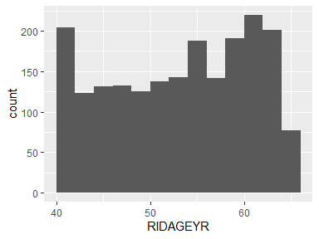

## RIAGENDR

| Feature | Result |
| --- | --- |
| Variable type | factor |
| Number of missing obs. | 0 (0 %) |
| Number of unique values | 2 |
| Mode | “Female” |
| Reference category | Male |

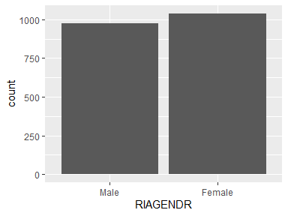

* Observed factor levels: "Female", "Male".

## RIDRETH1

| Feature | Result |
| --- | --- |
| Variable type | factor |
| Number of missing obs. | 0 (0 %) |
| Number of unique values | 5 |
| Mode | “Non-Hispanic White” |
| Reference category | Mexican American |

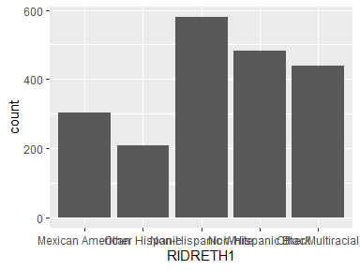

* Observed factor levels: "Mexican American", "Non-Hispanic Black", "Non-Hispanic White", "Other Hispanic", "Other/Multiracial".

## LBXBPB

| Feature | Result |
| --- | --- |
| Variable type | numeric |
| Number of missing obs. | 0 (0 %) |
| Number of unique values | 369 |
| Median | 1.02 |
| 1st and 3rd quartiles | 0.66; 1.51 |
| Min. and max. | 0.12; 42.48 |

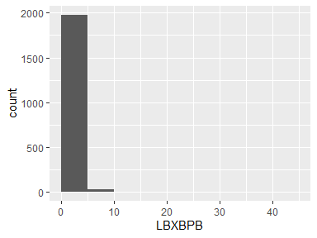

## LBXBCD

| Feature | Result |
| --- | --- |
| Variable type | numeric |
| Number of missing obs. | 0 (0 %) |
| Number of unique values | 231 |
| Median | 0.34 |
| 1st and 3rd quartiles | 0.2; 0.61 |
| Min. and max. | 0.07; 7.5 |

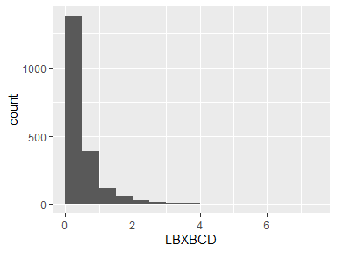

## LBXBMN

| Feature | Result |
| --- | --- |
| Variable type | numeric |
| Number of missing obs. | 0 (0 %) |
| Number of unique values | 997 |
| Median | 9.39 |
| 1st and 3rd quartiles | 7.5; 11.8 |
| Min. and max. | 1.57; 35.56 |

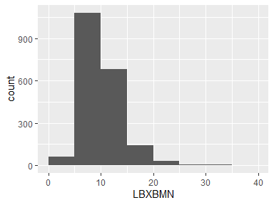

## BPXSY1

| Feature | Result |
| --- | --- |
| Variable type | numeric |
| Number of missing obs. | 0 (0 %) |
| Number of unique values | 62 |
| Median | 126 |
| 1st and 3rd quartiles | 116; 138 |
| Min. and max. | 78; 224 |

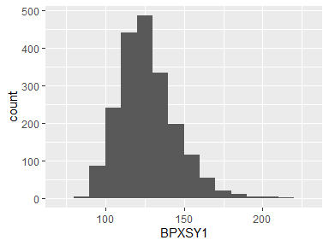

## BPXDI1

| Feature | Result |
| --- | --- |
| Variable type | numeric |
| Number of missing obs. | 0 (0 %) |
| Number of unique values | 46 |
| Median | 76 |
| 1st and 3rd quartiles | 70; 84 |
| Min. and max. | 0; 124 |

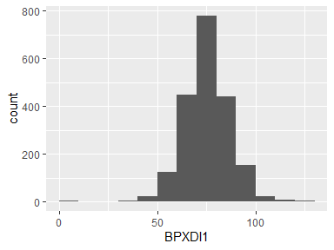

## WTMEC2YR

| Feature | Result |
| --- | --- |
| Variable type | numeric |
| Number of missing obs. | 0 (0 %) |
| Number of unique values | 1917 |
| Median | 23509.5 |
| 1st and 3rd quartiles | 14190.52; 42117.25 |
| Min. and max. | 4579.58; 419056.58 |

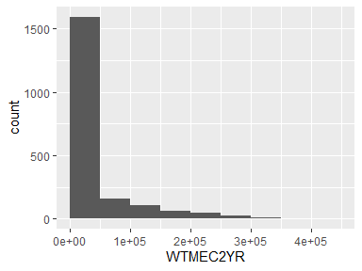

## SDMVPSU

| Feature | Result |
| --- | --- |
| Variable type | numeric |
| Number of missing obs. | 0 (0 %) |
| Number of unique values | 2 |
| Median | 2 |
| 1st and 3rd quartiles | 1; 2 |
| Min. and max. | 1; 2 |

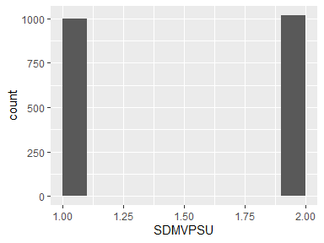

## SDMVSTRA

| Feature | Result |
| --- | --- |
| Variable type | numeric |
| Number of missing obs. | 0 (0 %) |
| Number of unique values | 15 |
| Median | 141 |
| 1st and 3rd quartiles | 137; 145 |
| Min. and max. | 134; 148 |

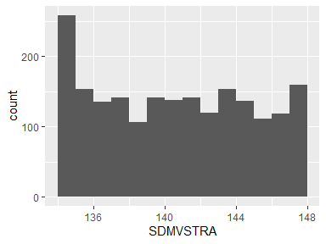

Report generation information:

* Created by: Could not determine from system (username: User).
* Report creation time: Fri Sep 26 2025 14:42:29
* Report was run from directory: C:/Users/User/sofiyavyshnya
* dataMaid v1.4.2 [Pkg: 2025-04-13 from standard (@1.4.2)]
* R version 4.5.1 (2025-06-13 ucrt).
* Platform: x86_64-w64-mingw32/x64(America/New_York).
* Function call: dataMaid::makeDataReport(data = nhanes_clean, mode = c("summarize", "visualize", "check"), smartNum = FALSE, file = "codebook_nhanes_clean.Rmd", checks = list(character = "showAllFactorLevels", factor = "showAllFactorLevels", labelled = "showAllFactorLevels", haven_labelled = "showAllFactorLevels", numeric = NULL, integer = NULL, logical = NULL, Date = NULL), listChecks = FALSE, maxProbVals = Inf, codebook = TRUE, reportTitle = "Codebook for nhanes_clean")