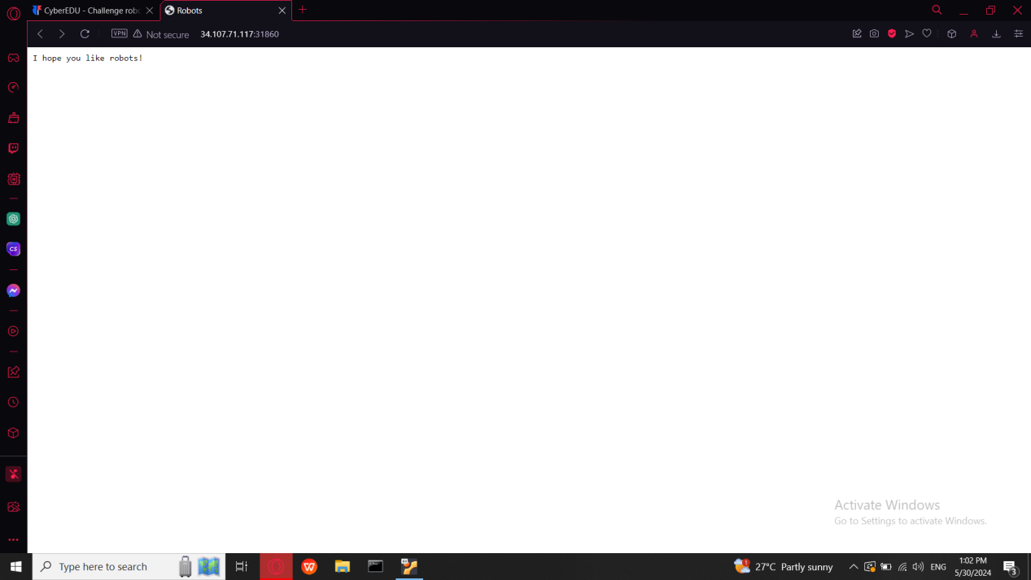

As always I started with discovering of page source

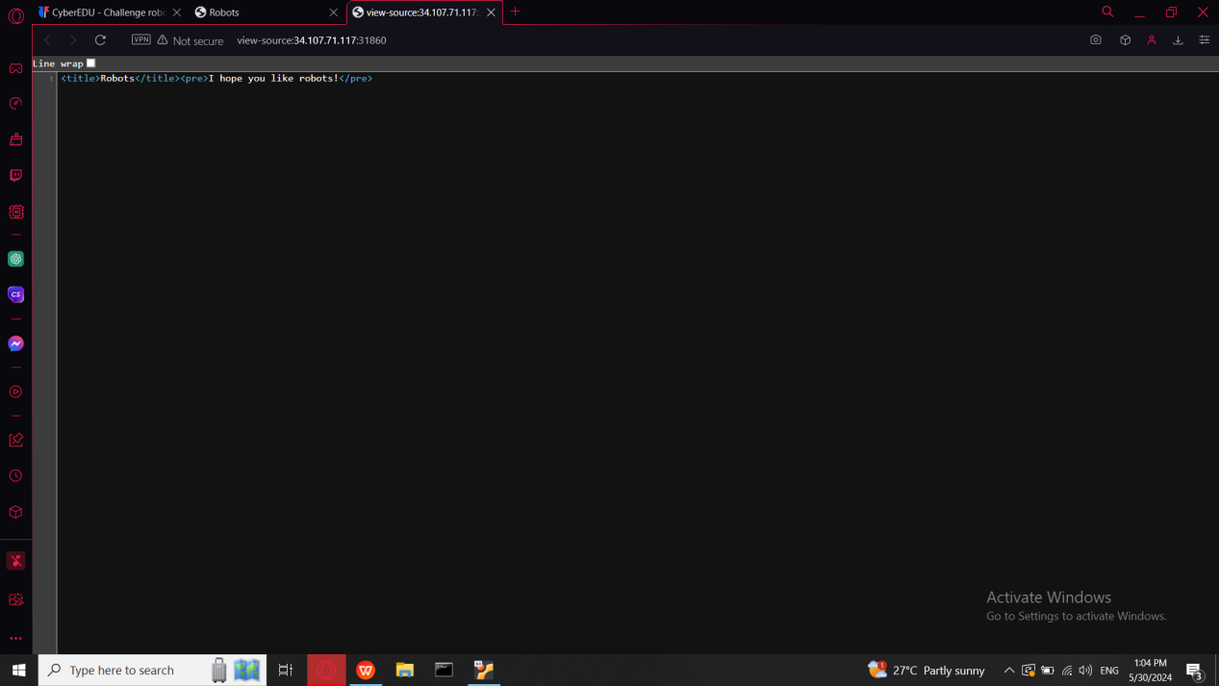

There is nothing interesting here So I tried to find some other weakness I used Dirsearch which is a linux tool used for discovering hidden directories and files on web servers

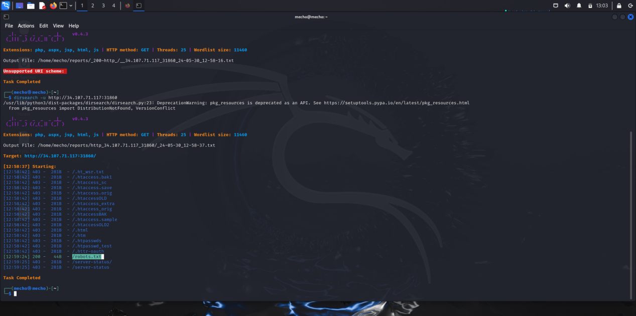

In the result, only one line was green-successful named robots.txt so I added it to the url

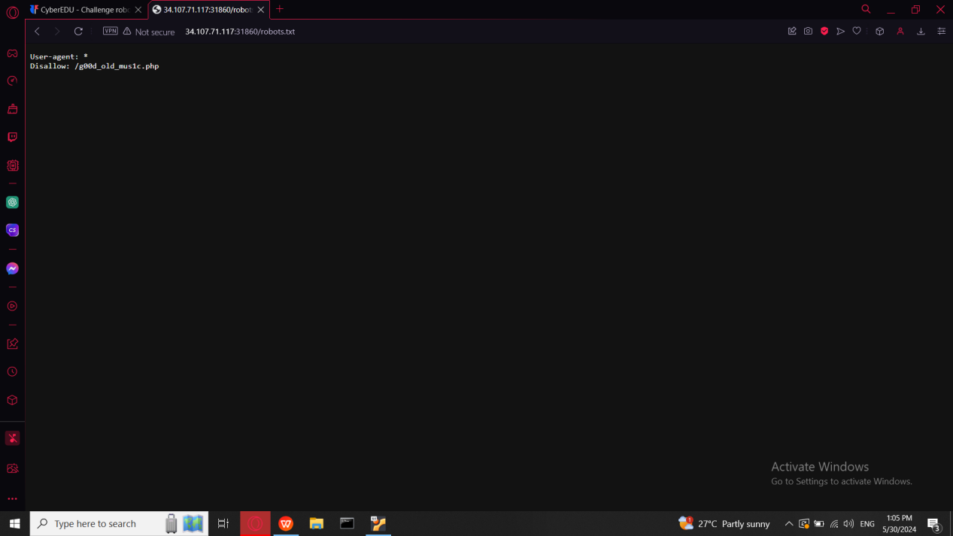

Then I also added /g00d_old_mus1c.php to the URL and get flag

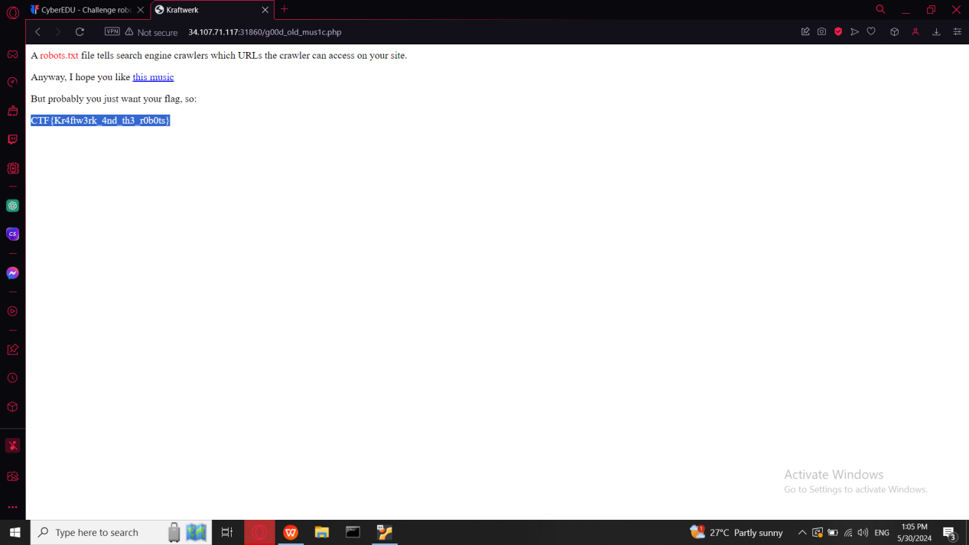

CTF{Kr4ftw3rk_4nd_th3_r0b0ts}