List of Contracts for {{company_name}}

{{company_city}}, {{company_country}}

**INFORMATION ABOUT THIS SAMPLE**

The purpose the document is to display all contracts that belong to a customer (account). The document is generated for an Account record. An Account has one or more contracts and a contract can have one or more lines. This data should exist to see the capabilities mentioned in this sample (You could use the same concept for other Salesforce objects such as quotes, order).

**This sample demonstrates the following capabilities**

1. This is an example of a 2 level display of repeating content. Here for an Account, there are many Contracts, and each Contract has many levels. Two nested repeating content tokens have been used **(#contracts and #items).** For every repeat of a contract, there are many repeats of a line item
2. The details about the Account are displayed on the first (cover) page. Information such as company name etc. are displayed using variable tokens such as **company_name.**
3. Every new contract is displayed on a new page. There is a *page break* within the outer **#contracts** loop. If a contract has no lines, then the following message is displayed “There are no products or services ordered as part of this contract”. The **#IF_contract_has_items** conditional token is used. The value passed to such and **#IF_** token as **token always has to be Boolean**. The evaluation of the condition that sets the token happens in the transform Dataraptor formula. The output data type has to be set to Boolean for this transformation.

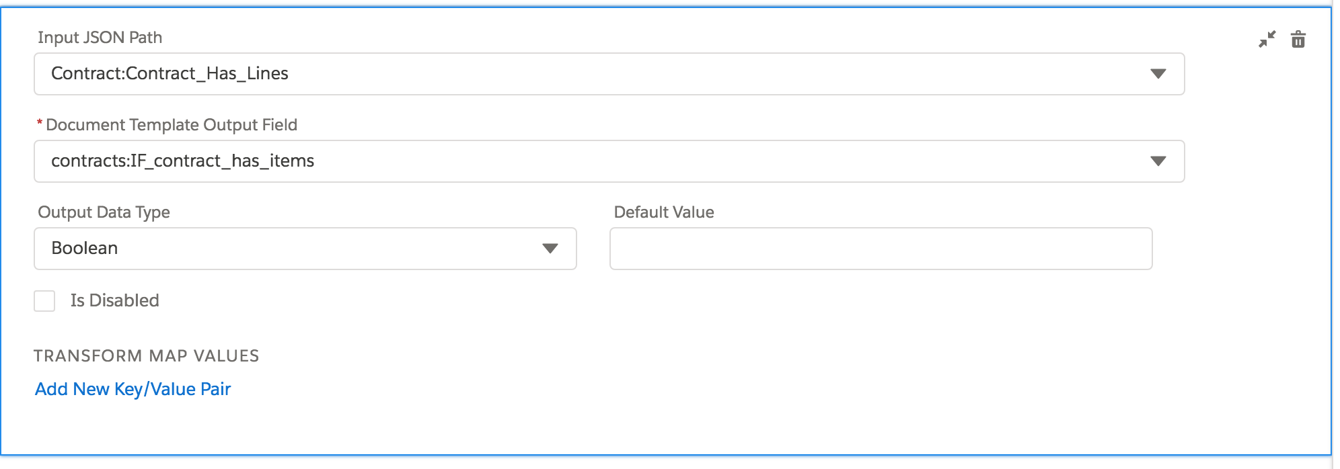

1. For each Contract, the list of contract items is display in a grid. If the product is a bundle, the top level items are shown in Blue and below that the lower level items are shown indented and in Red. This shows how conditional displays can be done, again using a **#IF_** conditional token within the **#items** repeating content. Here the **#IF_top_level** and **^IF_top_level** conditional tokens are used. If the line item is a top level in the bundle, this token has to be set to true. This happens in the transform Dataraptor formula. As for every #IF_ token, **the value passed has to be Boolean**.

{{#contracts}}

**Contract Number:** {{contractnumber}}({{term}} months)

**Start Date:** {{startdate}}

**Expires On:** {{enddate}}

{{#IF_contract_has_items}}

|  |  |  |  |
| --- | --- | --- | --- |
| **Product Name** | **Quantity** | **Monthly Recurring Charge** | **One Time Charge** |
| {{#item}} {{#IF_top_level}}{{name}} | {{qty}} | {{mrc}} | {{otc}} {{/IF_top_level}} |
| {{^IF_top_level}} {{name}} | {{qty}} | {{mrc}} | {{otc}} {{/IF_top_level}} {{/item}} |
|  |  | **{{mrc_total}}** | **{{otc_total}}** |

{{/IF_contract_has_items}}

{{^IF_contract_has_items}}There are no products or services ordered as part of this contract {{/IF_contract_has_items}}

{{/contracts}}