Project name : Volunteer hunt

- I am not sure what you mean by caregory so i can provide feedback
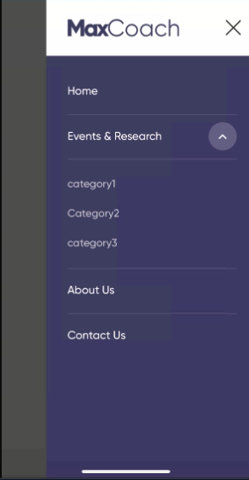

- I loves the home page. I will then give you some ‘about us-mission vision’ wording
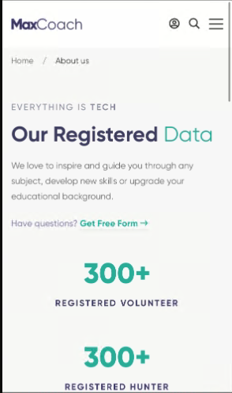

i would like to see a theme colour. In the mean while there is green, dark blue and purple. I would try other colours. I told you before i would love to see how the Maroon colour would look like?!

The other thing, when i first clicked on the link, i was taken to the registerarion/log in options rather than the home page

i think the home page should be the default with the ability to ‘browse and view’ the posts. Only those who wish to post a project should log in. Any visitor can hit the like (even if not registered). There will be an option for volunteers to register to see other features (maybe to see the contact details of the hunter) with a phrase like “ u must be registered to see contact details).

This is the main flow of work

u can always refer to the word file i sent about the project idea

would love to see different filters for event or research project

im thinking of ways to attract volunteers. Will update u about this point later

thanks a lot.

https://technomancy.in/hunter/login

https://technomancy.in/hunter/hunter-login

login page select login as hunter
hunter@gmail.com
password : test

and for admin
https://technomancy.in/hunter/admin

admin id : admin@gmail.com
password : test

