Youth Health Coach

**Software Project Management Plan**

**Group 3:**

Alexander Dao

Benjamin Carbaugh

Matthew Cole

Dylan Hubbs

Joseph Breen

Vince Lepatan

Cosc 412

**Update History**

|  |  |  |  |  |
| --- | --- | --- | --- | --- |
| **Version #** | **Revision**  **Date** | **Implemented by:** | **Approved By** | **Reason** |
| 1.0 | 02/18/2020 | Joseph Breen  Ben Carbaugh  Matthew Cole  Alexander Dao  Dylan Hubbs  Vince Lepatan | Alexander Dao | Create Use cases, Requirements, Create SPMP  Went over website ideas and goals with group members |
| 1.1 | 02/28/2020 | Dylan Hubbs  Alexander Dao | Alexander Dao | Domain bought; Theme selected for website. Create a registration/login screen for new users |
| 1.2 | 03/02/2020 | Matthew Cole  Alexander Dao | Alexander Dao | About page created  Homepage Setup with information about why we started the site  Create the first post to welcome incoming clients to the page |
| 1.3 | 03/09/2020 | Ben Carbaugh  Vince Lepatan | Alexander Dao | Game uploaded to the site. Added images to the site  Make website presentable for Mid-semester presentation |
| 1.4 | 3/25/2020 | Dylan Hubbs  Alexander Dao | Alexander Dao | Organized Website, logo added to website page and the login screen |
| 1.5 | 4/18/2020 | Ben Carbaugh | Alexander Dao | Created Nutrition, Health, Fitness page with facts |
| 1.6 | 4/19/2020 | Ben Carbaugh  Dylan Hubbs | Alexander Dao | Database Created to connect the score of the game to the user’s profile |
| 1.7 | 4/20/2020 | Joseph Breen  Dylan Hubbs | Alexander Dao | Added Advertisement and donation page(PayPal). |

**Preface: Scope and Purpose**

Results of a recent study commissioned by the US Dept of Health and Human Services (DHHS) reveal that teens today are more likely to develop a sustained interest in a healthy, active lifestyle if they are provided with some type of technology-based “game-like” tool to stimulate their interest in the areas.

Based on the results of this study, along with rapidly increasing public interest in health, the DHHS has made the decision to form the *Healthy Teen Healthy Life* committee or HTHL. The goal of this committee will be managing the creation of a technology-based, gaming tool to meet this need. The HTHL made the decision to hire Subject Matter Experts (SMEs) from various related industries including fitness, teaching, medical, health/nutrition and technology, to determine the initial needs of the product and lead this effort to fruition.

After months of planning the HTHL committee has secured funding for creation of a “revolutionary gaming-based website that educates while it stimulates young minds.” Initially the committee has decided to focus on high school aged teens and mobile devices however they have made it very clear that their final vision for the system is that it caters to children of all ages and able to be used on all popular devices.

**Table of Contents**

1. Introduction 5  
 1.1 Project Overview 5  
 1.2 Project Deliverables 5  
 1.3 Reference Materials 6  
 1.4 Definitions and Acronyms 6

2. Project Organization 6  
 2.1 Process Model 6

2.2 Organizational Structure 7  
 2.3 Organizational Interfaces 7  
 2.4 Project Responsibilities 7

3. Management Process 8  
 3.1 Management Objective 8  
 3.2 Assumptions, Dependencies, and Constraints 10  
 3.3 Risk Management 10  
 3.5 Monitoring and Controlling Mechanisms 10

4. Technical Process 11

4.1 Methods, Tools, and Techniques 11

4.2 Software Documentation 12

4.3 Project Support Functions 12

**Table of Contents (Cont..)**

5. Description of Work Packages 12

5.1 Work Breakdown Structure (WBS) 13

5.2 Gannt Chart 14

# **Part I: Introduction**

## 1.1 Project Overview

Develop a website that educates the youth of healthy and active lifestyle decisions. The website must provide users with an interactive game that stimulates interest in fitness, medicine, and healthy eating. The product will make use of the interest of the youth in game-like technology and pique their interest in a subject they might not necessarily choose to learn. Users will be able to play in single, team, and multiplayer modes on all platforms.

1.2 Project Deliverables

Create an educational website that incorporates a fun-interactive-learning game. The “game” will be a flash card game that will test the player on their knowledge on the following categories:

1. Fitness
2. Teaching
3. Medical
4. Health/Nutrition
5. Technology

**Project Deliverables:**

1. Requirements
   1. Due 2/18/2020 @ 5P.M.
   2. (Upload by) 5/1/2020 @ 5P.M.
2. Use Cases
   1. Due 2/18/2020 @ 5P.M.
   2. (Upload by) 5/1/2020 @ 5P.M.
3. Repo Setup
   1. Due 2/21/2020 @ 5P.M.
4. SPMP
   1. Due 2/25/2020 @ 5P.M. (Part 1)
   2. (Upload by) 5/1/2020 @ 5P.M.
5. Test Skeleton
   1. Due 3/10/2020 @ 5P.M.
   2. (Upload by) 5/1/2020 @ 5P.M.
6. Code Review (1,2,3)
   1. Due 5/1/2020 @ 5P.M.
   2. (Upload by) 5/1/2020 @ 5P.M.
7. Mid-Semester Presentation
   1. Due 3/24/2020
   2. (Upload by) 5/1/2020 @ 5P.M.
8. Deployment plan
   1. 4/8/2020 @ 5P.M.
   2. (Upload by) 5/1/2020 @ 5P.M.
9. All documents, Reviewed and complete
   1. Due 5/1/2020 @ 5P.M.
10. Project Presentation
    1. Due 5/19/2020 @ 7P.M.

1.4 Reference Materials

1.5 Definitions and Acronyms

SPMP: Software Project Management Plan

DHHS: Department of Health and Human Services

HTHL: Healthy Teen Healthy Life Committee

# **Part II: Project Organization**

## 2.1 Process Model

Users will be able to create an account on the website. Users can have their processes saved and can pick up where they left off on their game.

## 2.2 Organizational Structure

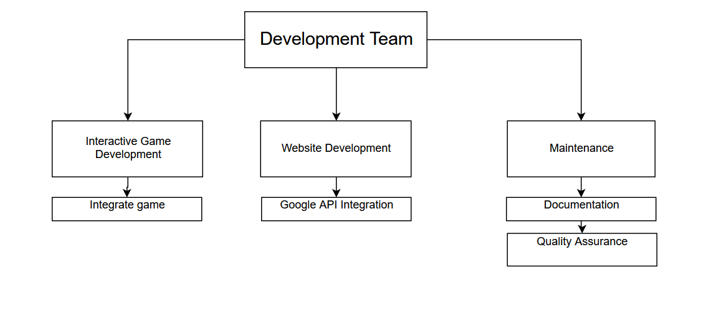

## 2.3 Organizational Interface

Visual Paradigm Online (<https://online.visual-paradigm.com/>) software used to create organizational structure and WBS.

## 2.4 Project Responsibilities

|  |  |  |
| --- | --- | --- |
| Role | Description | Person |
| Project Manager  Point of Contact | * Motivate team members to complete tasks * Ensure contribution of all team members * Find new tasks to add to agenda | Alexander Dao |
| Planning Manager | * Organize schedule for project * Declare deadlines for tasks to be completed * Determine who does what task | Matthew Cole |
| Game Development Manager | * Provide overview and details of the game * Create roles/tasks for each aspect of the game * Research and implement game features * Delegate tasks to other developers | Ben Carbaugh |
| QA/Process Manager | * Lead team in quality assurance plan * Alert team of quality problems * Establish quality development standards * Act as inspector and recorder of project specifications | Dylan Hubbs |
| Support Manager | * Guide team in all aspects of support * Help with tasks that other managers need assistance on | Joseph Breen |
| Documentation Lead | * Lead team in full documentation of project * Monitor and record all resources used * Record budget of the product | Vince Lepitan |

# **Part III: Management Process**

The management of the software project includes four focus areas. The first area is where we define our objectives and priorities. The second area focuses on the assumptions, dependencies, and constraints of the project itself. The third area will focus on the risk management of the process. Lastly, the final area will focus on monitoring and controlling for reporting.

## 3.1 The Management Objectives

The main objective of working on this software project is that everyone does their jobs on time and everyone puts in the same amount of effort as the other individual.

The project schedule below presents a listing of tasks, activities, and deliverables associated with the planning and requirements gathering stages for this project. In developing this software, it is difficult to have detailed tasks and activities at this stage of development. As of 4/29/2020, out current schedule is laid out as follows:

|  |  |  |
| --- | --- | --- |
| Phase | Project Deliverables | Due |
| Initial Structuring | * Brainstorm ideas for fun-yet-educational games for website * Purchase Domain * Create schedule * Set up Repo   + https://github.com/adao1220/Cosc412_Group3 | 2/30/2020 |
| Paste 1- Software Development | * Begin coding website/game * Understand what the core functionalities are that are necessary. * Get the game up and running for beta uses * Code should comply to all guidelines * Make sure Requirements are met and up-to-date * Use case followed |  |
| Phase 1- Testing | * Testing the website for possible bugs * Check that all core functionalities of the website are up and running * Make sure the website complies with all of the guidelines given by the group members | Mid Semester Presentation 3/24/2020 |
| Phase 2- Software Development | * Update coding for bugs found in Testing * Get response from Test players * Code should comply to all guidelines * Create a registration/login page for different users |  |
| Paste 2- Testing | * Testing the website for possible bugs * Check that all core functionalities of the website are up and running * Make sure the website complies with all of the guidelines given by the group members | 4/30/2020 |
|  | * Finalize all paperwork   + Software Project Management Plan   + Requirements   + Use Case   + Test Skeleton   + Code Review   + Deployment Plan | 5/1/2020 |
| Phase 3 Final | * Prototype Presentation | Final Presentation  5/19/2020 |

## 3.2 Assumptions, Dependencies, and constraints

**Assumptions:**

* Deliverables/tasks are completed on time for each member
* All programs and edits to the website will work properly
* Everything that was tested and complete were documented
* Weekly meetings every Tuesday after classes to make sure everyone is on track

**Dependencies:**

* Game (that Ben and Vince are creating) must be implemented before other things are set.

**Constraints:**

* Meeting with one another during coronavirus pandemic
* Group Project due 5/1/2020
* Cost- $49.99/year (BlueHost)

## 3.3 Risk Management

**Contingency planning**

1. If the client wants to add another game to the site OR if the client doesn’t approve of the educational level of the game.
   1. (Option 1) Create a Jeopardy game style system that will test the user with other players
   2. (Option 2) re-design the flash card game to make it more interactive
2. Client believes that the flash card game is too easy or difficult for the target audience of high school
   1. Redesign the game/course to better suit the “player”
3. If the client doesn't like the design of the website
   1. If there is time before the release date, as client for what their website would like to look like. Look for templates that will match what the client feels fits their vision.

## 3.4 Monitoring and Controlling for Reporting

GitHub, storing a separate folder on desktop for back-up.

# **Part IV: Technical Process**

## 4.1 Methods, Tools and Techniques

Methods:

* An Agile model was used to best accommodate for the changes in requirements so the design can be updated accordingly.

Tools:

* Wordpress.org
* Agile
* Host (BlueHost.com)
* Elementor
* Updraftplus
* wpDataTable

Techniques:

* Used WordPress HTML/CSS to develop the website
* Used JavaScript, HTML, and CSS to create game
* Testing all components of the game through all stages of development from initial coding to implementation
* Continued documentation of the project to include team meeting notes, deadlines, expected time of delivery, and level of effort (LOE)
* Modify our deliverables as new requirements and unanticipated problems occur through the developmental process
* Continued maintenance after initial implementation to ensure all bugs are patched

## 4.2 Software Documentation

All of the updated documentation will be located on page 2. This will have a detailed description of what was changed and the date that it was completed.

## 4.3 Project Support Functions’

Plans for the project’s support functions. The website will need all of the following in order to create a fun and interactive game for youth that educates them about healthy lifestyle decisions.

**Quality Assurance:**

* Update history
* Weekly reviews with Team Members (generally Tuesday @ 10P.M)
* Constant review of website to ensure website is functional
* Verify each plugin is up-to-date and will not crash the website
* Screen for bugs in the system before deployment
* Ensure database is up-to-date and viewable on the user end
* Deploy a test to evaluate the user experience and record any issues that may occur
* Correct any errors or bugs that may occur during testing

**Configuration Management Plan:**

* Verify each plugin is up-to-date and will not crash the website
* Screen for bugs in the system before deployment

**Verification and Validation Plan:**

* Test website every other day and check if all plugins are up-to-date
* Make sure all plugins work after every update

# **Part V: Description of Work Packages**

## 5.1Work Breakdown Structure (WBS)

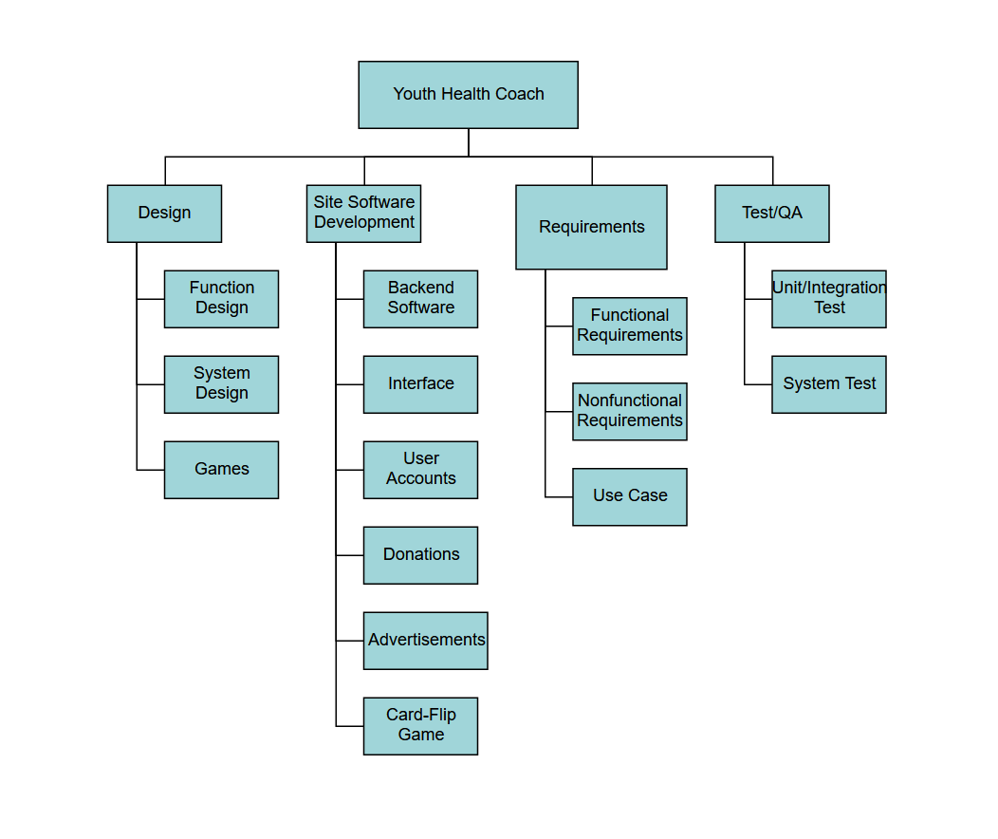

## 5.2Gantt Chart

