**Assignment 3-2: Design Sprint Day 1**

**Trello Link** [**https://trello.com/invite/b/1HiY3mWu/8394247864fa5eefe7a4ae6adaaca38a/assignment-3-2-design-sprint-day-1**](https://trello.com/invite/b/1HiY3mWu/8394247864fa5eefe7a4ae6adaaca38a/assignment-3-2-design-sprint-day-1)

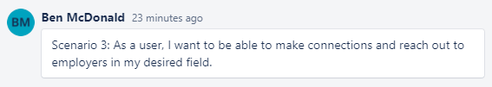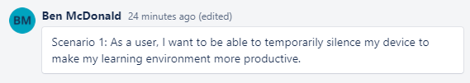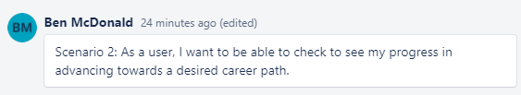**Scenarios**

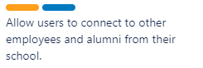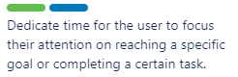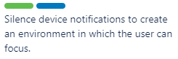**User Stories**

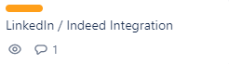**Feature List**

