**Restaurant Review Web API and Client**

There are two projects in this module. I have developed these two projects using Visual Studio Community 2017.

* RestaurantReviewAPI which acts as service/server to provide API.
* RestaurantWebClient is a console application which consumes API provided by RestaurantReviewAPI.

Set up required to run this successfully:

* RestaurantReviewAPI has DatabaseScript folder which contains script to create database. SQL server used in this project is SQL EXPRESS.

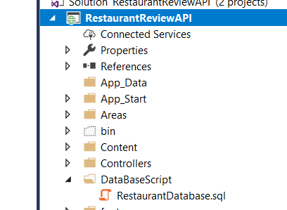

* Running RestaurantDatabase.sql script will create schema with data.
* Verify Web.Config connection string in RestaurantReviewAPI to reflect correct sql server name.

<connectionStrings>

<add name="RestaurantReviewEntities" connectionString="metadata=res://*/RestaurantReviewEntities.csdl| res://*/RestaurantReviewEntities.ssdl| res://*/RestaurantReviewEntities.msl;provider=System.Data.SqlClient;provider connection string=&quot;data source=**HP-PAVILION-15\SQLEXPRESS**;initial catalog=RestaurantReview;integrated security=True;multipleactiveresultsets=True;application name=EntityFramework&quot;" providerName="System.Data.EntityClient" />

</connectionStrings>

* Verify Project URL property and update it in the RestaurantReviewAPI project.

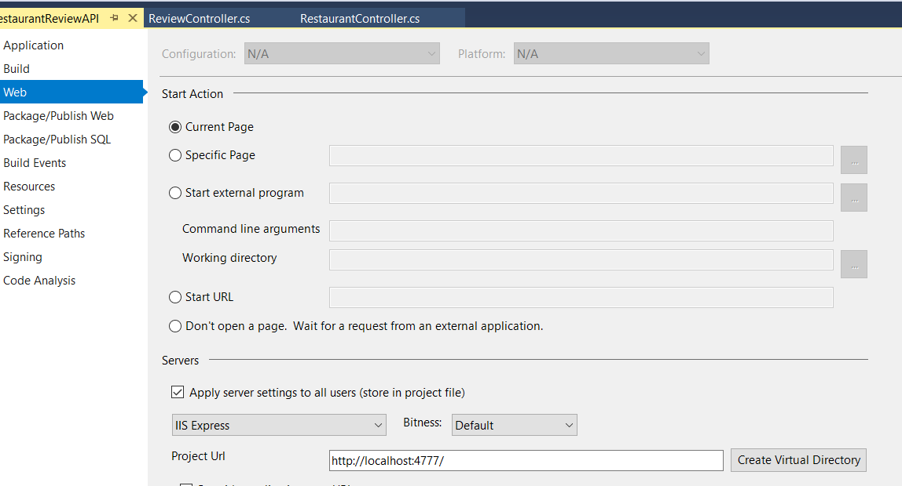

* Lastly you will need to verify Appsettings key in App.config of RestaurantReviewWebClient. This should match with what is set above.

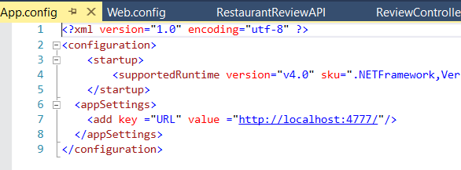

* To run this module first press F5 which will start the service. Right click on RestaurantReviewWebClient Project select Debug and start new instance.

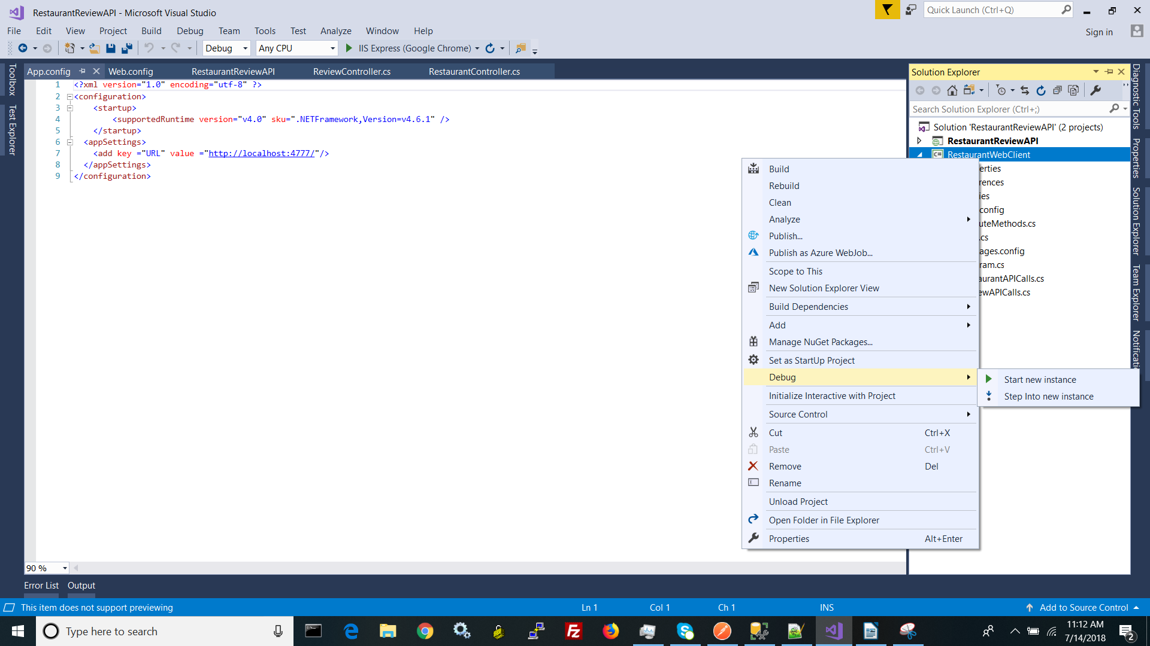

Here are working screen shots of the RestaurantWebClient

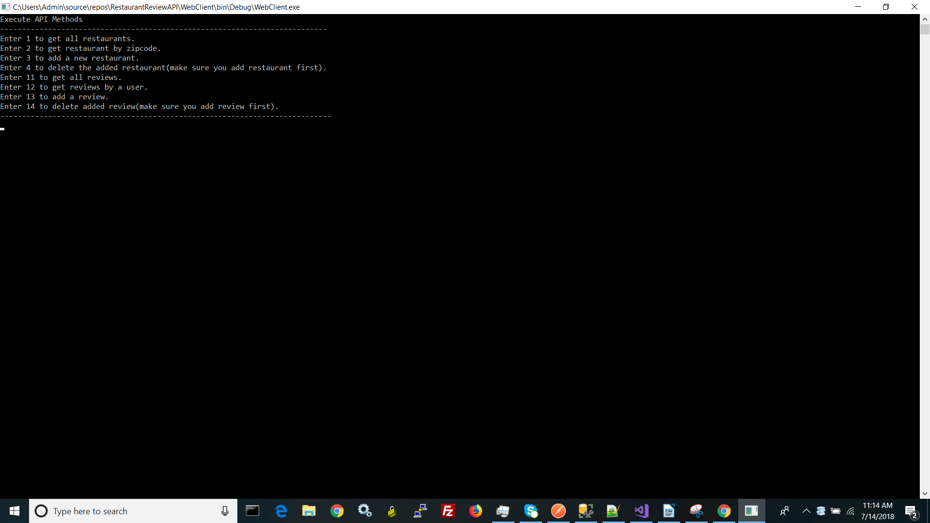

List of all restaurants

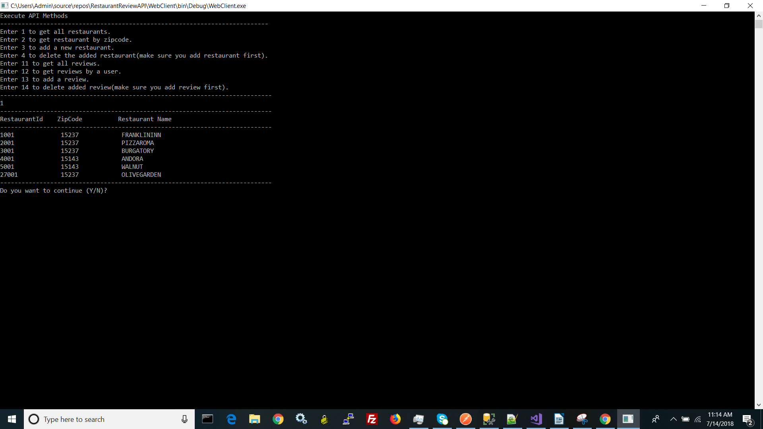

List of restaurants by zip codes

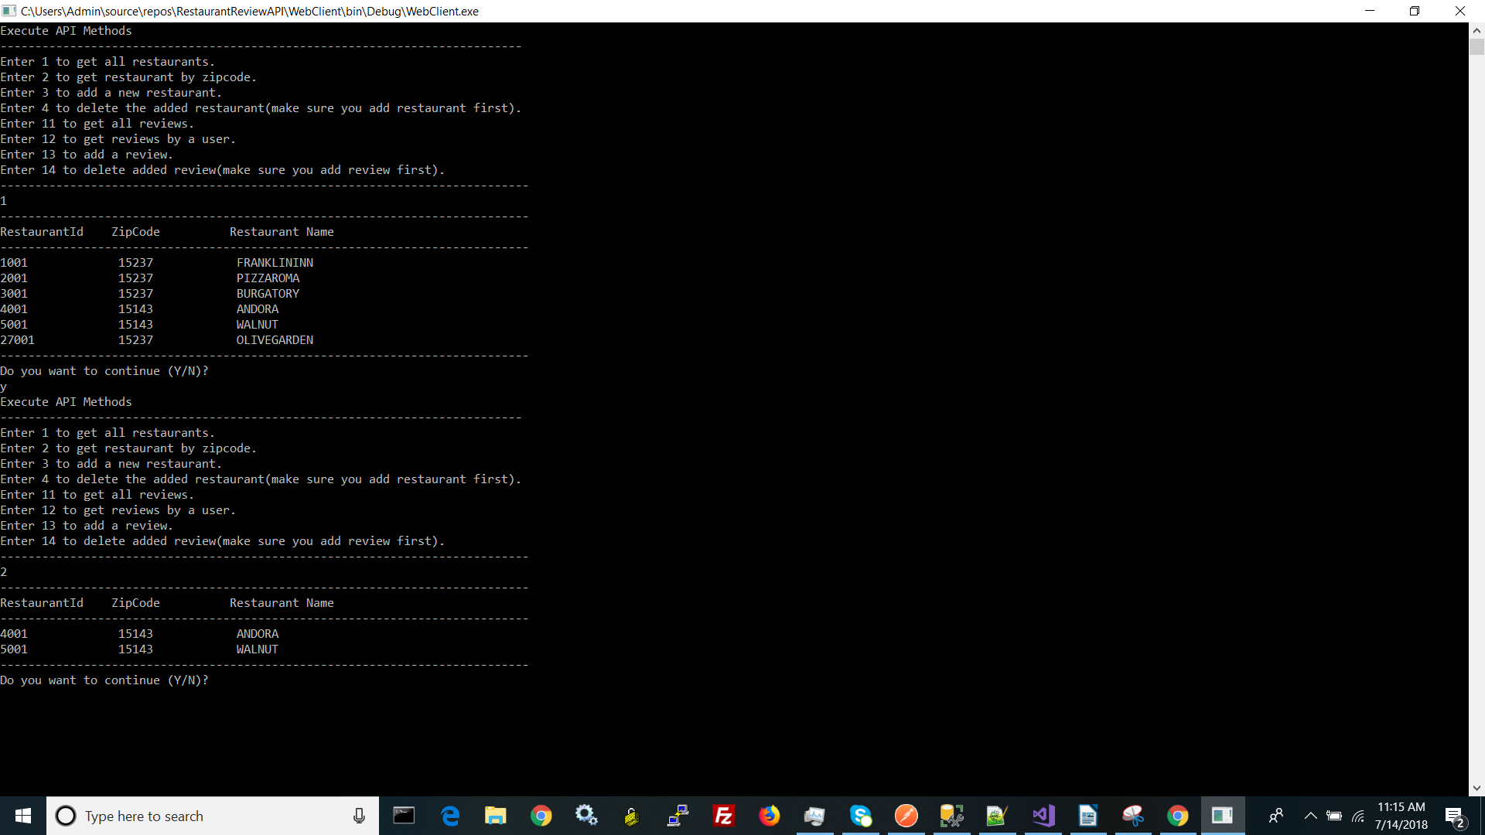

List of all the reviews

