CprE 381: Computer Organization and Assembly-Level Programming

Project Part 1 Report

Team Members: __Camden Fergen__

__Emil Kosic__

Project Teams Group #: __Group 2__

Refer to the highlighted language in the project 1 instruction for the context of the following questions.

[Part 1 (d)] Include your final MIPS processor schematic in your lab report.

[Part 2 (a.i)] Create a spreadsheet detailing the list of M instructions to be supported in your project alongside their binary opcodes and funct fields, if applicable. Create a separate column for each binary bit. Inside this spreadsheet, create a new column for the N control signals needed by your datapath implementation. The end result should be an N*M table where each row corresponds to the output of the control logic module for a given instruction.

Given in Proj1_control_signals(1)WORKING.xlsx

Control Logic

[Part 2 (a.ii)] Implement the control logic module using whatever method and coding style you prefer. Create a testbench to test this module individually and show that your output matches the expected control signals from problem 1(a).
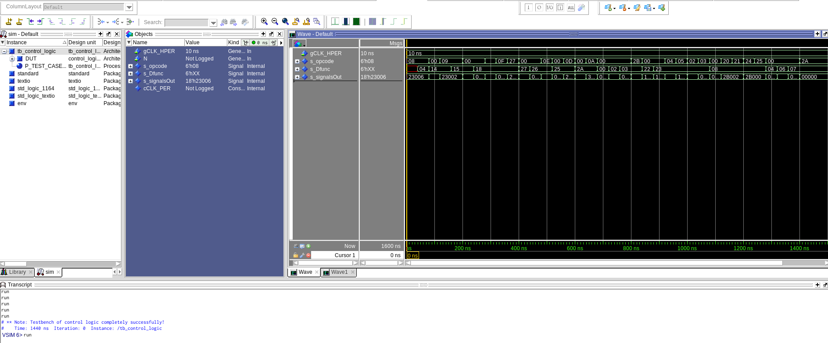
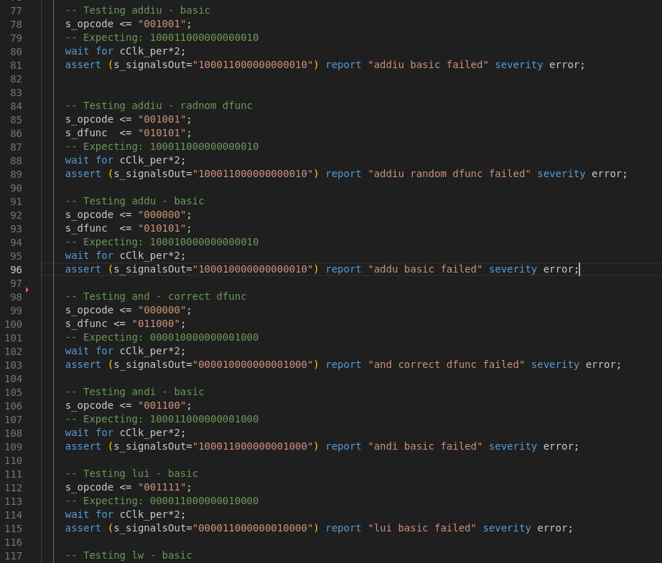
You can see in these two images that all tests did in fact pass, since the console did not report any errors when running through all the tests. The assert lines are the exact same as found in the control signals spreadsheet

Fetch Logic

[Part 2 (b.i)] What are the control flow possibilities that your instruction fetch logic must support? Describe these possibilities as a function of the different control flow-related instructions you are required to implement.

The control logic that the fetch must implement are as follows: inBranchLogic (calculated in a high level box depending on branch equals and branch not equals), jump logic, and jump register logic.

[Part 2 (b.ii)] Draw a schematic for the instruction fetch logic and any other datapath modifications needed for control flow instructions. What additional control signals are needed?
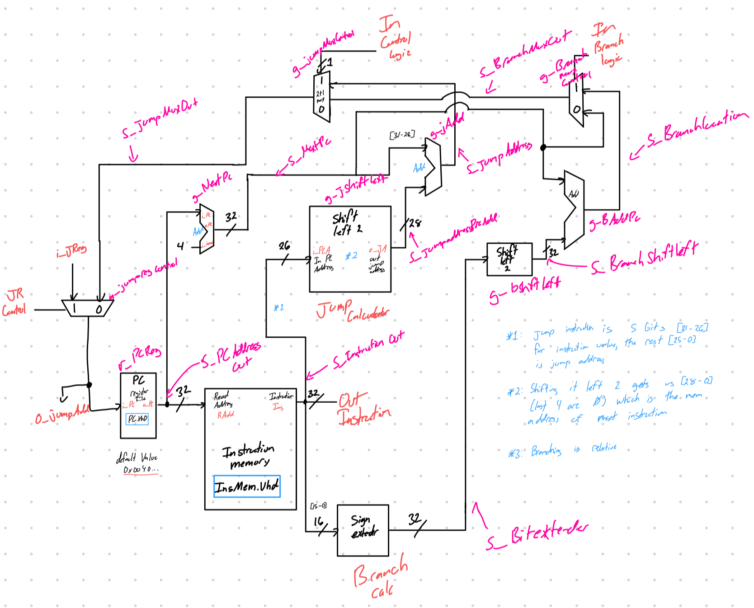

[Part 2 (b.iii)] Implement your new instruction fetch logic using VHDL. Use QuestaSim to test your design thoroughly to make sure it is working as expected. Describe how the execution of the control flow possibilities corresponds to the QuestaSim waveforms in your writeup.
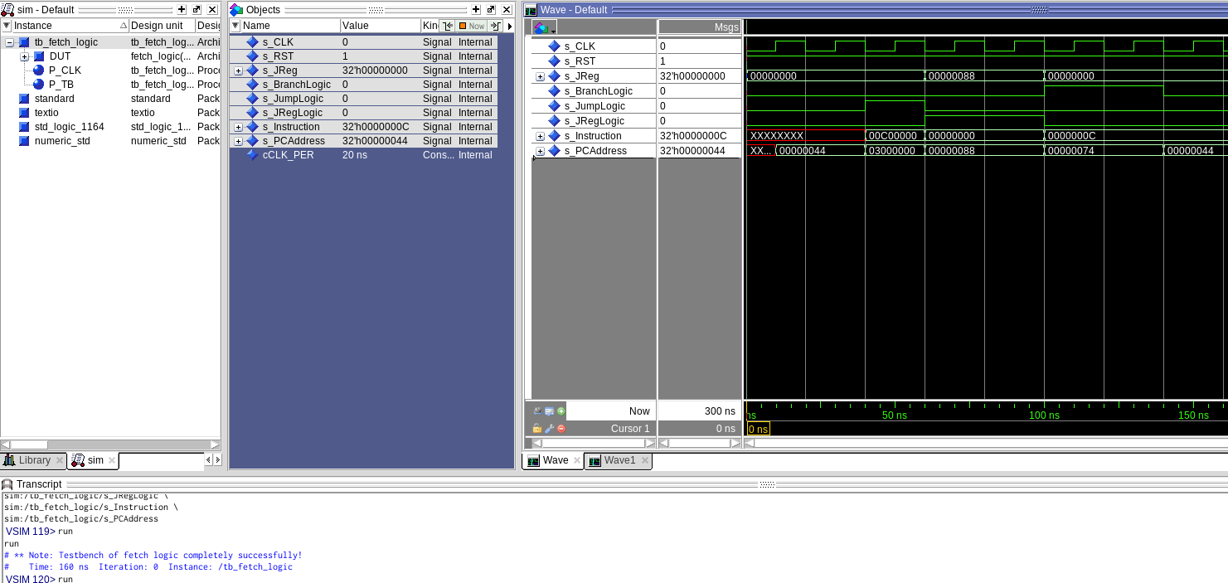
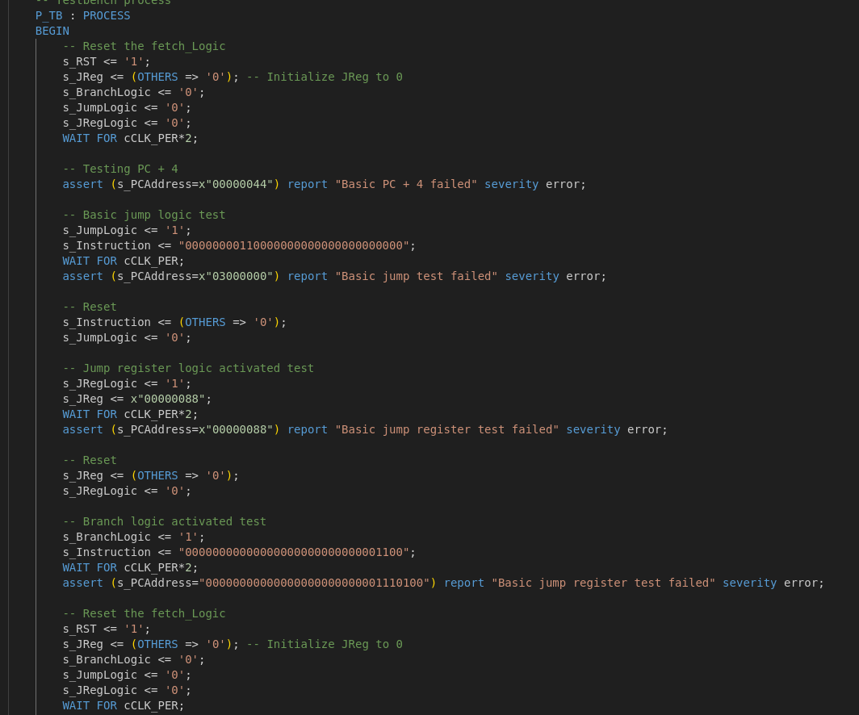
In these two images you can see that the fetch logic is performing correctly since it does not report any errors when running the test bench file in the console. The instructions were calculated by hand using the diagram above to ensure that the output would match what was expected.

ALU

[Part 2 (c.i.1)] Describe the difference between logical (srl) and arithmetic (sra) shifts. Why does MIPS not have a sla instruction?
The difference between srl and sra is that when doing srl, it shifts the amount to the right, adding a 0 to the left most side filling in empty spots. Sra shifts the number to the right, but wraps around, for example if you have 1001 and you sra it then you would get 1100. If you did 1001 with srl you would get 0100.
The reason that MIPS does not have sla is because you can instead use sra to shift it the same amount, by doing the max bit size (32) – the shift amount. This will result in the same answer.

[Part 2 (c.i.2)] In your writeup, briefly describe how your VHDL code implements both the arithmetic and logical shifting operations.

[Part 2 (c.i.3)] In your writeup, explain how the right barrel shifter above can be enhanced to also support left shifting operations.

[Part 2 (c.i.4)] Describe how the execution of the different shifting operations corresponds to the QuestaSim waveforms in your writeup.

[Part 2 (c.ii.1)] In your writeup, briefly describe your design approach, including any resources you used to choose or implement the design. Include at least one design decision you had to make.
My design approach for the ALU was to create a well thought out design of the ALU in paper, including what signals would be needed and approximately how many, after studying the green sheet. Other than the green sheet being used, and looking at how the ALU signals were used in the Zybook, I created the rest of it without any other resources. One design decision to used in making the ALU was to create everything using as much structural VHDL as possible, this is because if I can draw the ALU out on paper it would be extremely easy to understand and keep track of the many operations and eliminate future issues. The payoff of doing this was extremely high, once the ALU was added inside, with extensive test benches as a safe measure, no issues were found with it and all operations performed their needed tasks. Other than a one or 2 data flow and behavioral sub components, the entire ALU was created using structural VHDL.
[Part 2 (c.ii.2)] Describe how the execution of the different operations corresponds to the QuestaSim waveforms in your writeup.

[Part 2 (c.iii)] Draw a simplified, high-level schematic for the 32-bit ALU. Consider the following questions: how is Overflow calculated? How is Zero calculated? How is slt implemented?
Overflow is calculated using Cin of the last bit of the ripple carry adder and the final carry out of the same carry ripper adder. These 2 signals are then put into an xor gate, if the output is 1 then there is overflow, if not there is no overflow, a separate mux after this output is used to enable and disable overflow detection, which is also located inside the ALU. Zero is calculated by taking the output of the adder/subtractor unit in the ALU and then putting it inside a 32 bit or gate, then the output of this OR gate gets put inside an inverter gate. The output of the inverter gate is then zero value. SLT is implemented using behavioral vhdl by taking the data output of the adder/subtractor unit. This output is then compared, if the output is greater than or equal 0 and if the number is not negative then SLT will output 0, else it will output 1.
[Part 2 (c.v)] Describe how the execution of the different operations corresponds to the QuestaSim waveforms in your writeup.

[Part 2 (c.viii)] justify why your test plan is comprehensive. Include waveforms that demonstrate your test programs functioning.

Testing

[Part 3] In your writeup, show the QuestaSim output for each of the following tests, and provide a discussion of result correctness. It may be helpful to also annotate the waveforms directly.

[Part 3 (a)] Create a test application that makes use of every required arithmetic/logical instruction at least once. The application need not perform any particularly useful task, but it should demonstrate the full functionality of the processor (e.g., sequences of many instructions executed sequentially, 1 per cycle while data written into registers can be effectively retrieved and used by later instructions). Name this file Proj1_base_test.s.

[Part 3 (b)] Create and test an application which uses each of the required control-flow instructions and has a call depth of at least 5 (i.e., the number of activation records on the stack is at least 4). Name this file Proj1_cf_test.s.

[Part 3 (c)] Create and test an application that sorts an array with N elements using the BubbleSort algorithm (link). Name this file Proj1_bubblesort.s.

Synthesis

[Part 4] Report the maximum frequency your processor can run at and determine what your critical path is. Draw this critical path on top of your top-level schematic from part 1. What components would you focus on to improve the frequency?

