CprE 381: Computer Organization and Assembly-Level Programming

Project Part 1 Report

Team Members: __Camden Fergen__

__Emil Kosic__

Project Teams Group #: __Group 2__

Refer to the highlighted language in the project 1 instruction for the context of the following questions.

[Part 1 (d)] Include your final MIPS processor schematic in your lab report.

[Part 2 (a.i)] Create a spreadsheet detailing the list of M instructions to be supported in your project alongside their binary opcodes and funct fields, if applicable. Create a separate column for each binary bit. Inside this spreadsheet, create a new column for the N control signals needed by your datapath implementation. The end result should be an N*M table where each row corresponds to the output of the control logic module for a given instruction.

Given in Proj1_control_signals(1)WORKING.xlsx

[Part 2 (a.ii)] Implement the control logic module using whatever method and coding style you prefer. Create a testbench to test this module individually and show that your output matches the expected control signals from problem 1(a).
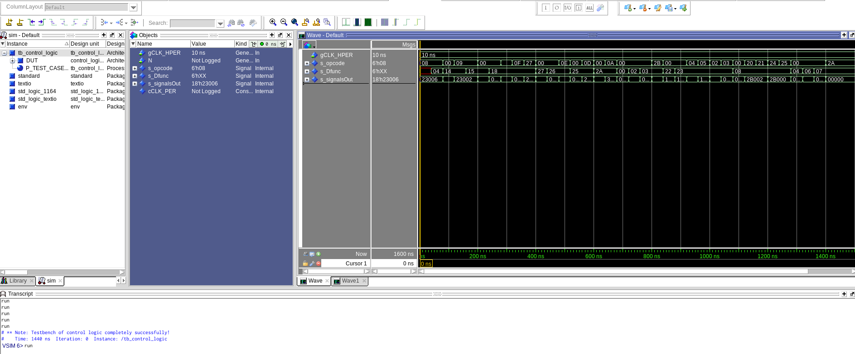
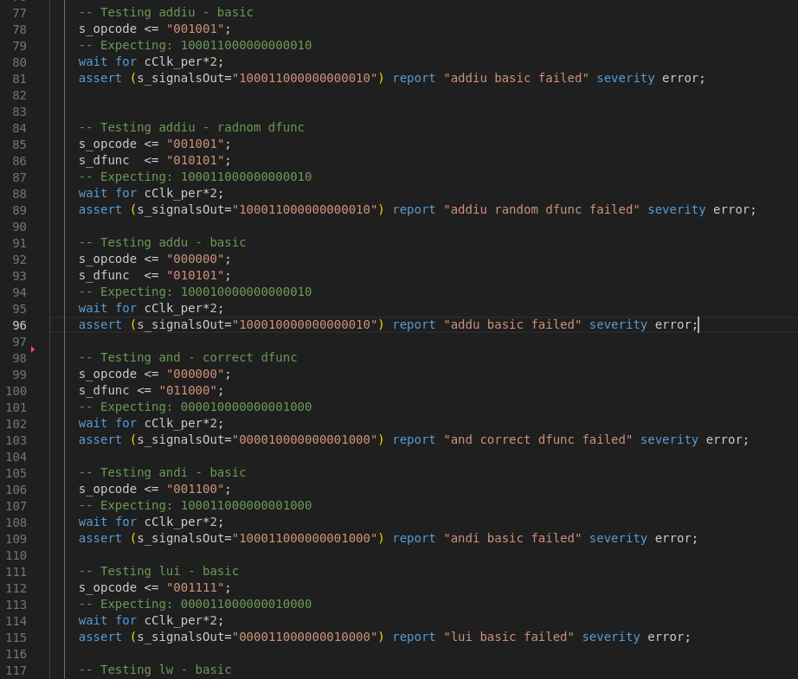
You can see in these two images that all tests did in fact pass, since the console did not report any errors when running through all the tests. The assert lines are the exact same as found in the control signals spreadsheet

[Part 2 (b.i)] What are the control flow possibilities that your instruction fetch logic must support? Describe these possibilities as a function of the different control flow-related instructions you are required to implement.

sdf

[Part 2 (b.ii)] Draw a schematic for the instruction fetch logic and any other datapath modifications needed for control flow instructions. What additional control signals are needed?
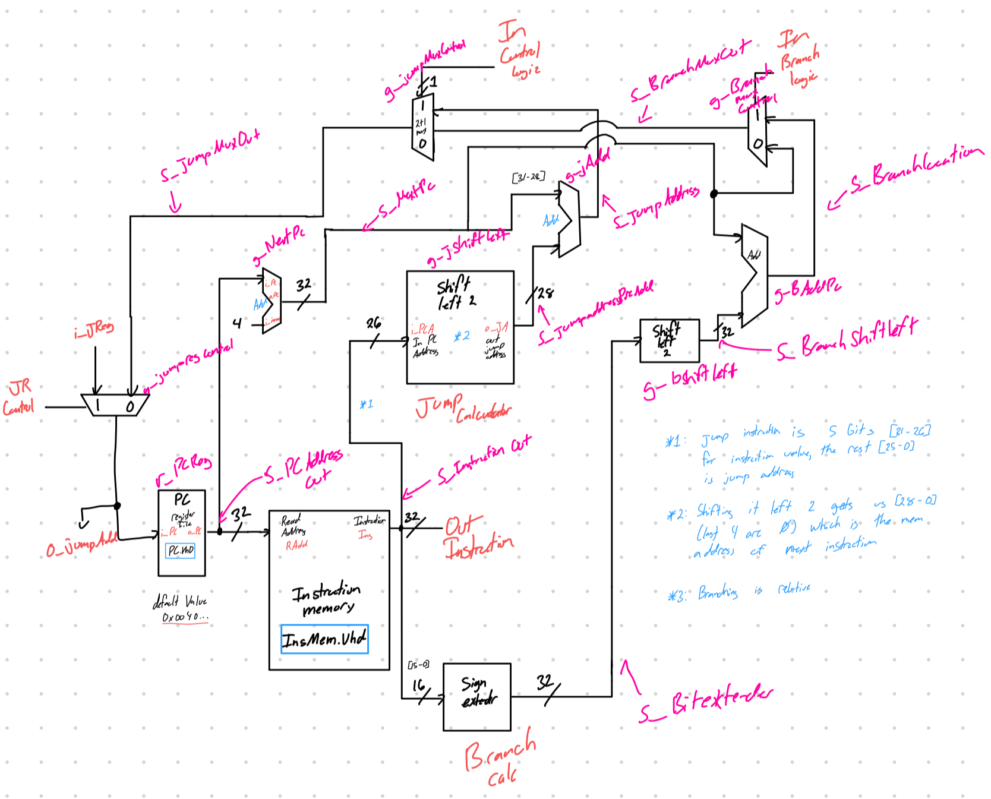

[Part 2 (b.iii)] Implement your new instruction fetch logic using VHDL. Use QuestaSim to test your design thoroughly to make sure it is working as expected. Describe how the execution of the control flow possibilities corresponds to the QuestaSim waveforms in your writeup.
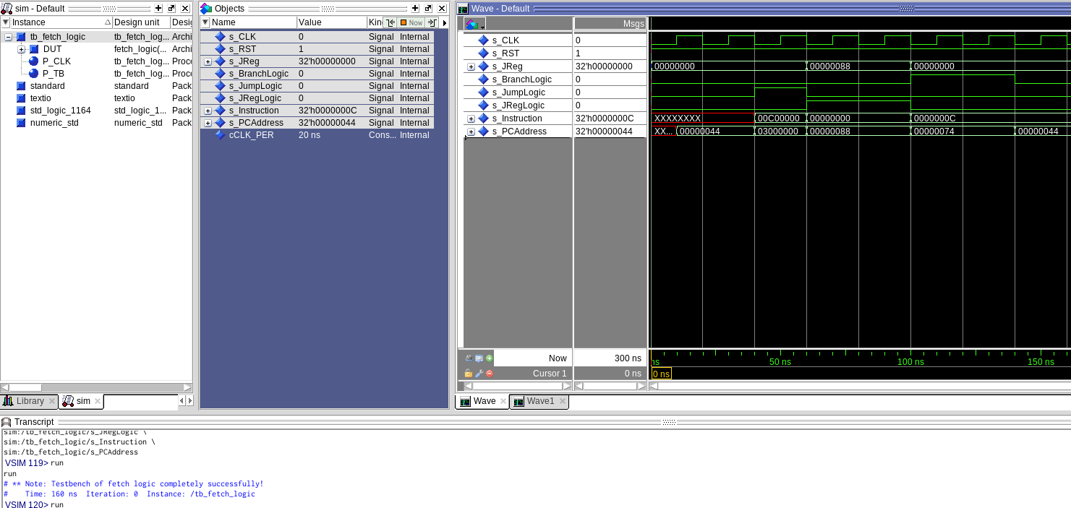
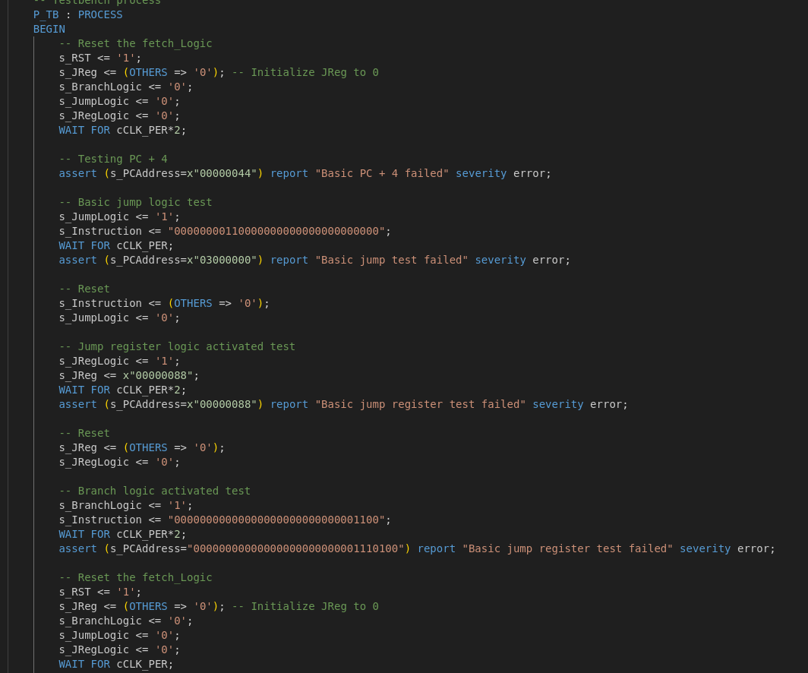
In these two images you can see that the fetch logic is performing correctly since it does not report any errors when running the test bench file in the console. The instructions were calculated by hand using the diagram above to ensure that the output would match what was expected.

[Part 2 (c.i.1)] Describe the difference between logical (srl) and arithmetic (sra) shifts. Why does MIPS not have a sla instruction?

[Part 2 (c.i.2)] In your writeup, briefly describe how your VHDL code implements both the arithmetic and logical shifting operations.

[Part 2 (c.i.3)] In your writeup, explain how the right barrel shifter above can be enhanced to also support left shifting operations.

[Part 2 (c.i.4)] Describe how the execution of the different shifting operations corresponds to the QuestaSim waveforms in your writeup.

[Part 2 (c.ii.1)] In your writeup, briefly describe your design approach, including any resources you used to choose or implement the design. Include at least one design decision you had to make.

[Part 2 (c.ii.2)] Describe how the execution of the different operations corresponds to the QuestaSim waveforms in your writeup.

[Part 2 (c.iii)] Draw a simplified, high-level schematic for the 32-bit ALU. Consider the following questions: how is Overflow calculated? How is Zero calculated? How is slt implemented?

[Part 2 (c.v)] Describe how the execution of the different operations corresponds to the QuestaSim waveforms in your writeup.

[Part 2 (c.viii)] justify why your test plan is comprehensive. Include waveforms that demonstrate your test programs functioning.

[Part 3] In your writeup, show the QuestaSim output for each of the following tests, and provide a discussion of result correctness. It may be helpful to also annotate the waveforms directly.

[Part 3 (a)] Create a test application that makes use of every required arithmetic/logical instruction at least once. The application need not perform any particularly useful task, but it should demonstrate the full functionality of the processor (e.g., sequences of many instructions executed sequentially, 1 per cycle while data written into registers can be effectively retrieved and used by later instructions). Name this file Proj1_base_test.s.

[Part 3 (b)] Create and test an application which uses each of the required control-flow instructions and has a call depth of at least 5 (i.e., the number of activation records on the stack is at least 4). Name this file Proj1_cf_test.s.

[Part 3 (c)] Create and test an application that sorts an array with N elements using the BubbleSort algorithm (link). Name this file Proj1_bubblesort.s.

[Part 4] Report the maximum frequency your processor can run at and determine what your critical path is. Draw this critical path on top of your top-level schematic from part 1. What components would you focus on to improve the frequency?

