**Lab 02 Report**

**LAB 2**

**SECTION 2**

**Camden Fergen**

**SUBMISSION DATE:**

**02/01/2022**

# Problem 1

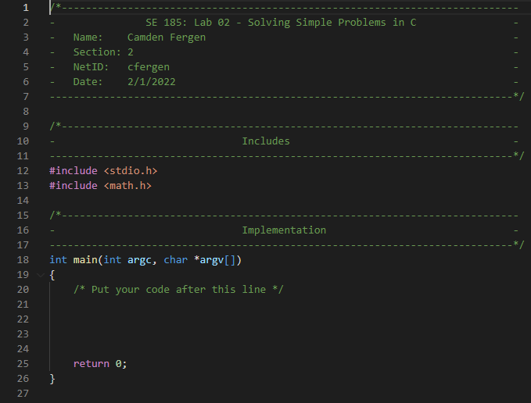

Not really sure what to add besides this picture for problem 1.

# Problem 2

Problem 2 was really easy, copy and pasting the code doesn’t work due to the “” converting to curly ones which don’t work in c. See picture #1 for this.

To change it to calculate a cube, you just had to add a variable z and then multiply the answer with the z variable as well. See picture #2.

# Problem 3

Problem 3 source code came with errors inside of it. I will list them off starting from the top to bottom numbering them 1-3:

**Error 1:** The first error is dividing a number that would result in a decimal using integer math, which does not have decimals.

**Error 2:** The second error is not defining the variable you are printing. In this case the printf includes the %d which is correct but doesn’t include the `, integer_result` that would be needed to print it correctly.

**Error 3:** The third error is that they are using the wrong %letter to print it. It was printing the double as an integer, resulting in it being a big number. To fix this you would need to do %f instead of %d.

You can find a screenshot of the corrected code under picture #3

# Problem 4

The first problem that differs from normal arithmetic is problem C. Problem C is using int, which drops off the decimals making it off by 0.4. The second problem that differs is problem F. The reason it differs is because it is again using int instead of double which leaves off the 0.44 again. Problem G is also wrong, but not for not using the correct double variable. This time it is only using ints to do the math, which results in only a int answer. Problem H also does the same thing as problem G. Problem J is wrong because it is using a int instead of double, resulting in leaving off the decimal places again.

You can find a screenshot of the code under picture #4

# Problem 5

See picture #5. I had a little trouble with this one as I kept forgetting to use the %lf! Haha.

# Screen Shots

**Picture 1:**

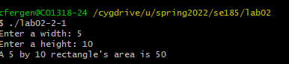

**Picture 2:**

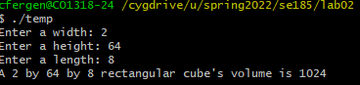

**Picture 3:**

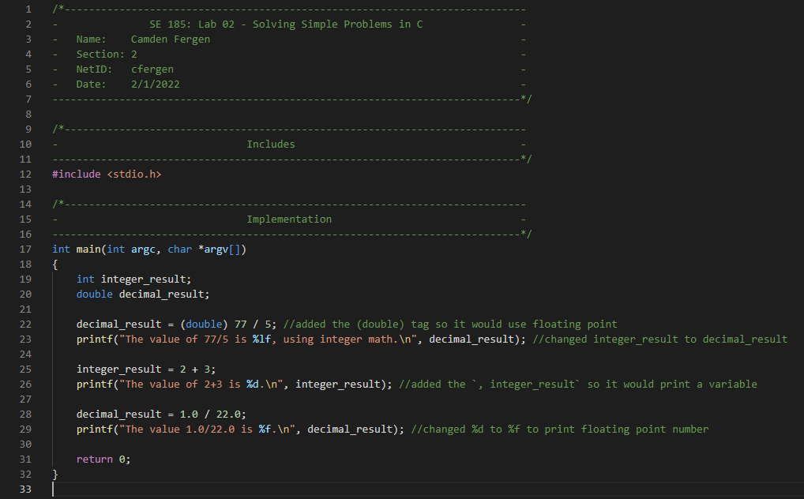

**Picture 4:**

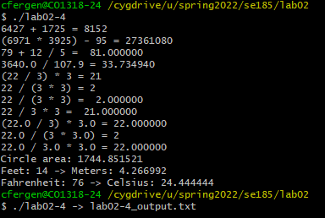

**Picture 5:**

