**LAB03 REPORT**

**LAB 3**

**SECTION 2**

**FULL NAME**

**CAMDEN FERGEN**

**SUBMISSION DATE:**

**2/8/2022**

**DATE**

**2/8/2022**

# Problem

Problem 1:

The first problem we had was recording some data using the program and then outputting it into a .cvs file so that we could make graphs with it. The hardest part of this was getting the graphs to be made correctly for some reason. Refer to SC #3-5 for pictures of the graphs.

Problem 2:

This one we had to take the input of of time as well as xyz inputs from the controller. This was done through a scanf. We had to modify the given program so that it would ouput in minuets seconds and ms and then the magnitude which was calculated using some functions and also using math.h pow and sqrt functions. This problem wasn’t that bad besides knowing how to convert ms to mins seconds and then ms. Check SC#1 for the outputs.

Problem 3:

In problem 3 we had to create a program from the skeleton code given. We had to get the input of the buttons from the controller in the 0,0,0,0 format, and then output how many buttons were being pressed from a function we created. This wasn’t that bad and the function wasn’t needed in my programming, but it is most likely useful for other students to try and understand them better. Check SC#2 for the outputs.

# Comments

This lab was pretty fun, the only difficulty that I had was in getting the controller to work with the software, which was no one’s fault.

# Screen Shots

S#1

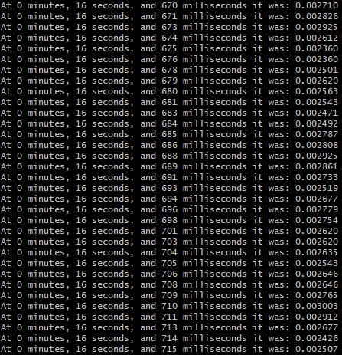

SC#2

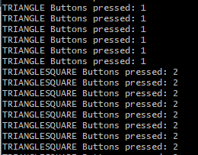

SC#3

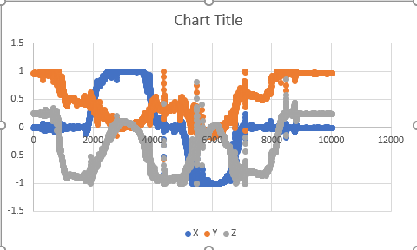

SC#4

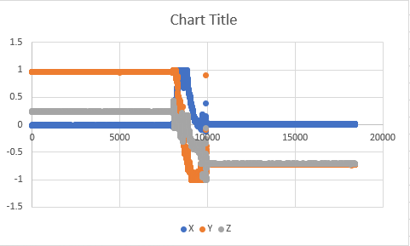

SC#5

