**Lab Report 04**

**LAB 4**

**SECTION 2**

**FULL NAME**

**Camden Fergen**

**SUBMISSION DATE:**

**2/21/2022**

# Problem 1

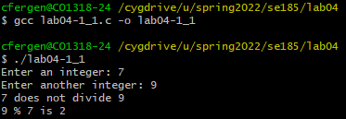

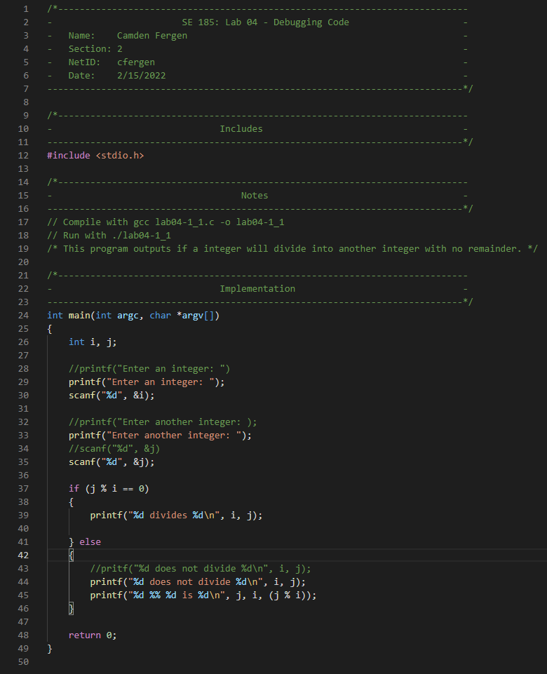

This one was fairly easy. There were just a few mistakes like leaving out the double quotes and missing the semicolons that are easy to make and cause a lot of problems.

# Problem 2

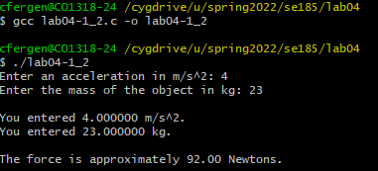

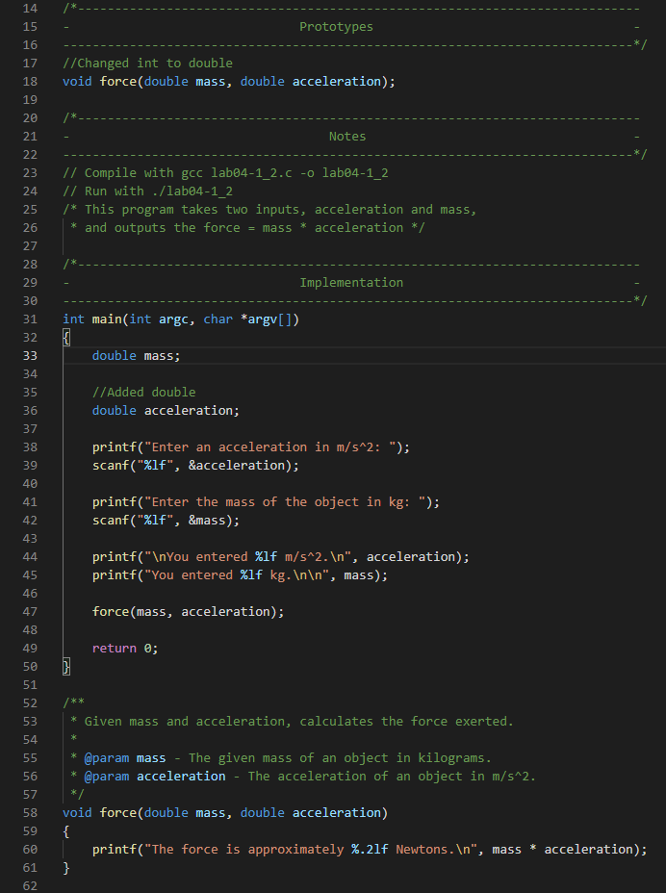

This one was another one of the simple mix ups. Instead of having doubles as the last printf statement had, almost all of the other declarations were in int which ended up with it printing only a int.

# Problem 3

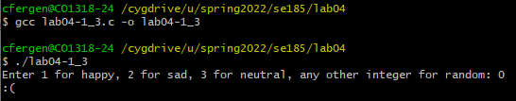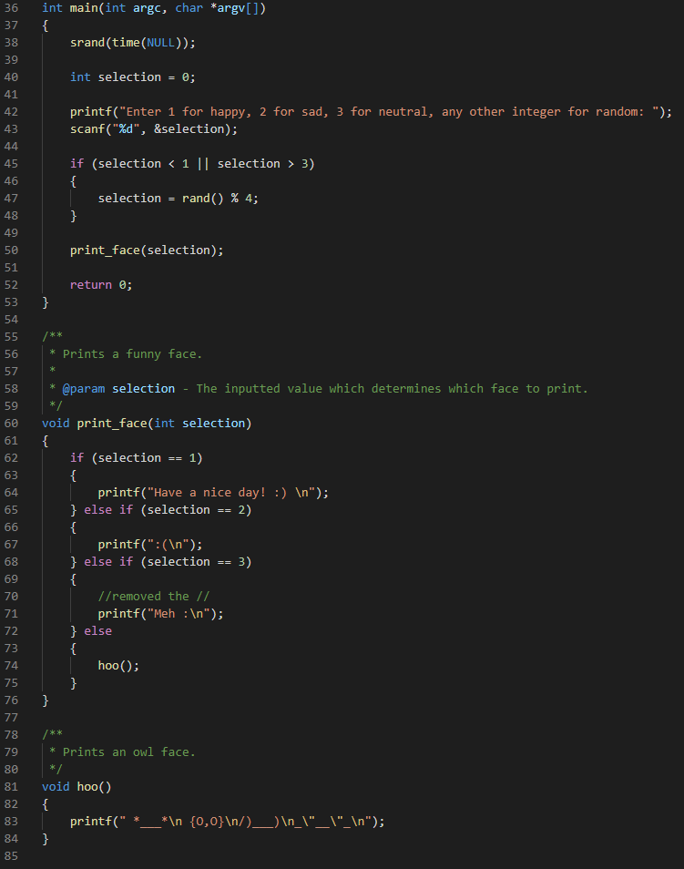

The only thing I could figure out that was wrong with this was that the 71st line had a // instead of a \n which commented half of the printf out making the problem not work.

# Problem 4

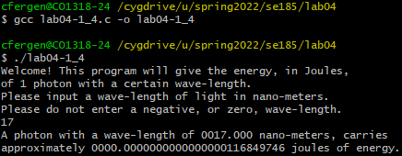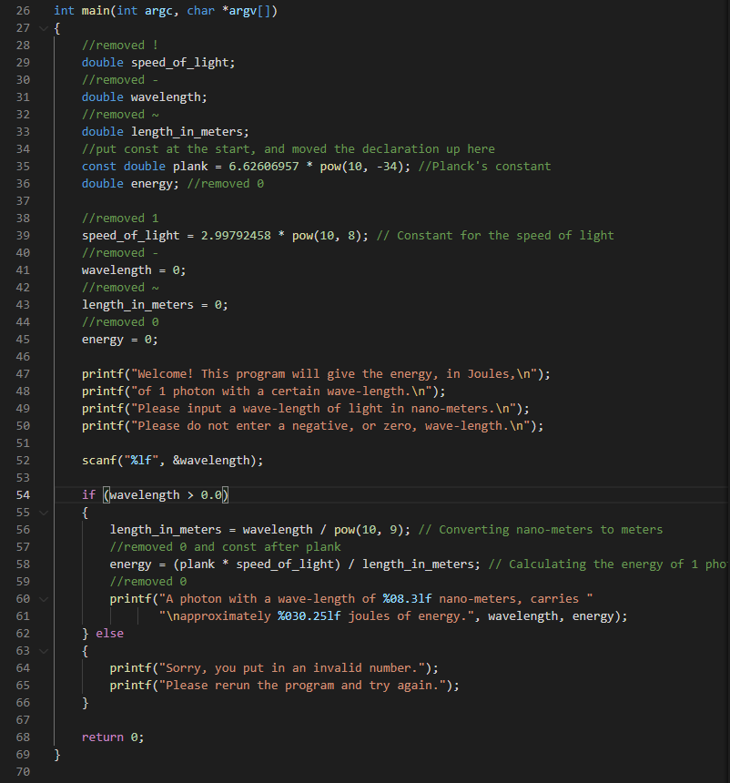

This one consisted of a lot of illegal characters in functions names like - ~ 1 and 0. These lead the problem to not work at all. Also the const was declared wrong.

# Problem 5

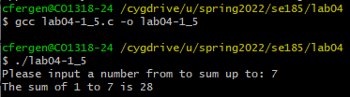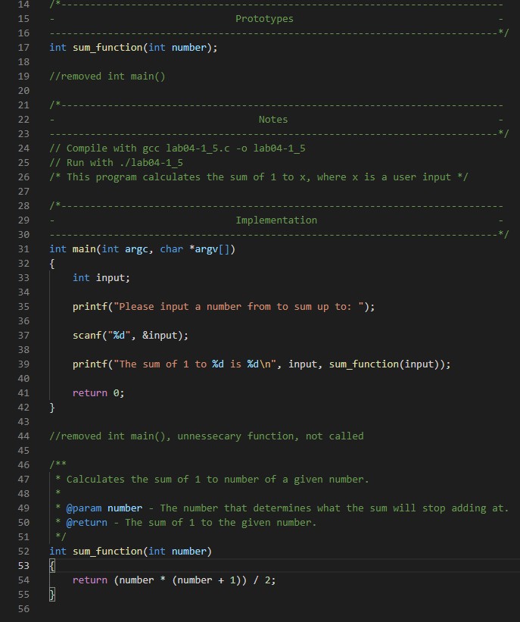

In this one I had to remove the second main function as 1, it didn’t do anything, and two, you cannot have two functions named the same and even worse so two main functions.

Section 2

# Problem 1

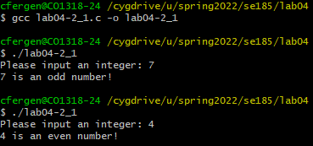

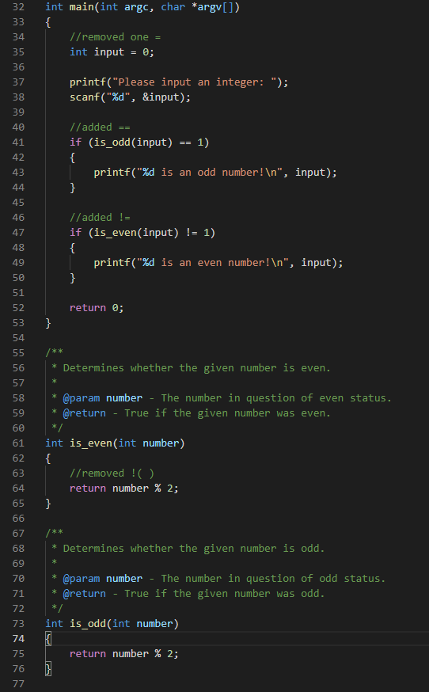

This one I just fixed a few simple logic mistakes such as the is even should return a 0 instead of a 1 which made me also witch up above it != 1. Also changing just is_odd() to is_odd() == 1 for the logic statement to work

# Problem 2

# 

I had to remove the (double) tag as converting it to double was unnecessary and also resulted in not 0 which means it always was 8 digits.

# Problem 3

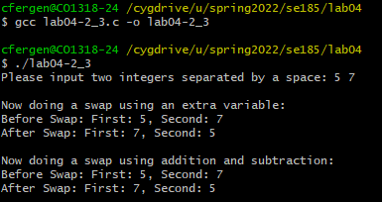

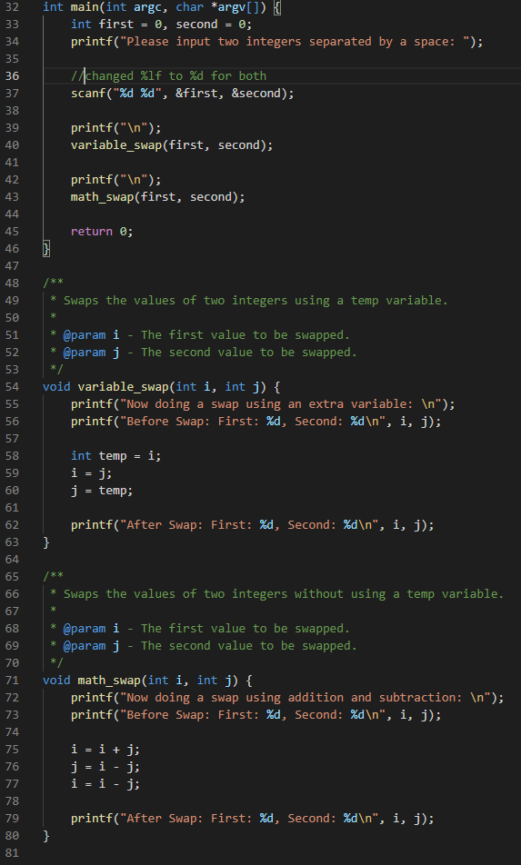

This one was really easy, all I had to change was the scanf on 37 from long outputs to int outputs.

# Problem 4

# 

I switched the int declaration to double as the int did not fit the code for how it was written out.

# Problem 5

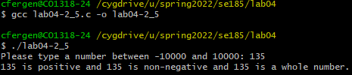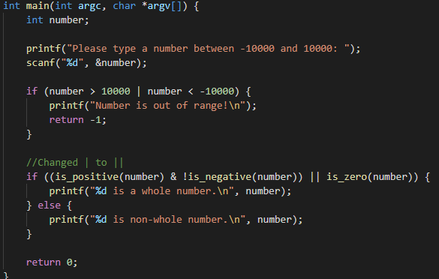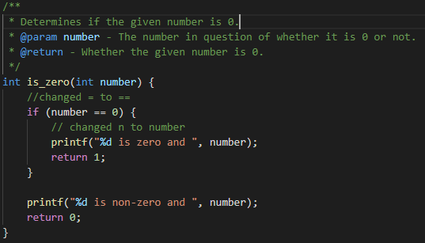

This one I had to change the | to || in the second if statement (first picture) as | does not work. Then I had to change a single = to a double as it was comparing two things not assigning.

Section 3

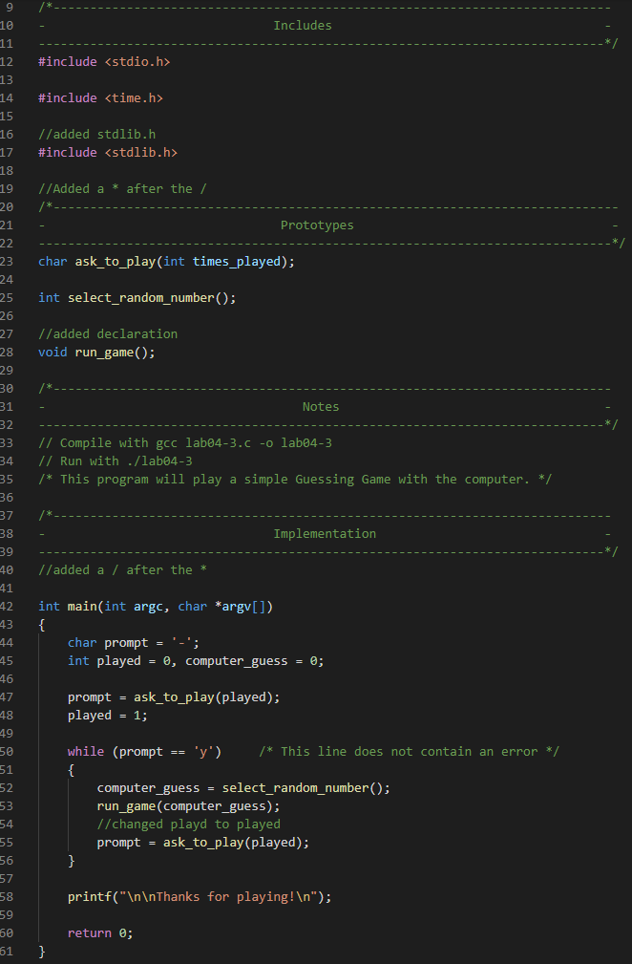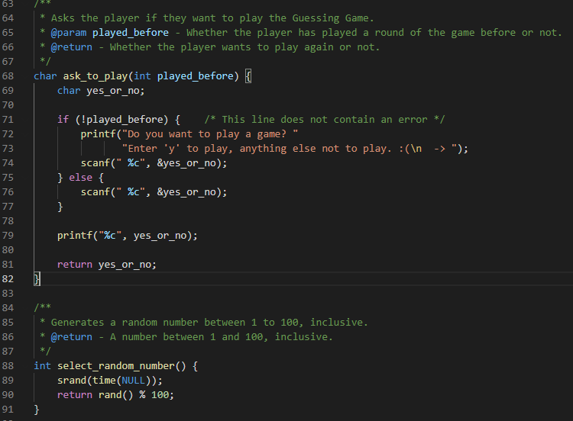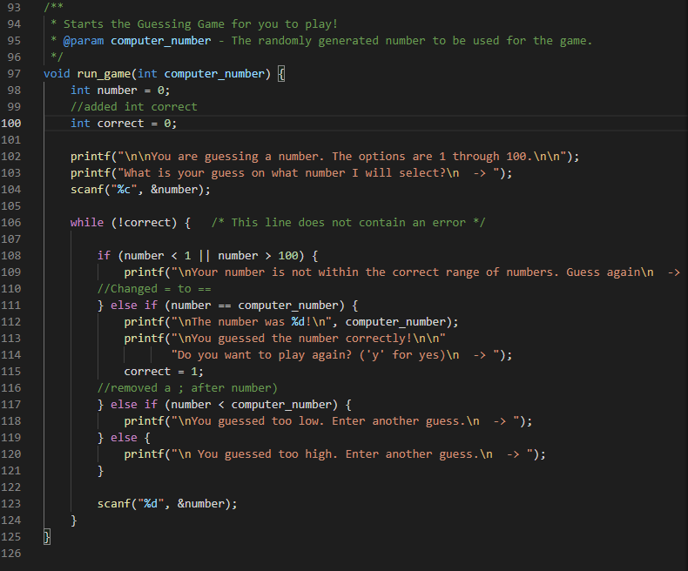

The first thing I had to do was a method declaration for run_game(). I also had to clean up the comments and added a / to end a multiline comment. Also on line 55 I fixed a spelling error.

On line 100 I had to add a int in front of the correct to declare the variable. I also had to fix a logic error with a == and also adding a semicolon.