**Lab 05 report**

**LAB 5**

**SECTION 2**

**FULL NAME**

**Camden Fergen**

**SUBMISSION DATE:**

**03/01/2022**

Questions

# How did you approach the design?

I looked through the whole document and check out what I was having to do. After this, I knew what my starting point/information I had and what the output had to be like, so I was able to make a few assumptions on what functions I was going to be needing such as close_to and side.

# What data did you have to read in?

The data that was being read it was the gyroscope data from the controller as well as the button data.

# What functions did you choose to implement and why?

I knew I was going to be needing to figure out how close I was to something, so I implemented a method that returned if the current value of the controller was within a threshold of 1, or a perfect scenario. (SC #1) The second function I implemented was a one called side. This returned a number (enum if it was a perfect world but this isn’t java) that was assigned to a side so that I knew which the controller was facing. (SC #2) The second to last function I implemented was called sidePrint; All this did was take the number then print the word for which side the controller was facing. (SC #3) The last function I had to simplify code was buttonCheck; All this did was check if the triangle button was pressed and if so, end the program. (SC #4)

Main (SC #5)

# What tolerance values did you pick and how did you decide on them?

I settled on a tolerance of 0.25 as if I went any lower, the program didn’t pick up as much as it should have and if I went higher it started to have a lot more noticeable errors when demoing the program.

# Overall

This was the first lab that actually implemented stuff and was slightly complicated. Very much enjoyed doing and I like the more real-world aspect that SE185 has over the programs in COMS 227 and 228 which were more backend type programs, stuff fun either way though. Hopefully by the end of the semester we will get to some more complicated programs as that would be pretty fun to complete and work on.

# Screen Shots

SC #1

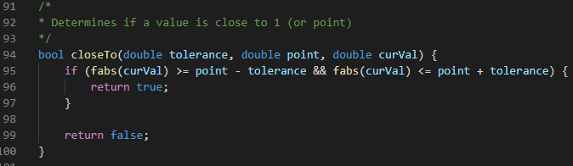

SC #2

SC #3

SC #4

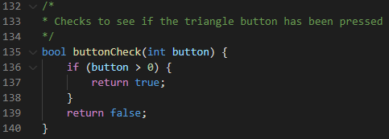

SC #5

