**TITLE**

**LAB 06**

**SECTION 2**

**Camden Fergen**

**SUBMISSION DATE:**

**03/21/2022**

# How did you randomize the buttons that needed to be pressed?

To randomize the button pressed I used the rand() function to choose a number between 1 and 4, which related to each button on the controller. I set it randomly each time by using a call to srand() and having time(NULL) (the current time) set as the seed SC#1.

# What game states, if any, did you keep track of?

The game states I kept track of were the time. I used a fancy function that calculated the time since the game started and not when the controller started recoding time. SC#2

# What mechanism did you use to make sure extraneous button presses were not registered?

I created a function that waited until all the buttons said 0 as the program collected data much faster than needed. I did this with a while look waiting for everything to say 0 then collecting the next user input and returning it using the button values. SC#3

# Overall:

This was a harder lab then expected with all the extra data collection as the program gets the data from the controller much faster than I wanted. I tried using things like the sleep function which didn’t work so I ended up with the function I created called keyPressed().

# Screen Shots

SC#1:





SC#2:



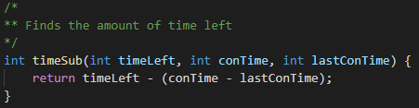

SC#3:

