**SE185: Problem Solving in Software Engineering**

**Quiz #1 (100 points)**

|  |  |
| --- | --- |
| Name: Camden Fergen | Name: Jun-sang Kim |

Answer the following questions and make a pdf file that includes the **source code, sample inputs, and outputs**. You must submit the **pdf file and all of the .c files** on Canvas for full credit. Do not forget to add your group partner name on the pdf file and the source codes.

1. **(50 points)** Write a complete c program to find the area code, exchange code, and the user number from any phone number (i.e., 10 digits) entered by the user. [hints: assume the common phone number format (3 digits area code)-(3 digits exchange code)-(4 digits user number)]

**Inputs and outputs format:**

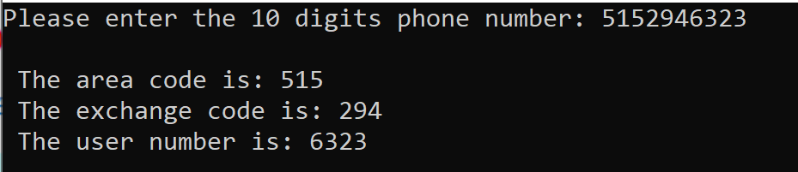

1. **(50 points)** Write a complete c program that print the Euclidian distance between the school and the following students:

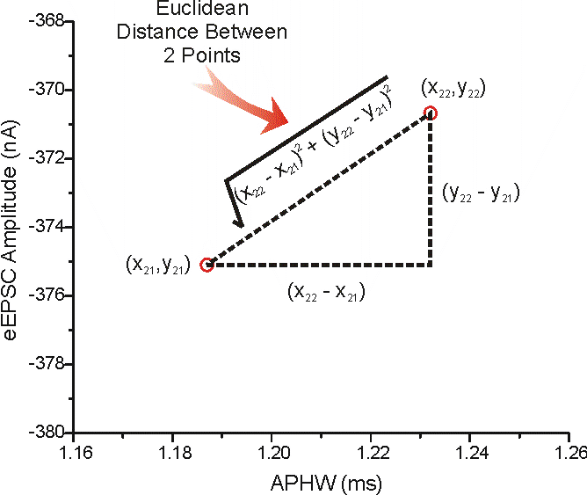

1. Mike located at x=22.05 and y=85.10
2. Mary located at x=43.25 and y=9.80
3. Gary located at x=2.55 and y=72.86
4. Logan located at x=15.15 and y =40.40

Given that the school is located at x=15.55 and y=55.15

**Inputs and outputs format:**

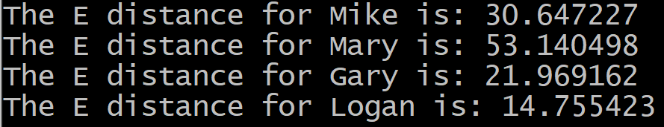

# Solutions:

**Problem 1:**

Output:

Source code:

**Problem 2:**

Source code:

Sample inputs:

x=22.05 y=85.10

x=43.25 y=9.80

x=2.55 y=72.86

x=15.15 y=40.40

Outputs:

