# Lab3

Camden Fergen

Part 1:

* Q1
  + Junit creates a new instance of ProfileTest
  + It then calls the before method to initialize each of the variables
  + It then calls the test function
  + Repeat for every test function
* Q2

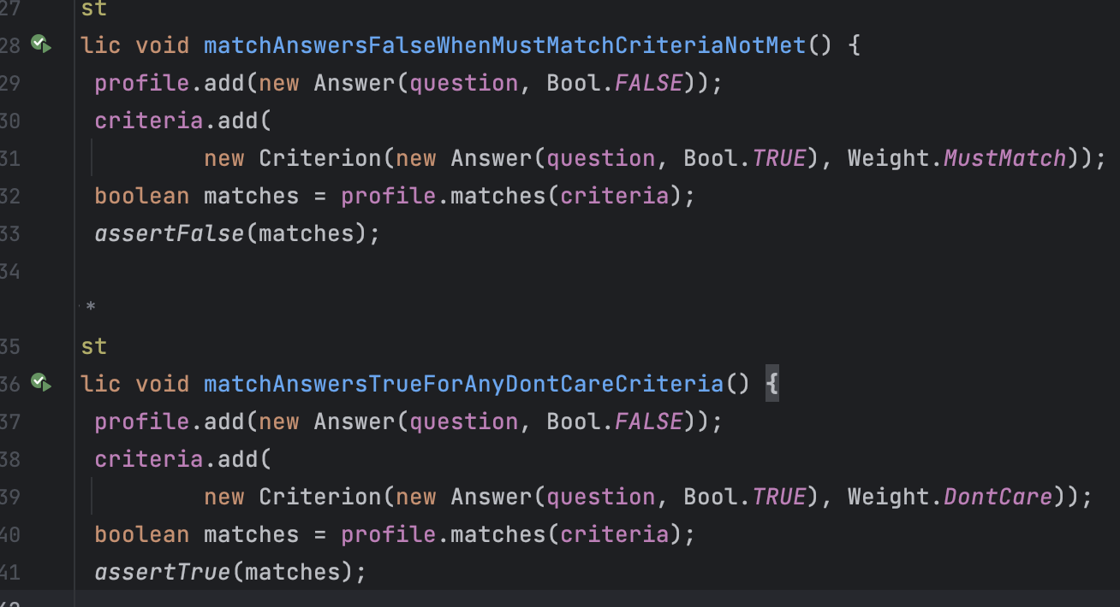Part 2:

* All code can be found commented in the files
* A screenshot of a computer program

  Description automatically generated  
  Showing the tests for the 2 letter combinations  
  A screen shot of a computer program

  Description automatically generated
* A screenshot of a computer program

  Description automatically generated  
  Showing tests for 3 letter combinations  
  A screen shot of a computer program

  Description automatically generated
* P2Q3
  + The limitations of the algorithm are defined by the computer you are running it on. Since its recursive it can take an in number under the 32bit integer limit, and try to compute it. Since we now have a recursive algorithm there is no limitation, but when we had the code to generate the two and 3 combinations the limit was 2 and 3 respectively.
  + For my computer my limit was length 6, as any greater than that it would crash
* A computer screen shot of a program code

  Description automatically generated  
  Tests for general algorithm  
  A screen shot of a computer program

  Description automatically generated