## EZGas

Author: Pierluigi Sacristano - s275493

Date: 24/03/2020

Version: 3

**Abstract**

EZGas is a crowdsourcing service that allows users to:

* Collect prices of fuels in different gas stations
* Locate gas stations in an area, along with the prices they practice.

Common users can search on the application for the gas stations with the best prices for fuel, by viewing them on a map. They can also insert some stations into the Favorites, so to be always updated with their new prices. If they want, they can join the EZGas community with a free account, that will allow them to contribute to the growth of the application, with reports of new or closed gas stations or with price updating of existing stations. The administrators of the application can check all the reports of the users and apply the modifications to the EZGas database.

# Table of contents

EZGas 1

Table of contents 2

1. Stakeholders 3

2. Context Diagram and interfaces 3

2.1 Context Diagram 3

2.2 Interfaces 4

3. Stories and personas 4

4. Use Case Diagram, Use Cases and Scenarios 5

4.1 Use Case Diagram 5

4.2 Use Cases 5

4.3 Relevant Scenarios 7

5. Functional requirements 9

6. Non-functional requirements 9

7. Glossary 10

8. GUI Prototype 10

# 1. Stakeholders

|  |  |
| --- | --- |
| **STAKEHOLDER NAME** | **DESCRIPTION** |
| Administrator | Manages the DBMS related to the application, that contains all the gas stations with their prices, and handles the maps included in the application, updating them thanks to the suggestions coming from the users. |
| User | Interacts with the system to get information about the price of the gas stations in an area. With an account, he can suggest new gas stations to add to the map, suggest a gas station to remove or can update prices for an existing gas station in the map. |
| Developer | Develops all the features of the system and maintains it by fixing the bugs eventually discovered by the users. |
| GoogleMaps | Influences the system through its API. |

# 2. Context Diagram and interfaces

### 2.1 Context Diagram

### 2.2 Interfaces

|  |  |  |
| --- | --- | --- |
| **ACTOR** | **LOGICAL INTERFACE** | **PHYSICAL INTERFACE** |
| User | GUI | Screen, Buttons, Keyboard |
| Administrator | GUI | Screen, Buttons, Keyboard |
| GoogleMaps | Google APIs | Internet connection |

# 3. Stories and personas

Bob is an administrator of the EZGas application. He really cares about the EZGas users and takes into account all the suggestions coming from them. But he doesn’t trust everyone, so he prefers to double check the reported gas stations to add or remove, before updating the database. It happens that some employee of a particular gas station reports a competitor’s gas station to be removed, so Bob always checks the information by going in person to the reported station.

Trudy is a user that doesn’t care about the EZGas community. She drives her car a lot for her work, and she just wants to save money on fuel, so she uses EZGas without a registered account, in order to find the gas stations with the lowest price around her. Trudy is quite selfish, and if she finds a new gas station with a great price, she won’t even tell the other users on EZGas.

Carl is a very generous user, who wants to have an active role in the EZGas community. He wakes up early in the morning and goes around his city and nearby ones with his car, almost every day, in order to update all the prices of the gas stations in the area. It’s obvious that Carl is a registered user of EZGas: he proudly sends the administrators dozens of reports every month, about new gas stations to add to the map.

# 4. Use Case Diagram, Use Cases and Scenarios

### 4.1 Use Case Diagram

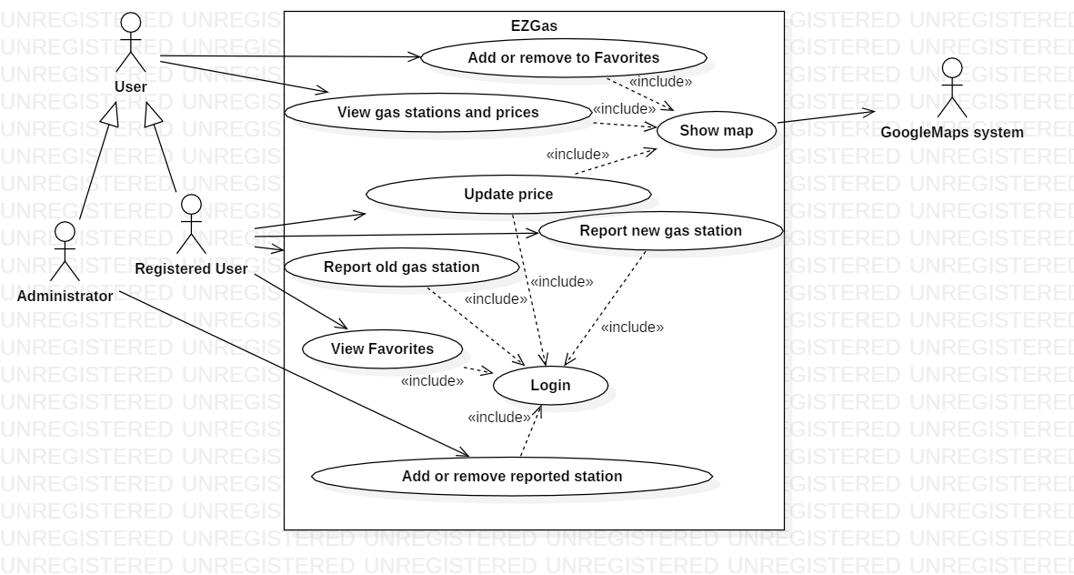

### 4.2 Use Cases

**Use Case 1, UC1 – FR1 View gas stations and prices on map**

|  |  |
| --- | --- |
| **Actors Involved** | **User** |
| Precondition | Internet connection is active |
| Post-condition | App displays the map with the requested information |
| Nominal Scenario | User clicks a button to load the map. This is loaded by communicating with the Google Maps system. |
| Variants |  |

**Use Case 2, UC2 – FR2 Report new gas station**

|  |  |
| --- | --- |
| **Actors Involved** | **Registered User** |
| Precondition | Internet connection is active,  User is logged in |
| Post-condition | Administrators receive the report from the user, or the report is aborted |
| Nominal Scenario | Registered user clicks a button to create the report. He inserts the needed information of the new gas station |
| Variants | User specifies an existing gas station, error message prompts |

**Use Case 3, UC3 – FR3 Update the prices of a gas station**

|  |  |
| --- | --- |
| **Actors Involved** | **Registered User** |
| Precondition | Internet connection is active,  User is logged in |
| Post-condition | Database contains the updated price |
| Nominal Scenario | Registered user selects a gas station from the map. He clicks on a button to update the prices of the fuel and inserts the new values |
| Variants |  |

**Use Case 4, UC4 – FR4 Report old gas station**

|  |  |
| --- | --- |
| **Actors Involved** | **Registered User** |
| Precondition | Internet connection is active,  User is logged in |
| Post-condition | Administrators receive the report from the user, or the report is aborted |
| Nominal Scenario | Registered user clicks a button to create the report. He inserts the needed information of the gas station that should be removed |
| Variants | User specifies a non-existing gas station, error message prompts |

**Use Case 5, UC5 – FR5 Add or remove a reported gas station**

|  |  |
| --- | --- |
| **Actors Involved** | **Administrator** |
| Precondition | A report has been created by a registered user |
| Post-condition | The reported gas station is added/deleted from the database, or no changes are made |
| Nominal Scenario | Administrator checks the report from the user. If it’s correct, the administrator confirms the change |
| Variants | The report contains wrong information. Administrator deletes the report without changing the database of the gas stations |

**Use Case 6, UC6 – FR6 Add/Remove gas station from Favorites**

|  |  |
| --- | --- |
| **Actors Involved** | **User** |
| Precondition | Internet connection is active,  Map is displayed |
| Post-condition | Favorites list updated |
| Nominal Scenario | User selects a gas station from the map. He clicks a button to add it or remove it from Favorites. |
| Variants |  |

**Use Case 7, UC7 – FR7 View Favorites list of gas stations**

|  |  |
| --- | --- |
| **Actors Involved** | **User** |
| Precondition | Internet connection is active,  User is logged in |
| Post-condition | Favorites list is displayed |
| Nominal Scenario | User clicks on the Favorites list button |
| Variants |  |

### 4.3 Relevant Scenarios

**Scenario 1**

|  |  |
| --- | --- |
| **Scenario ID: SC1** | **Corresponds to UC2** |
| Description | User creates a report containing a new gas station that should be added to the database |
| Precondition | Internet connection is active, user is logged in |
| Postcondition | Administrators receive the report from the user |
| Step# | Step description |
| 1 | User clicks on a button to create a report |
| 2 | User inserts the requested information (e.g. the address of the gas station) |
| 3 | User submits the report to the administrators |

**Scenario 2**

|  |  |
| --- | --- |
| **Scenario ID: SC1** | **Corresponds to UC2** |
| Description | User attempts to insert an already existing gas station into the report |
| Precondition | Internet connection is active, user is logged in |
| Postcondition | Report is aborted |
| Step# | Step description |
| 1 | User clicks on a button to create a report |
| 2 | User inserts the information (e.g. the address) of an already existing gas station |
| 3 | Error message prompts, and the report is not created |

# 5. Functional requirements

|  |  |
| --- | --- |
| **ID** | **DESCRIPTION** |
| FR1 | View all the gas stations with their prices nearby on the map, or in a specified area. |
| FR2 | Report a new gas station to be added to the EZGas database. |
| FR3 | Update a price in an existing gas station in the database. |
| FR4 | Report a closed gas station that should be removed from the database. |
| FR5 | Add or remove a reported gas station from the database. |
| FR6 | Add or remove gas station to Favorites |
| FR7 | View the Favorite list of gas stations |

# 6. Non-functional requirements

|  |  |  |  |
| --- | --- | --- | --- |
| **ID** | **TYPE** | **DESCRIPTION** | **REFERS TO** |
| NFR1 | Usability | The application should be used by new users with no training | ALL FR |
| NFR2 | Portability | The application must run on Windows and Android | ALL FR |
| NFR3 | Domain | Prices currency is in €/L | ALL FR |

# 7. Glossary

1. Class Diagram

# 8. GUI Prototype

2. Main screen for unregistered users

1. Main screen for registered users

# Immagine che contiene screenshot Descrizione generata automaticamenteImmagine che contiene screenshot, orologio, disegnando Descrizione generata automaticamenteImmagine che contiene orologio, disegnando Descrizione generata automaticamenteImmagine che contiene screenshot, disegnando Descrizione generata automaticamente

5. Favorites list

3. Show map and gas station details

6. Report new gas station

4. Update prices

# Immagine che contiene screenshot, disegnando Descrizione generata automaticamenteImmagine che contiene screenshot, disegnando Descrizione generata automaticamenteImmagine che contiene screenshot, disegnando Descrizione generata automaticamente

9. Confirm old gas station

7. Report old gas station

8. Confirm new gas station