-Requirements document for EZGas
Author: Alessandro Salvatore
Date: 26/03/2020

Abstract
EZGas is a crowdsourcing service that allows users to collect prices of fuels in different gas stations and locate gas stations in an area, along with the prices they practice.

Table of contents:
- Stakeholders
- Context diagram
- Interfaces
- Personas and stories
- Use case diagram and use cases
- Scenarios
- Functional requirements
- Non functional requirements
- Glossary
- GUI
Stakeholders
Drivers: regular people that can use the application for knowing the cheapest gas stations in their local area.
Gas station administrators: they can submit the prices of their gas station but also could look at the prices of nearby gas stations in order to adjust their own prices accordingly.

Context Diagram
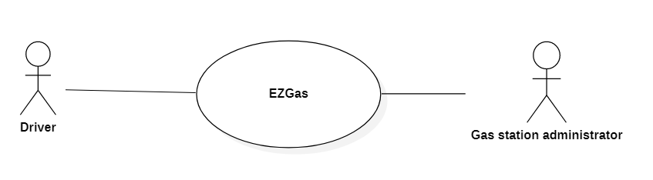

Interfaces
Actor | Logical interface | Physical interface
Driver | GUI | Screen, buttons
Gas station administrator | GUI | Screen, buttons

Personas and stories
Al is a post office employee that works in an office 50km away from his home. He’s had his Fiat Punto for 25 years so he is confident that he knows exactly when the fuel is about to end, regardless of what the indicator of the car says. He periodically checks EZGas to see what’s the cheapest gas station in his trip from home to work so he can stop at it at the last second.

John is a retired computer engineer, so he likes to spend his time by making long trips in his car around Italy. Each time he crosses Molise he checks EZGas because before retiring he didn’t know Molise existed so he’s not familiar with local gas stations.

Jack is the administrator of a gas station in Isernia. He met this guy John that periodically wanders around Molise and stops at the cheapest gas station for refilling his car, and Jack really likes him. So Jack looks every morning on EZGas the prices of all the gas stations in Molise and sets the price of his own to be the lowest one: this way Jack can spend all his days waiting for John to pass by his gas station, even after his death.

Use case diagram and use cases

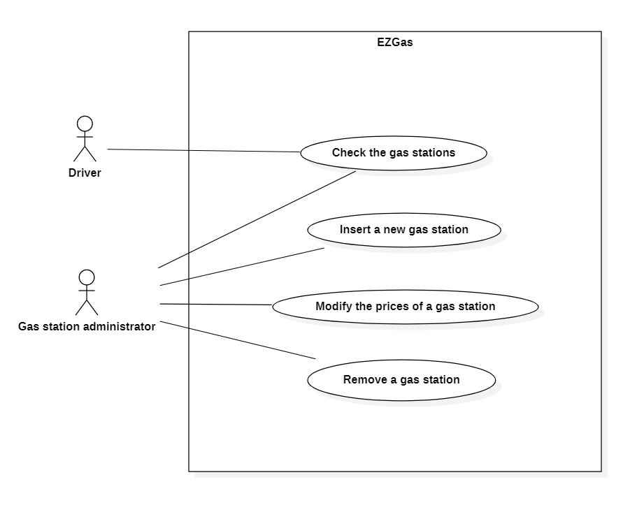
UC1 – Check the gas stations
Actors involved: driver, gas station administrator
Precondition: some gas stations exist in the system
Post condition: -
Nominal scenario: the user clicks on the “Map” button, the app shows the world map (navigable) with pointer icons where gas stations are located, then the user can tap on a gas station icon to see its prices
Variants: the user clicks on the magnifying glass button, then inserts a location L and a radius R to show just the map of the gas stations within R kilometers from L

UC2 – Insert a new gas station
Actors involved: gas station administrator
Precondition: the actor is registered in the system
Post condition: a new gas station is inserted in the system
Nominal scenario: the user clicks on the “Administrator” button, then he logs in the system, then he clicks the “+” button and inserts all the required info (including the station’s ownership document), then if everything is correct the system registers the new station in the database
Variants: -

UC3 – Modify the prices of a gas station
Actors involved: gas station administrator
Precondition: the actor is registered in the system, the gas station G is already inserted
Post condition: the prices of G are modified
Nominal scenario: the user clicks on the “Administrator” button, then he logs in the system, then he clicks on the pencil icon near the gas station G he wants to modify, then he inserts the new prices, then the system registers the prices in the database
Variants: -

UC4 – Remove a gas station
Actors involved: gas station administrator
Precondition: the actor is registered in the system, the gas station G is already inserted
Post condition: the station G is dropped from the system
Nominal scenario: the user clicks on the “Administrator” button, then he logs in the system, then he clicks the trash bin icon near the station G he wants to remove, then he’s prompted with an “Are you sure” prompt, then he presses the tick icon, then the system removes the station from the database
Variants: -

Notice that only the gas station administrators need to be registered in the system and that the map is implemented first party inside the application.

Scenarios
SC1 – Related to the use case UC2
Description: an administrator A tries to register a gas station G he doesn’t own
Precondition: G doesn’t exist
Post condition: G is not added to the system
Steps:
- The administrator A inserts the information about the gas station G
- The system checks the integrity and correctness of the ownership document, to find out that G isn’t owned by A
- The application prompts an error window, asking the user to retry

SC2 – Related to the use case UC1 (variant)
Description: an user wants to check the price of a new gas station near home
Precondition: -
Post condition: the user can navigate the map containing the stations near his home
Steps:
- The user clicks on the magnifying glass
- The application prompts a form containing two fields: “Location” (can be a city, a street, coordinates etc…) and “Radius” (integer number, expressed in kilometers, from 1 to 500)
- The user inserts his home address for “Location” and 5 for “Radius”
- The application shows a restricted map with gas stations based on the user’s inputs
- The user clicks on the gas station of interest
- The application shows the prices for that gas station

Functional requirements
FR1: let gas station administrators register themselves
FR2: let gas station administrators log in
FR2: let gas station administrators log out
FR3: let gas station administrators insert a new gas station
FR4: handle new gas stations insertion
FR5: display a navigable map of the world with the gas stations
FR6: show the prices of each gas station
FR7: let gas station administrators modify the price of their gas stations
FR8: let gas station administrators remove one or more of their gas stations
FR9: look on the map for a location given by the user
FR10: show a map of gas stations given a location and a radius

Non functional requirements
NFR1 (usability, all FR): every function should be executed easily by anyone
NFR2 (performance, all FR): every function should be completed in less than two seconds
NFR3 (portability, all FR): the application should run on Android (from 5.0), IOS (from 5)
NFR4 (standards, FR9): the user can input a location in form of the name of a city, or an address, or as geographical coordinates
NFR5 (standards, FR10): the radius given by the user can be in kilometers or miles
NFR6 (legislative, FR3): when a gas station administrator inserts a new gas station, its ownership document ID should be verified to be trusted

Glossary

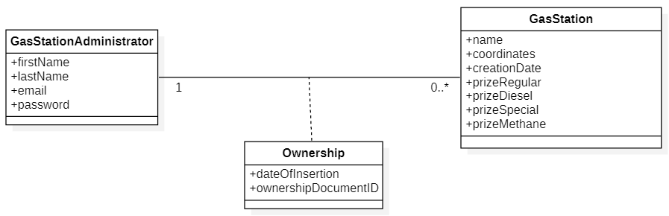

Regular users don’t have to be registered, so the system doesn’t store information about them. The class “GasStationAdministrator” holds info about gas station administrators and their login credentials. The class “GasStation” keeps data about the gas stations, including the prizes for fuel (of course not all the prize voices are mandatory, as not every gas station supports them all). The association class “Ownership” binds a gas station to his administrator and keeps trace of the ownership document, so that someone cannot insert data about a station he doesn’t own.

GUI
Overall view with interactions:
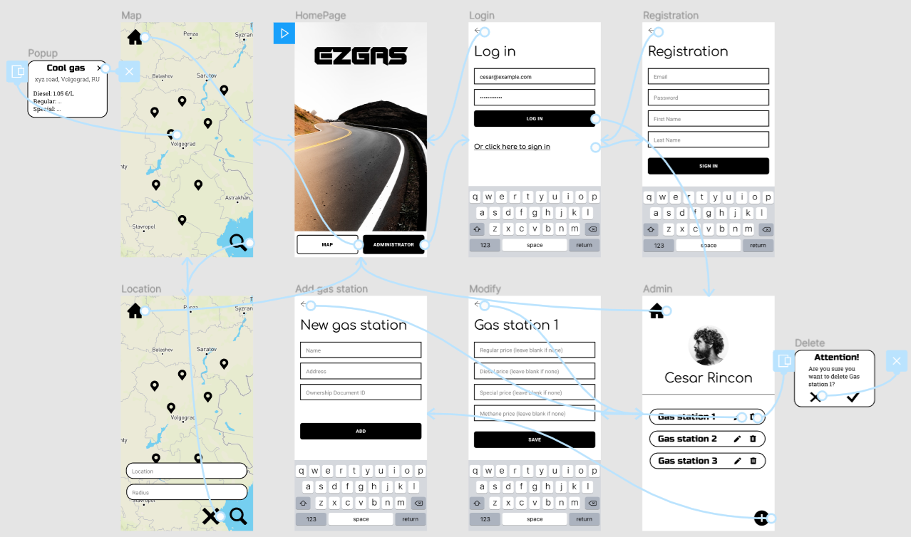

In-depth view of some pages:
Homepage Administrator page Map page
