# Lab2
Official Requirements Document

Author: Gianluca Mega (s226136)

Date: 24/03/2019

Version: 1

Contents
- Abstract
- Stakeholders
- Context Diagram and interfaces
  - Context Diagram
  - Interfaces
- Stories and personas
- Functional and non functional requirements
  - Functional Requirements
  - Non functional requirement
- Use case diagram and use cases
  - Use case diagram
  - Use cases
  - Relevant scenarios
- Glossary
- System design
- Deployment diagram

Abstract
Cars are used everyday by a lot of people as main transportation system. One of the most incident expenses is fuel. Every day fuel prices change and every fuel station applies its own ones so the amount for a refueling can vary significantly. A person (called user) would be happy if he/she could know in advance the prices applied by the gas stations near him/her in order to select the lowest price.

A person (called developer) decides to create an application that permits to all the registered users to add to the system the fuel prices of the gas stations and share them with the other users. Plus he/she decides to implement a system of like/dislike in order to show if prices are correct or not.

Stakeholders
Stakeholder name | Description
User | Uses the application to update ad insert prices of fuel stations
Developer | Creates the application and tests it to match the requirements
Map system | Set of services for geolocalization

Context diagram and interfaces
Context diagram
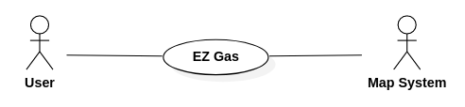

Interfaces

Actor | Logical Interface | Physical Interface
User | GUI | Screen
Map System | API | Web services

Stories and personas
Alice is a sales agent, she has to travel a lot everyday with her car to visit customers. Every morning she goes to a nearby gas station to refuel her car and get prepared for a new working day. As kilometers go by the fuel runs out so she has to stop to a gas station, wherever she is. Alice would be very happy if she could chose the cheapest gas station in order to save some money, maybe via an application that shows all the gas stations near her with their prices. She could also contribute to keep updated the information about the stations she usually goes to everyday and to share the prices of the places where no one has gone yet.
Bob is an employee and is going on vacation with his family. To do so they have to do several kilometer with their car so Bob expects to have some fuel stops during the journey. He wonders if there was an application that could tell him where is the nearest gas station and which fuel prices it make to manage if it is convenient to stop there or if maybe there is a cheaper station after some way.
Functional and non functional requirements
Functional requirements
ID | Description
FR1 | Geolocalization of the user and the gas stations near him/her
FR2 | Visualization of the gas stations’ fuel prices
FR3 | Registration of a user
FR4 | Insertion of fuel prices (only for registered users)
FR5 | Possibility to review a price with a like/dislike button
Non functional requirements
ID | Type | Description | Refers to
NFR1 | Usability | Application should be used with no training by any user | All FR
NFR2 | Efficiency | All functions should complete in < 0.5 sec | All FR
NFR3 | Portabillity | The application should be installed in less than 5 minutes | All FR
NFR4 | Portability | The application should run on every mobile OS | All FR
NFR5 | Localization | Decimal numbers use . (dot) as decimal separator | FR2 FR4
NFR6 | Domain | Currency is Euro | FR2 FR4

Use case diagram and use cases
Use cases diagram
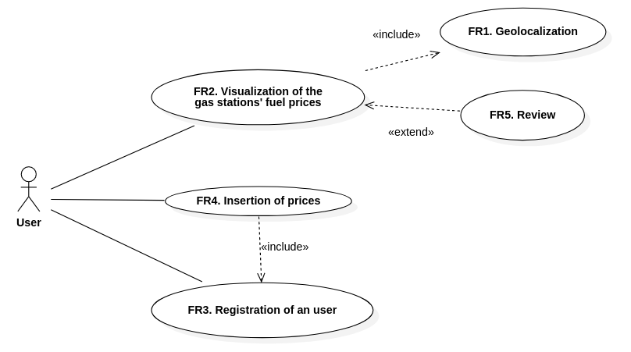

Use cases
Use case 1, UC1 – FR2 Visualization of the gas stations’ fuel prices
Actors involved | User
Precondition | User’s geolocalization
 | Inserted_prices != 0
Post condition
Nominal Scenario | User opens the app, the system localize him/her, screen shows the location of the gas stations with their prices
Variants | User adds “Like” or “Dislike” whether the price is correct or not

Use case 2, UC2 – FR3 Registration of an user
Actors involved | User
Precondition
Post condition
Nominal Scenario | User creates an account on the application in order to directly update the prices
Variants

Use case 3, UC3 – FR4 Insertion of prices
Actors involved | User
Precondition | User already registered
Post condition
Nominal Scenario | User logs in, visualize a gas station, insert the updated prices
Variants

Relevant scenarios
Scenario 1
Scenario ID: SC1 | Corresponds to UC1
Description | User wants to view gas stations and prices
Precondition | User geolocalized
Postcondition
Step# | Step description
1 | Gather user’s position
2 | Display nearby gas stations
3 | User selects one gas station
4 | Display prices

Scenario 2
Scenario ID: SC2 | Corresponds to UC3
Description | User insert prices
Precondition | User registered
Postcondition
Step# | Step description
1 | Gather user’s position
2 | Display nearby gas stations
3 | User selects one gas station
4 | Check user registration
5 | Update prices (if user registered)

