Official Requirements Document
Authors: Paolo D’Ambrosio, Lorenzo Lanari, Silvio Girolami, Stefano Cataldi
Date: 28/03/2020
Version: 1
Contents
Official Requirements Document 1
Abstract 1
Stakeholders 2
Context Diagram and interfaces 2
Context Diagram 2
Interfaces 3
Stories and personas 3
Functional and non functional requirements 4
Functional Requirements 4
Non Functional Requirements 4
Use case diagram and use cases 4
Use case diagram 5
Use Cases 5
Use case 1, UC1 – FR1 Insert a new gas station 5
Use case 2, UC2 – FR2 Delete a gas station 5
Use case 3, UC3 – FR3 Insert/change fuel price 6
Use case 4, UC4 – FR4 Leave a feedback 6
Use case 5, UC5 – FR5 Compute Route 6
Use case 6, UC6 – FR6 Add filters 7
Use case 7, UC7 – FR7 Compare fuels price 7
Use case 8, UC8 – FR8 Check inserted information 7
Relevant scenarios 8
Scenario 1 8
Scenario 2 8

Abstract
A crowdsourcing application that shows gas stations in an area, along with the prices they practice, has to be designed.
The application is meant to be used by everyone who wants to know this information. These information are inserted and updated by users themselves.
The application home shows a map of gas stations around user location and a list of all stations that can be sorted by price, alphabetic order or distance. Other filters may be applied (fuel type, fuel company, etc.).
Users can insert also a feedback about the gas station and those feedbacks are readable by other users.

Stakeholders
Stakeholder name | Description
User | Uses the application to read and insert information
GPS | Gives the real time position users and positions where all stations are located
Administrator | Checks that all information are correct
Developer | Creates the application
Application Database | Where all information are stored

Context Diagram and interfaces

Context Diagram

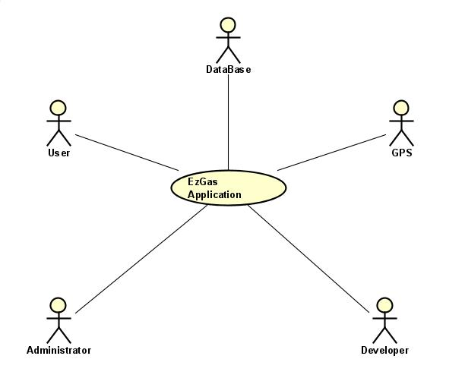

Interfaces
Actor | Logical Interface | Physical Interface
User | GUI | Smartphones
GPS | APIs | Internet connection
Administrator | GUI | Smartphones, screen, keyboard
Developer | GUI | Screen, keyboard
Database | GUI and APIs | Smartphones

Stories and personas
Arturo is a truck driver and is constantly on the road in order to carry goods all over the Europe.
He used to contact his truck driver friends to receive advices about the cheapest gas station,
near him. Despite being a truck driver for many years, it is not always easy for him to understand
the advices given by his colleagues, in particular the ones about the location of the various
gas stations. Another problem for Arturo is that most of his friends use a different type of
fuel, so it is a mess to filter all the incoming information.
He would really like to have the possibility to use the gps inside his phone
to reach his destination and moreover to be able to search specifically for GPL stations.
Jennifer is a 37 years old mother of four children. Every day she has to pick up her children from school
and it's difficult for her to choose the best route in order to be fast in cooking lunch.
Sometimes, in all this rush, she needs to go to a gas station so it's necessary for her
to get to the nearest gas station to the school of her children.

Functional and non-functional requirements

Functional Requirements
ID | Description
FR1 | Insert a new gas station
FR2 | Delete a gas station
FR3 | Insert/change price
FR4 | Leave a feedback
FR5 | Compute the route to the station
FR6 | Add filters
FR7 | Compare fuels and prices
FR8 | Check inserted information

Non-Functional Requirements

ID | Type | Description | Refers to
NFR1 | Usability | Application should be used easily while in a car | All FR
NFR2 | Performance | All functions should complete in < 0.5 sec | All FR
NFR3 | Portability | The application should run on smartphones | All FR
NFR4 | Reliability | The application should be available 99% of times

Use case diagram and use cases

Use case diagram
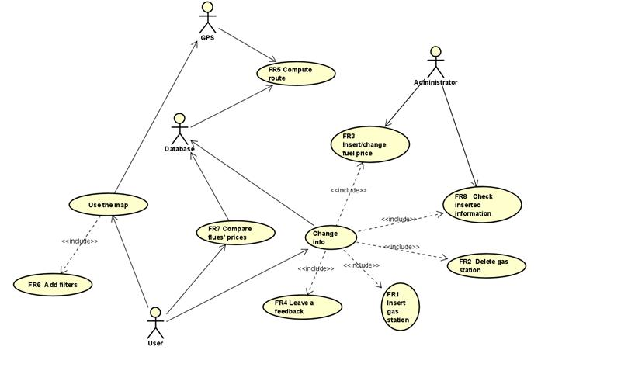

Use Cases

Use case 1, UC1 – FR1 Insert a new gas station
Actors involved | User, Database
Precondition | User U exists, database D exists, station S doesn’t exist
Post condition | S exists, S.fuel > 0
Nominal scenario | User inserts a new name and a new price, database adds a new entry
Variants | Station already exists, issue warning

Use case 2, UC2 – FR2 Delete a gas station
Actors involved | User, Database
Precondition | Station S exists
Post condition | Station S doesn’t exist
Nominal scenario | User selects station S and delete it
Variants

Use case 3, UC3 – FR3 Insert/change fuel price
Actors involved | Users, Database, Administrator
Precondition | Station S exists
Post condition | S.price > 0
Nominal scenario | User selects Station S, Price is inserted or changed
Variants

Use case 4, UC4 – FR4 Leave a feedback
Actors involved | User, Database
Precondition | Station S exists
Post condition | S.feedback.quantity_pre < S.feedback.quantity_post
Nominal scenario | User selects a station S and adds a feedback
Variants

Use case 5, UC5 – FR5 Compute Route
Actors involved | GPS, Database
Precondition | Station S exists, User.position is not NULL
Post condition
Nominal scenario | The application sets the route to the station S
Variants

Use case 6, UC6 – FR6 Add filters
Actors involved | User, GPS
Precondition | Filter F exists
Post condition
Nominal scenario | The user selects a filter
Variants

Use case 7, UC7 – FR7 Compare fuels price
Actors involved | User, Database
Precondition | Fuel Fu exists, Fu.price > 0, Station S exists
Post condition
Nominal scenario | User selects stations or a fuel to compare them
Variants | Stations doesn’t exist, issue warning

Use case 8, UC8 – FR8 Check inserted information
Actors involved | Administrator
Precondition | Station S exists, S.price > 0
Post condition | All information are correct
Nominal scenario | The administrator analyze a Station and its properties
Variants

Relevant scenarios

Scenario 1

Scenario ID:SC1 | Corresponds to UC 1
Description | User finds a Gas Station not inserted in the app yet and insert it.
Precondition | User is already signed in.
Postcondition | Database is updated with the new station
Step# | Step description
1 | User insert his credentials to sign in
2 | User insert data about the new station
3 | Administrator checks the data inserted
4 | The new station is inserted in the database

Scenario 2

Scenario ID:SC2 | Corresponds to UC 1
Description | User finds a Gas Station not inserted in the app yet and insert it, with wrong data.
Precondition | User is already signed in.
Postcondition | Administrator block the insertion on the new station
Step# | Step description
1 | User insert his credentials to sign in
2 | User insert wrong data about the new station
3 | Administrator checks the data inserted
4 | Administrator blocks the insertion request

Glossary
In this section we describe the principal concepts of the EZgas application through a UML class diagram.

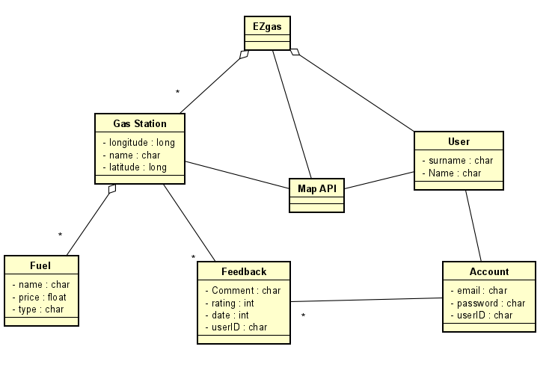

EZgas is a crowdsourcing application that allows users to insert and check information about gas stations. Each user can sign up using his name and surname in order to create an account with an email, a userID and a password to log in. The application collects several gas stations: a gas station is characterized by a name and a position on the map, indicated by 2 coordinates (latitude and longitude). Furthermore, a gas station can offer to his customers several type of fuel: a fuel has a name and a price. Each account can leave a feedback to a gas station: a feedback is composed of a comment and a rating (going from 0 to 5) and is identified by the date it was written and the userID of the user who wrote it. The Map API is used to show a map of the user area with the nearest gas stations.

