EZGas Requirements

Stakeholders
- Users can locate gas stations and submit updated prices.
- Google map offers users a map.

Context diagram
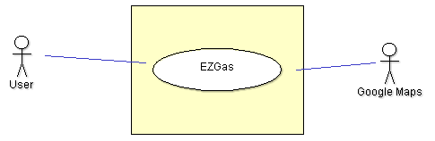

Interfaces
- With User
  - Physical Level: smartphone touchscreen
  - Logical Level: GUI
- With Google Maps
  - Physical Level: internet connection
  - Logical Level: Google Maps API

Stories and Personas
- John is a university student who uses his car in his free time. As a student, he wants to save money as much as possible, and he always choose the least expensive gas station near his house.
To do so, he opens EZGas on his smartphones, uses the GPS to view the area he is in and immediately localize the least expensive gas station near him.
When he’s done, he updates the data about that gas station in the app.
- Mary is a tourist in a new city, and she decided to rent a car. As she has to pay for the gas, she downloads EZgas, write the name of the city she’s in, and gets a list of all the gas station available there, with prices. This way, she can decide where to go to get the cheapest gas possible before returning the car.
- Andy is an employee in a company quite far from his house, so he must use his car every day. He wants the best for his car, so he filters his favourite gas stations, and verifies the cheapest one he can find in the route to and from home.

Functional requirements
- FR1: Show nearest stations on a map
- FR2: List nearest stations by distance and price
- FR3: View details and prices about a gas station
- FR4: Account creation
- FR5: Account login
- FR6: Submit updated prices

Non-functional requirements
- Usability: the app should be used with no training by any person with a smartphone
- Performance: search operation should be completed in less than 1 second, while navigating in the map and seeing details/prices of each gas station should complete in less than 0.5 seconds.
- Portability: app should work on the majority of smartphones in use today.
- Localisation: decimal numbers use , (comma) as decimal separator.

Use Cases
- UC1-FR1: Show nearest stations on a map
  - Precondition: GPS and internet are on, there are stations in a predefined range
  - Postcondition: A map is shown, station icons are shown
  - Nominal scenario: a user opens the app, wait for the localization and sees all stations near him
  - Variants: if localization doesn’t work, the last position used in the app is shown. A warning is shown when there is no internet connection.
- UC2-FR3: View details and prices about a gas station on the map
  - Precondition: the station appeared on the map, prices has been added before for it
  - Postcondition: address, name and saved prices for that station are shown
  - Nominal scenario: when the user selects a station on the map, all the details appear on the display
  - Variants: in case there is no price data, the app asks the user to add it.
- UC3-FR4: Account creation
  - Precondition: the user has an email address that is active
  - Postcondition: EZgas knows data about the user, who will can edit prices
  - Nominal scenario: the user registers with email and password. A confirmation email will be sent.
  - Variants: in case the email address is not active, the user won’t receive confirmation email.
- UC4-FR5: Account login
  - Precondition: the user has an active account on EZgas.
  - Postcondition: the user will be able to edit gas prices for each station near him
  - Nominal scenario: The user inserts his account email and password.
  - Variants: in case of wrong email/password, a warning appears. The user can repeat login.
- UC5-FR6: Submit updated prices
  - Precondition: the user has a valid account and he did login.
  - Postcondition: prices of a defined gas station are updated on the application
  - Nominal scenario: A user uses the relative page to insert new prices for a defined station.
  - Variants: in case of input prices that are 25% higher/lower than the average in that area, the app will show a warning and won’t accept data.
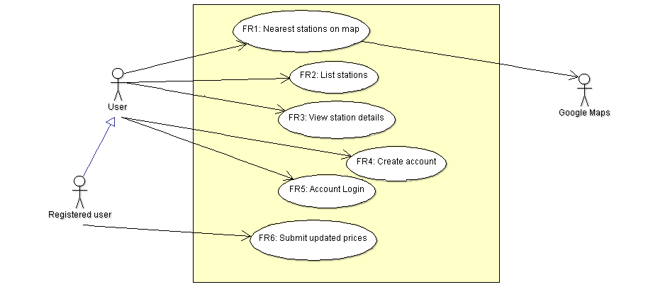
Use Case Diagram.

Scenarios
Some possible scenarios can be:
Scenario SC1, corresponds to UC1.
- Description: User uses GPS localization to find the cheapest station near him.
- Precondition: Installed application, Internet available, Geolocalization possible
- Postcondition: A map with nearest stations appears
- User opens the app
- Gas stations pop up as icons in the map, with a preview of prices.
- User touch a gas station to view details and prices.

Scenario SC2, corresponds to UC3.
- Description: User registers a new account.
- Precondition: Installed application, Internet available, user has an active email address
- Postcondition: The app has data of the user registered, the user can login.
- User opens the app and presses “Account” Icon
- User touches “I don’t have an account”
- User inserts email and password
- User visits his inbox and click on the verification email to activate his account.

Scenario SC3, corresponds to UC4.
- Description: User logins.
- Precondition: Installed application, Internet available, user has an active account
- Postcondition: The user can edit gas prices.
- User opens the app and presses “Account” Icon
- User inserts his email and password and click Login.
Scenario SC4, corresponds to UC5.
- Description: User send new gas prices.
- Precondition: Installed application, Internet available, user is logged in, stations are shown in the map
- Postcondition: New gas prices are immediately online.
- User touches a station on the map, details are shown
- User clicks Edit button
- User inserts new gas prices and clicks Completed.

Glossary
