Toni Saliba S275112
EZGas application
Abstract
EZGas is a crowdsourcing service that allows users to:
- Collect prices of fuels in different gas stations.
- Locate gas stations in an area, along with the prices they practice
Stakeholders
- User:
  - Consumer: Uses the application to collect prices of fuels and location of different gas stations. Uploads fuel prices with the location of the gas station that he visited.

- Administrator:
  - EZGas application administrator.
  - IT administrator: manages all the app’s IT infrastructure in the company.
  - Cyber Security manager: Responsible for cyber security issues.
  - DB administrator: manages DBMSs on which the application is based.
- Buyer:
  - CEO and CTO of the company.
- Developer:
  - Specialist that develops, deploys and maintains the application.
- Data analyst:
  - Checks the quality of the uploaded data from the consumer.
Context Diagram and interfaces
Context Diagram
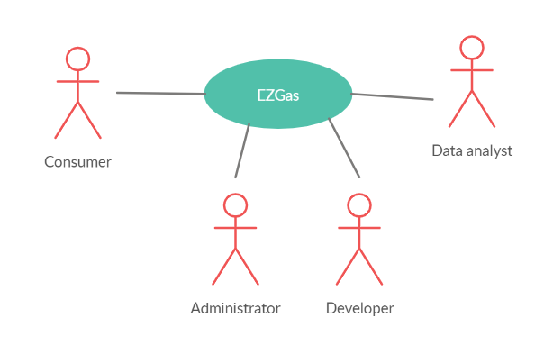

Interfaces
Actor | Logical Interface | Physical interface
Consumer | GUI | Mobile phone
Administrator | GUI | Screen and keyboard
Developer | GUI | Screen and keyboard
Data analyst | GUI | Screen and keyboard

Stories and personas
John is driving his car and decides to make a stop in order to fill the car with fuel. John opens the EZGas app, signs in to his own account (signs up if he didn’t already have an account) and looks for the nearby gas stations along their fuel’s price. Then, john chooses a gas station and makes a stop there, fills the car with fuel, pays for the fuel, and since john has an inclination to contribute to help people, decides to write his own review on the EZGas app. The review contains the gas station’s location and the price of the fuel.
But sometimes john does not use the app to find a gas station, instead he finds one himself, and uploads his review concerning that gas station, since he loves to contribute.
And sometimes after stopping by a gas station and uploading his review, john will check out the other reviews submitted by other people, and if he finds a wrong review, he will report it to the app’s administrators.

Functional and non functional requirements
Functional Requirements
ID | Description
FR1 | Login to account
FR2 | Logout of account
FR3 | Create a new account
FR4 | Submit Review (location of gas station and price of the fuel)
FR5 | Put the reviews on the map so that the consumers can view them
FR6 | Quality check the reviews
FR7 | Manage accounts
FR8 | Show Only the latest reviews (cause the markets change)
FR9 | Report faulty reviews
FR10 | Manage consumer reports on faulty reviews
FR11 | View the gas stations and fuel prices on the map

Non Functional Requirements
ID | Type (efficiency, reliability, .. see iso 9126) | Description | Refers to
NFR1 | usability | Application should be used with no training by any consumer | FR1, FR2, FR3, FR4, FR9
NFR2 | Performance | All functions should complete in <1 sec | FR1, FR2, FR3, FR4, FR9
NFR3 | Portability | The application runs on mobile phone | FR1, FR2, FR3, FR4, FR9
NFR4 | usability | Carefully run different functions and queries (with prior training) | FR5, FR6, FR7, FR7, FR10
NFR5 | Usability | Internet access provided | All FR
NFR6 | Reliability | Data is constantly updated | FR5, FR8, FR10
NFR7 | Implementation | Use of google maps API
NFR8 | Ethical | Consumer likes to collaborate | FR4, FR9

Use case diagram and use cases
Use case diagram
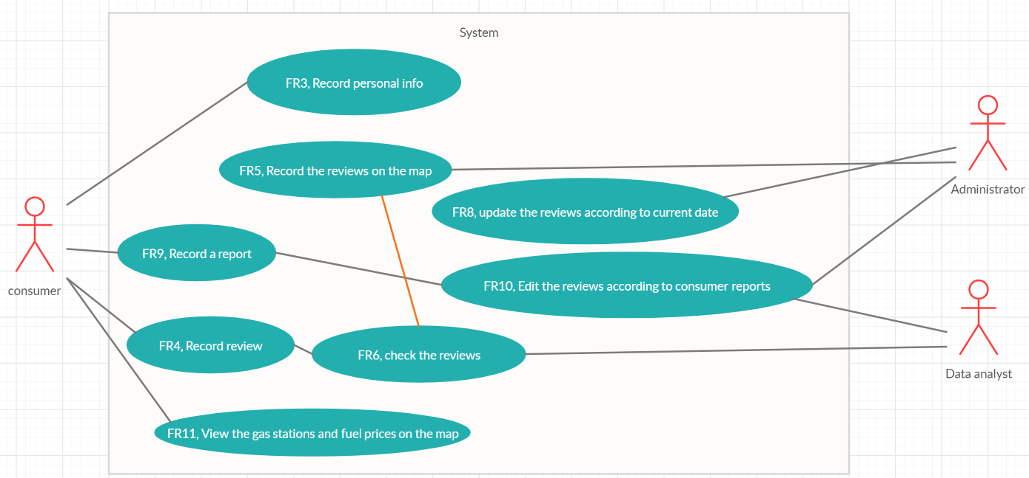

Use Cases
Use case 1, UC1 –FR3, Record personal info
Actors Involved | Consumer
Precondition | Consumer C exists, C.personalAccount_pre.exists() == false
Post condition | C.personalAccount_post.exists() == true
Nominal Scenario | Consumer signs up and fills in his personal info, account is added on the database.
Variants

Use case 2, UC2 –FR4, Record review
Actors Involved | Consumer
Precondition | Consumer C exists, C.personalAccount_pre.exists() == true, gas station G exists, fuel prices P exists,  (G.loaction.exists() == true || G.location.exists()==false)
Post condition | G.location.exists() == true  G.P.quantity_post>G.P.quantity_pre  G.quantity_post>=G.quantity_pre
Nominal Scenario | Consumer, selects the gas station that he visited, and adds a price review.  If the gas station is not shown on the application, then the consumer automatically records his fuel price review and the gas station’s location
Variants

Use case 3, UC3 –FR9, Record a repost
Actors Involved | Consumer
Precondition | Consumer C exists, C.personalAccount_pre.exists() == false
Post condition | C.personalAccount_post.exists() == true  personalAccount_quantity_pre < personalAccount_quantity_post
Nominal Scenario | Consumer signs up and fills in his personal info, account is added on the database.
Variants

Use case 4, UC4 –FR5, Record the reviews on the map
Actors Involved | Consumer, Data analyst, Administrator
Precondition | Consumer C exists, Data analyst D exists, Administrator A exists,  NewCheckedAndAcceptedReviews.count() > 0, map M exists.
Post condition | M.quantityReviews_pre < M.quantityReviews_post  NewCheckedAndAcceptedReviews.count() == 0
Nominal Scenario | After the consumers submit their reviews, and after that the reviews are quality checked by the data analyst, the accepted reviews are added to NewCheckedAndAcceptedReviews. Then, the administrator will add these reviews on the map.
Variants

Use case 5, UC5 –FR6, check the reviews
Actors Involved | Consumer, Data analyst, Administrator
Precondition | Consumer C exists, Data analyst D exists, Administrator A exists,  NewCheckedAndAcceptedReviews.count() > 0, map M exists.
Post condition | M.quantityReviews_pre < M.quantityReviews_post  NewCheckedAndAcceptedReviews.count() == 0
Nominal Scenario | After the consumers submit their reviews, and after that the reviews are quality checked by the data analyst, the accepted reviews are added to NewCheckedAndAcceptedReviews. Then, the administrator will add these reviews on the map.
Variants

Use case 6, UC6 – FR8, Update the reviews according to current date
Actors Involved | Administrator
Precondition | Administrator A exists, map M exists, reviews R exists  M.lastUpdate.Date()< today.Date()
Post condition | M.lastUpdate.Date() == today.Date()
Nominal Scenario | The reviews on the map are updated constantly by the administrator in order to get rid of old outdated data, cause Fuel prices change and gas station might get closed for good.
Variants

Use case 7, UC7 – FR10, Edit the reviews according to consumer reports
Actors Involved | Consumer, Data analyst, Administrator
Precondition | Consumer C exists, Data analyst D exists, Administrator A exists,  Reports R exists, New_reports.quantity()>0
Post condition | reports_quantity_Pre< reports_quantity_Post  New_reports.quantity() == 0
Nominal Scenario | After that the consumers submit their reports, the quality of the reports are checked by the data analyst and then the accepted reports are added to New_reports.  Then, the Administrator will add these reports and edit the concerned gas station according to the report.
Variants

Use case 8, UC8 – FR11, View the gas stations and fuel prices on the map
Actors Involved | Consumer
Precondition | Consumer C exists, Map M exists, Gas station G exists, Fuel price F exists
Post condition
Nominal Scenario | The consumer opens the map and searches for gas stations and fuel prices
Variants

Relevant scenarios
Scenario 1
Scenario ID: SC1 | Corresponds to UC2
Description | Consumer submits a review about a certain gas station
Precondition | Account of C exists.  Gas station does not exist.
Post condition | Gas station exists
Step# | Step description
1 | Consumer is currently at a certain gas station, buying fuel
2 | Consumer logs into his account
3 | Consumer tries to find that certain gas station, but can’t find it
4 | Consumer clicks a button to upload the gas station’s coordinates and uploads the fuel prices.

Scenario 2
Scenario ID: SC2 | Corresponds to UC2
Description | Consumer submits a review about a certain gas station
Precondition | Account of C exists.  Gas station exists.
Post condition | Gas station exists
Step# | Step description
1 | Consumer is currently at a certain gas station, buying fuel
2 | Consumer logs into his account
3 | Consumer tries to find that certain gas station and succeeds
4 | Consumer clicks a button to upload the fuel prices.

Scenario 3
Scenario ID: SC3 | Corresponds to UC8
Description | Consumer wants to view the gas stations on the map, and their fuel prices
Precondition | Account of C exists.  Gas station G exists.  Account of C exists.  Reviews on the map exist.
Post condition
Step# | Step description
1 | Consumer opens the application
2 | Consumer logs into his account
3 | Consumer observes the map
4 | Consumer clicks on a certain gas station and checks the corresponding fuel prices.

Scenario 4
Scenario ID: SC4 | Corresponds to UC5
Description | Data analyst checks the quality of the reviews.
Precondition | Past Records PR exist.  New Records NR exist.
Post condition | NR = null
Step# | Step description
1 | Data analyst receives the new Reviews
2 | Data analyst studies the new data and compares them to the old data
3 | Data analyst removes the outliers (bad data) from the set of new reviews
4 | Data analyst sends the set of new reviews (the correct one) to the administrator in order to record them on the map.

