Giuliano Ettore – s226285 (Bachelor) s280163 (Master)

EZGas application requirements

Abstract:

EzGas will be a crowdsourcing service that allows users to collect prices of fuels in different gas stations and it will locate gas stations in an area, along with the prices they pratice.

Stakeholders:
Stakeholder name | Description
Gas station owner | Uses the application to promote his own activity and to monitor prices of competitors
Customer user | Uses the application in order to know if there is a nearby gas station and to know different prices when needed

Context diagram and interface:
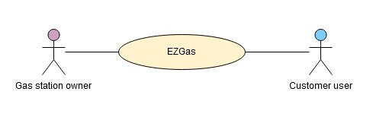

Actor | Logical Interface | Physical interface
Gas Station Owner | GUI – seller version | PC
Customer User | GUI – customer version | PC

Personas and stories:

Micheal desires to have a way to have cheap gas but the prices change a lot each day. He doesn’t want to travel among gas stations everytime in order to check the prices.

Jim is a gas station owner. He wants to check his competitor’s prices in order to make a good deal without losing too much money.

Scenarios, cases and case diagram:
Scenario 1
Description | Gas prices get lower, Jim needs to update his prices
Precondition | Jim has a lower prices, but anyone knows
Postcondition | Jim has lower prices, and it’s sponsored on EZGas
Step 1 - | Jim log into his own EZGas account
Step 2 - | Jim select the current prices of his gas and publish

Scenario 2
Description | Micheal is out of gas and want cheap prices
Precondition | Micheal doesn’t know where the gas is cheaper
Postcondition | Micheal has detailed information about his area’s stations
Step 1 - | Micheal log into his customer EZGas account
Step 2 - | Micheal select his location and the desired filters (area range, desired prices)
Step 3 - | Micheal can leave a feedback after the service

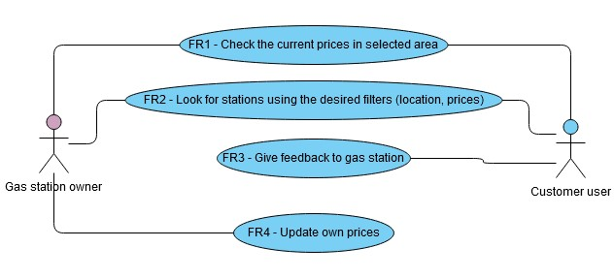
Functional requirements:

Functional requirement | Description
FR1 | Check the current prices in selected area
FR2 | Look for stations using the desired filters
FR3 | Give feedback to gas station (only customers)
FR4 | Update own prices (only owners)

Non-functional requirements:

Non-functional requirement | Type | Description
NFR1 | Performance | Even with a lot of stations and filters, any research can’t take more than 5 seconds
NFR2 | Statistics | Give the user and the owner the statistics about prices for each gas station and the trend in the area
NFR3 | GUI | The application should be easy to understand and to use
NFR4 | Usability | The application is easy to install
NFR5 | Contact | A way to contact the station

