EZGas Requirements Document

Author : Maxime Manassero
Date : 04/04/2020
Version : 2
Version | Changes
2 | Added Glossary  Added FR1.5 and FR1.6  Fixed NFR4 and NFR6

Contents
Abstract 2
Stakeholders 2
Context Diagram and interfaces 2
Context Diagram 2
Interfaces 3
Stories and personas 3
Functional and non-functional requirements 4
Functional Requirements 4
Non-functional requirements 4
Use case diagram and use cases 5
Use case diagram 5
Use cases 5
Relevant scenarios 8
Glossary 9

Abstract

Every people who own a car need to refuel their vehicle regularly, however fuels’ costs may be very variable from one gas station to another.
The idea is to create an application based on the crowdsourcing principle ; each user of the application will have the possibility to collect prices of fuels in different stations, to locate gas stations near his position and have the prices related to these stations.

Stakeholders

Stakeholder name | Description
User (driver) | Use the application to have information on gas stations’ locations and prices but also to update these information.
Station managers | Do not use the application directly. They are interested by the information on the application because it may have an influence on their turnover.
Developer | They represent a little part of the users, they help to improve and to provide maintenance of the application.
Administrator | Helps users who have troubles with their personal accounts, moderates the comportment of certain users (he can remove the account of a troublemaker)
Map system | A system like google maps can be used.
Data base | Contains all information about stations and prices.

Context Diagram and interfaces

Context Diagram

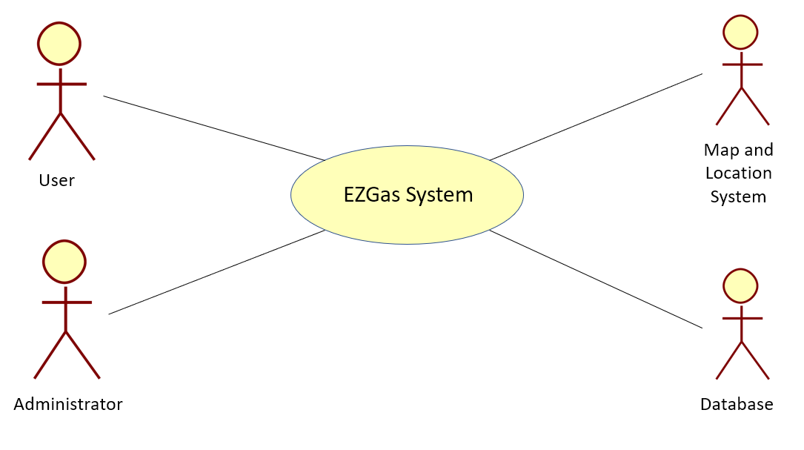

Interfaces

Actor | Logical Interface | Physical Interface
User | GUI | Screen, keyboard
Map System | API | Internet network
Database | Data exchanged | Internet network

Stories and personas

John often travels by his personal car; he simply wants to save some money on his gasoline budget. He is not really interested by participating to the life of the application, he just wants to have the information and use the app functionalities without being forced to update the application’s database.
He wants an application which is easy to use, and which can work without creating a personal account.

Monica is a user of social networks, she likes this spirit of sharing information, she is particularly interested in crowdsourcing systems. She therefore wants to invest in the application by updating the data each time she visits a petrol station.
She wants to have a personal account on the application, to have the possibility to save her favourites gas stations and be informed when the prices of fuels are particularly low in these stations.

Steven is wealthy person; he doesn’t really care about the prices of fuels. Steven is only interested by the gas station location service; he doesn’t want to lose time by searching a station. So, he wants an application which indicates all the stations available at a certain distance of his position without being polluted by tones of information which he doesn’t care.

Jessica is at the head of a small delivery company and she doesn’t have significant funds. Her employees are on the road all the day, so gasoline represents a huge source of expense. She dreams of an application which would allow her to search stations by prices. Thanks to such an application, she could make significant savings.

Marc is the manager of a gas station, he claims to have the lowest prices in the sector, he would like to compete by posting his prices on the application so that potential customers can compare prices and realize that his station is actually the cheapest.

Functional and non-functional requirements

Functional Requirements

Requirement ID | Description
FR1 | Access the information provided by the application
FR1.1 | Display stations within a radius of 10 km
FR1.2 | Display prices of a station by selecting it
FR1.3 | Indicate station breaking
FR1.4 | Search stations by distance
FR1.5 | Search stations by prices
FR2 | Allow members to update the information
FR3 | Allow members to save their favourites stations
FR4 | Give “veracity points” to an information
FR5 | Send notifications to members concerning their favourites stations
FR6 | Authorize and authenticate
FR6.1 | Create an account
FR6.2 | Log in
FR6.3 | Log out
FR7 | Ban the account of a user

Non-functional requirements

Requirement ID | Type | Description
NFR1 | Usability | Application should be used with no training by any non-member user
NFR2 | Performance | Function FR1.1 less than 1 sec
NFR3 | Performance | All functions less than 0.5 sec
NFR4 | Portability | Application runs on Android, iOS, Chrome and Mozilla
NFR5 | Privacy | Members’ data should be private
NFR6 | Reliability | Less than 5% of failure (bug, crash, …)

Use case diagram and use cases

Use case diagram

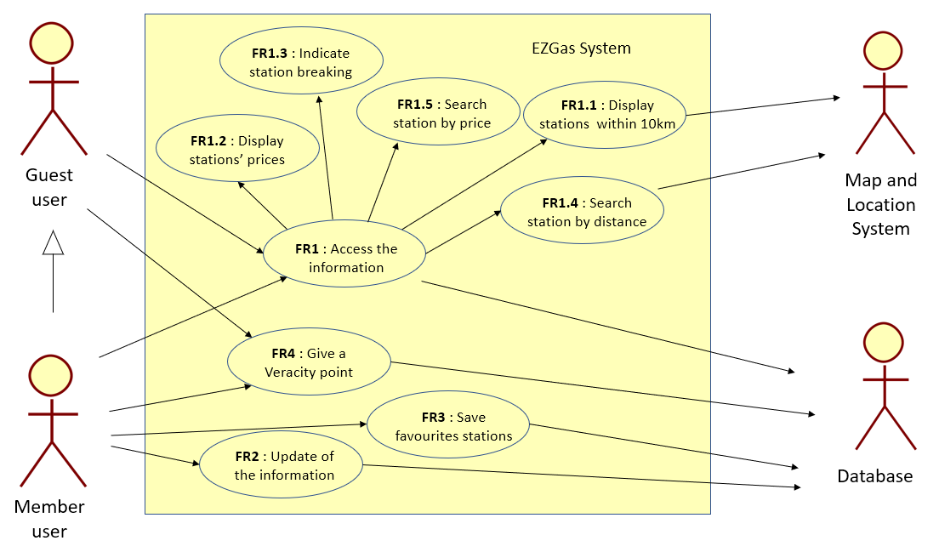

Use cases

Use case 1.1, UC1.1-FR1.1 : Display stations within a radius of 10km
Actor | All users
Precondition | Internet connection, nearby stations
Postcondition | Map with stations displayed on the screen
Nominal Scenario | User open the application, he is located on the map, all stations around appear on the map
Variants

Use case 1.2, UC1.2-FR1.2 : Display prices of a station by selecting it
Actor | All Users
Precondition | Internet connection, station existing
Postcondition | Station’s page displayed (with prices)
Nominal Scenario | User finds the station on the map, he clicks on it icon, information appear on the screen
Variants | User enters the name of the station in the search engine, he selects the right one, information appear on the screen

Use case 1.3, UC1.3-FR1.3 : Indicate station breaking
Actor | All users
Precondition | Internet connection, station existing, station has no more gasoline
Postcondition | Message displayed on the screen
Nominal Scenario | User selects a station, the station has no more gasoline, a message appears on the screen “station breaking”
Variants | User goes to a station, the station has no more gasoline, he can declare a station breaking (if he is member)

Use case 1.4, UC1.4-FR1.4 : Search stations by distance
Actor | All users
Precondition | Internet connection, stations existing at the distance selected
Postcondition | Station list displayed on the screen
Nominal Scenario | User selects an interval of distance, a list of stations in the interval appears on the screen
Variants

Use case 1.5, UC1.5-FR1.5 : Search stations by prices
Actor | All users
Precondition | Internet connection, stations existing at the prices selected
Postcondition | Station list displayed on the screen
Nominal Scenario | User selects an interval of prices, a list of stations in the interval appears on the screen (stations are sorted by distance)
Variants

Use case 2, UC2-FR2 : Allow members to update the database
Actor | Member user
Precondition | Internet connection, have an account
Postcondition | Station’s prices updated or new station created
Nominal Scenario | Member user selects the station, he clicks on the “update” button, he sets the new prices
Variants | Member user search a station which is not in the database, he clicks on the button ”create station”, he locates the station, he sets prices’ information

Use case 3, UC3-FR3 : Allow members to save their favourites stations
Actor | Member user
Precondition | Internet connection, have an account
Postcondition | Favourite station list updated
Nominal Scenario | Member user select a station, he clicks on the star icon
Variants

Use case 4, UC4-FR4 : Give “veracity points” to an information
Actor | All users
Precondition | Internet connection
Postcondition | Number of veracity points updated
Nominal Scenario | User goes to the station, he selects the station, the information are right, he clicks on the “like” button
Variants | User goes to the station, he selects the station, the information are wrong/out of date, he clicks on the “dislike” button (or he can update them if he is member)

Use case 5, UC5-FR5: Send notifications to members concerning their favourites stations

Actor | All users
Precondition | Internet connection, have an account with stations saved as favourites
Postcondition | Notifications sent
Nominal Scenario | User goes to the setting menu of his account, he clicks on “manage notifications”, he chooses what kind of notification he wants to receive
Variants

Use case 6, UC6-FR6: Authorize and authenticate

Actor | All users
Precondition | Internet connection
Postcondition | Have access to personal account
Nominal Scenario | User clicks on the “sign in” button, he enters his personal information, he can log in and log out at any moment
Variants

Use case 7, UC7-FR7: Ban the account of a user
Actor | Administrator
Precondition | Internet connection, a member user causes troubles
Postcondition | Account banned
Nominal Scenario | Administrator repair a troublemaker, he selects his account, he bans the account
Variants

Relevant scenarios

Scenario 1
Scenario ID : SC1 | Corresponds to UC1.2
Description | Display prices of an existing station by selecting it on the map
Precondition | Internet connection, station exist on the database
Postcondition | Station’s prices displayed on the screen
Steps | Step description
1 | The app locates the user
2 | Stations around appear on the screen
3 | He selects one of them
4 | Its prices are displayed

Scenario 2
Scenario ID : SC2 | Corresponds to UC1.2
Description | Display prices of an existing station by enter it name
Precondition | Internet connection, station exist on the database
Postcondition | Station’s prices displayed on the screen
Steps | Step description
1 | User enters the name of a station in the search engine
2 | He selects the station
3 | Its prices are displayed

Scenario 3
Scenario ID : SC3 | Corresponds to UC1.2
Description | Searching a station absent of the database
Precondition | Internet connection, station doesn’t exist on the database
Postcondition | Message displayed on the screen
Steps | Step description
1 | User enters the name of a station in the search engine
2 | The station doesn’t exist
3 | A message offers him to create this station

Glossary

