OFFICIAL REQUIREMENTS DOCUMENT
Author: Alkis Koudounas
Date: 28/03/2020
Contents:
Abstract 1
Stakeholders 1
Context Diagram 1
Interfaces 1
Stories and personas 2
Functional Requirements 2
Non functional Requirements 3
Use Case Diagram 3
Use cases: 4
Relevant Scenarios 6
Abstract:
Everyone wants to know where to refuel in the most convenient gas station of the zone, without spending ages finding it.
EZGas collects all the updated prices, provided by drivers and owners of gas stations. Then, based on the position of the user, the application can show the best solutions.
Stakeholders:
STAKEHOLDER NAME | DESCRIPTION
Driver | The user that directly use the app in order to know the best gas prices in the zone and updates them in case of inconsistency.
Gas Station owner | The one that can update prices, obtaining a certificate of veracity
Maps System | The system through which the app can show the gas stations available
Administrator | The person who mantains the application

Context Diagram:
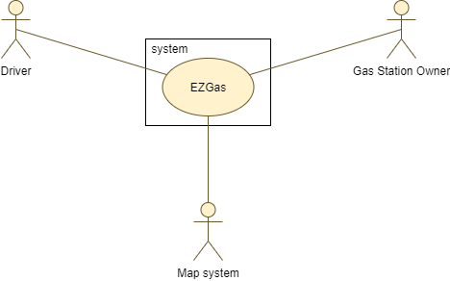
Interfaces:
ACTOR | LOGICAL INTERFACE | PHYSICAL INTERFACE
Driver | GUI | Smartphone display, touch screen
Gas Station owner | GUI | Smartphone display, touch screen, Screen, Keyboard
Map System | API | Network
Stories and personas:
Lorenzo is a sales agent. He drives for miles every day so he needs to stop several times during his working hours in order to refuel his car. Lorenzo understood that it was a good idea to take note of the best pricing gas stations in order to remember them for the next time. Day by day he noticed that the prices were not fixed so he thought that it could be useful to have a community of people keeping track of the prices all over the country. Lorenzo created a forum in order to share his notes about the prices and the places where he was used to refuel.
Giovanni is a truck driver. He discovered the forum created by Lorenzo and he considered that it could be useful for his long trips. Since he didn’t have time to write on the forum in order to update the prices, he decided not to sign up to it.
Maurizio is a gas station owner. He noticed that his earnigs were not so satisfying so he decided to lower his prices. The problem was that, in order to increase his income, he needed expensive sponsorships and he would know a cheaper way to gain visibility.

Functional Requirements:
ID | Description
FR 1 | The driver searches gas stations
FR 1.1 | The driver filters gas stations by distance
FR 1.2 | The driver filters gas station by price
FR 2 | Driver can register to the service
FR 3 | Driver logs in
FR 3.1 | The driver can update prices related to a gas station only if he is registered and logged in
FR 4 | Gas station owner can register to the service
FR 5 | The gas Station owner logs in
FR 5.1 | The gas station owner can confirm the updated prices only if he is registered and logged in
FR 5.2 | The gas station owner can update the prices only if he is registered and logged in
FR 6 | Gas station owner claims a gas station

Non functional Requirements:
ID | Type (efficiency, reliability, .. see iso 9126) | Description | Refers to
NFR1 | Usability | GUI must be user-friendly | All FRs
NFR2 | Portability | The application must be deployed on portable devices | All FRs
NFR3 | Reliability | The application must avoid crashes | All FRs
NFR4 | Functionality | Data must be consistent | All FRs
NFR5 | Performance | All functions must be completed in < 1 sec | All FRs
Use Case Diagram:
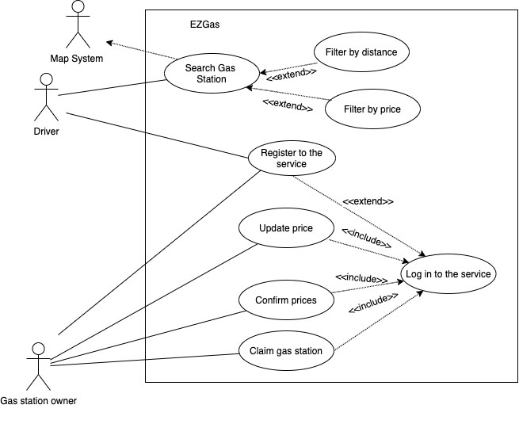

Use cases:
UC1: FR 1, FR 1.1, FR 1.2
Actors involved | Driver
Pre-condition | Internet and Gps connections and Map System work
Post-conditions | Get results
Nominal Scenario | Driver wants to retrieve informations about the stations
UC2: FR 2
Actors involved | Driver
Pre-condition | Driver account doesn’t exist
Post-conditions | Driver account exists
Nominal Scenario | Driver inserts Username, email and password, the account is created automatically by the system
Variants | Driver inserts Username or password already used
UC3: FR 3.1
Actors involved | Driver
Pre-condition | Prices are outdated
Post-conditions | Prices are temporarly updated and waiting for certification
Nominal Scenario | Driver notices that the prices related to a gas station are outdated so he updates them
UC4: FR 4
Actors involved | Gas station owner
Pre-condition | Gas station owner account does not exist
Post-conditions | Gas station owner account exists
Nominal Scenario | A gas station owner inserts Username and Password and presses Log in button
Variants | The gas station owner inserts Username or password already used
UC5: FR 5.1
Actors involved | Gas station owner
Pre-condition | Gas station prices are updated by a driver but not certified
Post-conditions | Gas station prices are certified
Nominal Scenario | Gas station owner checks and confirms prices
Variants | Gas station owner checks and updates wrong prices
UC6: FR 5.2
Actors involved | Gas station owner
Pre-condition | Prices are outdated and gas station owner has an account
Post-conditions | Prices are updated
Nominal Scenario | Gas station owner checks and confirms prices
Variants | Gas station owner notices that the prices related to his gas station are outdated so he updates them
UC7: FR 6
Actors involved | Gas station owner
Pre-condition | A gas station has not a certified owner
Post-conditions | The gas station has a certified owner
Nominal Scenario | Gas station owner decides to gain the possibility to certify its prices
Variants | Gas station owner claims a wrong gas station

Relevant Scenarios:
Scenario 1: Corresponds to UC 3
Scenario ID | SC1
Description | The driver notices an outdated price and decides to update it
Pre-condition | Price is outdated
Post-condition | Price is updated
Steps | Step description
1. | The driver selects the gas Station
2. | The driver selects the “Update Price” button
3. | The driver inserts the new price
4. | The driver submits the modification
5. | The price is updated but not certified
Scenario 2: Corresponds to UC 5
Scenario ID | SC2
Description | The gas station owner receives the modifications
Pre-condition | Price is updated but not certified
Post-condition | Price is correctly updated
Steps | Step description
1. | The gas station owner selects the request
2. | The gas station owner confirms the prices
3. | The prices are correctly updated

Scenario 3: Corresponds to UC 5
Scenario ID | SC3
Description | The gas station owner receives the modifications
Pre-condition | Price is updated but wrong
Post-condition | Price is correctly updated
Steps | Step description
1. | The gas station owner selects the request
2. | The gas station owner changes the prices
3. | The prices are correctly updated

