EZGas Requirement Document
Software Engineering (04GSPOV), a.a. 2019/2020 – BRESSANI Roberto s270079
Summary
Abstract 2
Stakeholders 2
Context diagram and interfaces 2
Context diagram 2
Interfaces 2
Personas and stories 3
Personas 3
PERSONA 1: “One-time user” 3
PERSONA 2: “Every-day user” 3
PERSONA 3: “Looking for customers” 3
Stories 3
“One-time user” 3
“Every-day user” 3
“Looking for customers” 3
Scenarios, use case, use case diagram 4
Use case diagram 4
Use cases 4
Use Case 1 – FR 1-2 Assist user in choosing and reaching the gas station 4
Use Case 2 – FR 4, 11 insertion of a new gas station 4
Use Case 3 – FR 5-10 insertion /update of data about a gas station 4
Use Case 4 – FR 12 remove a gas station 5
Scenarios 5
Scenario 1 5
Scenario 2 5
Scenario 3 5
Scenario 4 6
Scenario 5 6
Scenario 6 6
Scenario 7 6
Functional requirements 7
Non-functional requirements 7

Abstract
EZGas is a crowdsourcing service that allows users to:
- collect prices of fuels in different gas stations
- locate gas stations in an area, along with the prices they practice.
EZGas want to provide a web-based platform to provide user a way to find the best gas station in the area, collect all information about these and let share with the community opinions about reliability of information provided.

Stakeholders
Users:
- gas station users (profile 1)
- gas station owner (profile 2)
Administrators:
- EZGas account administrator (profile 3)
- EZGas DBMS administrator (profile 4)
Buyer:
- EZGas CEO or CTO
Developer
Map system

Context diagram and interfaces

Context diagram
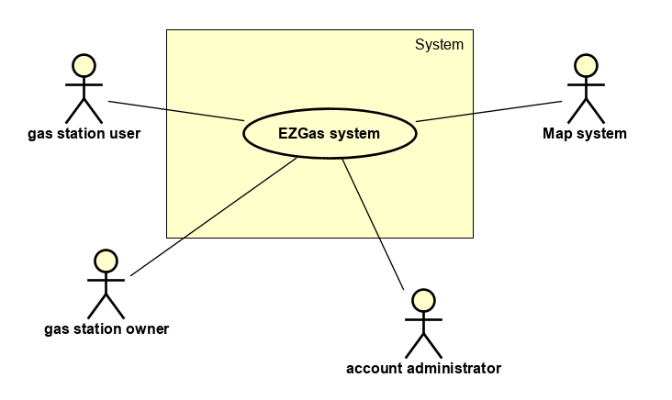

Interfaces
Actor | Logical interface | Physical
Gas station user | GUI | Screen, keyboard
Gas station owner | GUI | Screen, keyboard
Account manager | GUI | Screen, keyboard
Map system | Data (XML) and PDL | Network

Personas and stories

Personas

PERSONA 1: “One-time user”
Tom, 25 years. Student.
Last summer at the seaside met a girl from another city and got engaged.

PERSONA 2: “Every-day user”
Paul, 52 years. Business manager.
Because of his job, he has to travel to different countries every day. His timetable is rigorous and he must always be punctual.

PERSONA 3: “Looking for customers”
Cristopher, 61 years. Owner of a gas station in a secondary road.
Since the new highway has been built, its activity is losing money due to the scarcity of customers.
His daughter told him about EZGas platform, but he is not a technology expert.

Stories

“One-time user”
It’s Saturday afternoon. Tom wants to go to visit Mary. He runs out of fuel in a city he doesn’t know well. Unfortunately, the gas station he always uses is closed. He is looking forward to seeing his girlfriend and so he doesn’t want to lose much time searching for another gas station, but he also wants to save as money as possible to offer a pizza to her.
So, by connecting to EZGas website he can get in less than a minute the nearest cheap gas station.

“Every-day user”
It’s a common workday, Paul has to meet an important customer in a few minutes. Reaching the destination, he runs out of fuel and has no time to lose. The only thing he wants is to get the nearest gas station.
So, thanks to EZGas, he is able to know that right in the corner street he can find a gas station and can reach his customer at the scheduled time, concluding the best deal he has never done.

“Looking for customers”
It’s the same boring day at the gas station. No customers have arrived in the last two hours and he wants to challenge its technological skills.
So, after seeing a short video on EZGas, he can register his activity on the platform and attract more customers.
After few days, his gain has increased by 20%.

Scenarios, use case, use case diagram

Use case diagram
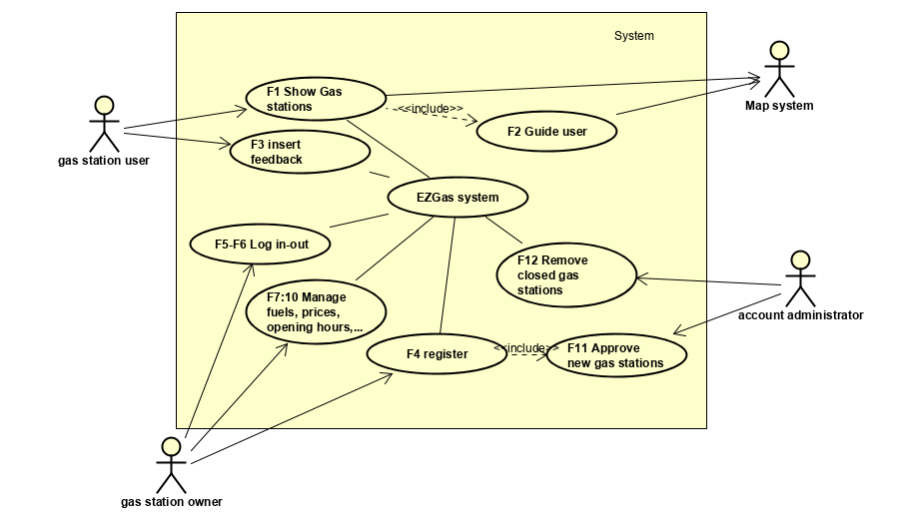

Use cases

Use Case 1 – FR 1-2 Assist user in choosing and reaching the gas station
Actors Involved | User, map system
Precondition | System has already information about the needed gas station
Postcondition | User gets to the gas station
Nominal scenario | User insert its position, gets the map with all gas stations in the area, selects most suitable gas station, uses map system to reach it
Variants | User knows by itself the best route, gas station is not there or has not the needed services

Use Case 2 – FR 4, 11 insertion of a new gas station
Actors Involved | Owner, account administrator
Precondition
Postcondition | Owner gets an account
Nominal scenario | Owner fills in data about himself and basic info about the gas station (company, address). Account administrator gets the request, does some check about data (by person or in other ways), accepts the request and activate the account
Variants | Data of the gas station are not valid

Use Case 3 – FR 5-10 insertion /update of data about a gas station
Actors Involved | Owner
Precondition | Owner has an account
Postcondition | Data about the gas station is updated
Nominal scenario | Owner logs in, enters type of fuels available, prices, opening hours and self-service availability, lists facilities and other service, saves changes and logs out
Variants | Authentication error

Use Case 4 – FR 12 remove a gas station
Actors Involved | Owner, account administrator
Precondition | Feedback received about closing of a gas station
Postcondition | Gas station is removed
Nominal scenario | Administrator considers the request, contact the owner and do some checks. Remove the account and the gas station
Variants | Feedback comes up to be not true

Scenarios

Scenario 1
Scenario ID | SC1
Corresponding Use Case | UC1 Assist user in choosing and reaching the gas station
Precondition | System has already information about the needed gas station
Post condition | User gets to the gas station
Step # | Description
1 | User insert its position
2 | User gets the map with all gas stations in the area
3 | User selects most suitable gas station
4 | User uses map system to reach it (optional)

Scenario 2
Scenario ID | SC2
Corresponding Use Case | UC1 Assist user in choosing and reaching the gas station
Precondition | System has already information about the needed gas station
Post condition | New feedback provided
Step # | Description
1 | User insert its position
2 | User gets the map with all gas stations in the area
3 | User selects most suitable gas station
4 | User uses map system to reach it (optional)
5 | User gets to the indicated place, but information is not correct (closed, there is no desired fuel, …)
6 | User inserts a new feedback about the gas station

Scenario 3
Scenario ID | SC3
Corresponding Use Case | UC2 insertion of a new gas station
Precondition
Post condition | Owner has an account
Step # | Description
1 | Owner fills in data about himself, gas station’s company and address
2 | Administrator does checks and approve
3 | Activate account

Scenario 4
Scenario ID | SC4
Corresponding Use Case | UC2 insertion of a new gas station
Precondition
Post condition
Step # | Description
1 | Owner fills in data about himself, gas station’s company and address
2 | Administrator does checks and rejects
3 | Request is removed and owner notified

Scenario 5
Scenario ID | SC5
Corresponding Use Case | UC3 insertion /update of data about a gas station
Precondition | Owner has an account
Post condition | Information about the gas station updated
Step # | Description
1 | Owner logs in
2 | Enter type of fuels and prices
3 | Set opening hours and availability of self-service
4 | List facilities and other services
5 | Save changes
6 | Log out

Scenario 6
Scenario ID | SC6
Corresponding Use Case | UC4 remove a gas station
Precondition | Feedback received about closing of a gas station
Post condition | Gas station is removed
Step # | Description
1 | Administrator is notified analyses the feedback
2 | Owner is contacted
3 | Gas station and account are removed

Scenario 7
Scenario ID | SC7
Corresponding Use Case | UC4 remove a gas station
Precondition | Feedback received about closing of a gas station
Post condition
Step # | Description
1 | Administrator is notified analyses the feedback
2 | Owner is contacted
3 | Feedback is not correct and it is deleted

Functional requirements
Requirement ID | Description
F1 | Show opened gas stations and their prices according to the fuel type needed
F2 | Guide user to the chosen gas station
F3 | Insert feedback
F4 | Register gas station (owner)
F5 | Log in (owner, account admin)
F6 | Log out (owner, account admin)
F7 | Manage type of fuels
F8 | Change prices
F9 | Manage opening hours and self-service availability
F10 | Manage facilities (bar, restaurant, …) and services (car-washing, mechanic, …)
F11 | Approve new gas stations (account admin)
F12 | Remove closed gas station

Non-functional requirements
Requirement ID | Type | Description
NF1 | Usability | Users can use the system with no tutorials provided
NF2 | Usability | Owners’ tutorial must be shorter than 10 minutes
NF3 | Performance | List of opened gas station must be provided within 1 second
NF4 | Portability | System must be used without distinction between mobile devices and PCs (adaptive GUI must me provided)
NF5 | Portability | No installation must be needed
NF6 | Implementation | System must provide a web application
NF6 | Privacy | No user’s personal data must be acquired

