Requirements document

Author: Gaetano Epiro s277875

Abstract

It is a common wish among who owns a car to know the best price of fuel sold by the gas station nearest to their house or to their workplace. Or they simply want to know where is the nearest gas station simply because they don’t have enough fuel.
Also professional drivers who travel across all Italy desire to know where is the nearest gas station during their trips on the highways and where to find the best price.

A group of students founded a startup to develop an application to help drivers save money for the fuel simply by using their smartphone.

Stakeholders

Stakeholder name | Description
Driver | Uses the EZGas application to find where is the most convinient gas station considering distance, fuel price or both
Gas station | Can use the application to reach more clients comparing their prices
Map service | Using the GPS system of the driver’s device, the map service can provide the maps to locate the stations
Analyst | Is interested in collecting data and retrieve informations about drivers habits

Context Diagram and Interfaces
------------------------------------------------------------------------------------------------------------------------
Context Diagram
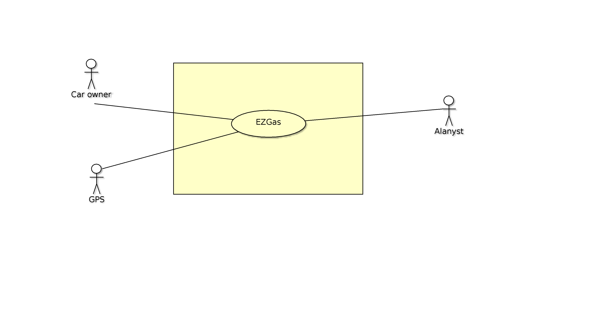
Interfaces

Actor | Logical Interface | Physicall Interface
Driver | GUI | Smartphone
Gas station | GUI | PC / Smartphone
GPS | API | GPS system of the smartphone
Analyst | Queries to database | Internet

Stories and personas

Ilaria lives in Milan and uses a scooter to go to work. For unknown reasons the gas station where she usually goes is closed and she hasn’t enough petrol to go to Mediaset offices.
Luckely she can use the EZGas application and find the nearest gas station without thinking to much about the price because at least she can go to work and conduct weather forecast.

Vincenzo is a truck drives who transports agricultural products from Sicily to Turin. Its company gives him a certain budget for the fuel and he has to cover any additional costs so he is concerned about the prices.
During its travel he can choose a destination and thanks to EZGas he can find the best price for fuel from all the gas stations on the highway.

Alberto is a student and a worker. This year managed to buy a car but since the pay is not very high he tries to save as much as he can. He wants to find the best price of the fuel for its car but also he doesn’t want to go crazy and travel miles to find the lowest price.
With the EZGas application he can find the lowest price in the gas station near to his house or to his working place.

Functional and non functional requirements
------------------------------------------------------------------------------------------------------------------------
Functional Requirements

Requirement ID | Description
FR1 | Insert username and password to log in
FR2 | Set the current position of the user
FR3 | User can set the fuel type of the vehicle the user is driving
FR4 | The application should show all the gas stations around the area where the user currently is
FR5 | The user can select the gas station with the lowest price
FR6 | The user can select the nearest gas station
FR7 | The application estimate which is the optimum gas station for lowest price and distance
FR8 | User can select a destination and the app shows the gas station with the lowest price in the way

Non Functional Requirements

ID | Type | Description | Refers to
NFR1 | Usability | Application should be used with no training | All FR
NFR2 | Performance | All functions should have a response time < 1 sec | All FR
NFR3 | Portability | The application runs on devices based on iOS and Android (5.0 and more recent) | All FR
NFR4 | Localisation | Prices can be converted into american dollars | FR5, FR7, FR8
NFR5 | Localisation | Language can be set to english | All FR
NFR6 | Privacy | The application must be GDPR compliant
NFR7 | Safety | Application can be used without interacting while driving | All FR

Use Cases

Use case 1: Register into the database

Actors involved | Driver
Pre-Condition | Install the application on the device
Post-Condition | User successifully registered
Nominal Scenario | The user inserts all the required fields to register inside the database and start using the application

Use case 2: Search the lowest price

Actors involved | Driver
Pre-Condition | Username and password are valid
Post-Condition | Show the gas station with lowest price
Nominal Scenario | User select the fuel used in its car and searches for the lowest price for that kind of fuel
Variants | More than one gas station have the same price

Use case 3: Select the nearest gas station

Actors involved | Driver
Pre-Condition | GPS is active and working
Post-Condition | Show the nearest gas station
Nominal Scenario | User searches the nearest gas station near its current position
Variants | User searches for the gas station nearest to a certain point of interest

Relevant scenarios

Scenario 1

Scenario ID: SC1 | Corresponds to UC2
Description | Driver need to fuel his car
Precondition | Driver is logged in
Postcondition | Driver can use the application
Step# | Step Description
1 | Launch the app and log in
2 | Activate the GPS
3 | Select to search the gas station with the lowest price
4 | Get the lowest price and where the gas station is

Scenario 2

Scenario ID: SC2 | Corresponds to UC3
Description | Driver need to fuel his car
Precondition | Driver is logged in
Postcondition | Driver can use the application
Step# | Step Description
1 | Launch the app and log in
2 | Activate the GPS
3 | Select to search fot the nearest gas station
4 | Get the nearest gas station

Glossary
