EZGas Requirement Document
Summary
Abstract 2
Stakeholders 2
Context Diagram and interfaces 3
Context Diagram 3
Interfaces 3
Stories and personas 4
Functional and non functional requirements 5
Functional Requirements 5
Non functional Requirements 5
Use Case Diagram and use cases 6
Use case diagram 6
Use cases 7
Use case 1, UC1 - FR1 Research gas stations 7
Use case 2, UC2 – FR2 Handle storing 7
Use case 3, UC3 – FR3 User account creation (User sign up) 7
Relevant scenarios 8
Scenario 1 8
Scenario 2 8
Scenario 3 8
Scenario 4 9
Scenario 5 9
Scenario 6 9
Scenario 7 10
Scenario 8 10
Scenario 9 10
Scenario 10 11
Scenario 11 11
Scenario 12 11
Scenario 13 12
Scenario 14 12
Scenario 15 12
Scenario 16 13
Glossary with Class Diagram 13
Glossary 13
Class Diagram 14

Abstract
Many drivers could store in their devices the localities of cheapest gas stations visited by them; moreover they could know the gas stations position (with their available fuels) which are located closer to their position. The EZGas application is a crowdsourcing application, i.e. an effort by users for users. A registered user can access in it with 'seeker' or 'collector' modality.
- 'Seeker' modality allows to find the gas stations, among those memorized in database system, that are cheaper and closer to a given position and/or that sell a given fuel type.
- 'Collector' modality allows to store in the own user space a gas stations position specified by the user, with fuels sold and their prices. In this way the 'collector' user can collect the gas stations that are more convenient for him. Note that all information stored in the user space will be copied in the database system in order to make searchable these information to 'seeker' user.

Stakeholders

Stakeholder name | Description
User | Use the application to sign up (if unregistered). They use the application (if registered) to collect prices of fuels in different gas stations (Collectors) or to localize gas stations in an area with a specific fuel with related price (Seekers)
Developer | Develops the application
Google Map | Checks the locations selected and it locates the gas stations in an area specified by user

Context Diagram and interfaces

Context Diagram

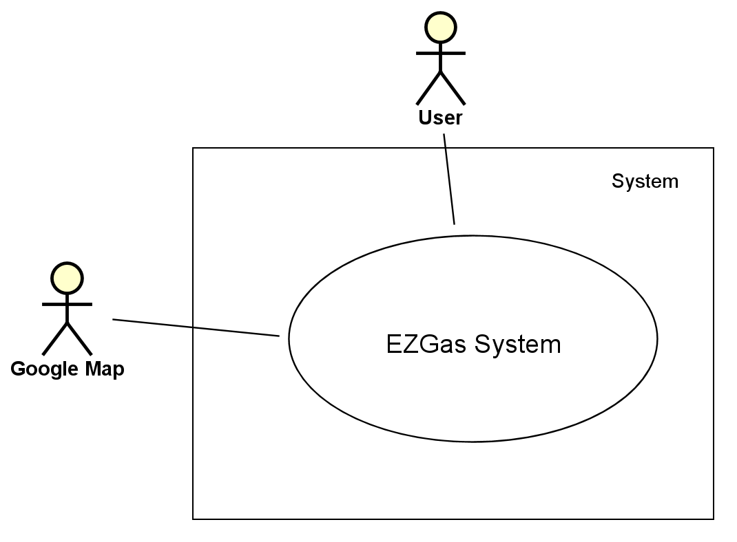

Interfaces

Actor | Logical Interface | Physical Interface
Unregistered User | GUI | Screen
Seeker | GUI | Screen
Collector | GUI | Screen
Google Map | WEB SERVICE | Internet Connection

Stories and personas

Sara is a nature lover. In order to avoid polluting, she has bought an electric car.
However it is not very easy for her to find gas stations that allow battery charging of her car. On Tuesday morning, she discovered a gas station that does it. So, she decides to note down it and to share this information with friends which have an electric car.
Sara would like to have a simple way to know nearest gas stations which sell electricity for cars. In addition, she would like to have a way to share these information with others that have an electric car.

Every morning, Giovanni must drive with his car a long way in order to reach his new work place.
The previous one was very near to his house, so he could reach it walking. For this reason, Giovanni has to pay more money for the fuel to go to work.
Giovanni would like to have a simple way to discover more convenient gas stations which sell the fuel type that he use.

Rita enjoys travelling and she drives with her family to her favorite destinations every week end. They are usually far from her house.
One day, while she is travelling, she realizes that the fuel in her car is low and she thinks she would get her supplies. However, Rita stays in a place unknown to her; she decides to ask for information to locals in order to discover nearest gas stations.
While Rita is travelling, she would like to have a simple way to discover nearest gas stations respect her current position.

Tom is a truck driver that must drive long ways to reach his destinations every day. On Wednesday afternoon, during an his travel he decides to do a break and refuel his transportation. Tom stops at a first gas station and he discovers that its prices are very convenient compared to gas station known by him. Tom notes down the location of this gas station and he informs his colleagues with messages and calls. This is very difficult for him because he has many colleagues.
Tom would like to have a simple way to share with colleagues the locations of cheaper gas stations.

Functional and non functional requirements

Functional Requirements

ID | subID | Description
FR1
 | FR1.1 | Start research gas stations with specific features (location, fuel, price) requested by user
 | FR1.2 | End of research
FR2
 | FR2.1 | Start storage gas station locality in the user space
 | FR2.2 | End of storage
 | FR2.3 | Start copy gas station locality from user space to the system database
 | FR2.4 | End of copy
 | FR2.5 | Start storage fuel type in the user space
 | FR2.6 | End of storage
 | FR2.7 | Start copy fuel type from user space to the system database
 | FR2.8 | End of copy
 | FR2.9 | Start storage fuel price in the user space
 | FR2.10 | End of storage
 | FR2.11 | Start copy fuel price from user space to the system database
 | FR2.12 | End of copy
FR3
 | FR3.1 | Start creation
 | FR3.2 | End creation

Non functional Requirements

ID | Type (efficiency, reliability, .. see iso 9126) | Description | Refers to
NFR1 | Usability | Application should be used by any driver | All FR
NFR2 | Performance | Functions should complete in < 0.5 sec | FR2
NFR3 | Performance | Functions should complete in < 1.0 sec | FR1
NFR4 | Portability | The application runs on Android | All FR
NFR5 | Portability | The application should be portable from a mobile phone to another one or a PC in less than 5 minutes | All FR
NFR6 | Privacy | The application must contains account and password for each user
NFR7 | Privacy | The application must satisfy all rules of GDPR (in order to protect the privacy of the users)

Use Case Diagram and use cases

Use case diagram

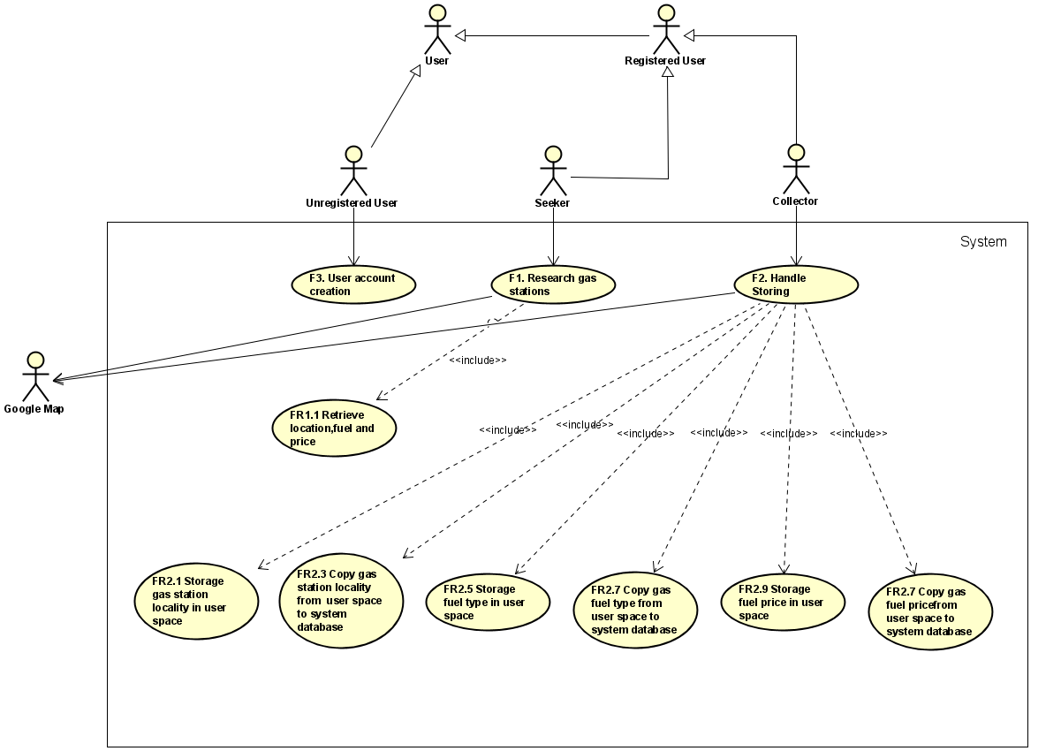

Use cases

Use case 1, UC1 - FR1 Research gas stations

Actors Involved | User Google Map
Precondition | User U registered and he log in as 'seeker'
Post condition
Nominal Scenario | User logs in as 'seeker', he insert the locality L (or he activates the GPS), the fuel F and its price P; the system provides a list of gas stations near L which sell F at a cost of at most P
Variants | Goggle Map doesn't found the locality (or user position), issue warning; User not insert the fuel and its price; User not insert the fuel price

Use case 2, UC2 – FR2 Handle storing

Actors Involved | User Google Map
Precondition | User U registered and he log in as 'collector'
Post condition | User space updated, System database updated
Nominal Scenario | User logs in as 'collector', he insert the locality L, the fuel F and its price; system store these information both on user space and on system database
Variants | Goggle Map doesn't found the locality (or user position), issue warning; Locality L is already present in the system database, update of fuel and price information (if available); User not insert the fuel and its price; user not insert the fuel price

Use case 3, UC3 – FR3 User account creation (User sign up)

Actors Involved | User Google Map
Precondition | User U is 'Unregistered user'
Post condition | Accounts database of the system updated
Nominal Scenario | User creates his account
Variants

Relevant scenarios

Scenario 1

Scenario ID: SC1 | Corresponds to UC1
Description | User searches gas stations next to a locality L
Precondition | User U registered and he logs in as 'seeker'
Post condition
Step# | Step description
1 | User logs in as 'seeker'
2 | User selects a locality L (or activates the GPS)
3 | Google map looks for the locality (or the user position)
4 | System returns a list of gas stations within a radius of 5km from the locality L (or user position)
5 | User logs out

Scenario 2

Scenario ID: SC2 | Corresponds to UC1
Description | User searches gas stations next to a locality L
Precondition | User U registered and he logs in as 'seeker'
Post condition
Step# | Step description
1 | User logs in as 'seeker'
2 | User selects a locality L (or activates the GPS)
3 | Google map doesn't find the locality (or the user position), issue warning

Scenario 3

Scenario ID: SC3 | Corresponds to UC1
Description | User searches gas stations next to a locality L with fuel type F
Precondition | User U registered and he logs in as 'seeker'
Post condition
Step# | Step description
1 | User logs in as 'seeker'
2 | User selects: a locality L (or activates the GPS), a fuel type F
3 | Google map looks for the locality (or the user position)
4 | System returns a list of gas stations within a radius of 5km from the locality L (or user position) and which sell fuel type F
5 | User logs out

Scenario 4

Scenario ID: SC4 | Corresponds to UC1
Description | User searches gas stations next to a locality L with fuel type F
Precondition | User U registered and he logs in as 'seeker'
Post condition
Step# | Step description
1 | User logs in as 'seeker'
2 | User selects: a locality L (or activates the GPS), a fuel type F
3 | Google map doesn't find the locality (or the user position), issue warning

Scenario 5

Scenario ID: SC5 | Corresponds to UC1
Description | User searches gas stations next to a locality L with fuel type F that has a price minus equal to P
Precondition | User U registered and he logs in as 'seeker'
Post condition
Step# | Step description
1 | User logs in as 'seeker'
2 | User selects: a locality L (or activates the GPS), a fuel type F and a price P
3 | Google map looks for the locality (or the user position)
4 | System returns a list of gas stations within a radius of 5km from the locality L (or user position) and which sell fuel type F at cost minus equal to P
5 | User logs out

Scenario 6

Scenario ID: SC6 | Corresponds to UC1
Description | User searches gas stations next to a locality L with fuel type F that has a price minus equal to P
Precondition | User U registered and he logs in as 'seeker'
Post condition
Step# | Step description
1 | User logs in as 'seeker'
2 | User selects: a locality L (or activates the GPS), a fuel type F and a price P
3 | Google map doesn't find the locality (or the user position), issue warning

Scenario 7

Scenario ID: SC7 | Corresponds to UC2
Description | User stores locality of gas station L in his user space and the system copies L in system database
Precondition | User U registered and he log in as 'collector', locality isn't present in system database
Post condition | System database updated, user space updated
Step# | Step description
1 | User logs in as 'collector'
2 | User selects: a locality L (or activates the GPS)
3 | Google map looks for the locality (or the user position)
4 | System stores locality L (or user position)
5 | System doesn't contain the locality L, it copies locality L in database system
6 | User logs out

Scenario 8

Scenario ID: SC8 | Corresponds to UC2
Description | User stores locality of gas station L in his user space and the system copies L in system database
Precondition | User U registered and he log in as 'collector', locality isn't present in system database
Post condition | User space updated, System database updated
Step# | Step description
1 | User logs in as 'collector'
2 | User selects: a locality L (or activates the GPS)
3 | Google map doesn't find the locality (or the user position), issue warning

Scenario 9

Scenario ID: SC9 | Corresponds to UC2
Description | User stores locality of gas station L in his user space and the system copies L in system database
Precondition | User U registered and he log in as 'collector', locality is already present in system database
Post condition | user space updated
Step# | Step description
1 | User logs in as 'collector'
2 | User selects: a locality L (or activates the GPS)
3 | Google map looks for the locality (or the user position)
4 | System stores locality L in the user space
5 | System database already contains the locality L, it is not updates
6 | User logs out

Scenario 10

Scenario ID: SC10 | Corresponds to UC2
Description | User stores locality of gas station L and a fuel type F in his user space and the system copies L and F in system database
Precondition | User U registered and he log in as 'collector', locality isn't present in system database
Post condition | System database updated, user space updated
Step# | Step description
1 | User logs in as 'collector'
2 | User selects: a locality L (or activates the GPS), a fuel type F
3 | Google map looks for the locality (or the user position)
4 | System stores locality L (or user position) with fuel type in the user space
5 | System doesn't contain the locality L, it copies locality L with fuel type F in database system
6 | User logs out

Scenario 11

Scenario ID: SC11 | Corresponds to UC2
Description | User stores locality of gas station L and a fuel type F in his user space and the system copies L and F in system database
Precondition | User U registered and he log in as 'collector', locality isn't present in system database
Post condition | User space updated, System database updated
Step# | Step description
1 | User logs in as 'collector'
2 | User selects: a locality L (or activates the GPS), a fuel type F
3 | Google map doesn't find the locality (or the user position), issue warning

Scenario 12

Scenario ID: SC12 | Corresponds to UC2
Description | User stores locality of gas station L and a fuel type F in his user space and the system copies L and F in system database
Precondition | User U registered and he log in as 'collector', locality is already present in system database
Post condition | user space updated
Step# | Step description
1 | User logs in as 'collector'
2 | User selects: a locality L (or activates the GPS)
3 | Google map looks for the locality (or the user position)
4 | System stores locality L with fuel type F in the user space
5 | System database already contains the locality L, it is not updates
6 | User logs out

Scenario 13

Scenario ID: SC13 | Corresponds to UC2
Description | User stores locality of gas station L, a fuel type F and its price in his user space and the system copies L, F and P in system database
Precondition | User U registered and he log in as 'collector', locality isn't present in system database
Post condition | System database updated, user space updated
Step# | Step description
1 | User logs in as 'collector'
2 | User selects: a locality L (or activates the GPS), a fuel type F and a price P
3 | Google map looks for the locality (or the user position)
4 | System stores locality L (or user position) , fuel type F and price P in the user space
5 | System doesn't contain the locality L, it copies locality L with fuel type F and its price P in database system
6 | User logs out

Scenario 14

Scenario ID: SC14 | Corresponds to UC2
Description | User stores locality of gas station L, a fuel type F and its price in his user space and the system copies L, F and P in system database
Precondition | User U registered and he log in as 'collector', locality isn't present in system database
Post condition | User space updated, System database updated
Step# | Step description
1 | User logs in as 'collector'
2 | User selects: a locality L (or activates the GPS), a fuel type F and a price P
3 | Google map doesn't find the locality (or the user position), issue warning

Scenario 15

Scenario ID: SC15 | Corresponds to UC2
Description | User stores locality of gas station L, a fuel type F and its price in his user space and the system copies L, F and P in system database
Precondition | User U registered and he log in as 'collector', locality is already present in system database
Post condition | user space updated
Step# | Step description
1 | User logs in as 'collector'
2 | User selects: a locality L (or activates the GPS), a fuel type F and a price P
3 | Google map looks for the locality (or the user position)
4 | System stores locality L (or user position) , fuel type F and price P in the user space
5 | System database already contains the locality L, it is not updates
6 | User logs out

Scenario 16

Scenario ID: SC16 | Corresponds to UC3
Description | User creates an account
Precondition | User U is unregistered
Post condition | Accounts database of the system updated
Step# | Step description
1 | Start sign up
2 | Insert username
3 | Set password
4 | End sign up

Glossary with Class Diagram

Glossary

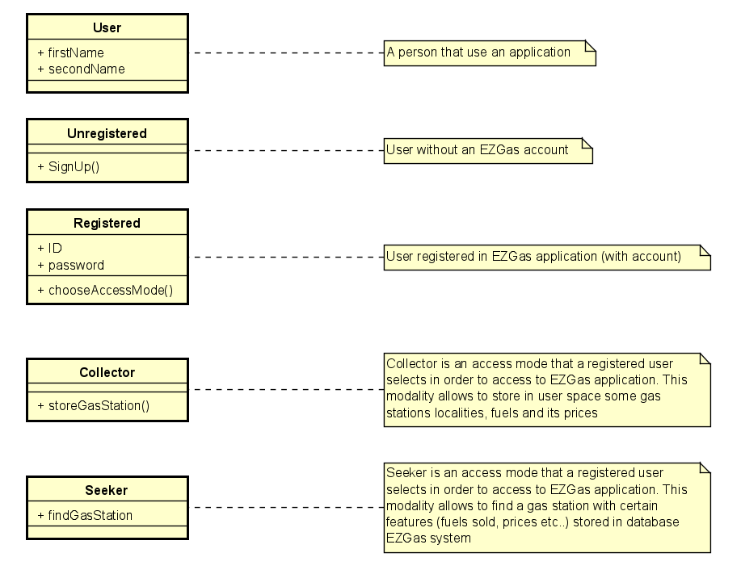

Class Diagram

