Requirement document
Abstract
A group of neighbours (which are car drivers) want know the different prices of the fuel stations around them: in order to do that, whenever one of them go in a flue station, he collect the current price of each flue type and share it with the station location on a Facebook group.
A developer develops an application in order to simplify the prices consulting and notifying. Each neighbour of that group can now use that app and see the list of flue stations with their location and prices. If one of them logs into the app, he can also notifies a new price (or a change) for a specific fuel type for a certain gas station and possibly its location.
Stakeholder
Stakeholder name | Description
User | uses the application
Registered Car Driver (User Profile 1) | uses the application to know the list of fuel prices for each gas station around him and to notify a different price or a new gas station
Car Driver (Unregistered - User Profile 2) | uses the application to know the list of fuel prices for each gas station around him
App developer | manages the system and databases
Map system | the system is based on a map system (such as Google Maps) and every change can possibly modify the behaviour of the application

Context diagram
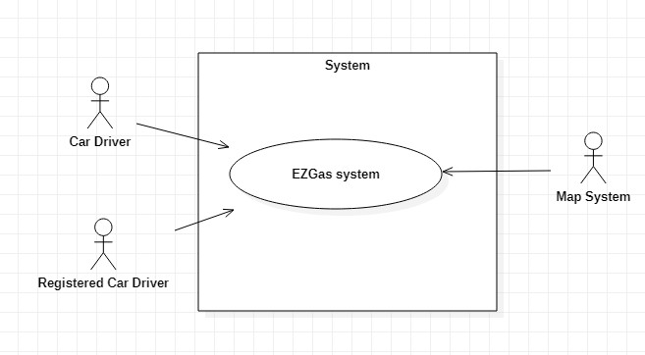
Interfaces
Actor | Logical Interface | Physical Interface
Registered Car driver | GUI | Touchscreen
Car driver | GUI | Touchscreen
Map System | API | Internet
Stories and personas
Mike
Mike is a young man with three children and lives in a pretty neighbourhood with kindly people. He must move for tens of kilometers because of his work, so he is very interested in saving money for fuel. For these reasons, he joined a Facebook group with his neighbours, where everyone posts the price of a gas station every time he goes there. Therefore, every morning he consults this group and choose the best gas station in terms of distance from his house and current price.
Some days not all prices are updated. Therefore, if he finds a gas station on his way with a better price (or if the station has not the price that he knew), he posts on the Facebook group the new price for that station and its location (useful if the station wasn’t never notified before).
Mike would like to have a simpler mechanism to know the fuel price of each gas stations around him. Every morning he spent a lot of time in consulting the Facebook group and check the price and distance for each interesting gas station.
He would like to have a virtual map that shows the most interesting gas stations for the current area, with the possibility to update the prices if they are wrong or to add a new gas station. In this way he may have much more time to have breakfast with his children in the morning and he can use this map to choose the better gas station also in other areas far away from his home.

Jess
Jess is a car driver that wants only saving her money for fuel. She would have a system to choose the cheapest gas station in the area where she is, but she is not interested in supporting this system. Therefore, she has not an account and she cannot update prices or notify the presence of a new gas station.

Functional and non functional requirements
Functional requirements
ID | Description
FR1 | Visualize the list of the gas stations’ prices for a certain area
FR2 | Visualize the route to reach the selected gas station from the user position
FR3 | Check if the prices are daily updated or not
FR4 | Log in
FR5 | Log out
FR6 | Record a price for a fuel type of a gas station for a specific day
FR7 | Signal a price error
FR8 | Signal a location error
FR9 | Add a new gas station
FR10 | Manage different type of fuels and their prices
FR11 | Get Map from Map system
FR12 | Get route from Map system

Non functional requirements
ID | TYPE | DESCRIPTION | Refers to
NFR1 | Performance | Login, logout, signal functions should be completed in < 1 sec | FR5,FR6,FR7,FR8
NFR2 | Performance | Record new price function should be completed in < 3 sec | FR1
NFR3 | Performance | Add gas station function should be completed in < 5 sec | FR9
NFR4 | Portability | The application runs on Android and iOS devices | ALL FR
NFR5 | Usability | No training time for user | ALL FR
NFR6 | Localisation | Prices are provided in EUR | ALL FR
NFR7 | Reliability | Probability of unavailability of map system must be 0 | ALL FR
NFR8 | Performance | Show list of gas stations located within a range of 10 km from the user location | FR2,FR3,FR4
NFR9 | Performance | Route must be provided in < 10 sec | FR3

Use case diagram and use cases
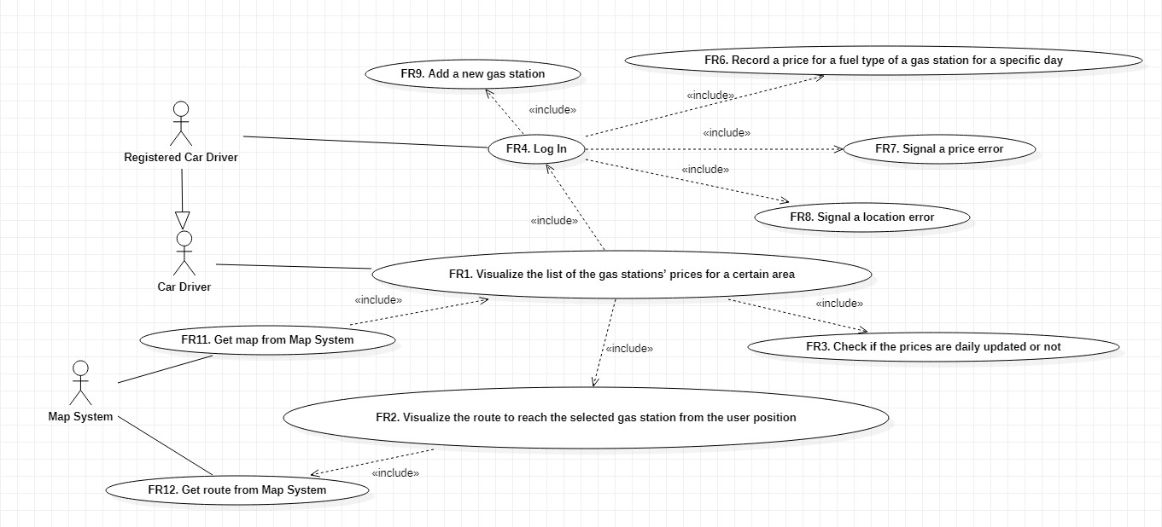

UC1 – FR1. Visualize the list the gas stations’ prices for a certain area
ACTORS INVOLVED | Car Driver, Map System
Precondition | User has installed the Map M exists, Gas stations positions <= Car Driver Position + 10 Km
Post condition
Nominal scenario | Car Driver opens the app, the map is retrieved by the map system, the gas stations and their relative prices are lists on the map
Variants

UC2 – FR2. Visualize the route to reach the selected gas station from the user position, FR12. Get route from Map system
ACTORS INVOLVED | Car Driver, Map System
Precondition | Map M exists, Gas stations position <= Car Driver Position + 10 Km
Post condition | Selected Gas station position <= Car Driver Position + 10 Km
Nominal scenario | Car Driver choices a gas station on the list, the map systems generates a route for this destination
Variants

UC3 – FR4. Log In
ACTORS INVOLVED | Registered Car Driver
Precondition | Map M exists, Gas stations list exists
Post condition | Registered Car Driver correctly logged
Nominal scenario | Registered Car Driver opens the app, the map is retrieved by the map system, the gas stations and their relative prices are lists on the map, Registered Car Driver perform the log in
Variants | Incorrect log in, issue a warning

UC4 – FR6. Record a price for a fuel type of a gas station for a specific day
ACTORS INVOLVED | Registered Car Driver, Map System
Precondition | Map M exists, Registered Car Driver logged, Gas Station S exist
Post condition | S.Price>=0, S.Price correctly updated
Nominal scenario | Registered Car Driver select the Gas Station S and update the price
Variants

UC5 – FR7. Signal a price error, FR8. Signal a location error
ACTORS INVOLVED | Registered Car Driver, Map System
Precondition | Map M exists, Registered Car Driver logged, Gas Station S exist
Post condition
Nominal scenario | Registered Car Driver select the Gas Station S and signals a price error or a location error
Variants

UC6 – FR9. Add a new gas station
ACTORS INVOLVED | Registered Car Driver, Map System
Precondition | Map M exists, Registered Car Driver logged, Gas Station S not exist
Post condition | S exist, S.location is in the correct 10km area, S.price>0
Nominal scenario | Registered Car Driver select the “new gas station” option and he registers S.location and S.price.
Variants

Relevant scenarios

Scenario ID: SC1 | Corresponds to UC1
Description | Visualize list of Gas Stations
Precondition | The Car Driver (CD) has installed the app on his smartphone, his GPS should be activated
Postcondition | The gas stations that are listed are within a range of 10 Km
Step# | Step description
1 | CD opens the app
2 | The GPS signal is captured
3 | The Map is retrieved by the Map system
4 | The gas stations are selected and listed with their price on the map

Scenario ID: SC2 | Corresponds to UC2
Description | Visualize a route to reach the designed Gas Station
Precondition | The Car Driver has selected a gas station less than 2 km away
Postcondition | The Car Driver location must be the same of the Gas Station
Step# | Step description
1 | The Gas station location and the Car Driver location are sent to Map System
2 | Map System provides a route
3 | Car Driver follows the route
4 | Car Driver has reached the gas station

Scenario ID: SC3 | Corresponds to UC4
Description | Report of a new price by a Registered Car Driver (RCD)
Precondition | RCD must have an account and he should be correctly logged into it
Postcondition | The price of the gas station must be updated, and it must be > 0
Step# | Step description
1 | RCD choose a gas station among those available
2 | RCD choose the fuel type
3 | RCD insert the new price
4 | Price updated

Scenario ID: SC4 | Corresponds to UC9
Description | Add of a new gas station by a Registered Car Driver (RCD)
Precondition | RCD must have an account and he should be correctly logged into it
Postcondition | The new gas station must be correctly insert
Step# | Step description
1 | RCD choose the location
2 | RCD fills all the required information about gas station and its fuel types and related prices
3 | RCD insert the new gas stations
4 | Gas Station added

