What language to learn expert system

Objective:

1. Helps in making decision about which language to learn first as per the student’s interest.

How to use:

1. Consult language.pl file from SWI-Prolog
2. Run command : main.
3. Then follow the instruction
4. Always type (.) after the options. (Eg. Main. 1. 0. )

Screenshots:

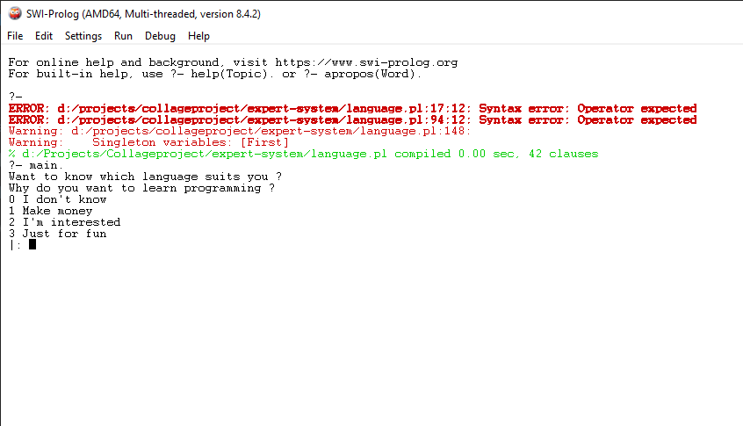

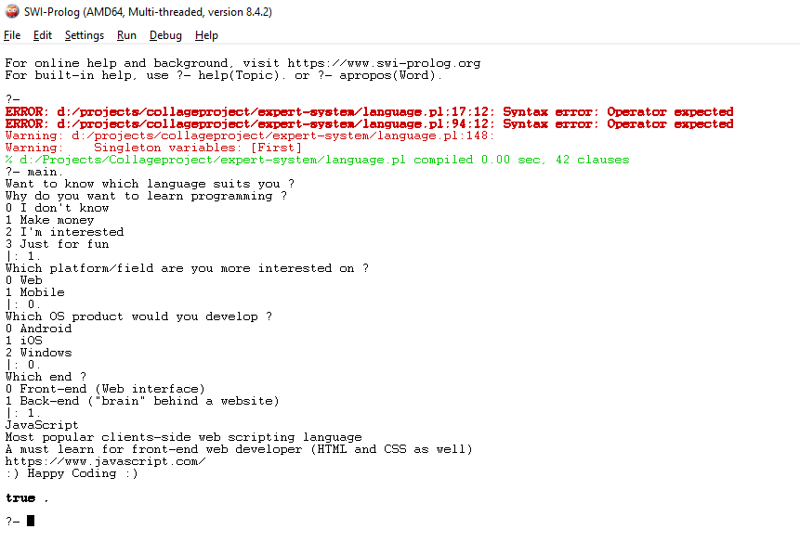

Thank You and Happy Coding…