Cairo University  
Faculty of Computers and Information



**CS251**

**Software Engineering I**

Smart Home Board

Software Requirements Specifications

Team Names

Month & Year

Contents

Instructions [To be removed] 3

Team 3

Document Purpose and Audience 3

Introduction 3

Software Purpose 3

Software Scope 4

Definitions, acronyms, and abbreviations 4

Requirements 4

Functional Requirements 4

Non Functional Requirements 4

System Models 5

Use Case Model 5

Use Case Tables 5

Ownership Report 6

Policy Regarding Plagiarism: 6

# Instructions [To be removed]

* **IMPORTANT. Rename this document to CS251-LeaderID-SRSDocument.docx**

**(e.g. CS251-20040752-SRSDocument.docx)**

# Team

|  |  |  |  |
| --- | --- | --- | --- |
| **ID** | **Name** | **Email** | **Mobile** |
| 20146020 | Sara Ali ElSheemi | saraelsheemi93@yahoo.com | 01126304767 |
| 20146014 | Hagar Mostafa Gadallah | [hagargadallah@gmail.com](mailto:hagargadallah@gmail.com) | 01001668169 |
| 20146021 | Hana Ahmed Salah | Hanasalah864@yahoo.com | 01159338801 |
| 20146015 | Youssef Nabil Mustafa | [Youssefnabil48@outlook.com](mailto:Youssefnabil48@outlook.com) | 01069285812 |

# Document Purpose and Audience

* **Formal document that describes the functionality of the software and the use cases model and table.**
* **Product Owner.**

# 

# Introduction

## Software Purpose

The purpose of the Smart Home Board is to monitor home appliances through a user friendly interface.

## Software Scope

* **The Board will control the devices using sensors embedded in them.**
* **Control options available to user will be to start or shut down the device.**
* **It is available as a web application and Android mobile application.**
* **It won’t support IOS or windows platform.**
* **Each device will have an icon at the home page that shows the current status of it.**
* **Only the admin will have the ability to add/remove users and devices.**

## Definitions, acronyms, and abbreviations

NULL.

# Requirements

## Functional Requirements

* The Admin user has to first create an account to login and add users and devices.
* The user can search for compatible devices in the house and connect them to the Smart Board.
* The home page will show the status of each machine at the current time. By clicking on the name of each device another page opens up with all options that could be done at the current state.
* Home User will have access to all functions as the Amin User except Editing Users/Devices.
* The device connection could be suspended without having to remove the device.

## Non Functional Requirements

**Usability:**

* User must have an account to access the devices.
* The board will come with different themes and colors to suit every user’s choice.
* On startup a use guide will load to go through the whole system and how it could be used

**Reliability:**

* In case of system failure the user will have to restart the application.
* System won’t remove any of the installed devices if system shut down.
* In case of application crash, none of the other applications or the OS will be affected.

**Performance:**

* Application launching should not take more than 2 seconds 90% of the time.
* In case of lost connection with device, application will try to reconnect automatically every 30 seconds for 5 times and then it will be disconnected if the user did not manually click retry.
* The status of devices could be manually or automatically updated, and in case of the automatic the user could choose to be done every 1 or 2 or 5 minutes. Longer periods are not preferable to ensure quality and accuracy of events.
* Discovering new devices should not take more than 10 seconds.

**Security:**

* Only users registered can have access to the devices connected to their board.
* Access differs depending on the type of user whether an Admin or a Home User.

**Scalability:**

* System will support all home appliances with embedded sensors.
* System will support Android mobile application and web based application.
* System should handle smoothly up to 15 devices.

# 

# System Models

## Use Case Model

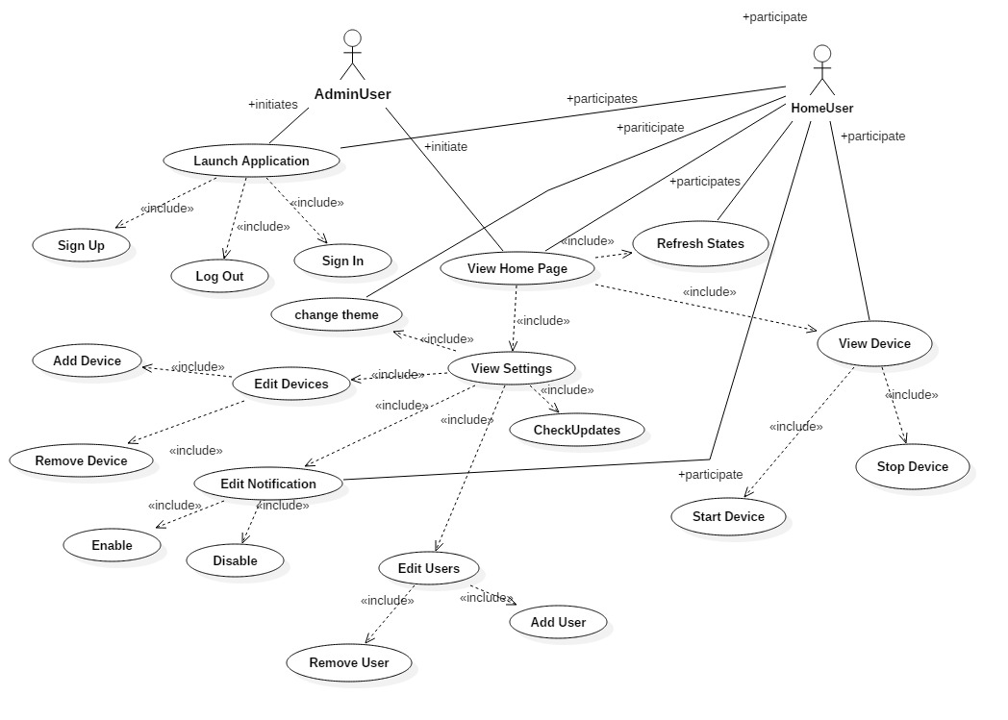

## 

## Use Case Tables

|  |  |  |
| --- | --- | --- |
| Use Case ID: | 1 | |
| Use Case Name: | Sign Up | |
| Actors: | Admin-User/Home-User | |
| Pre-conditions: | User Launches application | |
| Post-conditions: | User successfully submitted correct information  User exits the application | |
| Flow of events: | **User Action** | **System Action** |
| 1-User fills the sign up form with all correct personal information |  |
|  | 2- System verifies user information |
| 3- user will submit the information |  |
|  | 4-System creates an account and notifies the user |
| Exceptions: | **User Action** | **System Action** |
| 1- User enters invalid email address. |  |
|  | 2- System rejects email address and notifies user to enter a valid one. |
|  |  |  |
|  | 1-User enters a password with less than 8 characters. |  |
|  |  | 2-system rejects the password and notifies user to change it. |
|  |  |  |
| Use Case ID: | 2 | |
| Use Case Name: | Sign In | |
| Actors: | Admin-User/Home-User | |
| Pre-conditions: | User launches application | |
| Post-conditions: | User enters correct Username and password  User exits the application | |
| Flow of events: | **User Action** | **System Action** |
| 1- User Enters username and Password. |  |
|  | 2-System checks database to match the info with an account |
|  |  |
|  |  | 3-System opens home page for the User |
| Exceptions: | **User Action** | **System Action** |
| 1- User enters an invalid username. |  |
|  |  | 2- System rejects username and notifies the user. |
|  |  |  |
|  | 1-User enters a non-matching password to username. |  |
|  |  | 2-System rejects the password and notifies the user to enter it again. |
| Includes: | NULL | |
|  | | |
| Use Case ID: | 3 | |
| Use Case Name: | Log Out | |
| Actors: | Home-User /Admin-User | |
| Pre-conditions: | Home-User/Admin-User clicks on logout button | |
| Post-conditions: | System successfully logged the user out of his account | |
| Flow of events: | **User Action** | **System Action** |
| NULL |  |
| Exceptions: | **User Action** | **System Action** |
| NULL |  |
| Includes: | NULL | |
| Notes and Issues: | NULL | |

|  |  |  |
| --- | --- | --- |
| Use Case ID: | 4 | |
| Use Case Name: | Add Device | |
| Actors: | Admin-User | |
| Pre-conditions: | Admin-User clicks Edit Devices | |
| Post-conditions: | Admin-User successfully added a device  Admin-User returned to home page | |
| Flow of events: | **User Action** | **System Action** |
| 1-User clicks on Edit devices option and chooses add device. |  |
|  | 2-System finds available devices in the house displays them to the user. |
| 3-User chooses the device s/he wants to add. |  |
|  | 4-System checks if device is compatible and connects it to the board. |
| Exceptions: | **User Action** | **System Action** |
| 1- User chooses add device. |  |
|  | 2-System doesn’t find any available devices and notifies the user that there are no devices to be added. |
|  | 1-User chooses an incompatible device. |  |
|  |  | 2-System tries to connect with the chosen device and fails so it notifies the user. |
| Includes: | NULL | |
| Notes and Issues: | NULL | |

|  |  |  |
| --- | --- | --- |
| Use Case ID: | 5 | |
| Use Case Name: | Remove Device | |
| Actors: | Admin User | |
| Pre-conditions: | Admin user clicks Edit devices | |
| Post-conditions: | Admin user successfully removed a device  Admin user returns to the home page | |
| Flow of events: | **User Action** | **System Action** |
| 1-User launches the application. |  |
|  | 2- System displays the home page to the user. |
| 3- User clicks on settings and chooses Edit Devices and then remove device. |  |
|  | 4- System displays connected device to the user. |
|  | 6- User chooses the device he wants to remove. |  |
|  |  | 7- System removes the selected device and notifies the user that device was successfully removed. |
| Exceptions: | **User Action** | **System Action** |
| 1-User chooses to remove devices and there are no devices connected. |  |
|  | 2-System notifies that there are no devices connected. |
| Includes: |  | |
| Notes and Issues: |  | |

|  |  |  |
| --- | --- | --- |
| Use Case ID: | 6 | |
| Use Case Name: | Add User | |
| Actors: | Admin User | |
| Pre-conditions: | Admin user clicks Edit Users | |
| Post-conditions: | Admin user successfully added a new user.  Admin user returns to home page. | |
| Flow of events: | **User Action** | **System Action** |
| 1- User launches the application. |  |
|  | 2- System displays the home page to the user. |
| 3- User clicks on settings and then Edit Users option and chooses to add a user. |  |
|  | System displays the search box and waits for user to enter the email connected with the other user he wants to add. |
| 5- User enters the desired email address. |  |
|  | 6- System searches for the entered email address and displays the user if found. |
|  | 7-User chooses to add the user to his home board. |  |
|  |  | 8- System notifies the admin user that a new user was successfully added. |
| Exceptions: | **User Action** | **System Action** |
| 1-User enters an email address that is not found or invalid. |  |
|  | 2- System displays an error message. |
|  |  | 3- System asks the user to enter a valid username. |
| Includes: | NULL | |
| Notes and Issues: | NULL | |

|  |  |  |
| --- | --- | --- |
| Use Case ID: | 7 | |
| Use Case Name: | Remove User | |
| Actors: | Admin User | |
| Pre-conditions: | User clicks on Edit Users | |
| Post-conditions: | Admin user successfully removed a user.  Admin user returns to the home page. | |
| Flow of events: | **User Action** | **System Action** |
| 1- User launches the application. |  |
|  | 2- System displays the home page to the user. |
| 3- User clicks on settings then on Edit Users option and chooses to remove a user. |  |
|  | 4- System displays connected users. |
| 5- User chooses the desired user to be removed. |  |
|  |  | 6-System removes the chosen user and notifies the admin user that a user was successfully removed. |
| Exceptions: | **User Action** | **System Action** |
| 1- User chooses to remove a user and there are no users connected to this board. |  |
|  | 2- System displays that there are no users connected. |
| Includes: | NULL | |
| Notes and Issues: | NULL | |

|  |  |  |
| --- | --- | --- |
| Use Case ID | 8 | |
| Use Case Name: | Stop device | |
| Actors: | Admin-User/Home-User | |
| Pre-conditions: | User clicks View device | |
| Post-conditions: | User successfully stopped the wanted device  User returns to home page | |
| Flow of events: | **User Action** | **System Action** |
| 1-User launches application |  |
|  | 2- System displays home page to user |
| 3-User clicks on view device and selects the desired device. |  |
|  |  | 4- System displays the page of the device with all its information. |
|  | 5-User clicks on stop device. |  |
|  |  | 6- System stops the desired device and displays message to user. |
| Exceptions: | **User Action** | **System Action** |
| 1-User clicks on the device he wants to terminate and it’s already in the stopped state. |  |
|  | 2-System displays error message that device is already stopped. |
| Includes: |  | |
| Notes and Issues: |  | |

|  |  |  |
| --- | --- | --- |
| Use Case ID | 9 | |
| Use Case Name: | Refresh States | |
| Actors: | Admin-User/Home-User | |
| Pre-conditions: | User clicked Refresh States | |
| Post-conditions: | User successfully refreshed all devices  User returns to home page. | |
| Flow of events: | **User Action** | **System Action** |
| 1-User launches application |  |
|  | 2- System displays home page to user |
| 3-User clicks on refresh devices |  |
|  | 4-System refreshes the states of all connected devices and display updated ones. |
| Exceptions: | **User Action** | **System Action** |
|  |  |
|  |  |
| Includes: | NULL | |
| Notes and Issues: | NULL | |

|  |  |  |
| --- | --- | --- |
| Use Case ID | 10 | |
| Use Case Name: | Check updates | |
| Actors: | Admin-User/Home-User | |
| Pre-conditions: | User clicks on View Settings | |
| Post-conditions: | System shows all new updates.  User returns to home page. | |
| Flow of events: | **User Action** | **System Action** |
| 1-User launches application |  |
|  | 2- System displays home page to user |
| 3- User clicks on view settings and then check for updates. |  |
|  | 4-System checks for newest updates and displays them to user |
| 5-User chooses the available update and clicks on update. |  |
|  |  | 6-System displays a message to user to wait until updates are installed and installs the update. |
|  |  | 7-System notifies the user when the installation is finished. |
| Exceptions: | **User Action** | **System Action** |
| 1-User clicks on check updates and there are no system updates available. |  |
|  |  | 2-System notifies user that there no available updates. |
| Includes: |  | |
| Notes and Issues: |  | |

|  |  |  |
| --- | --- | --- |
| Use Case ID | 11 | |
| Use Case Name: | Start Device | |
| Actors: | Admin-User/Home-User | |
| Pre-conditions: | User clicks on View Device | |
| Post-conditions: | User successfully started the desired device  User returns to home page. | |
| Flow of events: | **User Action** | **System Action** |
| 1-User launches application |  |
|  | 2- System displays home page to user |
| 3- User clicks on view device and selects the desired device. |  |
|  | 4-System displays the page of the device with all its information. |
| 5-User clicks on start device. |  |
|  |  | 6- System stops the desired device and displays message to user. |
| Exceptions: | **User Action** | **System Action** |
| 1-User clicks on the device he wants to start and it’s already in the activated state. |  |
|  |  | 2-System displays an error message that device is already running. |
| Includes: |  | |
| Notes and Issues: |  | |

|  |  |  |
| --- | --- | --- |
| Use Case ID | 12 | |
| Use Case Name: | Enable Notification | |
| Actors: | Admin-User/Home-User | |
| Pre-conditions: | User clicks on Edit Notifications | |
| Post-conditions: | User successfully enabled the desire notification.  User returns to home page. | |
| Flow of events: | **User Action** | **System Action** |
| 1-User launches application |  |
|  | 2- System displays home page to user |
| 3- User clicks on Settings |  |
| 4- User clicks on Edit Notifications |  |
|  | 5-System displays the connected devices. |
| 6-User chooses the desired device and enables the notification button. |  |
|  |  | 7- System notifies the user that notifications have been enabled to the selected device. |
| Exceptions: | **User Action** | **System Action** |
|  |  |
|  |  |  |
| Includes: |  | |
| Notes and Issues: |  | |

|  |  |  |
| --- | --- | --- |
| Use Case ID | 13 | |
| Use Case Name: | Disable Notification | |
| Actors: | Admin-User/Home-User | |
| Pre-conditions: | User clicks on View Settings | |
| Post-conditions: | User clicked on Edit Notifications  User returns to home page. | |
| Flow of events: | **User Action** | **System Action** |
| 1-User launches application |  |
|  | 2- System displays home page to user |
| 3- User clicks on settings. |  |
| 4- User clicks on Edit Notifications |  |
|  | 5-System displays the connected devices. |
| 6-User chooses the desired device and disables the notification button. |  |
|  |  | 7- System notifies the user that notifications have been disabled to the selected device. |
| Exceptions: | **User Action** | **System Action** |
|  |  |
|  |  |  |
| Includes: |  | |
| Notes and Issues: |  | |

# 

# Ownership Report

|  |  |
| --- | --- |
| **Item** | **Owners** |
|  |  |
|  |  |