Cairo University  
Faculty of Computers and Information



**CS251**

**Software Engineering I**

Project Name

Software Requirements Specifications

Team 3

2015-2016

Contents

Instructions [To be removed] 3

Team 3

Document Purpose and Audience 3

Introduction 3

Software Purpose 3

Software Scope 4

Definitions, acronyms, and abbreviations 4

Requirements 4

Functional Requirements 4

Non Functional Requirements 4

System Models 5

Use Case Model 5

Use Case Tables 5

Ownership Report 6

Policy Regarding Plagiarism: 6

# Team

|  |  |  |
| --- | --- | --- |
| **ID** | **Name** | **E-mail** |
| 20146010 | Tarek Abdullah | [t.abdallah@stud.fci-cu.edu.eg](mailto:t.abdallah@stud.fci-cu.edu.eg) |
| 20146017 | Habiba Bahaa | habiba.saleh96@gmail.com |
| 20146007 | Rana Muhammed | r.mohamed@stud.fci-cu.edu.eg |
| 20146006 | Hussein Khaled | husseinkk96@gmail.com |
| 20146019 | Abdullah Ahmed | abdala.fatla95@gmail.com |

# Document Purpose and Audience

**This is a SOFTWARE REQUIREMENTS SPECIFICATION “SRS” document it contains a description of the system software system to be developed. It lays out functional and non-functional requirements, set of use-cases. The audience expected to read this document is the TA.**

# Introduction

## Software Purpose

## Smart home is a board that allows you to control several devices at your own house using a mobile application.

## Software Scope

# Requirements

## Functional Requirements

**Smart home is a board that allows you to control several devices at your own house using a mobile application.**

**The user will have to sign up to the board, add the required devices, connect the sensors and then sign in to the board.**

**Once the user has signed in, an immediate feedback on all connected devices should be given showing their current statuses and if there is a problem with the electric current (i.e. power cut). The user will select the device that needs to be modified and will enable or disable it accordingly. If the devices didn’t respond to the action given the user should wait for few minutes and retry.**

**In case of emergency, (i.e. device overheating, smoke detected) the device should be disabled and the user should be immediately notified**

## Non Functional Requirements

1. **Board cannot be accessed unless a valid username and password is inserted.**
2. **The software is used as a mobile app.**
3. **The system should respond to emergency cases within one second.**
4. **If the system didn’t respond to the user’s action, the user will have to wait for 2 minutes before retrying.**

# System Models

## Use Case Model

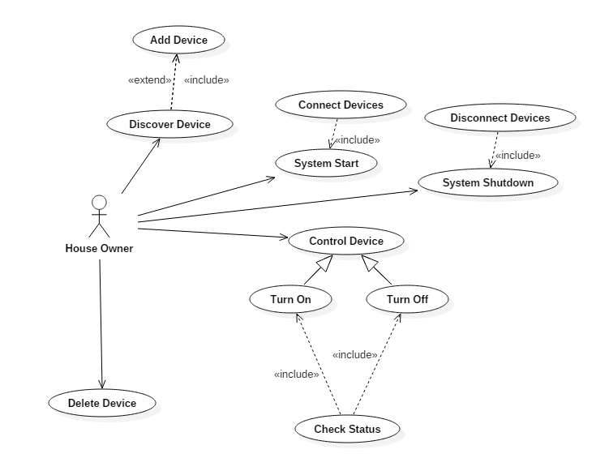

## Use Case Tables

|  |  |  |
| --- | --- | --- |
| Use Case ID: | 1 | |
| Use Case Name: | System Start | |
| Actors: | House Owner | |
| Pre-conditions: | System is turned off | |
| Post-conditions: | System is turned on | |
| Flow of events: | **User Action** | **System Action** |
| 1- House owner turned on the power button |  |
|  | 2-System allows electric current to pass |
| Exceptions: | **User Action** | **System Action** |
| 1-Electric current is cut out |  |
| 2-Try again after few minutes |  |

|  |  |  |
| --- | --- | --- |
| Use Case ID: | 2 | |
| Use Case Name: | Add Device | |
| Actors: | House Owner | |
| Pre-conditions: | Device not installed | |
| Post-conditions: | Device successfully added to the system | |
| Flow of events: | **User Action** | **System Action** |
| 1- Owner select edit devices from options and chooses add device |  |
|  | 2- System displays the available devices to be added |
| 3-Owner chooses the device he wants to add |  |
|  |  | 4-Device successfully added |
| Exceptions: | **User Action** | **System Action** |
|  | 1-Owner chooses an installed device |  |
|  |  | 2- System rejects the process  3-System asks the owner to choose a new device |

|  |  |  |
| --- | --- | --- |
| Use Case ID: | 3 | |
| Use Case Name: | Remove device | |
| Actors: | House Owner | |
| Pre-conditions: | Device is installed | |
| Post-conditions: | Device successfully removed | |
| Flow of events: | **User Action** | **System Action** |
| 3- Owner selects edit devices from options and chooses remove device |  |
|  | 4- System displays connected devices |
| 5-Owner chooses the device he wants to remove |  |
|  |  | 5-Device successfully removed |
| Exceptions: | **User Action** | **System Action** |
| 1-Owner chooses to remove a device which is currently in use |  |
|  | 2- System rejects the process. |

|  |  |  |
| --- | --- | --- |
| Use Case ID: | 4 | |
| Use Case Name: | Connect device | |
| Actors: | User | |
| Pre-conditions: | System started | |
| Post-conditions: | Device connected to the board | |
| Flow of events: | **User Action** | **System Action** |
| 1- Owner clicks connect device |  |
|  | 2- System shows all devices |
| 3-Owner select a device |  |
|  | 4- System connects the device to the board |
| Exceptions: | **User Action** | **System Action** |
| 1- User clicks connect device [No available devices] | System allow user to add device |

|  |  |  |
| --- | --- | --- |
| Use Case ID: | 5 | |
| Use Case Name: | Disconnect device | |
| Actors: | User | |
| Pre-conditions: | System started | |
| Post-conditions: | Device disconnected from the board | |
| Flow of events: | **User Action** | **System Action** |
| 1- Ownerr click disconnect device |  |
|  | 2- System disconnects device from the board |
| Exceptions: | **User Action** | **System Action** |
| 1- Owner clicks disconnects device [No connected devices] | System announces the failure [no connected devices] |

|  |  |  |
| --- | --- | --- |
| Use Case ID: | 6 | |
| Use Case Name: | Check Status | |
| Actors: | House Owner | |
| Pre-conditions: | Notification popped | |
| Post-conditions: | Checked what happen | |
| Flow of events: | **User Action** | **System Action** |
| 3-Chooses the device to check its status |  |
|  | 2- System displays the status |
|  |  |
|  |  |

|  |  |  |
| --- | --- | --- |
| Use Case ID: | 7 | |
| Use Case Name: | Turn on | |
| Actors: | User (initiator) | |
| Entry-conditions: | System started | |
| Exit-conditions: | Device turned on | |
| Flow of events: | **User Action** | **System Action** |
| 1- User clicks control device |  |
| 2-User clicks Turn on |  |
|  | 3- System checks status |
|  | 4- System Turns on device |
| Exceptions: | **User Action** | **System Action** |
| 1- User click control device [no connected devices] | Announce the failure and allow the user to connect a device |
| 2- User Clicks Turn on [Device already on] | System shows current status |

|  |  |  |
| --- | --- | --- |
| Use Case ID: | 8 | |
| Use Case Name: | Turn off device | |
| Actors: | User | |
| Pre-conditions: | System started | |
| Post-conditions: | Device turned off | |
| Flow of events: | **User Action** | **System Action** |
| 1- User clicks control device |  |
| 2-User Clicks Turn off |  |
|  | 3- System checks status |
|  | 4- System Turns off device |
| Exceptions: | **User Action** | **System Action** |
| 1- User click control device [no connected devices] | Announce the failure and allow the user to connect a device |
| 2- User Clicks Turn off [Device already off] | System shows current status |

|  |  |  |
| --- | --- | --- |
| Use Case ID: | 9 | |
| Use Case Name: | System Shutdown | |
| Actors: | House Owner | |
| Pre-conditions: | System is running | |
| Post-conditions: | System stopped | |
| Flow of events: | **User Action** | **System Action** |
| 1- House owner turned off the power button |  |
|  | 2-System stops the electric current from flowing |
| Notes and Issues: | Don’t Turn off the system while any device is running. | |

# Ownership Report

|  |  |
| --- | --- |
| **Item** | **Owners** |
| Functional requirements | *Tarek Abdullah, Habiba Bahaa* |
| Use case table | *Rana Muhammed, Abdullah Ahmed* |
| Case model | *Hussein Khaled* |