Guard Logs

Software Requirements Specification

Jehoiakim Jade Esgana

Joshua James Cabrera

Christopher Lawrence Rosario

Hazel Joy Arnado

Software Engineering BSIT – 3B

**System Overview**

**1.1 Software Description**

Guard Logs is a software system which aims to modernize the Logging System of Security Guards. Guard Logs presents a system that will help this demographic to tally and view their daily logs in a paperless and automatically organized way.

**1.2 System Requirements Gathering Method**

The System Requirements had been identified and gathered by using the “Active or Visible Observation” method. These personals had since been using the traditional paper Logbook which takes time to summarize and review.

**1.3 Type of Software System**

Guard Logs is a Browser- based Generic Software.

**1.4 Target Client**

The system is designed in mind for the Security Personals of every company.

**System Requirements**

**Non- Functional Requirements**

**2.1. Security Guard’s View**

**2.1.1. Security Guard’s Processes**

* A Security Guard is assigned a unique ID and Password.
* He can open his account only during the period time of his duty.
* A Security Guard shall be able to input the events and visitor details that happened during his shift.
* He shall be able to edit his report to revise an unclear or incomplete log.

**2.1.2 Use Cases**

**Use Case # 1**

A Security Guard logs a record during his shift.

**Navigation Path:**

* The user clicks the “Login” button.
* The user types his ID and Password.
* The user can choose from two types of report, “Visitor Details” and “Events”.
* After choosing an option, the user types the details to the system.
* The user clicks the “Save Log” button.
* The log is now saved to the database.

**Use Case # 2**

A Security Guard edits his log report due to an edit suggestion “Comment” that may contain unclear details from the Security Head.

**Navigation Path:**

* The user clicks the “Login” button.
* The user clicks a log report from the list of daily reports.
* The user clicks the “Edit” button.
* The user edits the content of his report.
* The Security Guard clicks the “Save Log” button.
* The log is now saved to the database.

**2.2 Security Head’s View**

**2.2.1 Security Head’s Processes**

* The Security Head like the Guards is assigned a unique ID and Password.
* Unlike the individual Guards who are restricted only to their duty hours to open their account, he can open his account anytime.
* The Security Head shall be able to view the Summary of a Log Report of a Security Guard as well as the “Daily Summary of Logs” which tabulates all the reports in a specific day from all the Guards under his management.
* He shall be able to comment on a log to point out unclear or incomplete details.

**2.2.2 Use Cases**

**Use Case # 3**

The Security Head views the summary and composed a comment on a log report.

**Navigation Path:**

* The Security Head clicks the “Login” button.
* The user clicks a log report.
* The summary of the report is displayed.
* After reviewing, the user can comment to point out incomplete and unclear details.
* The user clicks the “Save Comment” button.
* The comment is now saved to the database and can be viewed by the Guard who created the report.

**Use Case # 4**

The Security Head views the list of log summaries on a specific date.

**Navigation Path:**

* After login, the Security Head picks a date in the system display.
* A list of all the log summaries in the picked date will be displayed according to their time of creation.
* The user will pick one in the list.
* The summary of the log will be displayed.

**Functional Requirements**

**Operational Requirements**

* Usability. Guard Logs must be highly usable. The system must be highly accessible and usable to the major browsers.
* User Interface. The system shall be easy to navigate. Buttons and Sections should be comprehensible to the both end users.
* Reliability. The system server must be reliable to always provide service to the client.

**DIAGRAMS**

**CONTEXT LEVEL DIAGRAM**

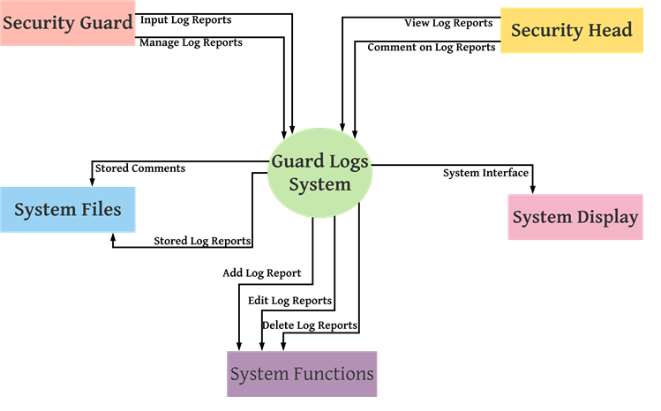

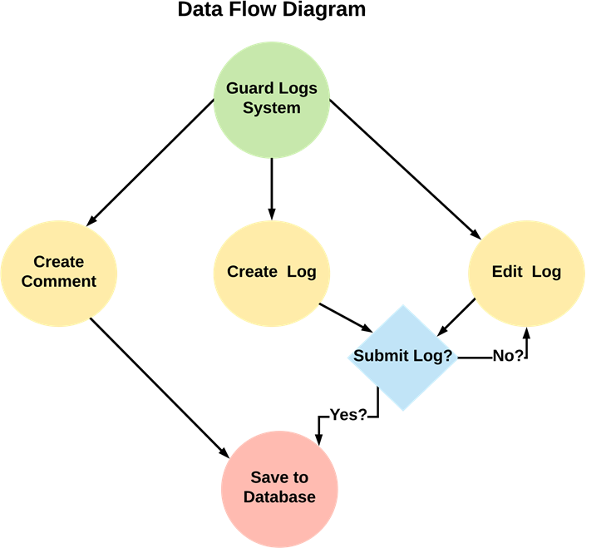

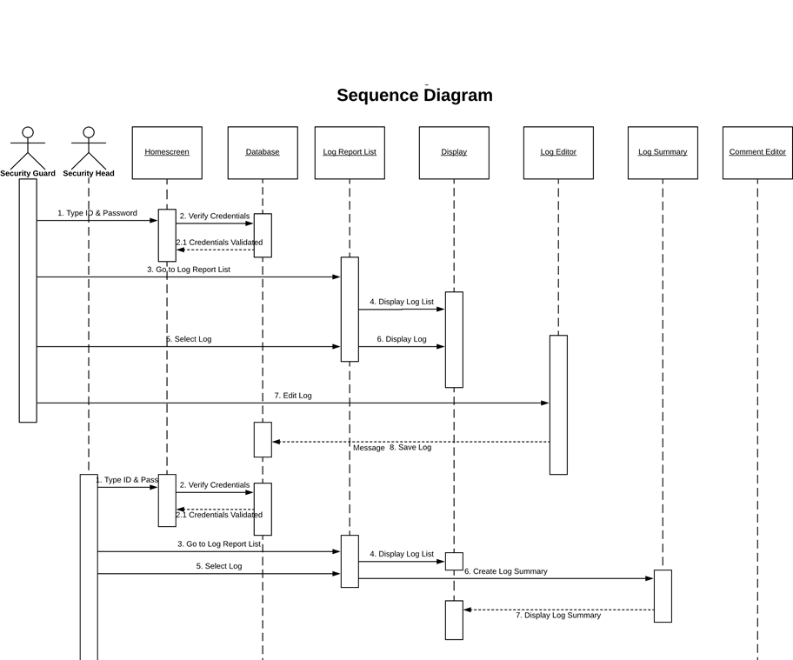

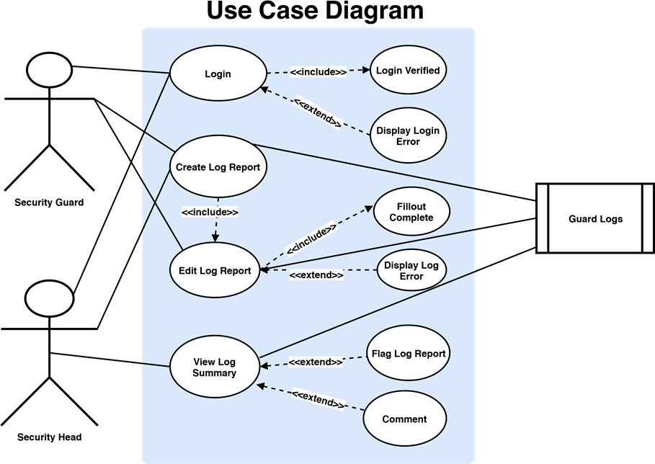

**SYSTEM ARCHITECTURE DIAGRAM**

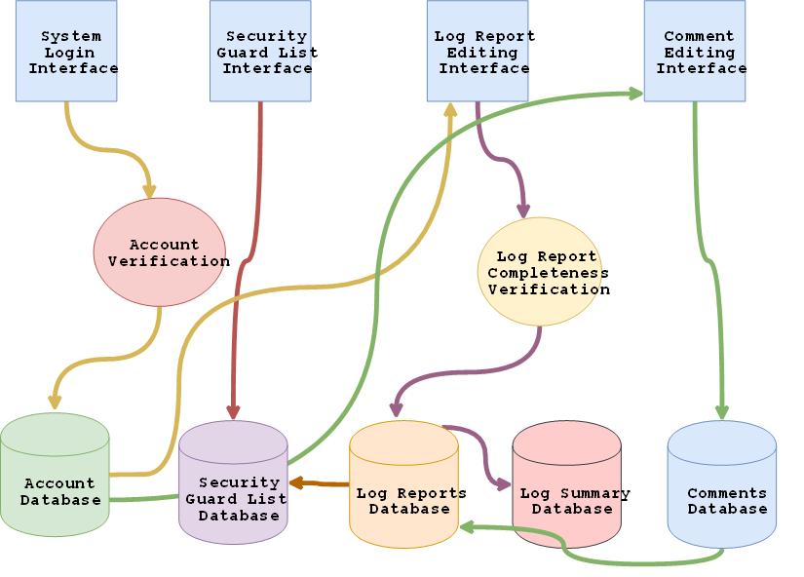

Use Case # 1 A Security Guard finished his 10 hours shift and logs in to his System Account.

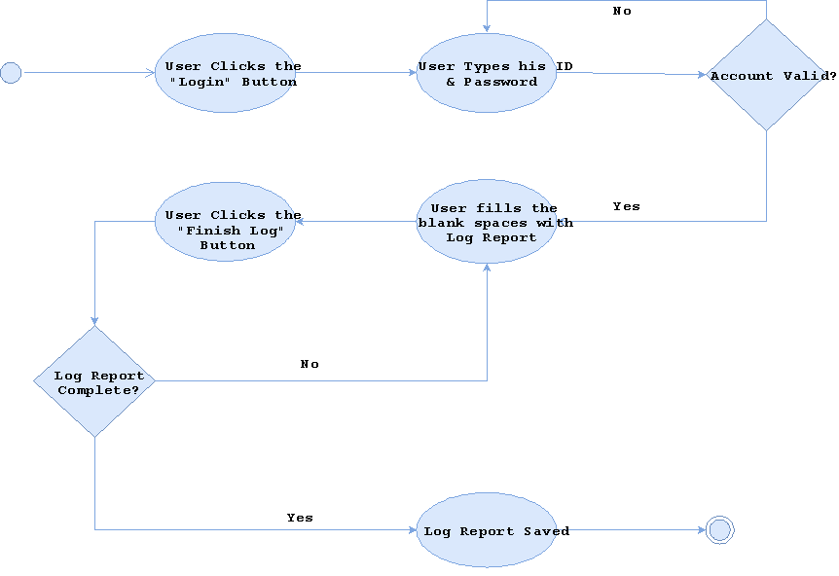

Use Case # 2 A Security Guard edits his Log Report due to a flag or comment from the Security Head

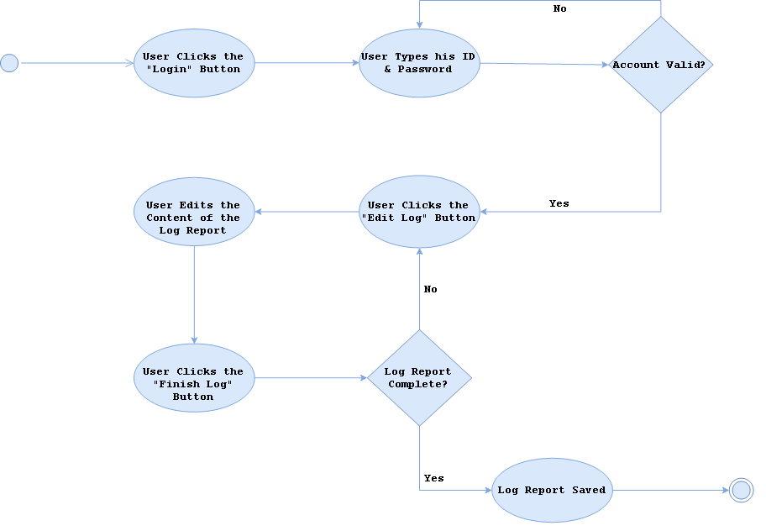

Use Case # 3 The Security Head views a Log Report of a Security Guard

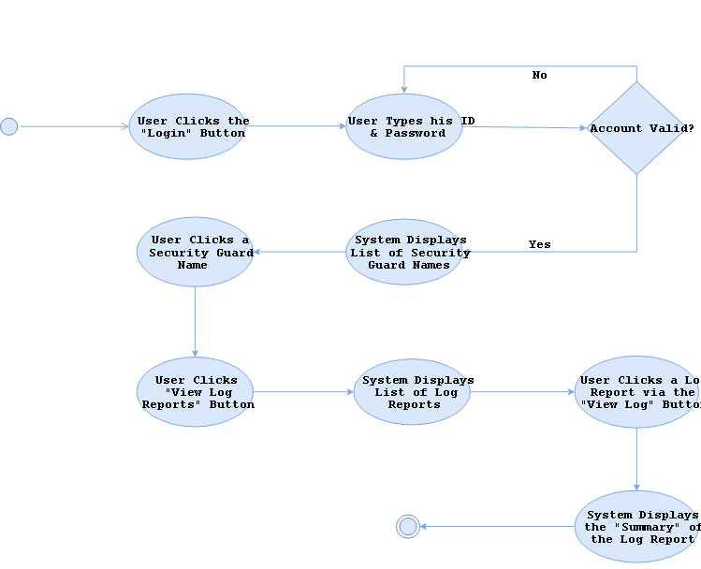

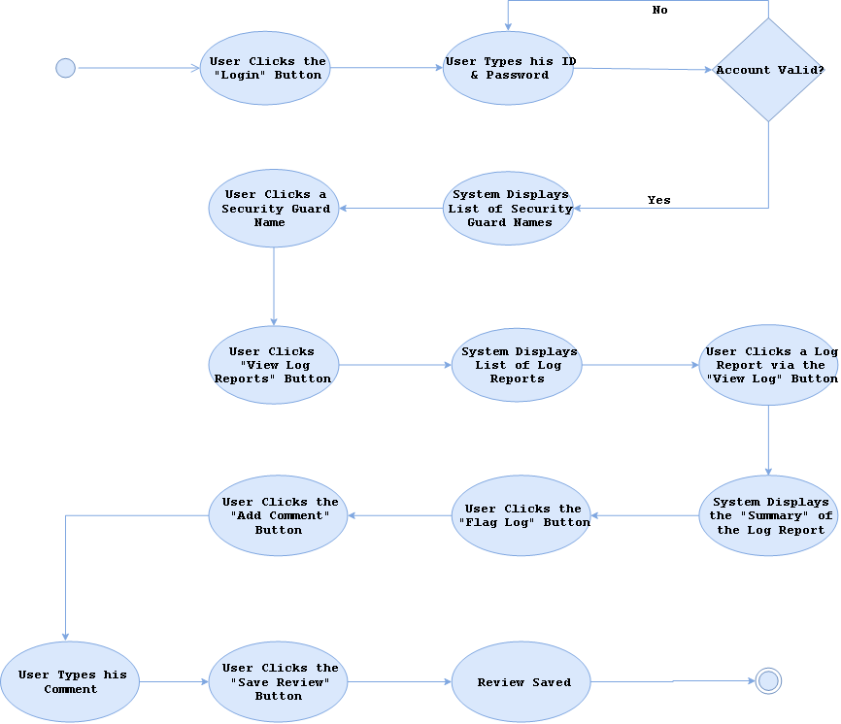

**Prototype**

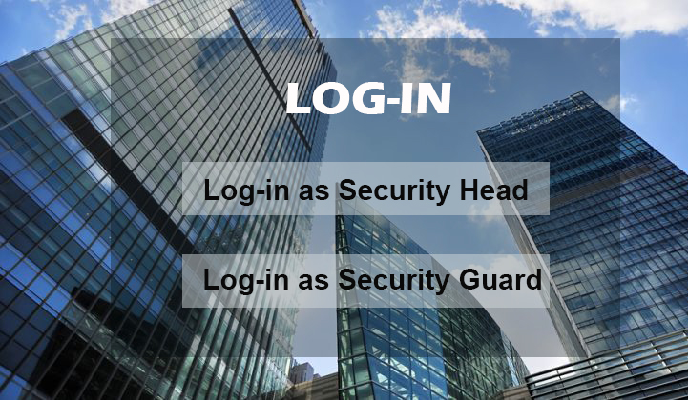

**Login Screenshot**

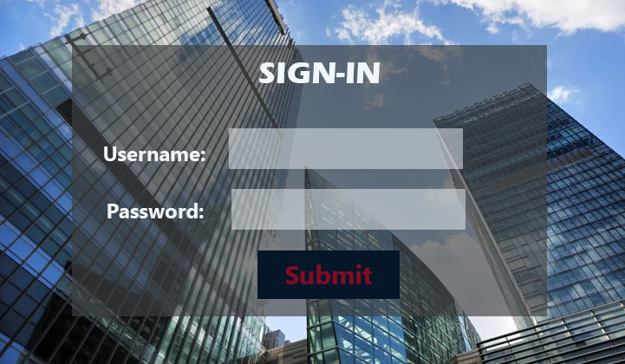

**SignIn ScreenShot**

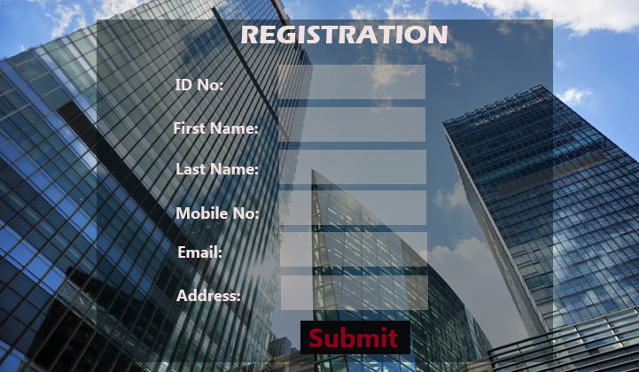

**Registration Screenshot**

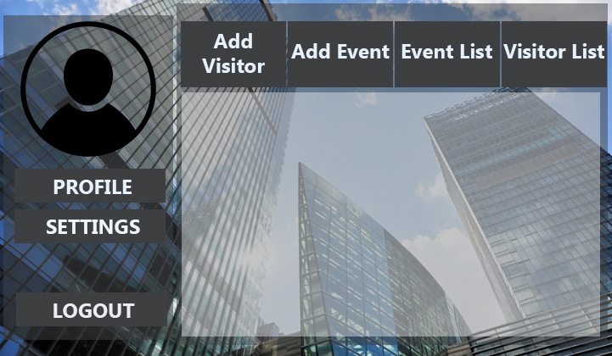

**Security Head Homepage Screenshot**

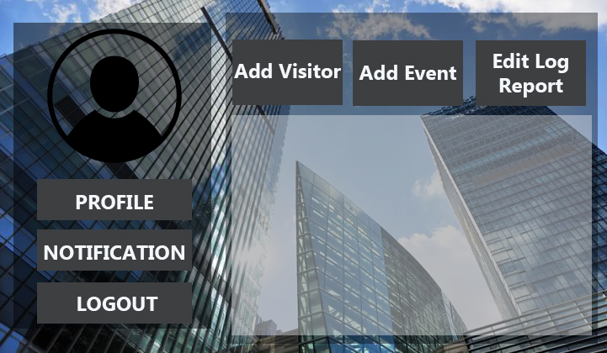

**Security Guard Homepage Screenshot**

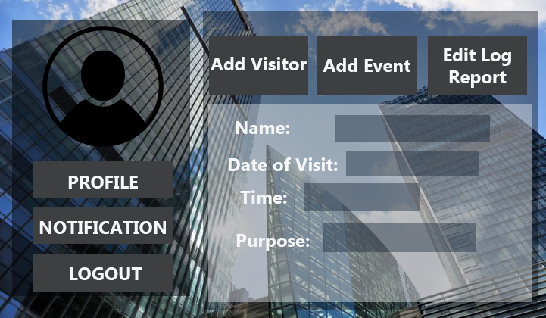

**Add Visitor Screenshot**

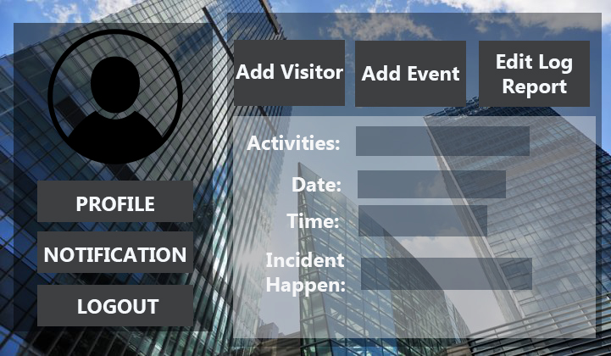

**Add Event Screenshot**