Introduction
This document presents a set of CI-related assignments for the instructor’s reference.

Github
Please create a public repository for your team project on GitHub. In the root directory, create a folder named "docs," and within it, create a Markdown file named "DesignDoc.md." Use the attached "DesignDoc.md" as a template and complete this file.
You need to submit a URL pointing to your project's design document.

First Unit Test
Please create your first unit test on GitHub. Depending on the programming language you have chosen for your project, select a unit testing framework accordingly. For this homework, you only need to complete one successful test case related to a single feature mentioned in your MVP feature list.
What needs to be submitted:
(1) URL pointing to your test file. In addition to the test code, the test file must include enough comments to help the grader understand your code.
(2) The name of the unit testing framework.
(3) A screenshot of the test result.
(4) One MVP feature related to your unit test.

Automating Builds and Tests
Please read the following tutorial: Automate builds and tests with GitHub Actions.
https://docs.github.com/en/actions/automating-builds-and-tests
Please note that you should set up and verify your project locally before following this CI tutorial. These tutorials are intended to help you run your program in a CI environment. If your program does not run correctly locally, it will likely fail in CI and make debugging more difficult.
Please submit your repository page to show that you are using a CI pipeline. On your page, our grader can find logs that demonstrate successful execution of unit testing.
The following two screenshots are what our grader would like to see in your repository. The results may vary depending on the programming language you choose.
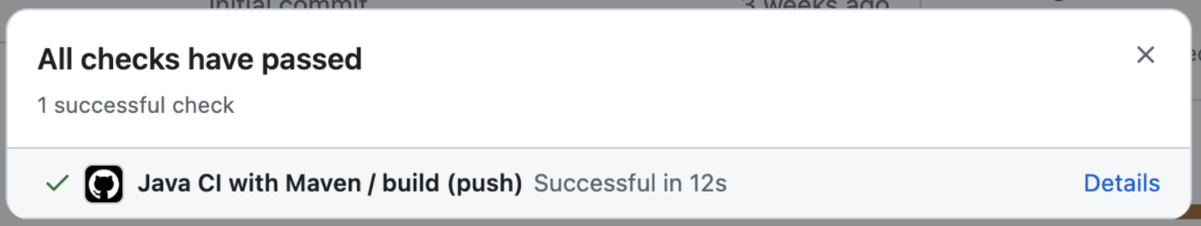
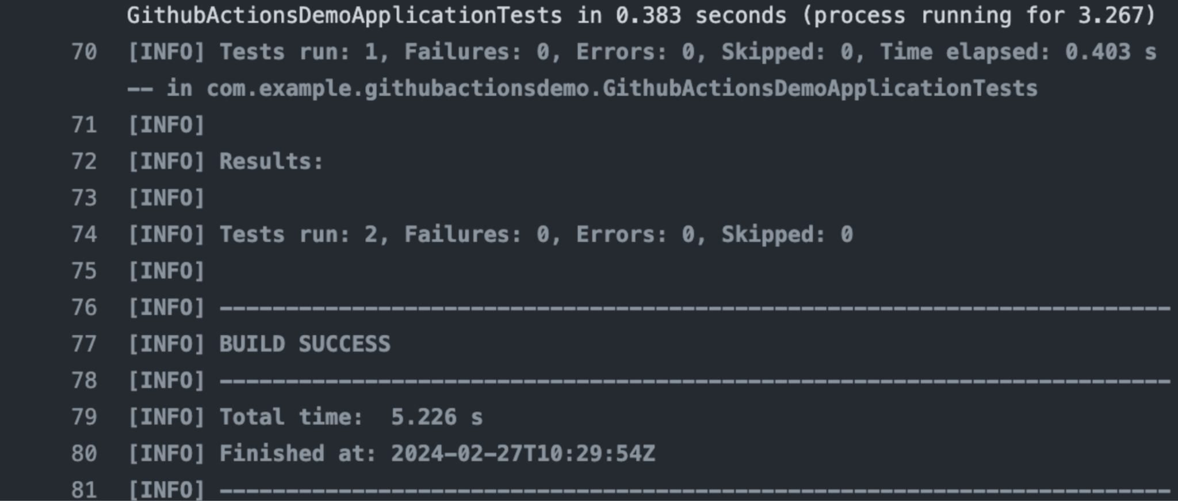

Unit test
At this moment, you need to have implemented all MVP features of the project. Please create at least 15 test cases in total to test your project and ensure that testing coverage exceeds 90% (you could include the test cases from previous homework).
What needs to be submitted:
(1) URL pointing to your test file. In addition to the test code, the test file must include enough comments to help the grader understand your code.
(2) The name of the unit testing framework.

Project Documentation and Repository Enhancement
Add a README.md file to your project repository.
1. Present code coverage results for your unit testing in the README. I recommend using Codecov. You can use any GitHub app you prefer if you have other options (3 points).
1.1 First, ensure that your unit testing can produce code coverage results locally. For example, if you are using Java and Maven, you need to add the JaCoCo plugin to Maven file to generate tests' code coverage.
1.2 Install Codecov on GitHub: https://github.com/apps/codecov
1.3 Configure Codecov by the tutorial below:：
https://docs.codecov.com/docs/quick-start
1.4 If status checks pass, go to your repository's page on Codecov. Then, navigate to Settings -> Badges & Graphs and find the Markdown code. Copy and paste it into your README file.
1.5 The final result will look like this:
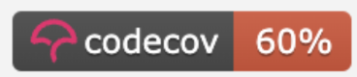
2. Add a license to your project (2 points).
2.1 Please choose a license you prefer. Follow the tutorial below to add a license to your program.
https://docs.github.com/en/communities/setting-up-your-project-for-healthy-contributions/adding-a-license-to-a-repository
2.2 Select the corresponding markdown code for the badge on the following website and copy it to the README file.
https://gist.github.com/kofiav/c1059e1075b67582e86b07aa9759e20d
2.3 The final result will look like this:
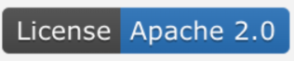
3. In the upper right corner of your repository page, under About, add a brief description of your project (1 point).
4. Update your README.md file to include additional sections and details beyond the basic description. Your README should be well-structured, informative, and easy to navigate (3 points).
At minimum, consider including the following sections (if applicable to your project):
- Project Overview: A clear description of what your project does and its purpose
- Installation Instructions: Steps required to set up and run your project
- Usage / Examples: Code snippets or examples demonstrating how to use your project
- Project Structure: Brief explanation of key directories or files
- Technologies Used: Programming languages, frameworks, or tools
- Contributing Guidelines: How others can contribute to your project
- Contact or Support Information: How users can reach you or report issues
You are encouraged to organize your README using headings, bullet points, and clear formatting.
You may refer to high-quality open-source project READMEs for guidance, such as:
Apache Airflow
Apache Kafka
Apache Flink
Apache Dubbo.
5. Create and include a Code of Conduct in your repository (1 point).
Please submit a link to your repository.

Software quality analysis
You have now implemented all MVP features. It's time to analyze your software and enhance it!
(1) Following the tutorial below, you need to install SonarCloud for your project repository:
https://docs.sonarsource.com/sonarcloud/getting-started/github/
When you configure the repository on SonarCloud, choose the "Number of days" option to identify new code. You should select the appropriate number of days based on your project's progress.
Click on "Information" in the project menu, then copy the Markdown code for the badge and paste it into the README file. Eventually, you will end up with something like (3 points).

If the badge shows "no computed status", you may fix this to push a new commit.
Submit a link to your README file so that our grader can check if you have included this badge.
(2) After your quality gate passes, please submit a link to the SonarCloud analysis report page. The page can be accessed by clicking on "Details" of the SonarCloud Analysis in the screenshot below.
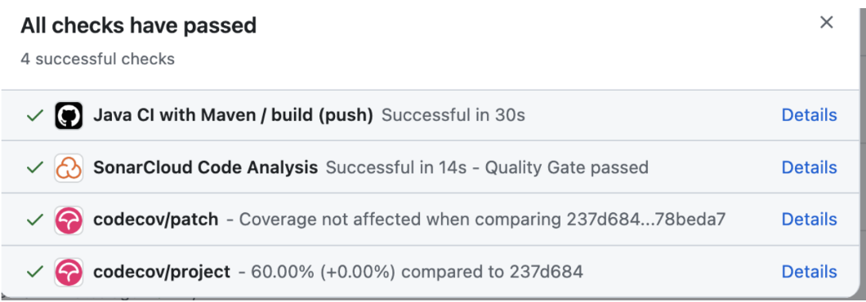
Through the link you submitted, the grader can find the number of issues reported by SonarCloud (2 points).
(3) If you have issues reported, please fix them. Please submit a report about how you fixed them. If you don't have any issues reported, please submit a report about what you have learned from this homework (5 points).
-------
If you are interested in other GitHub apps, you can install them via the link below:
https://github.com/marketplace/category/code-quality

