Software Requirements Specification
for
CIIE Website
Version 1.0
Prepared by:
Moksh Gupta(S3 U101116FCS071)
Gaurav Mundhra(S2 U101116FCS037)
Ankit Gupta(S1 U101116FCS037)
NIIT University
September 5, 2018
Table of Contents

1. Introduction
1.1 Purpose
1.2 Document Conventions
1.3 Intended Audience and Reading Suggestions
1.4 Product Scope
1.5 References
2. Overall Description
2.1 Product Perspective
2.2 Product Functions
2.3 User Classes and Characteristics
2.4 Operating Environment
2.5 Design and Implementation Constraints
2.6 User Documentation
2.7 Assumptions and Dependencies

3. External Interface Requirements
3.1 User Interfaces
3.2 Hardware Interfaces
3.3 Software Interfaces
3.4 Communications Interfaces
4. System Features
4.1 System Feature 1

5. Other Non-functional Requirements
5.1 Performance Requirements
5.2 Safety Requirements
5.3 Security Requirements
5.4 Software Quality Attributes
5.5 Business Rules
6. Other Requirements
Appendix A:Glossary
Appendix B: Analysis Models

Introduction

Purpose
The purpose of this document is to present a detailed description of the CIIE Website. It will explain the purpose and features of the website.
Version 1.0

Document Conventions
This document provides the software requirements and expected behavior of the
online portal. The document provides certain statements and requirements in a bold or highlighted format to represent the significance of the same. Detailed notes along
with reference to the other documents are provided where ever applicable with an
asterisk. All the assumptions that are made will be mentioned beforehand and no
external assumptions are required.

Intended Audience and Reading Suggestions
The document is intended for the developers, end-user for CIIE website. The document will cover all the features that the website will consist of.
The next chapter, the Overall Description section, of this document gives an overview of the functionality of the product. It describes the informal requirements and is used to establish a context for the technical requirements specification in the next chapter.
The third chapter, Requirements Specification section, of this document is written primarily for the developers and describes in technical terms the details of the functionality of the product.
Both sections of the document describe the same software product in its entirety, but are intended for different audiences and thus use different language.

Product Scope
This website will be for the CIIE Team, NIIT University. It will be designed to maximize the team’s productivity and reach by providing tools to automate the processes of notification, reminders, form integration for data collection, database connectivity and to publish and archive events. By maximizing the work efficiency and production the website will meet the CIIE Team’s needs and will mark their reach on a wider set of people .
The software will facilitate communication between CIIE Team, viewers, and the participants via automated E-Mail. The system also contains a database containing a list of participants with their details, events, winners, etc.

References
IEEE. IEEE Std 830-1998 IEEE Recommended Practice for Software Requirements Specifications. IEEE Computer Society, 1998.
This website has been prepared on the basis of discussion with Team members and our course in charge.

Overall Description

Product Perspective
This is the first ever version of the software designed specifically for the CIIE Team. It is delivered in the form of a website which will be functional on all hardware devices connected to the Internet.

Product Functions
The website will contain the following features:
- Sign-up and Sign-in
- Password Reset
- User Dashboard
- Automated Email
- Digital Certificate Download
- Admin Dashboard for creating, editing, closing events, managing and retrieving database information

User Classes and Characteristics
There are mainly three main modules:

Users
Administrator

User:
In this module , User can open the website and can be updated with the news and events and also can participate or enroll for the same online.

Administrator:
In this module, first of the administrator have to login with mail id and password. He/she can has the right to add or delete any user or staff members. He/she has the right to see details of the registered members.

Operating Environment
This website will run on all hardware devices capable and connected to the Internet and will be formatted according to the screen size of the hardware device it will run on.

Design and Implementation Constraints
The website will be fully delivered in technologies such as Python, Django, Jinja, HTML, CSS, Bootstrap, J Query, JS, etc. This may result in some kind of difficulty for the client as they may face problems operating and managing the website on their own. Also, their requirements suggest that they do not intend to use any kind of CMS such as Wordpress for their website and thus the website should be purely coded which restricts the developer from providing a simple interface for managing the website.

User Documentation
The product will include a user manual. The user manual will include product
overview, complete configuration of the required software and hardware, technical
details and contact information which will include email address.

Assumptions and Dependencies
Proper working of this app is dependent on the Internet connectivity Of the users. Assumptions and dependencies: It is assumed that the user has basic knowledge of the system (i.e. he/she is not a first time user) as any action by the user is considered valid while Submitting User Details review the status of the events. It is assumed that the data entered by the CIIE Volunteers while logging is true.
It is assumed that the Admin work and maintains whole service plus database.

External Interface Requirements

User Interfaces
Login: This window has two types of logging that are:-

1. Administrator login
2. User login

Hardware Interfaces
Website will be hosted on a share/dedicated Server which will be decided by the website owner.

Software Interfaces
FRONTEND - All web browser which support Html, JS, CSS, Bootstrap
BACKEND – MySQL, python, Django, Jinja, Flask

OPERATING SYSTEM- WINDOWS, UBUNTU(Linux) or MAC(Unix)

Communications Interfaces
Following communication interfaces are used in system and the data is actually
transmitted through physical layer of OSI Model. IPv4 will be used for connection.
HTTP, SMTP, FTP protocol will be used.

System Features

The system will contain the following features- Sign-up and Sign-in , Password Reset , User Dashboard displaying the current events enrolled in , Automated Email , Automated Email Reminders , Digital Certificate Download , Admin Dashboard for creating, editing, closing events, managing and lastly retrieving database information .

Sign Up, Sign In & Sign Out
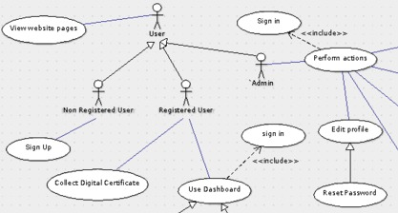

Sign-Up enables user to create an account on the website. Sign-In will enable user to enter into his user dashboard. Sign-Out will log the User out of his account.

SIGN-UP

4.1.1 Description
The User can sign-up for an account to register for events.
4.1.2 Stimulus Sequences
When you press this button.

Response Sequences
Your account registers with unique email-id and password.

4.1.3 Functional Requirements
Sign Up: The user must use a valid email-id to sign up and must provide a strong password.

SIGN-IN
4.1.1 Description
The User can sign-in to their account using the registered email and password.
4.1.2 Stimulus Sequences
When you press this button.
Response Sequences
You can sign in to your account using your credentials by clicking sign in option.
4.1.3 Functional Requirements
Sign In: The user must sign-in with the registered email-id and password, failing in which system will generate an error message.

SIGN-OUT
4.1.1 Description
The User can log out from their account.
4.1.2 Stimulus Sequences
By clicking on sign out button,
Response Sequences
Your account is logged out to home page.
4.1.3 Functional Requirements
Sign Out: The user can only logout only if the user is logged-in.

Automated Email

The server will send automated emails to the users. It has different types of emails, for example, email reminder, email upon account creation, password reset email, custom email.

WELCOME EMAIL

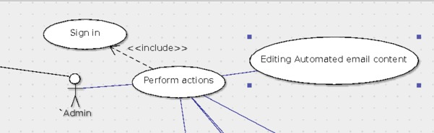

4.1.1 Description
Upon creation of a new account, user will receive a system generated email.
4.1.2 Stimulus Sequences
On creation of a new account.
Response Sequences
You will receive a conformation mail from the website.
4.1.3 Functional Requirements
For all the above valid Email Id of the users are required, failing in which the system will generate error which will be sent to the administrator.

PASSWORD RESET EMAIL

4.1.1 Description
User will receive new temporary password to the registered email-id.
4.1.2 Stimulus Sequences
By clicking this button.
Response Sequences
you get an option to reset your password .
1.3 Functional Requirements
For all the above valid Email Id of the users are required, failing in which the system will generate error which will be sent to the administrator.

CUSTOM EMAIL

4.1.1 Description
The Website administrator can send custom emails with attachment to users.
4.1.2 Stimulus Sequences
On signing up with the website.
Response Sequences
The system sends a mass mail to all attached created by admin.
4.1.3 Functional Requirements
For all the above valid Email Id of the users are required, failing in which the system will generate error which will be sent to the administrator.

Managing Web Contents
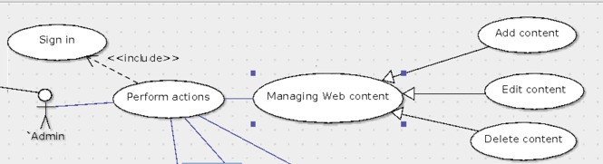

The Administrator can manage the static web content of the website.

ADD Content
4.1.1 Description
Administrator can Add static pages.
4.1.2 Stimulus Sequences
By clicking this button.
Response Sequences
Admin has option to add new web pages with new content.
4.1.3 Functional Requirements
None

DELETE Content
4.1.1 Description
Administrator can remove the static pages.
4.1.2 Stimulus Sequences
On clicking this button.
Response Sequences
System shows web pages which can be deleted by admin.
4.1.3 Functional Requirements
None

UPDATE Content
4.1.1 Description
Administrator can modify the static page contents.
4.1.2 Stimulus/Response Sequences
By clicking this option.
Response Sequences
Admin has rights to edit content of a page.

4.1.3 Functional Requirements
None

Managing event module
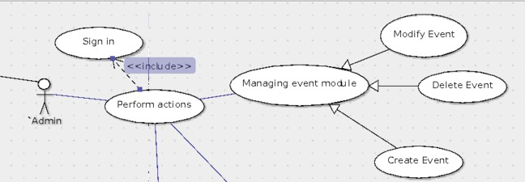

4.4.1 Close event

4.4.1.1 Description:
Admin can close or block the participation page of event at his will.

4.4.1.2 Stimulus/Response Sequences:
By clicking this option,

Response Sequences
A particular event get restricted to users to participate in them as long as the user wants.

4.4.1.3 Functional requirements:
A valid email id of the Admin and a Internet enabled smart device

4.42 Delete event
4.4.1.1 Description:
Admin can delete an event from the timeline at his will.

4.4.1.2 Stimulus Sequences:
By clicking this option.

Response Sequences:
A particular event’s content, that is information about them get deleted from the page.

4.4.1.3 Functional requirements:
A valid email id of the Admin and a Internet enabled smart device

4.43 Create event
4.1.1.1 Description:
Admin can create any event at his will

4.1.1.2 Stimulus/Response Sequences:
By clicking this option.

Response Sequences:
a new event is created showing information such as date, type in that page.

4.1.1.3 Functional requirements:
A valid email id of the Admin and a Internet enabled smart device

4.14 Modify event
4.1.1.1 Description:
Admin can edit a existed event at his will.

4.1.1.2 Stimulus Sequences:
By clicking this option,

Response Sequences:
modification of event can be done, such as a closed event can be made active again.

4.1.1.3 Functional requirements:
A valid email id of the Admin and a Internet enabled smart device

Managing registered Users
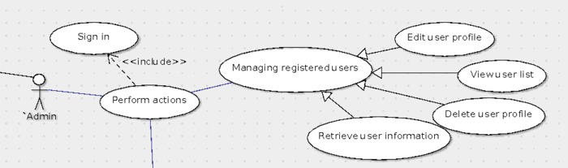

4.51 View user list

4.511 Retrieve User Information
4.5.1.1 Description:
Admin can retrieve registered user information from the website at his will.

4.5.1.2 Stimulus/Response Sequences
by clicking option.

Response Sequences
Registered user list is stored in an organized order in an excel sheet and is downloaded in the admin smart device.

4.5.1.3 Functional requirements:
A valid email id of the Admin and a Internet enabled smart device

4.512 Delete user profile
4.5.1.1 Description:
Admin can delete registered user records from the website at his will.

4.5.1.2 Stimulus/Response Sequences
By clicking option,

Response Sequences
Registered user can delete his registration details from the website’s database, so that that particular user cant open his account.

4.5.1.3 Functional requirements:
A valid email id of the Admin and a Internet enabled smart device

4.5.2 Edit User profile

4.5.1.1 Description:
Admin can edit his profile in the website, such as updating his/her photo, role, etc.

4.5.1.2 Stimulus/Response Sequences
By clicking option.

Response Sequences
Registered user can edit his information from website’s database.

4.5.1.3 Functional requirements:
A valid email id of the Admin and a Internet enabled smart device

View Website pages
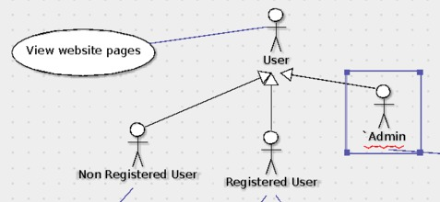

4.6.1 Description:
This feature allows user to access the information available in different pages of this website.

4.6.1.2 Stimulus Sequences
On opening the website.

Response Sequences
User can surf through the website.

4.6.1.3 Functional requirements:
A Internet enabled smart device.

User Dashboard

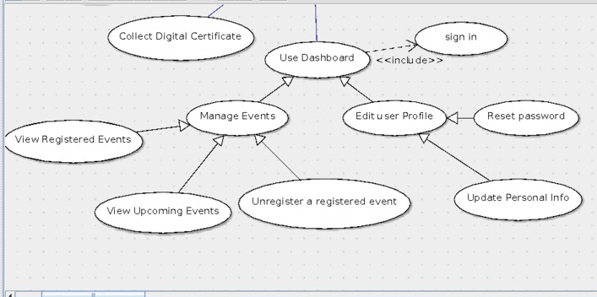

4.7.2 Managing Events

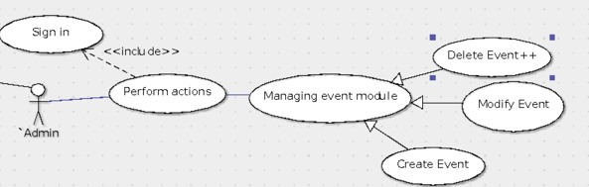

4.7.2.1 Register Events
4.7.2.1.1 Description:
This feature allows user to participate in a CIIE event.

4.7.2.1.2 Stimulus Sequences:
On clicking this button.

Response Sequences:
Registered user get enrolled with that particular event.

4.7.2.1.3 Functional requirements:
An user valid email id and a Internet enabled smart device to operate.

4.7.2.2 View Registered Events
4.7.2.2.1 Description:
This feature allows user to view the participated or registered events of CIIE.

4.7.2.2.2 Stimulus/Response Sequences:
On clicking this button.

Response Sequences:
User can view his registered events.

4.7.2.2.3 Functional requirements:
An user valid email id and a Internet enabled smart device to operate.

4.7.2.2.2 Unregistered Registered Events
4.7.2.2.2.1 Description:
This feature allows user to unregistered the previously selected event.

4.7.2.2.2.2 Stimulus/Response Sequences:
On clicking this button.

Response Sequences:
User can unregister the previously enrolled event.

4.7.2.2.2.3 Functional requirements:
An user valid email id and a Internet enabled smart device to operate.

4.7.3 Collect digital Certificate
4.7.3.1 Description:
This feature allows user to download the digital certificate for his participation in any of the CIIE event.

4.7.3.2 Stimulus/Response Sequences:
By clicking this button.

Response Sequences:
It downloads digital certificate of user if any.

4.7.3.3 Functional requirements:
An user valid email id and a Internet enabled smart device to operate.

4.7.4 Edit Profile

4.7.4.1 Update Personal Information

4.7.4.1.1 Description:
This feature allows user to edit his /her profile such as updating photo, etc.

4.7.4.1.2 Stimulus/Response Sequences:
On clicking this button.

Response Sequences:
User can update/modify his/her profile.

4.7.4.1.3 Functional requirements:
An user valid email id and a Internet enabled smart device to operate.

4.7.4.2 Password Reset
4.7.4.2.1 Description:
This feature allows user to reset his/her password for its registered email id in the website.

4.7.4.2.2Stimulus/Response Sequences:
On clicking this button.

Response Sequences:
It will display a dialog box to reset his/her password to a new one.

4.7.4.2.3 Functional requirements:
An user valid email id and a Internet enabled smart device to operate.

Other Nonfunctional Requirements

Performance Requirements
The application is expected to meet certain performance criteria .However, there are
other dependencies which could cause an impact on these performance criteria
depending on the speed of the network, server response time, load etc.
Depending on the nature of the connectivity(broadband or Wi-Fi ), the response time
is expected to be in the range of 15 –25 seconds
The display loading may depend on the data volume and maytake10– 15 seconds
The numbers of concurrent users are expected to be 50 in the each phase.

Safety Requirements
The application needs to take proper safety measures to handle the database and concerned data. The exception handling while handling the data updates needs to be handled carefully. The database locking and committing needs to be appropriate so that no data corruption happens through the functionality. The user scenarios need to tested properly to ensure the application functionality is
accurate.

Security Requirements
The application needs to implement the role based security and authentication mechanism. The various roles are administrator, Volunteers/Students. Login credentials and roles should be implemented. Need to maintain these in DB with encryption. Appropriate error messages and warning messages need to be displayed.

Software Quality Attributes
The Quality of the System is maintained in such a way so that it can be very user Friendly to all the users. Accurate and hence reliable: The system should be robust enough to handle fault tolerances. The system should not crash and should be able to identify invalid inputs and produce a suitable error message. Availability: The system should beavailable24/7. It should always provide Real time information. Usability: The system should provide an easy to use Graphical interface similar so that users do not have to learn a new style of interaction. Any notification or error messages generated should be clear, succinct, polite and free of jargon. Fast speed: The system should be fast enough to display error messages, notification, results etc. Integrity: Only system administrator has the rights to change system parameters, such as pricing policy etc. Users need to be authenticated before accessing personal data.

Business Rules
The application needs to follow the role based access and functionality to ensure the data security. The detailed role based matrix will be provided in the design phase based on the business rules defined by the application owners.

Other Requirements
Appendix A: Glossary
None
Appendix B: Analysis Models
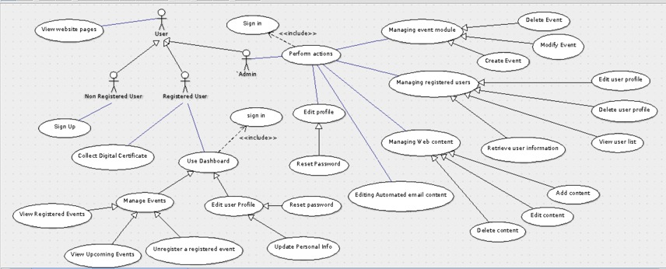

Appendix C: To Be Determined List
None

