**Software Requirements Specification**

**for**

**Catero**

**Version 2.0 approved**

**Prepared by**

|  |  |
| --- | --- |
| **Desu Lohith** | **U101116FEC159** |
| **Ajay Sharma GS** | **U101116FCS006** |
| **CVN Sai Koushik** | **U101116FCS024** |
| **Ashish Bisht** | **U101116FCS015** |
| **Mitul Kumar** | **U101116FCS068** |

**NIIT University**

**October 10th 2018**

**Revision History**

|  |  |  |  |
| --- | --- | --- | --- |
| **Name** | **Date** | **Reason For Changes** | **Version** |
| **Catero Team** | **Oct 10th** | **Modified Use Case diagram** | **2.0** |

**Table of Contents**

**Software Requirements Specification 1**

**for 1**

**Catero 1**

**Table of Contents 2**

**Revision History 2**

1. **Introduction 1**
   1. Purpose 1
   2. Document Conventions 1
   3. Intended Audience and Reading Suggestions 2
   4. Product Scope 2
   5. References 2
2. **Overall Description 2**
   1. Product Perspective 3
   2. Product Functions 3
   3. User Classes and Characteristics 3
   4. Operating Environment 3
   5. Design and Implementation Constraints 3
   6. User Documentation 4
   7. Assumptions and Dependencies 4
3. **External Interface Requirements 4**
   1. User Interfaces 4
   2. Hardware Interfaces 4
   3. Software Interfaces 5
   4. Communications Interfaces 5
4. **System Features 5**

4.2 Update Order(Owner Side) 6

4.3 Chat Box 7

1. **Other Nonfunctional Requirements 7**
   1. Performance Requirements 8
   2. Safety Requirements 8
   3. Security Requirements 8
   4. Software Quality Attributes 8
   5. Business Rules 8
2. **Other Requirements 9**

**Appendix A: Glossary 9**

**Appendix B: Analysis Models 9**

**Appendix C: To Be Determined List 9**

1. **Introduction**

## Purpose

Catero is a catering management system in which we will add a tasty, well-organized menu on our website and enable customers to pre-order your exquisite meals and drinks online. You can offer them different kind of packages as per occasion like wedding, birthday party, etc. Add as many products as you wish, manage orders and process payments. Clients only have to make their choice, select their preferred payment method and wait for their delivery. Catero is designed to simplify the catering order process for our customer. It can be integrated with mobile phone, tablet, and web applications. We are bringing business processes to the digital age.

## Document Conventions

We will use some acronyms throughout this SRS document. This subsection presents definitions for the terms used in this SRS document.

|  |  |
| --- | --- |
| **Term** | **Description** |
| Item | Single serving of food/beverage. |
| Menu | Representation of available items and other options. |
| Order | Consists of one or more items. |
| User | Person who orders/pays from Catero website. |
| Payment | Comprises the total cost of zero or more orders and zero or more tips. |
| Server | Backend computer that hosts the menu & orders. |
| Owner | The owner of the catering company |

The document uses the conventions like database, entity relationships, user interface, use case diagrams and bold letters to emphasis important topics and for all the major functions of the system and Times font of 12 font size indicates the complete description about the whole sub parts.

## Intended Audience and Reading Suggestions

This document is written especially for web developers, researchers, software developers and documentation writers, etc. By reading this document a reader can learn about what the project is implemented for and how it will present the basic information of project. This document has a sequential overview of whole project so if a reader reads the whole document so that reader can get a whole idea about the project.

## Product Scope

This system will consist of a website with AI Chat bot and database to store the orders ordered by the customers. The website is intended to boost the sales of the catering company and create an efficient and sustainable business model of the company. The scope of the product is high because this catering company is already popular in its region and is willing to increase its online customers.

The purpose of the Catering management system is to create a convenient and easy-to-use application for customers, trying to book the orders. The system is based on a relational database with its Catering management. We will have a database server supporting to account all the orders and dates of events as well as we give important notifications. Above all, we hope to provide a comfortable user experience along with the best pricing available.

## References

Reference for web scripting [https://www.w3schools.com](https://www.w3schools.com/)

HTML and CSS: design and build web site by Jon Duckett*.*

Fundamentals of database systems by ramez elmarsi and shamkant b.navathe.

**2. Overall Description**

## 2.1. Product Perspective

The Catero helps the owner to manage the catering process more efficiently and effectively by computerizing the orders. This system replaces the current manual and telephone process for ordering food for events through creating an online system and digitization of menu items with user friendly interface reduces the ambiguity to the user for ordering the food items. The system merges various hardware and software elements and it will evolve over several releases ultimately with chat bot integration.

## 2.2. Product Functions

Whole functions will performed through this project are:

* Registration: Customer should register before login if he wants to visit the Catero.
* Login: Customer logins with valid Username and Password.
* Customer view: Customer can view all the features like menu, gallery, bookings, contact details etc.
* Owner view: Owner can view booking orders, stocks, and maintenance of company.

## 2.3. User Classes and Characteristics

**USERS** are divided into two types:

* **Customers**

Customer will have the access to the functions present on the screen like menu, gallery, bookings, contact details etc. It is considered that the user do have the basic knowledge of operating the internet and to have access to it.

* **Registered Customers:**

Registered Customers are the users who have already registered and they can login into catero website with their credentials.

* **Unregistered Customers:**

These are the users who have not yet registered in catero website. They can fill the registration form and create their credentials and login into catero website.

* **Owner**

The Owner is expected to be familiar with the interface of the tech support system and can view booking orders, maintenance of company.

## 2.4. Operating Environment

This is a web-based system and hence will require the operating environment for a client and server GUI. The server must be able to operate unattended indefinitely. It should not need physical interaction except for upgrades and failure of hardware elements. Backup and recovery should be handled by the DBMS and operating system, or external software running on a timed backup system.

**Operating System**: Windows or UNIX based OS.

**Database**: MySQL.

## 2.5. Design and Implementation Constraints

This system is provisioned to be built on the HTML, CSS, Java Script, which is highly flexible. Decision regarding which database to use should be taken considering the fact that data being stored is large, and the appropriate data management system will yield efficient performance.

## 2.6. User Documentation

* This project comes with a user manual as a guide to its interface options.
* The details of designs, analysis and documentation will be provided along with project.
* Online contact through email and phone number will be provided along with the software.

## 2.7. Assumptions and Dependencies

* The customer and seller must have basic knowledge of computers and English language.
* Each User must have a User ID and password that will stored in encrypted format in database.
* Bot libre platform which acts as an interpreter for AIML.
* Paytm API for advance payment*.*

**3.External Interface Requirements**

There are many types of interfaces as such supported by this software system namely:

User Interfaces, Hardware Interfaces, Software Interfaces and Communications Interfaces.

## 3.1. User Interfaces

The interface will be user friendly. So that every kind of customer can place the food order easily.

Some of the Interfaces for the product would be:

* Login Page
* Registration Form
* View menu, gallery, and contacts.
* Add to cart option for saving the order.
* Payment mode

The user interface for the software shall be compatible to any browser such as google, Internet Explorer, Mozilla Firefox by which user can access to the system.

## 3.2. Hardware Interfaces

It is expected that the user will have a device (computer/mobile) having active Internet connection in order to access the catering website.

## 3.3. Software Interfaces

User only need a web browser which supports HTML5. As for developers would require having database in order to store user information.

## 3.4. Communication Interfaces

Communication function requires the Internet protocol version 4/6 in order to access the website. Protocol that will be used are HTTP/HTTPS and SMTP for communication through mail. SSL, SET, IOTP will be used for online transactions.

**4.System Features**

## 4.1 Registration

**4.1.1 Description and Priority**

It’ s purpose is to create a new customer of the Catero.

A customer must be registered if he/she wants to view menu, gallery etc.

The priority to this feature is high.

**4.1.2 Stimulus/Response Sequences**

**Stimulus:** User wants to have an account to view menu and place order.

**Response:** The system will display the form with required data to signup.

**Stimulus:** User is unregistered and enters incorrect email or phone-number while registering.

**Response:** Display an error message.

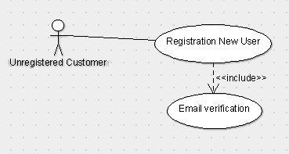

**4.1.3 Functional Requirements**

**REQ -1:** For User the required details are Name, Password, Phone number,E-mail.

**REQ-2:** For admin, details are Name, Username and Password.

**REQ-3:** After any of the above users have signed up a dedicated account has been created for the user and owner.

**4.2 Authentication**

**4.2.1 Description and Priority**

This feature will be used to Log In into the Website (only registered users can use Catero). It is done in order to prevent any misuse of Website.

The Priority for this feature is high.

**4.2.2 Stimulus/Response Sequences**

**Stimulus:** User wants to have an account to view and place order.

**Response:** System will display a login page with Username and password.

**Stimulus:** The User is unregistered and tried to Log in or the user is registered and puts incorrect username or password.

**Response:** Display an error message.

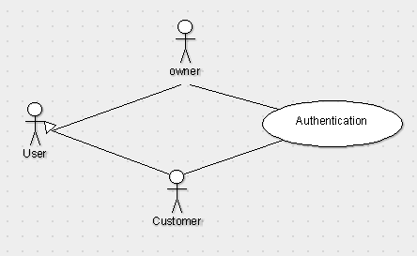

**4.2.3 Functional Requirements**

**REQ-1:** For Customer the required details are Username and password to login.

**REQ-2:** For admin the required details are Username and password.

**4.3.View Contact Details:**

**4.3.1.Description and Priority:**

Users can view the contact details of the catering company and contact them for any clarifications.

The priority is moderate.

**4.3.2.Stimulus/Response Sequences**

**Stimulus:**  User wants to see the details of owner.

**Response:** The system will provide a new page containing details of owner.

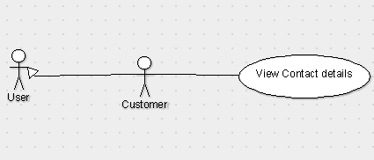

**4.3.3 Functional Requirements**

**REQ:** For user to know about the company and to clarify any queries this details will help him out.

**4.4.Standard menu:**

**4.4.1.Description and priority:**

Users can view the items list from the menu available on the home page and select their desired items and add to the cart and place order.

**4.4.2.Stimulus and response:** Customers can select the items from the standard menu which is like a menu provided at hotel.

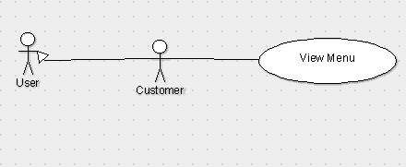

**4.4.3.Functional Requirements:**

**REQ1:** Standard menu is required to present the customer about all the items which can be done by the catering service.

**REQ2:** Customers should be able to see the standard menu and select items from it.

**4.5.Customized Menu:**

**4.5.1.Description and Priority:**

Users can view the items that are recommended by the owner according to the event and he can choose any of the desired list from the set of option.

**4.5.2.Stimulus/Response Sequences:**

**Stimulus:** Users can view the items list suggested by owner.

**Response:** It displays the list to user to pick any of the items.



**4.5.3.Functional Requirements**

**REQ:** It is useful to those customers who have zero background about food to choose according to the event helps this feature to help them.

**4.6.View Gallery:**

**4.6.1.Description and priority:**

Users can view the gallery which consists pictures of previous events like flower decoration, food items, DJ etc; organized by the company.

**4.6.2.Stimulus/Response Sequences:**

**Stimulus:** Customers select the gallery option to view pictures.

**Response:** The gallery must then be opened for them which contains the photographs of past events.

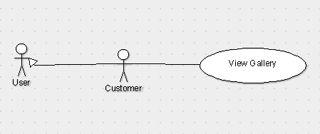

**4.6.3.Functional Requirements:**

**REQ**: Gallery is required to showcase the previous events organized by the catering service.

**4.7.Sample tasting:**

**4.7.1.Description and priority:**

Users can specify an item from their desired menu for sample tasting.

**4.7.2.Stimulus/Response Sequences:**

**Stimulus:** Customers select the few items of their choice for sample tasting.

**Response:** The selected sample tasting items should have been provided to the owner.

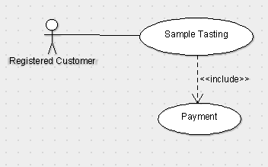

**4.7.3.Functional Requirements:**

**REQ1:** Payment should have been done in order to place the sample tasting.

**REQ2:** Customer is required to provide the information about the event and select the menu of his choice.

**4.8.Placing order**

**4.8.1.Description and priority:**

Can place order by choosing the required items from the menu provided for their occasion. Selected menu will be added into the cart. If the User wants to remove the item, it can be done by the remove option.

Users can also book additional activities for their event like Flower Decoration, DJ, Photography, Tattoos etc.,

This function carries high priority.

**4.8.2.Stimulus/Response Sequences:**

**Stimulus:** User wants to place the order.

**Response:** The required items will be selected and added to the cart for checkout.

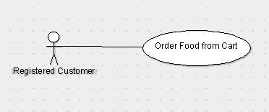

**4.8.3.Functional Requirements:**

**REQ1**: The required items would be presented in the menu provided in the website.

**REQ2:** Customers should be able to design the menu of their choice.

**4.9.Payment:**

**4.9.1.Description and priority:**

After adding the menu to the cart, user proceeds to payment mode where he can pay the advance amount through PayTm and the remaining by cash.

This function has high priority.

**4.9.2.Stimulus/Response Sequences:**

**Stimulus:** Customer selects to pay the advance payment.

**Response:** paytm information will be provided when he wants to pay the advance payment.

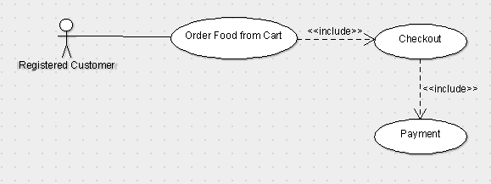

**4.9.3.Functional Requirements:**

**REQ1:** paytm information should be provided as soon as the customer wants to pay.

**REQ2:** In order to pay customer should have completed designing the menu of his choice.

**4.10.Notifications:**

**4.10.1.Description and priority:**

After the order is placed successfully, instant notification is of order details is sent through E-mail.

**4.10.2.Stimulus/Response Sequences:**

**Stimulus and Response:** Notification must be sent to the customer after the payment has been done through the mail which the customer has provided at the time of checkout.

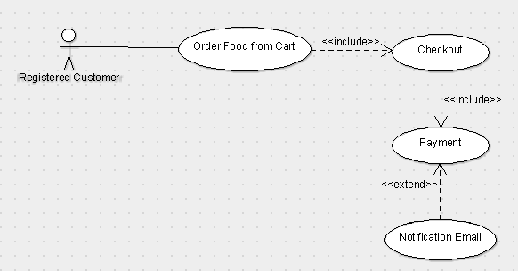

**4.10.3.Functional Requirements:**

**REQ1:** Customer should have completed the advance payment.

**REQ2**: Email should have been provided by the customer.

**4.11.Ask queries through Chat Bot:**

**4.11.1.Description and priority:**

Users should be able to place their queries and get appropriate answer. This function carries least priority.

**4.11.2.Stimulus/Response Sequences:**

**Stimulus:** Users ask about certain queries which they have.

**Response:** Users must be able to get their query resolved in an appropriate way possible.

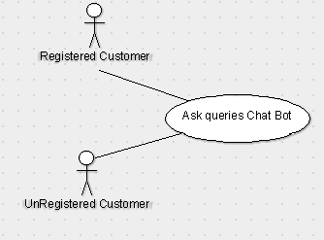

**4.11.3.Functional Requirements:**

**REQ:** ChatBot is being used in order to resolve user queries instantly to clarify their doubts.

**4.12. Update Menu:**

**4.12.1 Description and Priority**

 This function is for owner side of the application.If the owner decides to change the current menu, he can do so with this feature.This function carries highest priority.

**4.12.2 Stimulus/Response Sequences**

**Stimulus:** Owner updates the list of items on menu present on the owner side.

**Response:** It displays menu updated successfully and the menu visible to the customers on catero website is updated.

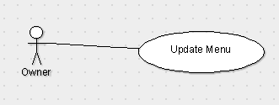

**4.12.3 Functional Requirement:**

**REQ-1:** Owner can add items from the current menu.

**REQ-2:** Owner can remove items from the current menu. This feature gives an option for the owner to change the menu according to particular season.

**4.13. Add/Remove multiple Categories:**

**4.13.1 Description and Priority**

This function is for owner side of the application. With this function,  owner should be able to add multiple categories to the menu. This  function carries highest priority.

**4.13.2 Stimulus/Response Sequences**

**Stimulus:** Owner adds a new category of food into menu.

**Response:** A new category is added into the current menu.

**Stimulus:** Owner uploads an image for the new category created.

**Response:** New category with an enhanced UI is created.

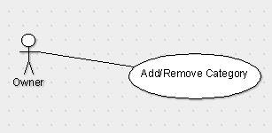

**4.13.3 Functional Requirements**

**REQ-1:**  Owner should be able to Create various product categories as per their required menu like starters, drinks, desserts, etc.

**REQ-2:** Personalise each category by adding a title and representative image.

**4.14. Calendar of upcoming events:**

**4.14.1 Description and Priority**

All the upcoming events will appear as a calendar of events which will    allow the owner to stay updated with orders to be prepared and cater them in real time. This function is of moderate priority.

**4.14.2 Stimulus/Response Sequences**

**Stimulus:** Owner clicks on Calendar of Upcoming events.

**Response:** All the upcoming events are displayed sorted in date order.

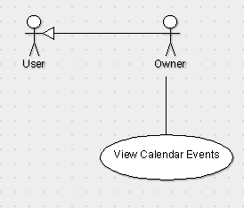

**4.14.3 Functional Requirements**

**REQ-1:** Owner can view the orders placed by the users for particular date and get ready to prepare delicious food.

**4.15. Manage Orders:**

**4.15.1 Description and Priority**

 Owner can view the orders placed through catero website. This function carries highest priority.

**4.15.2 Stimulus/Response Sequences**

 All the orders placed by the customers through catero website are made visible to the owner.

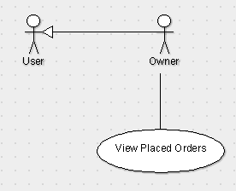

**4.15.3 Functional Requirements**

**REQ:**  Owner can check(view) all the latest online orders at a glance.

1. **Other Nonfunctional Requirements**

This subsection presents the non-functional requirements of Catero. The subcategories of other non-functional requirements are performance requirements, safety, security, software quality attributes.

## 4.1.Performance Requirements

* The product will be based on AWS server.
* The product will take initial load time.
* The performance will depend upon hardware components.
* Database will contain user information.
* Payment system will be ensured through Paytm gateway.

## 4.2.Safety Requirements

If there is extensive damage to the database due to sudden failure, such as a database misinterpretation or disk crash, the recovery method restores a past copy of the database that was backed up to storage and reconstructs the same database as of previous one. We will use PreparedStatement which will prevent sql injections.

## 4.3.Security Requirements

The whole system is secured, only registered user and owner can access all the data. Security systems need database storage just like many other applications. However, the special requirements of the security market mean that vendors must choose their database partner carefully.

So, it’s important that we ensure the overall web application and database does not get hacked by the hackers.

## 4.4.Software Quality Attributes

**AVAILABILITY:** The menu should be available to the customers all the time and it should be updated seasonally.

**CORRECTNESS:** The order should reach customer correctly as placed by customer and delivery should be reached from correct source.

**MAINTAINABILITY:** The owner and menu in chargers should maintain correct availability of items.

## 4.5.Business Rules

Users who visit Catero website will be able to login, view items in the menu and add desired menu to the cart and confirm their order by making payment.

Owner of the catering company will be able to view the orders ordered by users through Catero website and process the order.

1. **Other Requirements**

All requirements are specified above, there are no other requirements to be mentioned.

**5.1.Appendix : Analysis Models**

**Use Case Diagram:**

A use case diagram at its simplest is a representation of a user's interaction with the system that shows the relationship between the user and the different use cases in which the user is involved.

