

**Software Design Document**

**Course Name:** Software Engineering

**Course code:** CS301

**Year:** 3nd

**Semester:** 5th

**Session:** 2018-19

**Discipline: CSE**

**Project:** NU NEWSLETTER

**Software Design Specification**

**1. Introduction**

The Software Design Document is a document to provide documentation which will be used to aid in software development by providing the details for how the software should be built. Within the Software Design Document are narrative and graphical documentation of the software design for the project including use case models, sequence diagrams, collaboration models, object behaviour models, and other supporting requirement information.

**1.1 Purpose of this document**

This document will define the design of the one runway simulator. It contains specific information about the expected input, output, classes, and functions. The interaction between the classes to meet the desired requirements are outlined in detailed figures at the end of the document.

**1.2 Scope of the development project**

We describe what features are in the scope of the software and what are not in the scope of the software to be developed.

In Scope:

1. Website for the news taking place in NIIT University.
2. The important events taking place in NIIT University will be published on the website.
3. Placement news of students in NIIT University will be available in the website.

Out of Scope:

1. The news/events taking place in India.

**1.3 Definitions, acronyms, and abbreviations**

IEEE: Institute of Electrical and Electronics Engineers

SDS: Software Design Specification

**1.4 References**

**1.4.1** R. S. Pressman, Software Engineering: A Practioner’s Approach, 5thEd, McGraw-Hill, 2001.

**1.4.2** IEEE SDS template

**1.5 Overview of document**

This SDS is divided into seven sections with various sub-sections. The sections of the

Software Design Document are:

1. **Introduction**: describes about the document, purpose, scope of development,project definitions, and abbreviations used in the document.
2. **Conceptual Architecture**/**Architecture Diagram:** describes the overview ofcomponents, modules, structure and relationships and user interface issues.

* 1. **Logical Architecture:** describes Logical Architecture Description andComponents.
  2. **Execution Architecture:** defines the runtime environment, processes,deployment view.
  3. **Design Decisions and Trade-offs:** describes the decisions taken along withthe reason as to why they were chosen over other alternatives.
  4. **Pseudocode for components:** describes pseudocode, as the name indicates.
  5. **Appendices:** describes subsidiary matter if any.

**2.Conceptual Architecture/Architecture Diagram**

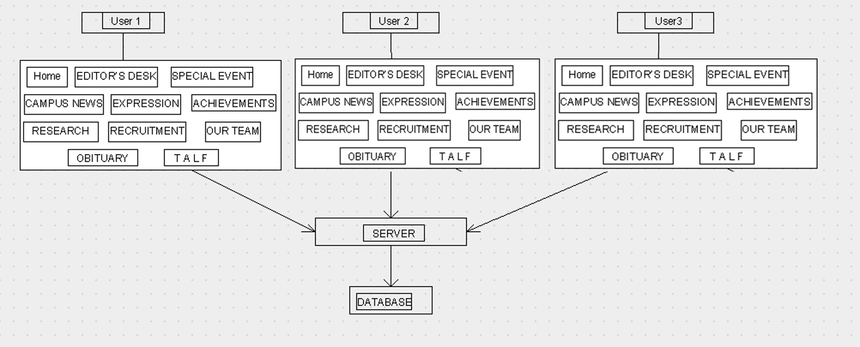**Architecture Diagram 1:**

**Architecture Diagram 2:**

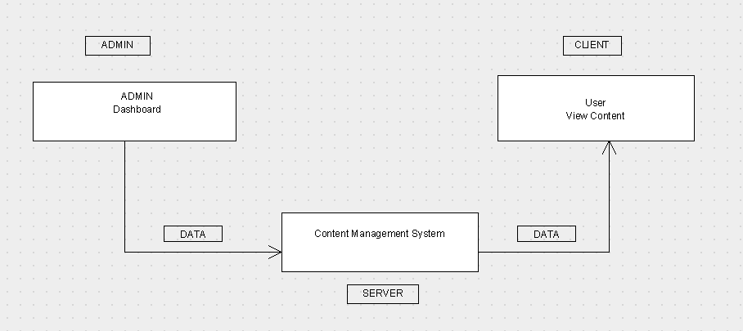

**2.1 Overview of components**

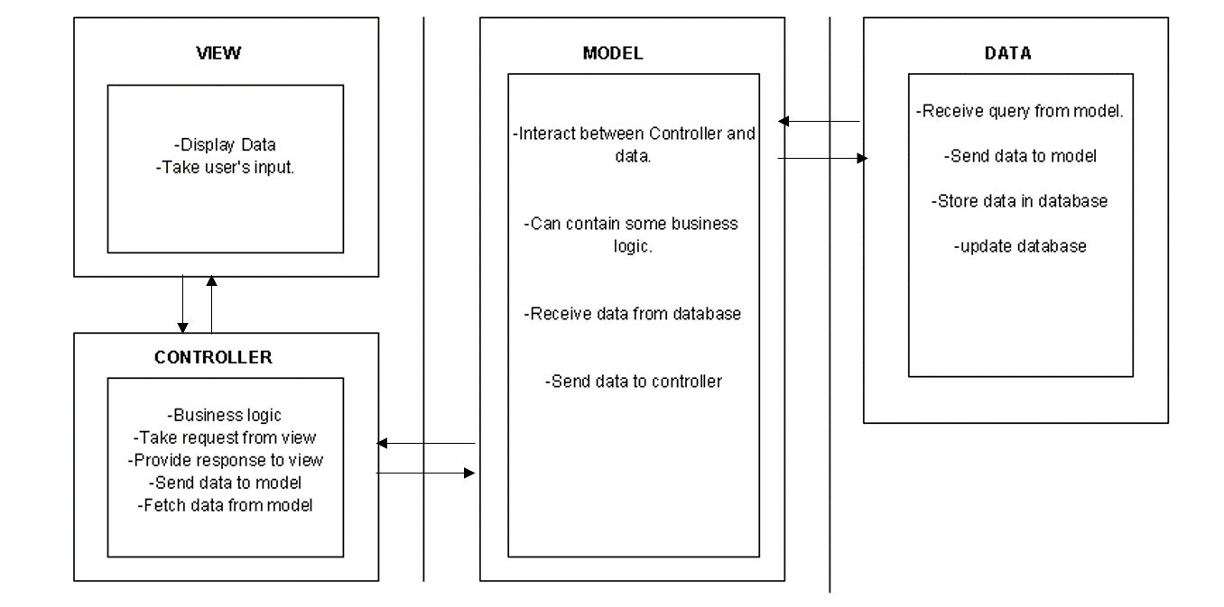

**2.2 Structure and relationships**

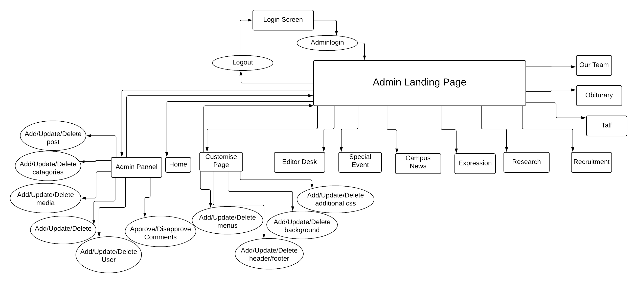2.2.1 Admin’s Side

Note: User can shift between varies tab’s directly.



**3.Sequence Diagrams:**

**3.1 Access website:**

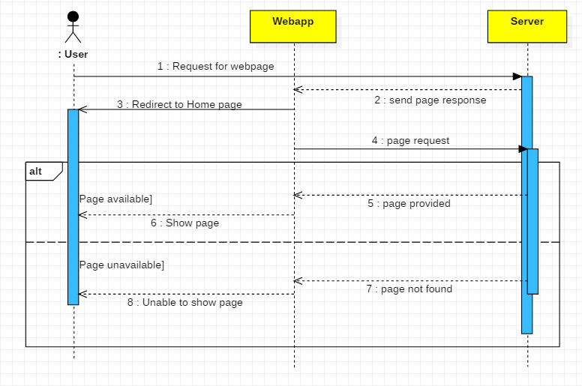

**3.2 Comments validation:**

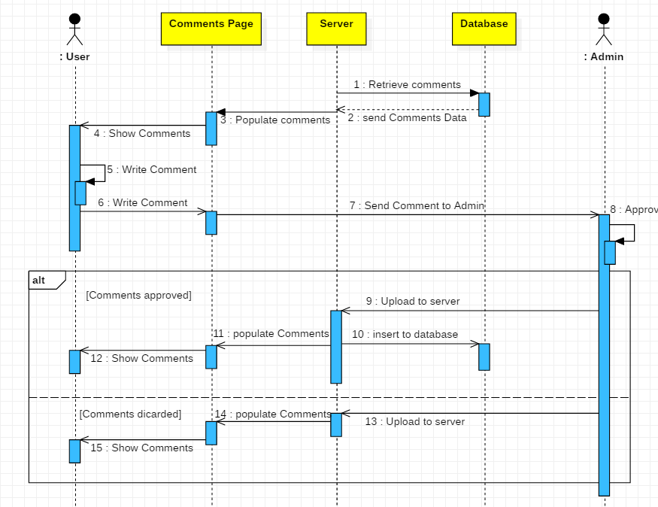

**3.3 Admin login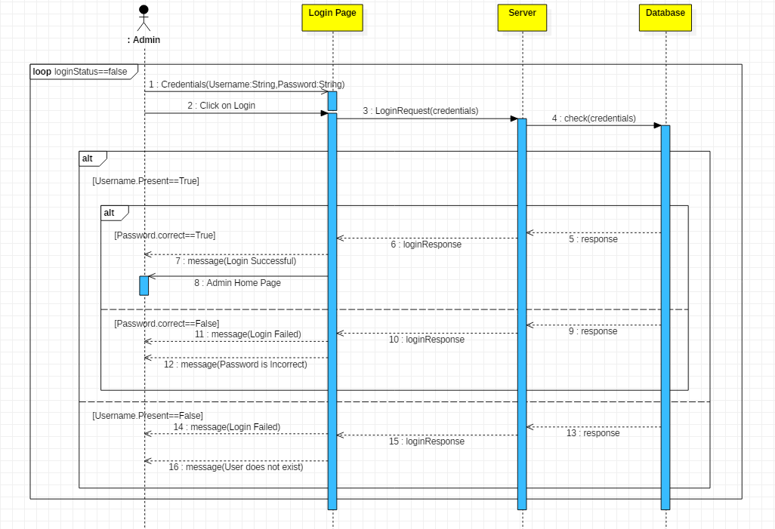:**

**3.4 Create Post:**

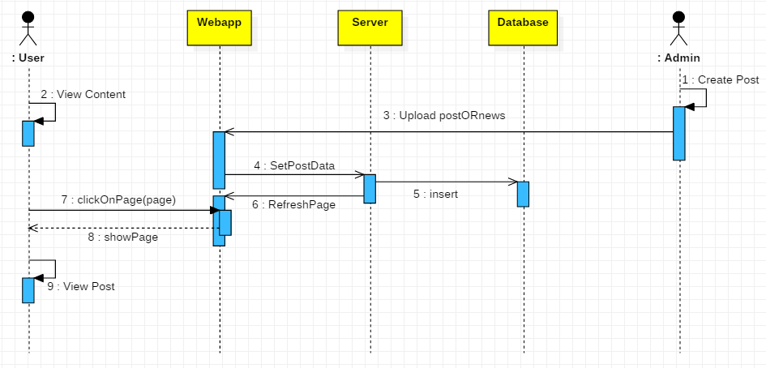

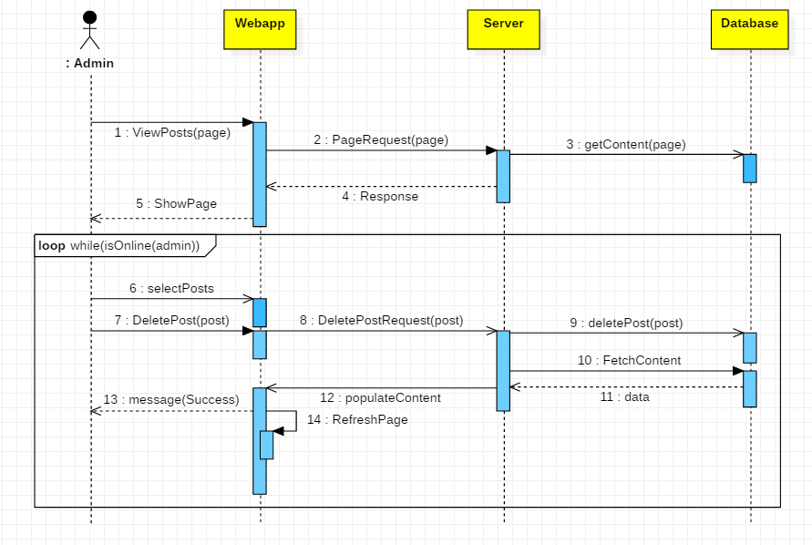

**3.5 Delete post:**

**3.6 User Login:**

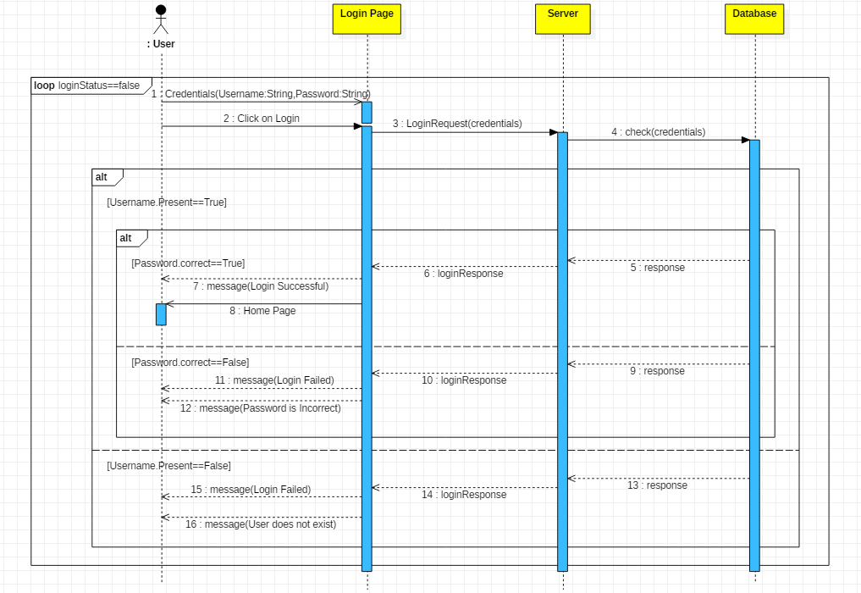

**3.7 View Posts:**

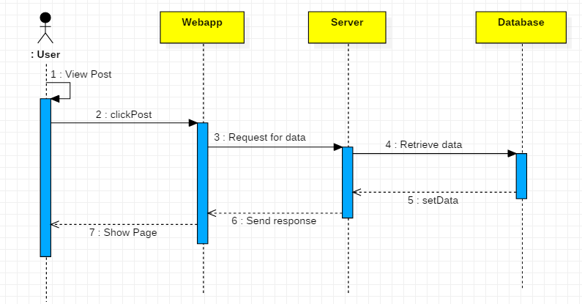

**4. State Diagram: Overview**

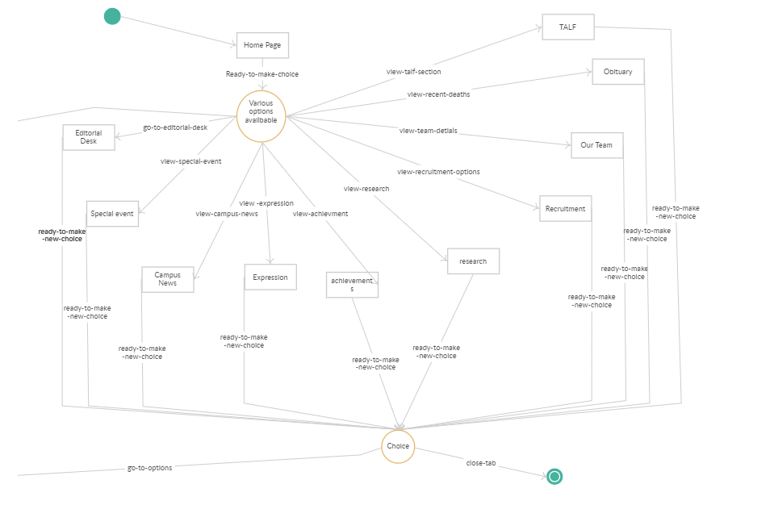

State Diagram: Home

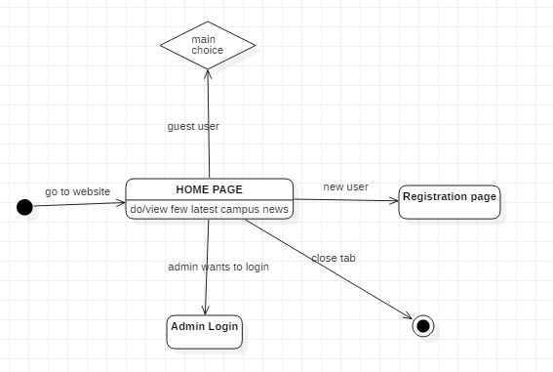

State Diagram: Admin

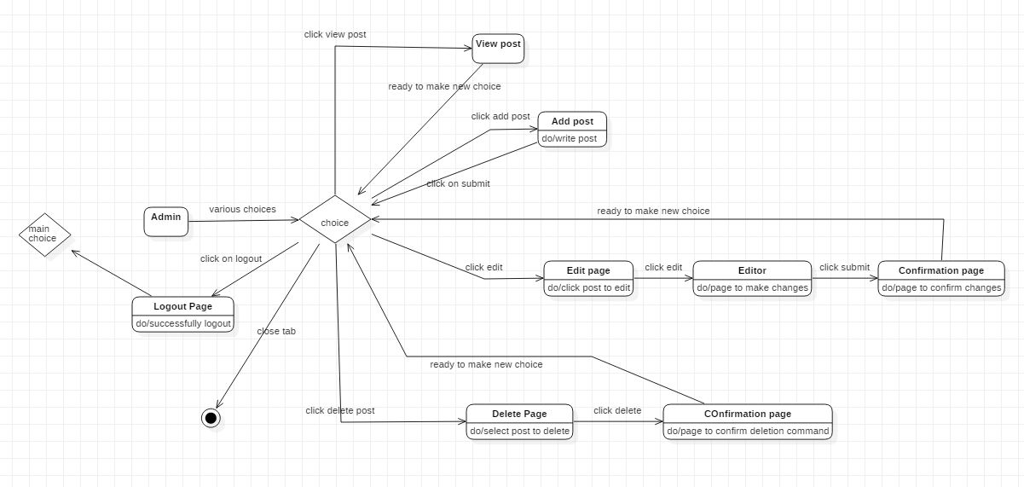

State Diagram: Guest User

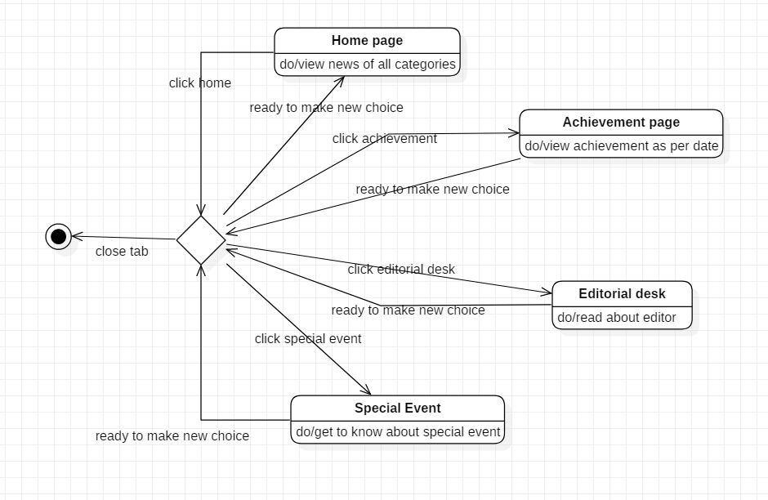

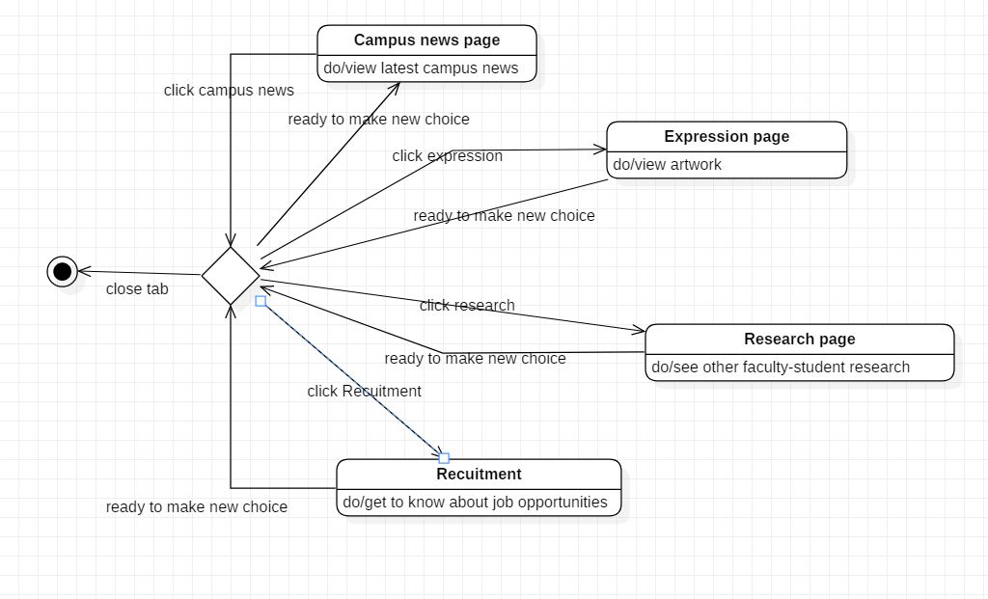

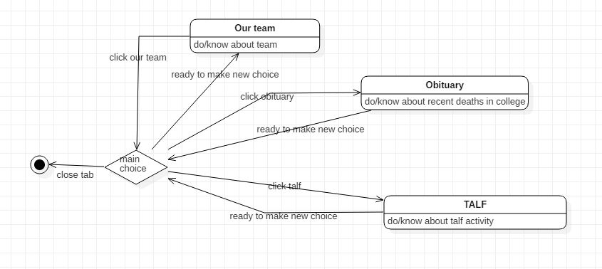

State Diagram: Registered User

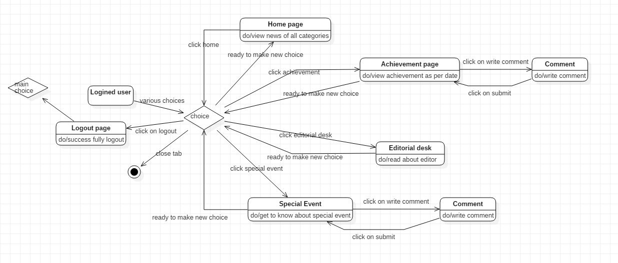

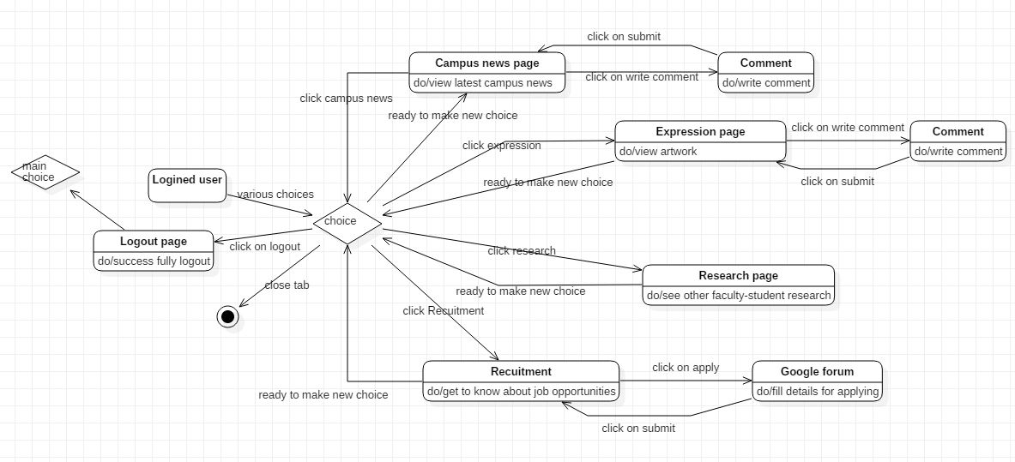

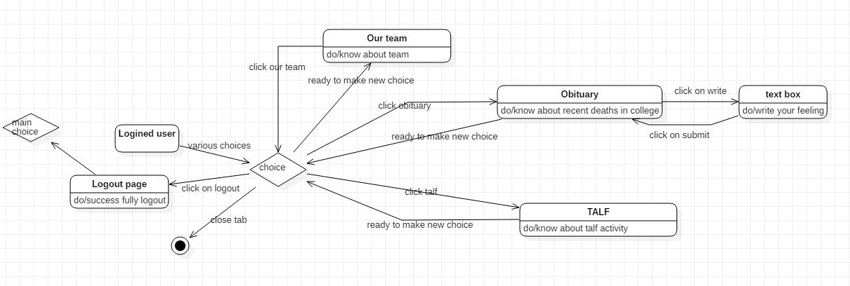

**Class Diagram:**

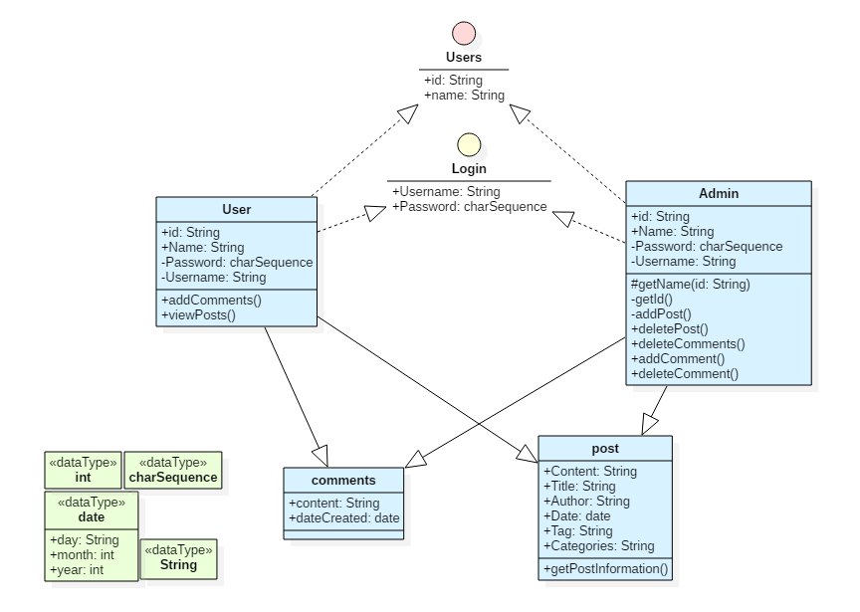

**5. Logical Architecture Description**

The Architecture is based on Client – Server communication where the data is stored in MySQL Database and the server retrieves the data as and when the client requires it to.

**6. Sequence Diagrams**

**6.1 Access website**

The User first enter the domain URL and hit enter to send request to access the page to the server. After the server has received the request it will redirect the user to the Home page of the website.

**6.2 Comment Validation**

User can go through the news articles and can put their comments. The comments then will be evaluated by the admin. After evaluation the comments will be published.

**6.3 Create posts**

Admin can create posts after login and upload the content to the server after which the content is published. The post may contain news articles, media files or images etc.

**6.4 Delete Posts**

The admin can delete posts or make necessary updates if required. The updated data gets fetched by the server and is then published.

**6.5 User Login**

The User fill the credentials for logging in to the website. By logging in the user can put their comments as the comment require a username and valid authentication.

**6.6 View Post**

Once the user is redirected to the home page, user can view the page of choice.

**6.7 Admin Login**

The Admin fill the credentials to log in to the website. After logging in, the admin is redirected to the admin home page and can Create, Read, Update, Delete operations on the desired posts and comments.

**7.States Diagram:**

**7.1 Home**

The User first go to the website either by logging in (Registered user) or without logging in (Guest user). Admin also require an authorized login to access the features. Once the user gets to the home page, user can read the posts and news.

**7.2 Admin**

The admin must log in first to access the functionalities. The admin gets the right to add and delete posts, read, validate, modify and delete comments.

**7.3 Guest User**

The user who only wants to view the content of the posts falls in this category. The guest user does not have the right to comment on the posts.

**7.4 Registered User**

The registered user can login to view the content and write comments. User can register to the website by clicking on the signup button and filling the required fields of the form.

***********