Software Requirements Specification
For
TRAINING AND PLACEMENT CELL
Version 1.0 approved & Prepared by
ABDUL ARSHIYA
M.PRANEETH SAI
B.NAGA.MAHITHA
K.D.S.VIVEK
ASHISH DWIVEDI
FAAIZ ARZOO

NIIT UNIVERSITY
Table of Contents
Table of Contents ii
Revision History ii
1. Introduction 1
1.1 Purpose 1
1.2 Document Conventions 1
1.3 Intended Audience and Reading Suggestions 1
1.4 Product Scope 1
1.5 References 1
2. Overall Description 2
2.1 Product Perspective 2
2.2 Product Functions 2
2.3 User Classes and Characteristics 2
2.4 Operating Environment 2
2.5 Design and Implementation Constraints 2
2.6 User Documentation 2
2.7 Assumptions and Dependencies 3
3. External Interface Requirements 3
3.1 User Interfaces 3
3.2 Hardware Interfaces 3
3.3 Software Interfaces 3
3.4 Communications Interfaces 3
4. System Features 4
4.1 System Feature 1 4
4.2 System Feature 2 (and so on) 4
5. Other Nonfunctional Requirements 4
5.1 Performance Requirements 4
5.2 Safety Requirements 5
5.3 Security Requirements 5
5.4 Software Quality Attributes 5
5.5 Business Rules 5
6. Other Requirements 5
Appendix A: Glossary 5
Appendix B: Analysis Models 5
Appendix C: To Be Determined List 6

Revision History
Name | Date | Reason For Changes | Version

Introduction

Purpose
The purpose of this project is to develop an online system to ease the recruitment process during placements in a specific university. This helps the colleges to overcome the difficulty in keeping records of thousands of students.

Document Conventions
TPC – Training and placement cell

CV – Curriculum vitae

HTTP – Hyper Text Transfer Protocol

JDBC – Java Database Connectivity

Intended Audience and Reading Suggestions
This project is a prototype for the training and placement cell management system and it has no restrictions. But it can be used only in a specific university. This has been implemented under the guidance of college professors. This project is useful for the placement and training team and as well as to the students and company representatives.

Product Scope
TPC is an online application that can be accessed throughout the organization and outside as well with proper login provided. Students logging will be able to upload their information in the form of a CV. Visitors or company representatives logging in may also access/Search any information put up by the Students

1.5 Benefits :

- 1. As it is online application, communication with placement offer is easy to students and recruiters, so here intimating about the new placements is a very easy task.
- Students can know about the company details through the details provided by the placement officer and through the websites provided by him at recruiters’ option.
- Placement officer can send required materials used for placements preparation to students. With this option preparation for placements becomes easy.

1.6 References
[1] The Complete Reference “Crystal Reports 2008” by George peck.
[2]Training and placement website of IIT,Patna.
[3] “Microsoft Visual Basic 2010” by Michael Halvorson.
[4] Tynjälä, P., Perspective into learning at the workplace, Educational Research Review, 3, 2008, pp.130-154.
[5] “The Complete Reference ASP.NET” book by Robert Standefer III.

Overall Description

Product Perspective
The earlier system is not computerized. All the transactions in the system are done manually maintaining number of records . To make this laborious job simple we have computerized the system. The proposed system(TPC) is fully computerized, which removes all the drawbacks of the existing system.
The management and all the departments that have been carrying out this job using manually makes the job more complicated and tedious most of the times. So, the best way is computerization of the current environment.

Product Functions
There are mainly 3 modules in the project. They are:
1. Student module
functions :
- Update details : This service provides the user to update their details.
- Check details : This service provides the user to check his/her details.
- Material : This service provides the user to check for materials uploaded by administrator
- Mailing : This service provides the user to mail to the administrator.
- Change password : This service enables the user to change password
2. Administrator module :
- Update details
- Add Students
- Update Statistics
- Add recruiter : Allows admin to add a recruiter to the database
- Add event : allows admin to add/insert an event
- Approve
- Change password
3. Recruitment module:
- update details
- College details : allows user to check college details
- Student details : allows recruiter to search for student information according to the eligibility criteria for recruitment process.
- Mailing : This service provides the user to mail to administrator
- Change password

User Classes and Characteristics
There are mainly three user classes in this project. They are :
1. Students
2. Administrator
3. Recruiter
- All Users have common services like
- Changing password
- Updating details
- searching for details
- checking the details
- mailing to the administrator
- reading the material uploaded by the admin(if user is a student)
- Administrator has to do services like :
- Adding events
- adding achievements
- upload materials
- search for student details
- has the right to approve the students

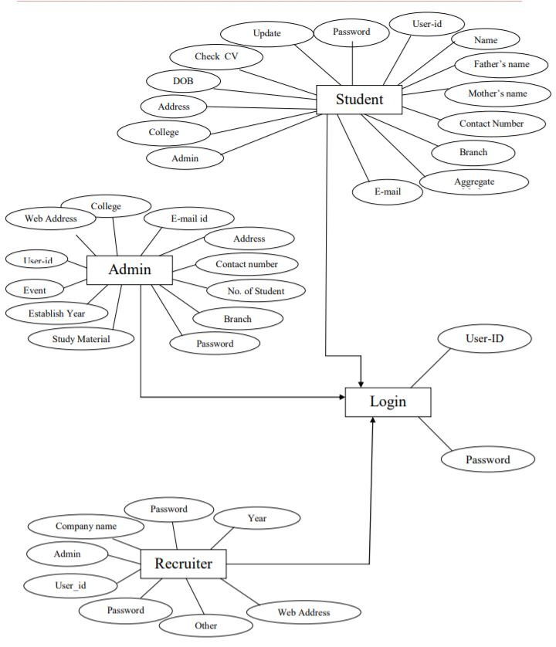

w

Operating Environment
- Operating System : Microsoft Windows
- Programming environment : java
- Database : Oracle/MySQL
- Web Browsers : Internet Explorer
- Database Drivers : JDBC/ ODBC drivers

Design and Implementation Constraints

- Excel Export has not been developed for TPC due to some criticality.
- Off-line reports for training, technical skills, Student cannot be generated due to batch mode execution.
- Fault Tolerance: Data should not become corrupted in case of system crash or power failure
- Security: The files in which the information regarding securities and portfolios should be secured.

User Documentation
User documentation components such as user manuals, online help, and tutorials will be delivered along with the software. other tutorials and support form will be made available in case to report any bug or other support related issues.

Assumptions and Dependencies
- We are assuming that user should have some basic knowledge of computer.
- Job seeker should be from any field.

External Interface Requirements

User Interfaces
- Some of the interfaces of the product could be
- Login page(Secured with password)
- For new user there will be the registration page to create an account
- List of jobs matching to student’s(user) profile
- For each matching profile there will be one link to apply
- List of replies he got by company HR.(about the interview scheduled or position he applied)
- Link to know that how many and which companies are related with consultancy.
- Link for practice tests
- Link for model question papers of few top most companies.

Hardware Interfaces
- The device must be connected to internet to use this application.
- The program will communicate with hard drive via proper Java code. The user can communicate through browser using keyboard and a display through graphical interface displayed on user’s screen.

Software Interfaces
- The software interface uses:
- Windows 10 operating system
- Chrome web browser
- Oracle, MySql for server and database
- Java , HTML and CSS for scripting

Communications Interfaces
- The protocol that we have been using for communication in TPC is HTTP.
- The web links provided for aptitude test preparation for the use of students is accessed through web browser

System Features

Notice generation
4.1.1.
Here, the user has to provide information to the system about company mane, date and the venue at which campus drive might take place. With this information the system will generate a notice which can be seen on students’ account to intimate student about placement drive.

4.1.2
When a company actually comes to recruit, the recruiters are supposed to use the application and fill their details and the notice will be generated automatically by the application and sent to the students based on their requirements.

4.1.3
- Name
- Company Company details
- Requirements to get recruited

  - Student List generation

4.2.1.
Here the user has to provide information to the system about requirements of the company (such as, cut off percentage, number of backlogs allowed, etc.)

4.2.2
This student list should be created by the placement cell of the Organization to which the recruiters are about to come. Or the students are given access to the registration portal and asked to get signed up. And a list will be created and will be available for the company to view depending on their requirements.

4.3.3
- Specialization required
- Cut off percentage(CGPA)
- Back logs allowed
- Internship experiences

  - View Student Profile

4.3.1
Here the user is able to view a student’s profile of his interest by giving any unique attribute (such as, roll number, complete name, etc.)

4.3.2
This feature is available to both organization and recruiters. When the recruiter get a list of students based on their requirements, and if they want to view students’ profile to shortlist them or to know more info.

4.3.3
- Student name(complete name)
- Student id
  - Result analysis

4.4.1
Here, the user (students and Organization) is able to get the results which are released and store them for later usage.

4.4.2
When the recruiters short-list the students to the next phase of recruitment, all the details will be available to the placement cell of the organization and if they choose to let the students know, the students will get the notification (manual sending by the cell or direct notification).

4.4.3
- Selected candidates’ names(by Company)
- Selected candidates’ id(by company)

  - Posts

4.5.1
Here the user is provided to post updates or any necessary details to students or others (for example –company officials) depending on his need.

4.5.2
When a Company selects the candidates and after they get the notification, they will get the details of any officials of the Company or the contact information to stay in touch with the company

4.5.3
- Final selected candidates’ names(Complete names)
- Final selected candidates’ id

Other Nonfunctional Requirements

Performance Requirements

The completely separate business logic at server side from the student interface ensures good performance.

The system exhibits high performance because it is well optimized. The business logic is clearly separate from the User Interface.
- The response to the user is within seconds, providing all the information at a glance

Safety Requirements
If there is extensive damage to a wide portion of database due to catastrophic failure such as disk crash, the recovery method restores a past copy of the database that was blocked up to the archival storage and reconstructs a more current state by reapplying or redoing the operations of committed transaction from the backed up log, up to the time of failure

Security Requirements
Security Systems need database storage just like many other applications. However, the special requirements of the security market mean that vendors must choose their database partner carefully.

Software Quality Attributes
- CORRECTNESS: The information related to students provided in CV should be accurate and clearly mentioned.
- MAINTANABILITY
- AVAILABILITY
- USABILITY

Business Rules
<List any operating principles about the product, such as which individuals or roles can perform which functions under specific circumstances. These are not functional requirements in themselves, but they may imply certain functional requirements to enforce the rules.>

Other Requirements

  - Performance requirements

- The users must get the response within seconds i.e. the response time of a particular function should be minimum.
- Completely separate business login at server side form the student interface ensure good performance
- The system would exhibit high performance because, it would be well optimized. The business logic would be clearly separate from the user interface.

  - Usability

- The software must have a simple and user friendly interface
- The navigation to various pages should be convenient to the users so as to save time and confusion

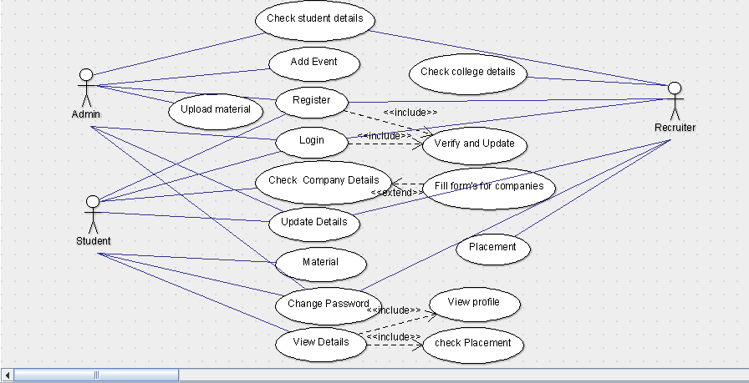
Use Case Diagram:

