**[Training and Documentation]**

**[Oscar’s users stories]**

**CONDUCTED FOR DESIGN**

**Report No. [US-01]**

**For the Week Ending or Date Submitted: [11/12/2020]**

**PREPARED BY**

**[Nguyen Minh Nhut]**

[Product Owner]

[nhutnguyenf330@gmail.com]

[giadungthongminhsg.com]

[Nguyen Huu Tho, district 7, Ho Chi Minh city]

**PREPARED FOR**

**[Dang Duc Vinh]**

[Designer & Core developer]

[*Added later*]

[giadungthongminhsg.com]

[Nguyen Huu Tho, district 7, Ho Chi Minh city]

**Table of Contents**

[Oscar e-commerce website user stories overview] 3

Report No. [US-01] 3

Real-time Oscar e-commerce functions: 3

User stories mapping for Oscar site 4

A basic users journey 4

User stories mapping 5

# [Oscar e-commerce website user stories overview]

# Report No. [US-01]

* Firstly, you should visit Oscar’s documentation main page [here](https://readthedocs.org/projects/django-oscar/).

## Real-time Oscar e-commerce functions:

|  |  |
| --- | --- |
| **Name** | **Activity Description** |
| Authentication | signup/login/logout |
| Items for sale | User can view lists of items for sale and search by name, filter by price. |
| Shopping cart | User can add items to shopping cart and the app remembers it next time you login. User can view all the items in their shopping cart. User can delete items in the shopping cart. Shopping cart uses an integer column to store "state". |
| Checkout | User can fill in form and submit billing info. After submitting billing info, items in the shopping cart will move to a different "state" |

# User stories mapping for Oscar site

## A basic users journey

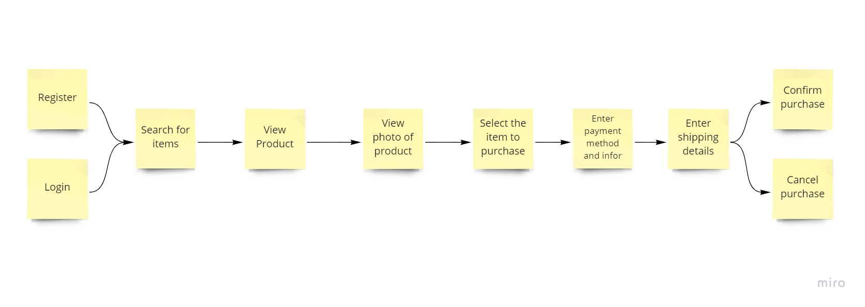

## User stories mapping

