

Django-Oscar:

Domain-driven e-commerce for Django

Requirements Analysis & Design (RAD)

By Students:

Nguyễn Minh Nhựt – 518H0545
Đặng Đức Vinh - 518H0075
Võ Lâm Duy Thuần - 518h0282
Hà Quán Quân - 518H0047
Nguyễn Thanh Nguyên - 518H0659

Reference: | Group 17
Audience: | Mr. Le Ngoc Thach | Lastest update: | 24th October, 2020
Outcome: | Django-Oscar - Domain-driven e-commerce for Django
Abstract: | This document provides an in-depth analysis of a proposed college social network with the requirements modelled utilizing the UML framework. This document is compiled by members of Group 17.

Intellectual Property
Copyright 2020 Group 17

The following documentation, the content there in and/or the presentation of its information is proprietary to and embodies the confidential processes, designs, technologies and otherwise of Group 17. All copyright, trademarks, trade names, patents, industrial designs, and other intellectual property rights contained herein are, unless otherwise specified, the exclusive property of Group 17.

The ideas, concepts and/or their application, embodied within this documentation remain and constitute items of intellectual property which nevertheless belong to Group 17.

The information (including, but by no means limited to, data, drawings, specification, documentation, software listings, source and/or object code) shall not be disclosed, manipulated, disseminated or otherwise in any manner inconsistent with the nature and/or conditions under which this documentation has been issued.

The information contained herein is believed to be accurate and reliable. Group 17 accepts no responsibility for its use in any way whatsoever. Team Five shall not be liable for any expenses, damages and/or related costs which may result from the use of the information contained herein.
The information contained herein is subject to change without notice.

All Rights Reserved. Copyright herein is expressly protected at common law, statute and under various International and Multi-National Treatises (including, but by no means limited to, the Berne Convention for the Protection of Literary and Artistic Works).

Table of Contents
Intellectual Property 3
Table of Contents 4
I. Executive Summary 6
II. Business Requirements 7
2.1 Organization Chart / Project Chart 7
2.2 Business Modeling / Requirements 7
2.3 Business Processes / Flowchart of Requirements 9
2.4 List of Requirements 10
III. System Requirements Analysis (Coming soon) 12

Executive Summary
Overview about Django Oscar:
According to the main documentation, Django Oscar is an e-commerce framework for Django designed for building domain-driven sites. It is structured such that any part of the core functionality can be customised to suit the needs of your project. This allows a wide range of e-commerce requirements to be handled, from large-scale B2C sites to complex B2B sites rich in domain-specific business logic.
From that Group 17 will turn a whole framework to a working online shop which can be used everywhere.
Target market and challenges
- Oscar’s target is everyone who wants start a business and needs a fine, fair-use online cart adding website and lack in malfunction.
- Why choose Oscar?
- Because it is an extensible core - any class can be overridden, replaced and extended. This is the key feature that allows any project to be captured accurately in the codebase - no work-arounds!
- A well-designed set of models built on the experience of many e-commerce projects, both large and small.
- Comprehensive documentation including recipes for solving common problems.
- Extensive test suite
- Since every project comes with its own risks and challenges, choosing Oscar as our core project has some too. When problems come, there will be many ways to solve them but using Oscar can cost a lot of time to customize since there is a huge security to protect every method inside the layout folder which can cause a lot of misunderstanding to make it implemented correctly. Further, Oscar is a good choice if your domain has non-trivial business logic. Oscar’s flexibility means it’s straightforward to implement business rules that would be difficult to apply in other frameworks.
Overview of operational highlights
- A checkout that allows a single order to be paid by up to 9 different payment sources, using multiple payment partners.
- Sales representatives are able to place orders on behalf of their customers, using allocated budgets managed within the system.
- Integration with a series of SAP web services to provide catalogue and inventory updates.
- Handling of a catalogue of around 15 million products, with stock provided by a range of international partners. Stock and updates happening continuous using a Celery-driven backend.
- Sophisticated access-control rules governing which customers can see which products.
- Manages a 12 million catalogue supported by 100+ suppliers for a single project.

Business Requirements

Organization Chart / Project Chart
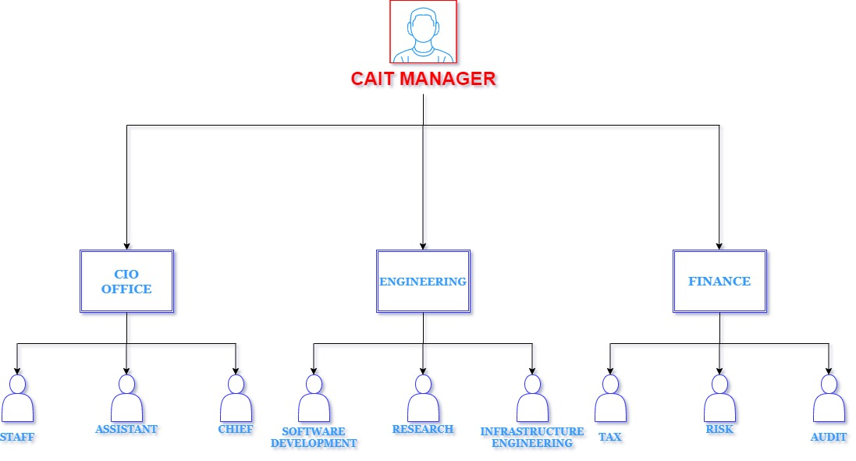

Business Modeling / Requirements

Business need:

- Paying for an order with multiple payment sources (e.g., using a bankcard, voucher, gift card and points account).

- Complex access control rules governing who can view and order what.

- Supporting a hierarchy of customers, sales reps and sales directors - each being able to “masquerade” as their subordinates.

- Multi-lingual products and categories.

- Digital products.

- Dynamically priced products (e.g. where the price is provided by an external service).

Project sponsorship:

Note: This model is built to support subject Software engineering 2020-2021 and we are looking to having a real sponsorship, this might come to reality

Business requirement:
By implementing Oscar, we will be provided with these functions below:
- Online access to every information
- Classmates and Lecturers suggestion, Higher level schoolmates with same major as yours suggestion to support your study experience
- User report if there is problem with the user because the account is hacked
- Friends and Lecturers searching capabilities
- Experience Problem Report
- Online user support from admin and support team
- Adding friends to your friend-list, unfriending them but you don’t want to
- Report any content which is illegal or be againts the TDTU School rules
- Matching you and your parents together by automatically accept student’s parent friend requests
Business Value:

By implementing Oscar, TDTU can expect to receive those benefits:
- Incresing in school picture and reputation, when TDTU got its very own social network and everyone know anyone, how good
- Increasing in number of students who expect to get in TDTU for having such good facility, new students will feel no fear or shyness getting to know their new schools.
By implementing Oscar, TDTU students can expect to have those benefits:
- Increasing in relationship quality when you and classmates can get closer toghether by CLASSMATE SUGGESTION LIST
- Increasing quality in relationship between you and lecturers not just boringly sending email on elit or gmail
- You can expect higher safety when your parents can watch you long distance when system will match you with your parents so do your parents while Elit or TDTU System web based cannot provide

Business Processes / Flowchart of Requirements
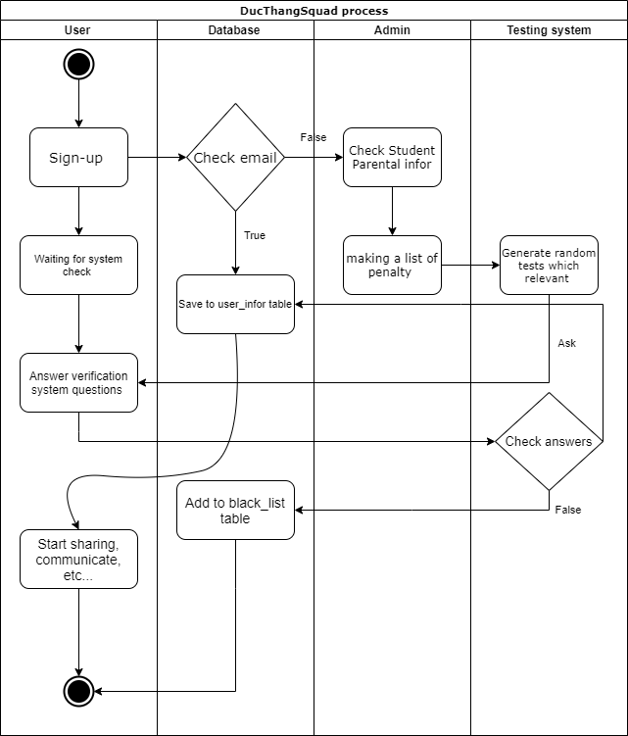

List of Requirements

Functional requirements:
Process – oriented
- Oscar allows new users to create new accounts.
- Oscar allows users who have already created their accounts to forget their password and get it back by sending a private email to their TDTU emails and it is automatically
- Oscar will send you friend suggestion list who will be your classmates and lecturers in new classes
- Oscar allows registered users to add more friends on their Friends lists or unfriend
- Oscar allows registerd users report groups, clubs, status or even accounts that are against TDTU’s rules
- Oscar allows users to update their information from descryption, changing status content, comment content
- Oscar allows users to share picture, audio, video, documentation files
- All users will receive notifications if there are news, friend acception, information updating susccessfully, etc.
Information – oriented
- Oscar must contain all information of students, lecturers and parents in its database
- Oscar includes friend tree of every students to make suggestions
- Oscar will save email address marked as black list mails who are not parents but strangers outside TDTU
- Oscar will save user’s online history and who were online for 1 hour and will delete the history if the user comes back within 1 hour or after 1 hour
Non- Functional requirement:
Operational:
- Oscar is a web app so it can be runned by any device from PC to mobile phone
- Oscar can work on any web browser and until now work best with Chrome
Performance:
- Oscar is now using just localhost so there will be some limits
Security:
- Oscar was designed to receive the full technical control of system admin and this admin is managed by CAIT manager
- Oscar’s users can control every doing they are making, just like the other social network such as Facebook, Twitter or Instagram, we can see what we are doing, who are our friends, we can look for them and our messages are totally private.
- After signing – up from Oscar, the users are expected to have a private email which is not a spam to verify that they have just made the account.
- Oscar is prepared to handle some attacks such as brute force, Trojan horse, SQL Injection, Phishing attack, etc
- Only TDTU students and parents can see what happened in Oscar interface but strangers can just see the sign up and Login interface, sorry strangers
Cultural and Political
Oscar is built under supervision of TDTU and the Government; Oscar is fully controlled by TDTU and protected by strict rules of TDTU

Under construction.
Appendix 1: the Full size of use case Diagram

Appendix 2: the full size of Collaboration Diagram

Appendix 3: the full size of Class Diagram

